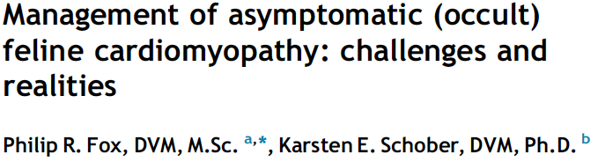

- Cats with asymptomatic heart disease include those with incidental findings of a heart murmur, gallop heart sounds, or arrhythmia. Some with occult CM not have any detectable abnormalities.

Limitation: Evidence based treatment
- Levels of evidence (ranked as A, B, C) denote categories of ‘proof’ derived by amalgamation of available published evidence that supports treatment recommendations.
  - A: strongest weight of evidence, includes multiple randomized trials with large number of subjects
  - C: based on expert opinion.
- In vet med level A evidence is rare, and level B is occasionally available.
- Treatment recommendations in feline occult CM typically based on level C evidence and frequently non-consensus opinions

Hazards of over classification of disease (medicalization of normal variation, equivocal or mild conditions)
- There is an absence of consensus guidelines that could provide direction and rationale for diagnosing and managing occult cardiomyopathy in cats.
- There is a tendency to view patients whose echo parameters fall slightly outside reference range as being affected.
  - This can affect decisions made by owners in terms of anesthesia, unnecessary medications etc.

Feline cardiovascular risk markers
- Processes responsible for initiating progression from occult state to symptomatic are poorly understood, but involve genetic factors.
- High proportion of cats with asymptomatic HCM have been documented to have 5 year survival or greater (Fox PR. Unpublished data. 2013)
  - Long-term prognosis is generally poor for RCM, DCM, and ARVC.
- Two retrospective HCM studies
  - Payne JSAP 2010;51:540-547: 127 cats (54% symptomatic, 46% asymptomatic)
    - LA size, age, breed were associated with survival time
  - Payne JVIM 2013;27:1427-1436: 282 cats (33% symptomatic 67% asymptomatic)
    - Echocardiographic variables of LA dysfunction, low left ventricular systolic function (left ventricular shortening fraction ≤ 30%), and extreme left ventricular hypertrophy (left ventricular end-diastolic wall thickness ≥ 9.0 mm) were prognostic indicators for risk of cardiac death
- The importance of dynamic right ventricular outflow tract obstruction in cats is currently undetermined.

Factors associated with cardiac morbidity
- Diastolic dysfunction
- Left atrial enlargement and dysfunction
- Left ventricular modeling and systolic dysfunction
- Malignant family history of sudden death (high risk genotype)
- Advanced structural lesions

- Diastolic dysfunction – main pathophysiologic consequence of a wide range myocardial disorders.
- Factors that compromise diastolic function, promote ventricular stiffness and cause reduction of chamber compliance include:
  - Increased myocardial mass (hypertrophy)
  - Increased calcium sensitivity and altered calcium handling of contractile elements
  - Myocardial injury (inflammation, myocytolysis, apoptosis, necrosis) and repair (fibrosis, matrix changes)
  - Myocyte disorganization
  - Ischemia

- Preclinical diastolic dysfunction appears to be prevalent in most cats with occult cardiomyopathy (especially in RCM and HCM).
- Diastolic heart failure is the most common cause of feline cardiac-related hospital visits.
- Diastolic dysfunction and restrictive filling pattern is associated with decreased survival in cats.
- Regional left ventricular wall hypokinesis and systolic dysfunction are poor prognostic indicators in feline HCM.

- Left atrial enlargement and dysfunction – associated with shortened survival in cats with HCM.
- Impaired LA systolic function and LA appendage flow velocities are associated with feline cardiovascular morbidity.
- In humans LA spontaneous echo contrast is a significant predictor of thrombus formation and thromboembolic events.
  - This association is believed to be similarly important in cats.

- Left ventricular modeling and systolic dysfunction
- Extreme left ventricular hypertrophy (end-diastolic left ventricular posterior wall or interventricular septum thickness > 9.0 mm), regional left ventricular wall motion abnormality and thinning, and reduced (≤30%) left ventricular fractional shortening are risk factors for cats with HCM.
- In humans extreme LV hypertrophy is associated with severity of diastolic dysfunction and sudden death.

- Malignant family history of sudden death (high risk genotype)
- Main coon cats with HCM have heritable patterns of sudden or unexpected death.
- Screen asymptomatic siblings for similar phenotypes (similar to affected individuals).

- Advanced structural lesions
- Asymptomatic cats with arrhythmic right ventricular cardiomyopathy are at risk for developing CHF.
  - ARVC: severe right ventricular dilation and ventricular arrhythmia
- Cats with end-stage HCM are at high risk for adverse outcomes.
  - End stage HCM: Progressive left ventricular systolic dysfunction, dilation, regional or global wall thinning of previously concentrically hypertrophied ventricles, severe left atrial enlargement, restrictive left ventricular filling, and myocyte injury with interstitial fibrosis and replacement fibrosis
- Cats with endomyocardial fibrosis are at risk for CHF and ATE.
  - Endomyocardial fibrosis: prominent/diffuse scarring that bridges ventricular septum and left ventricular posterior wall, left ventricular remodeling and myocardial dysfunction, extreme left atrial dilation

- Dynamic obstruction of the left ventricular outflow tract
- Recent studies DO NOT support the notion that SAM (i.e. HOCM) increases cardiac morbidity or mortality (Payne. Prognostic indicators in cats with hypertrophic cardiomyopathy. J Vet Intern Med 2013; 27; Fox PR. Unpublished data. 2013.)

Medical therapies considered for asymptomatic cats with risk markers for cardiac morbidity and mortality
- Presently, there is no data that establishes a treatment benefit for cats with mild to moderate asymptomatic (occult) cardiomyopathy.
- Drug therapy remains controversial until benefit can be established from clinical trials.
- Typically cats with occult CM are treated based on evidence extrapolated from human trials, research models or personal opinion.
- Drugs most commonly considered include:
  - Drugs that reduce TE risk in cases with substantial left atrial enlargement or dysfunction.
  - Agents to counteract left ventricular remodeling.
  - Drugs that ameliorate systolic or diastolic dysfunction.

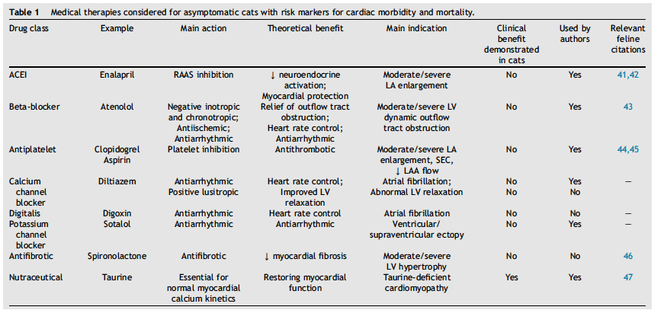

Summary
- No consensus guidelines for diagnosing and managing occult cardiomyopathy in cats.
- The importance of dynamic right ventricular outflow tract obstruction in cats is currently undetermined.
- Recent studies DO NOT support the notion that SAM increases cardiac morbidity or mortality.
- There is no data that establishes a treatment benefit for cats with mild to moderate asymptomatic cardiomyopathy.
- Drug therapy remains controversial until benefit can be established from clinical trials.
- Drugs most commonly considered include:
  - Drugs that reduce TE risk in cases with substantial left atrial enlargement or dysfunction.
  - Agents to counteract left ventricular remodeling.
  - Drugs that ameliorate systolic or diastolic dysfunction.

Questions
- Based on a retrospective study by Payne et al in 2013, which of the following was shown to be an indicator of increased risk of cardiac death?
  - Dynamic right ventricular outflow tract obstruction
  - Systolic anterior motion of the mitral valve
  - Left ventricular shortening fraction ≤ 30%

- Name three factors associated with cardiac morbidity in cats.

- True or False. Preclinical diastolic dysfunction appears to be prevalent in most cats with occult cardiomyopathy.

- True or False. Recent literature has established a survival benefit for cats with mild to moderate asymptomatic cardiomyopathy, treated with clopidigrel.

Bonus: Name 2 factors that compromise diastolic function.

Answers
- Based on a retrospective study by Payne et al in 2013, which of the following was shown to be an indicator of increased risk of cardiac death?
  - Dynamic right ventricular outflow tract obstruction
  - Systolic anterior motion of the mitral valve
  - Left ventricular shortening fraction ≤ 30%

- Name three factors associated with cardiac morbidity in cats.
- Diastolic dysfunction
- Left atrial enlargement and dysfunction
- Left ventricular modeling and systolic dysfunction
- Malignant family history of sudden death (high risk genotype)
- Advanced structural lesions

- True or False. Preclinical diastolic dysfunction appears to be prevalent in most cats with occult cardiomyopathy.

- True or False. Recent literature has established a survival benefit for cats with mild to moderate asymptomatic cardiomyopathy who are treated with clopidigrel.

Bonus: Name 2 factors that compromise diastolic function.
- Increased myocardial mass (hypertrophy); Increased calcium sensitivity and altered calcium handling of contractile elements; Myocardial injury (inflammation, myocytolysis, apoptosis, necrosis) and repair (fibrosis, matrix changes); Myocyte disorganization; Ischemia

