Management of Acute Right Ventricular Failure in the Intensive
Care Unit

Key Points:
- Flattening of the RV free wall during systole produces a large decrease in volume without much change in free wall area, allowing the RV to achieve a similar stroke volume as the LV with lower energy expenditure
- When RV end-diastolic pressure exceeds LV end diastolic pressure, the septum shifts toward the LV during diastole, creating a flattened septum and a “D” shape when the heart is viewed in cross-section
- Causes of RV failure in critical illness can be divided into three main categories: (1) excessive preload; (2) excessive afterload; and (3) insufficient myocardial contractility
  - The RV has a flatter Starling curve than the LV, meaning there is less of a change in RV contractility over a wide range of filling pressures

Summary:
- Despite a rise in cardiac output during heavy exertion that may be fourfold above baseline, pulmonary arterial pressure increases minimally and pulmonary vascular resistance falls.
- Contrast to the systemic circulation, where increased cardiac output during exercise is associated with a significant increase in blood pressure
- The difference between the two circulations is based on the ability of the lung to recruit partially collapsed or unused vessels as cardiac output increases and the relatively low degree of vascular motor tone in the proximal pulmonary vascular bed
- The difference between mean arterial and venous pressure in the pulmonary circulation is less than 10mmHg,
- The greatest drop in pressure occurs across the non-muscularized microcirculation and alveolar capillaries
- Flattening of the RV free wall during systole produces a large decrease in volume without much change in free wall area, allowing the RV to achieve a similar stroke volume as the LV with lower energy expenditure
- The more compliant RV is better suited to accommodate large increases in right-sided venous return but tolerates acute increases in afterload poorly
- Myocytes of the interventricular septum and LV free wall are oriented circumferentially, resulting in concentric narrowing of the LV lumen during systole
- The RV free wall, on the other hand, is comprised of a superficial, transversely oriented muscle layer and a deeper layer where the fibers are arranged longitudinally from apex to base
- Systolic pressures are generated by longitudinal contraction with the apex moving toward the tricuspid valve
- RV systolic function can be assessed by measuring the longitudinal systolic displacement of the RV base toward the RV apex
- This is commonly referred to as the tricuspid annular plane systolic excursion and is relatively simple to perform highly reproducible, and has been shown to correlate well with RV ejection fraction derived from radionuclide angiography
- When RV failure occurs in the setting of increased RV afterload, volume loading can result in displacement of the interventricular septum toward the LV and impaired LV diastolic filling
- At the same time, RV dilation increases free wall tension, resulting in increased oxygen demand and decreased RV perfusion
- In this setting, intravascular volume may need to be decreased
- The RV has a flatter Starling curve than the LV, meaning there is less of a change in RV contractility over a wide range of filling pressures
- Right ventricular (RV) failure occurs when the RV fails to maintain enough blood flow through the pulmonary circulation to achieve adequate left ventricular filling
- When RV end-diastolic pressure exceeds LV end diastolic pressure, the septum shifts toward the LV during diastole, creating a flattened septum and a “D” shape when the heart is viewed in cross-section
- The degree of septum shift is dependent on the difference between RV and LV end diastolic pressure
- Can occur suddenly in a previously healthy heart due to massive pulmonary embolism or right-sided myocardial infarction, but many cases encountered in the intensive care unit involve worsening of compensated RV failure in the setting of chronic heart and lung disease
- Management of RV failure is directed at optimizing right-sided filling pressures and reducing afterload
- Vasoactive medications have less salient effects on reducing vascular resistance in the pulmonary than in the systemic circulation
- Systemic systolic arterial pressure should be kept close to RV systolic pressure to maintain RV perfusion
- When these efforts fail, the judicious use of inotropic agents may help improve RV contractility enough to maintain cardiac output

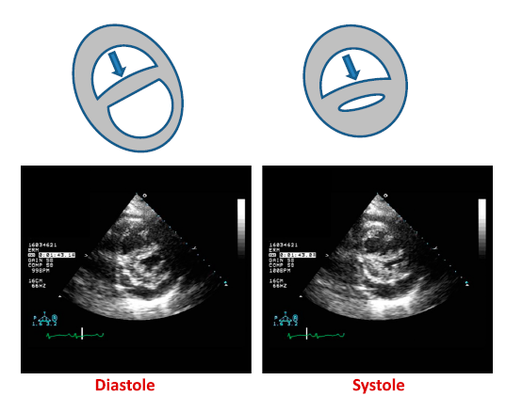
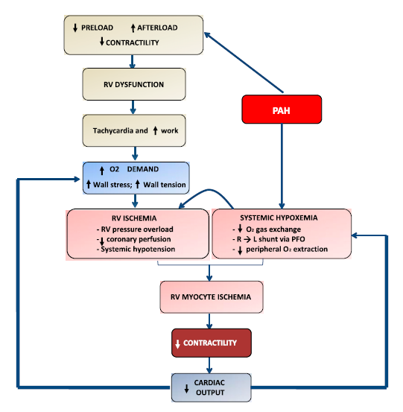

- Changes in vascular resistance are mediated by _______________ causing vasoconstriction or ___________ and ______________________ causing vasodilation.

- List possible physical exam findings of elevated right sided pressures

- List the 3 main categories of RV failure in critical illness

- What does TAPSE stand for? Draw the B-mode image and where you would place the M-mode cursor

- Draw and explain the physiology of decreased cardiac output with pericardial effusion

- Changes in vascular resistance are mediated by _______________ causing vasoconstriction or ___________ and ______________________ causing vasodilation.
  - Sympathetic/catecholamines, prostaglandins, NO
- List possible physical exam findings of elevated right sided pressures
  - Jug venous distension, peripheral edema
  - RV dilation can cause splitting of the second heart sound and produce a tricuspid regurgitation murmur
- List the 3 main categories of RV failure in critical illness
  - (1) excessive preload; (2) excessive afterload; and (3) insufficient myocardial contractility
- What does TAPSE stand for? Draw the B-mode image and where you would place the M-mode cursor

- Draw and explain the physiology of decreased cardiac output with pericardial effusion

