Tiley Chap. 6 - Acquired Valvular Disease & SACCM Chap. 43 – Valvular Heart Disease

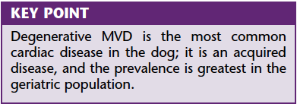
- Myxomatous valvular degeneration, myxomatous transformation, mucoid degeneration, endocardiosis, chronic valvular disease, degenerative valvular disease
- Progressive disease
- Small breed dogs; CKCS (younger age for onset), male dogs
- Uncommon in cats
- ≈ 75% of cases of cardiovascular disease seen in dogs
- Incidence in older small breed dogs approaches 100%
- May affect all 4 cardiac valves
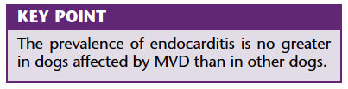
- Nodular distorsion, thickening, elongation of the valve leaflets; lengthening of chordae tendineae
- Initially at the free edge; increase in # and size and coalesce; severe: contraction of the leaflets (roll toward LV)
- prevent coaptation of valve leaflets
- Deposition of GAGs (mucopolysaccharides) and other EC matrix proteins within spongiosa layer*, fibrosis, NO inflammation, sterile, degenerative disease
- Classes of severity (research setting, rarely used in clinic)


- Chondrodysplastic dogs – possible systemic connective tissue disease (collapsing trachea, bronchomalacia, IVDD, MVD)
  - Imbalanced collagen degeneration and synthesis
  - Histo: abnormal collage distribution; MMPs may play a role in the turnover of collagen
- Possible role of vasoactive peptide endothelin (greater density of endothelin receptors related to severity of MVD)
  - Other neurohormonal factors: serotonin, TGF-α and β, insulin-like growth factor I, ATII, NO.
- Polygenetic
- Age at which MVD developed appears to be inherited
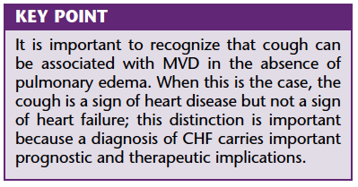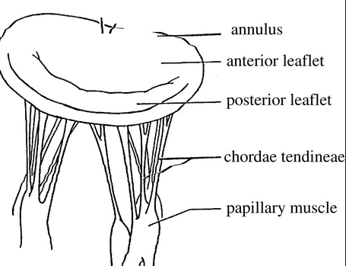
- When the MV is incompetent, a fraction of the SV is ejected through the MV regurgitant orifice into the LA (decreased forward CO)
- Degree of valvular insufficiency is determined principally by size of the orifice, pressure gradient across LA and LV pressures, and duration of systole (AV valves) or diastole (semilunar valves)
- MR increases LA pressure LA dilation
- When the MV leaks, the pulmonary venous return is augmented by the MR volume the LV is filled in diastole by blood that has returned from the lungs AND blood that has been regurgitated into LA (= volume load on the LV and LA)
- High ED pressures and volumes LV dilation and hypertrophy (eccentric)
- Enlargement of valve annulus displacement of leaflets and more regurgitation
- Severe MR may increase LV filling pressures; high filling pressures are reflected backward, raising pulmonary vein pressure and pulmonary edema
- Cardiomyopathy of overload may develop deterioration of systolic myocardial function; in general MR is relatively well tolerated by the myocardium because the LA = low-pressure reservoir into which the LV can eject blood
- Often in dogs with MR/CHF have systolic myocardial function that is normal or only mildly diminished (until late in the course of the disease)
- Large breed-dogs: most often myocardial dysfunction than smaller dogs (geometry or pattern of contraction of larger ventricle?
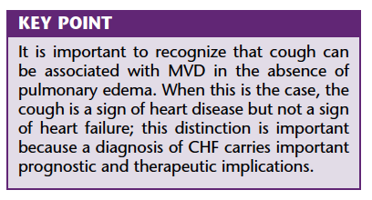
Pathophysiology (from MVD to HF) – see presentation

Clinical Signs
- Cough
  - = centrally mediated reflex; most cough receptors are located in the large AW (result from pulmonary edema, compression of mainstem bronchi by large LA, increase in pulmonary venous pressure and stimulation of juxtapulmonary (J) receptors)

- Murmur
  - Usually chronic; can be new finding in case of chordal rupture
  - Intensity of the murmur has been correlated with the severity of regurgitation
  - Acquired, left apical, systolic, plateau-shaped
  - Sometimes precordial thrill
  - Mid-systolic click: may be associated with prolapse of MV
  - Sometimes S3 gallop
- Syncope
  - From arrhythmias, from decreased SV, from sudden onset of reflex-mediated bradycardia (exercise, excitement, paroxysmal cough)
- Tachypnea
- Pulmonary edema
- Right-sided HF – pleural effusion, ascites, jugular distension/pulsation, positive hepatojugular reflux test
- Femoral pulse usually normal to strong until late in the disease (unless acute chordal or LA rupture cardiac tamponade); may have rapid raise
- Exercise intolerance
- Tachyarrhythmias: sinus tach, premature contractions, a-fib

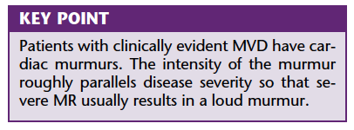

- Concurrent respiratory tract disease
  - Collapsing trachea, chronic bronchitis
- In patients with severe cardiac disease there is little vagal influence on HR and rhythm and as a result respiratory sinus arrhythmia is not prominent

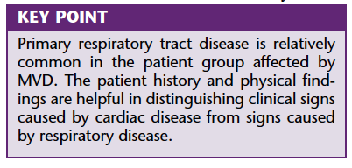
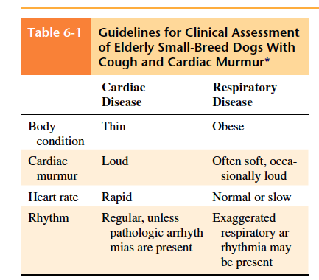
Diagnostics
Thoracic radiographs
- If clinically consequential MR: enlarged heart
- LA enlargement precedes CHF (most commonly)
- Distension of pulmonary veins (due to increase in venous pressure due to congestion)
- DDx for interstitial pulmonary infiltrates: pulmonary edema (cardiogenic or noncardiogenic), PH, PTE, primary lung diseases, neoplasia
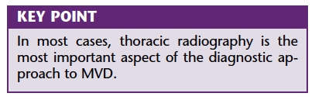
Echocardiography
- LA and LV dilation, hypertrophy (LA:Ao > 2)
- Thick mitral leaflets; prolapse of the leaflets, echogenicity of leaflets is uniform, diffused nodular thickening; ruptured chordae tendinae
- Pleural/pericardial effusion, rupture of LA, pericardial thrombus…
- Moderate-Severe MR altered loading conditions on LV hyperdynamic (if myocardial function is preserved)
  - FS is elevated (load-dependent)
- Impedance to ventricular emptying is reduced because blood can be ejected into LA (low pressure)
- ED ventricular stretch increases the force of contraction ( hyperdynamic)
- End-systolic volume index calculated as LVIDs³/BSA where LVIDs is the end-systolic left ventricular dimension and BSA = body surface area has been used in the assessment of myocardial function in dogs with MR; > 30 ml/m² suggests myocardial dysfunction
- Evaluation of blood flow with Doppler echocardiography (velocity, direction, character)
- Area of the color Doppler regurgitant jet relative to that of the receiving chamber is one means of semi-quantitatively evaluating the severity of valvular regurgitation
- The width of the regurgitant jet at its origin is perhaps more accurate; greater width indicates a larger orifice.
- Appearance of proximal flow convergence (color Doppler appearance of acceleration through the regurgitant orifice) - Proximal isovelocity surface area (PISA) or flow convergence
- Effect of valvular regurgitation might be of greater importance that its magnitude (chamber size and myocardial function)
ECG
- P mitrale: relatively specific for LA enlargement; wide P waves (>40 msec) in caudal frontal leads (II, III, aVF) or P pulmonale (tall P - > 0.5 mV)
- R > 2.5 mV or > 60 msec (LV enlargement)
- Supraventricular tachyarrhythmias that reflect atrial stretch – sinus tach, APC, a-fib
- Ventricular arrhythmias (LV dilation and myocardial fibrosis or hypoxia; large breeds)
Laboratory Evaluation
- Non specific
- Passive congestion of the liver hepatopathy
- Hyponatremia/hypochloremia in chronic HF
- Other concomitant diseases
- Hypoxemia with metabolic acidosis
- Elevated NT-proBNP/ANP
  - Could also be elevated in patients with pulmonary hypertension, renal dysfunction
- Elevated cardiac troponin I – sensitive but relatively nonspecific
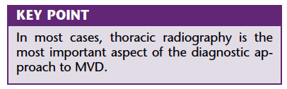
Complications
- Development of azotemia associated with diuretic and ACEI
- Rupture of chordae tendineae
  - When a primary chorda ruptures, the attached mitral leaflet becomes suddenly flail potentially resulting in catastrophic MR, marked elevations in ventricular filling pressures, and fulminant pulmonary edema.
- Pulmonary hypertension
  - Multifactorial
  - Elevations in LA pressure cause commensurate increases in RV systolic pressure. The tendency for LA hypertension to cause pulmonary hypertension is probably the primary explanation for high pulmonary artery pressures in most cases; in some patients, the increase in estimated pulmonary artery pressure is disproportionate to any credible estimate of LA pressure. In these cases, pulmonary arterial constriction – reactive vasoconstriction - probably contributes. Pulmonary hypertension may be also related to the presence of concurrent pulmonary or AW disease.
- Rupture of LA cardiac tamponade
Prognosis
- Long (1-3 years) preclinical phase
- When CHF develops worse prognosis
  - Medical therapy: 6-18 months
- Ruptured chordae tendinae or ruptured LA: poor/grave prognosis

QUESTIONS
- Which of the following P-V loops represent a patient with mitral valve regurgitation

A. 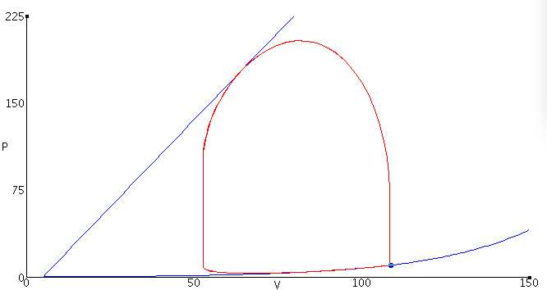B. 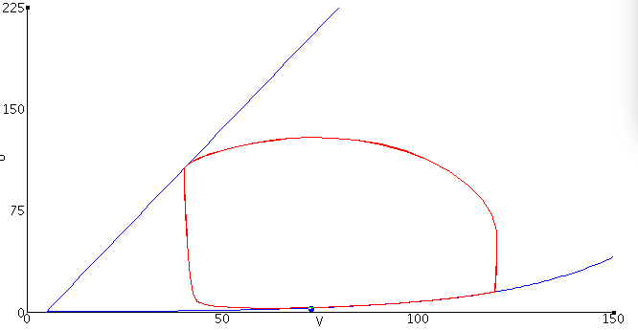
C. 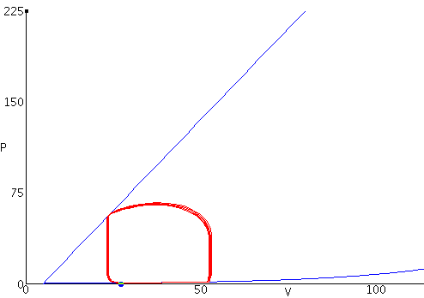D. 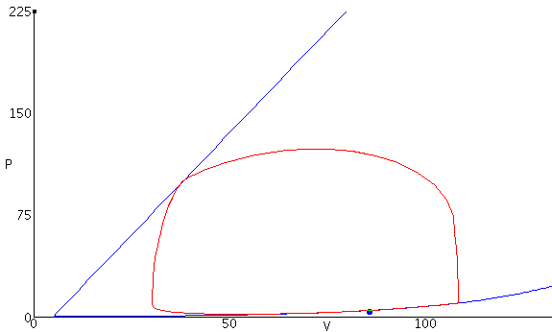

- The degree of mitral regurgitation is dependent on ___________________, ___________________, and _____________________.

- Name complications that can be seen in patients with MVD

- Why is the cardiac output reduced in dogs with MVD?

QUESTIONS & ANSWERS
- Which of the following P-V loops represent a patient with mitral valve regurgitation

A. = Aortic stenosis; left ventricular emptying is impaired because of high outflow resistance caused by a reduction in the valve orifice area when it opens. This high outflow resistance causes a large pressure gradient to occur across the aortic valve during ejection, such that the peak systolic pressure within the ventricle is greatly increased. This leads to an increase in ventricular wall stress, a decrease in stroke volume, and an increase in end-systolic volume. Stroke volume (width of PV loop) decreases because the velocity of fiber shortening is decreased by the increased afterload. Because end-systolic volume is elevated, the excess residual volume added to the incoming venous return causes the end-diastolic volume to increase. This increases preload and activates the Frank-Starling mechanism to increase the force of contraction to help the ventricle overcome, in part, the increased outflow resistance
B. Aortic regurgitation; the aortic valve does not close completely at the end of systolic ejection. As the ventricle relaxes during diastole, blood flows from the aorta back into the ventricle so the ventricle immediately begins to fill from the aorta. Therefore, there is no true phase of isovolumetric relaxation (no vertical line between aortic valve closure and mitral valve opening) because as the ventricle relaxes, even before the mitral valve opens, blood is entering the ventricle from the aorta thereby increasing ventricular volume. Once the mitral valve opens, filling occurs from the left atrium; however, blood continues to flow from the aorta into the ventricle throughout diastole because aortic pressure is higher than ventricular pressure during diastole. This greatly enhances ventricular filling so that end-diastolic volume is increased as shown in the pressure-volume loop. Ventricular end-diastolic volume is also increased because in chronic aortic regurgitation the ventricle anatomically dilates (remodels) so that ventricular compliance is elevated. When the ventricle begins to contract and develop pressure, blood is still entering the ventricle from the aorta because aortic pressure is higher than ventricular pressure; therefore, there is no true isovolumetric contraction because volume continues to increase. Once the ventricular pressure exceeds the aortic diastolic pressure, the ventricle then begins to eject blood into the aorta. The increased end-diastolic volume (increased preload) activates the Frank-Starling mechanism to increase the force of contraction, ventricular peak (systolic) pressure, and stroke volume (as shown by the increased width of the pressure-volume loop).
C. Mitral stenosis, impairs left ventricular filling so that there is a decrease in end-diastolic volume. This leads to a decrease in stroke volume (reduced width of PV loop) by the Frank-Starling mechanism and a fall in cardiac output. Reduced ventricular filling and reduced aortic pressure decrease ventricular wall stress , which may result in a small decrease in ventricular end-systolic volume; however, this is not sufficient to offset the reduction in end-diastolic volume. Therefore, because end-diastolic volume decreases more than end-systolic volume decreases, the stroke volume (shown as the width of the loop) decreases.
D. Mitral regurgitation; as the left ventricle contracts, blood is not only ejected into the aorta but also back up into the left atrium. This causes left atrial volume and pressure to increase during ventricular systole. Note in the pressure-volume loop that there is no true isovolumetric contraction phase because blood begins to flow across the mitral valve and back into the atrium before the aortic valve opens as soon as ventricular pressure exceeds left atrial pressure. Because of mitral regurgitation, the afterload on the ventricle is reduced (total outflow resistance is reduced) so that end-systolic volume can be smaller than normal. There is no true isovolumetric relaxation because when the aortic valve closes and the ventricle begins to relax, the mitral valve is not completely closed so blood continues to flow back into the left atrium (therefore further decreasing ventricular volume) as long as intraventricular pressure is greater than left atrial pressure. During ventricular diastolic filling, the elevated pressure within the left atrium is transmitted to the left ventricle during filling so that left ventricular end-diastolic volume (and pressure) increases. Ventricular end-diastolic volume is also increased because in chronic mitral regurgitation the ventricle anatomically dilates (remodels) so that ventricular compliance is elevated. Increased end-diastolic volume would cause wall stress (afterload) to increase if it were not for the reduced outflow resistance because of mitral regurgitation that tends to decrease afterload during ejection because of reduced pressure development by the ventricle. The net effect of these changes is that the width of the pressure-volume loop is increased (i.e., ventricular stroke volume is increased); however, ejection into the aorta (forward flow) is reduced. The increased ventricular "stroke volume" (measured as the end-diastolic minus the end-systolic volume) in this case includes the volume of blood ejected into the aorta as well as the volume ejected back into the left atrium.
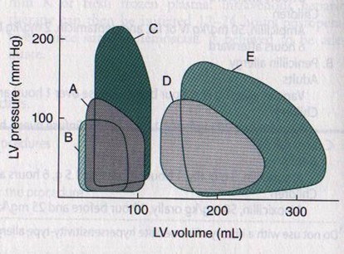
A. Normal
B. Mitral stenosis
C. Atrial stenosis
D. Mitral regurgitation (chronic)
E. Aortic regurgitation (chronic)
- The degree of mitral regurgitation is dependent on size of the orifice, pressure gradient between LA and LV, and duration of systole.

- Name complications that can be seen in patients with MVD: Rupture of chordae tendinae, rupture of LA, arrhythmia

- Why is the cardiac output reduced in dogs with MVD? Because part of the SV is ejected into the LA (mitral insufficiency)

