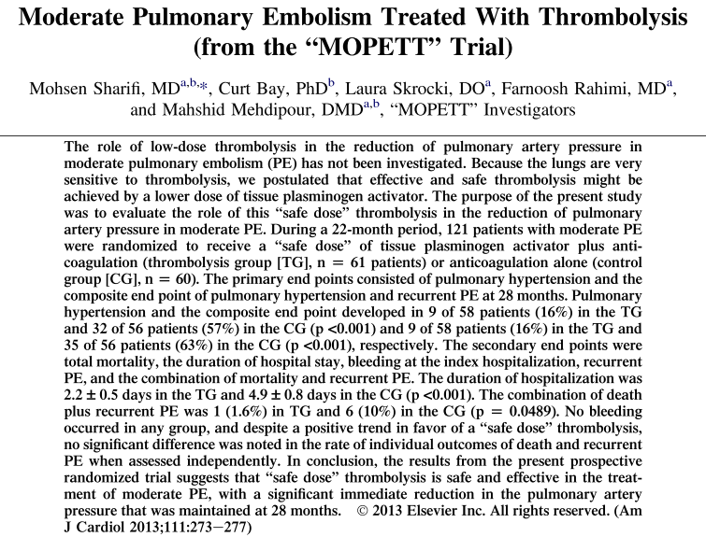
- Moderate PE: presence of signs and symptoms of PE plus
computed tomographic pulmonary angiographic involvement of >70% involvement of thrombus in ≥ 2 lobar or left or right main pulmonary arteries or by a high
probability ventilation/perfusion scan showing ventilation/
perfusion mismatch in ≥2 lobes.
- Why are lungs very sensitive to thrombolysis: only organs that receive the entire CO.
- Among patients with submassive PE, does low-dose tPA reduce the incidence of pulmonary hypertension or recurrent PE when compared to anticoagulation alone (is it effective – PH/PE; and safe?)
- Anticoagulants: UFH or enoxaparin; warfarin at admission
- Low-dose = 0.5 mg/kg (max 50 mg) – (standard dose = 100 mg)
- In the treated group:
  - Lower incidence of PH
  - Lower incidence of PH and PE (incidence of PE was NSD though)
  - Lower mortality and recurrent PE (mortality or recurrent PE NSD independently though)
  - Shorter hospital stay
- No bleeding in any group
In this unblinded, single-center trial of patients with a particular definition of submassive PE, low-dose tPA plus anticoagulation reduced the incidence of pulmonary hypertension and of the composite outcome of pulmonary hypertension or recurrent PE compared to anticoagulation alone.
Questions
- The authors of a 2013 study evaluating the use of a tPA in the treatment of patients with moderate pulmonary embolism used a lower dose than the standard dose commonly used for the treatment of this condition. What was the rationale for the use of a lower dose of tPA?

- True or False – The authors of the study mentioned above showed that mortality was reduced in patients treated with a low dose of tPA compared to the patients that were not given a thrombolytic agent.

- What is the definition of submassive pulmonary embolism?

Questions & Answers

- The authors of a 2013 study evaluating the use of a tPA in the treatment of patients with moderate pulmonary embolism used a lower dose than the standard dose commonly used for the treatment of this condition. What was the rationale for the use of a lower dose of tPA?
The lungs are more sensitive to thrombolysis because they are the only organs that receive the entire cardiac output; therefore they will be exposed to the entire dose of thrombolytic agent administered. A lower dose than the dose used for the treatment of a coronary thrombus (5% of the CO) or acute ischemic stroke (15% of the CO) may be sufficient.

- True or False – The authors of the study mentioned above showed that mortality was reduced in patients treated with a low dose of tPA compared to the patients that were not given a thrombolytic agent.
False – there was a trend towards reduction in mortality but did not reach significance; there was a reduction in mortality AND recurrent PE (but not mortality or recurrent PE independently)

- What is the definition of submassive pulmonary embolism?
Pulmonary embolism in which the patient is hemodynamically stable but in which there is enlargement or hypokinesia of the right ventricle or elevation of the biomarkers of RV injury (TnI, BNP)

