Constant rate therapy of anesthetics
- Aimed at delivering drug at a rate approximating the rate of drug clearance to maintain in a specific therapeutic window for as much time as possible
  - Intermittent boluses
    - After loading dose, maintained with repeated injections
      - Causes oscillations between peak and trough. Poor consistency and can lead to large total drug dose and slower/longer recovery

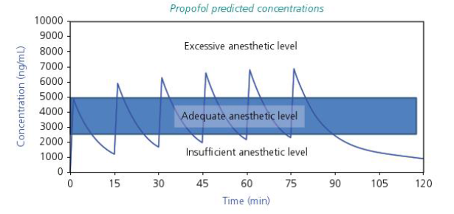

- Continuous rate infusions
  - Eliminates peaks and troughs
    - When using drip set, continuous adjustments are needed as bag empties or if patients’ position of venous blood pressure changes
  - Classified as non-pharmacokinetic-dependent or pharmacokinetic dependant
  - Non-pharmacokinetic-dependent
    - CRI (constant rate infusion)
      - No variation of rate - can be problematic with drugs with long half-lives as this will allow accumulation and will need loading bolus
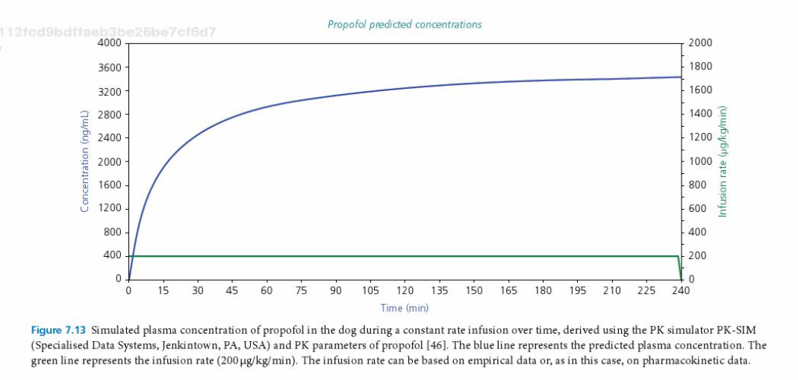
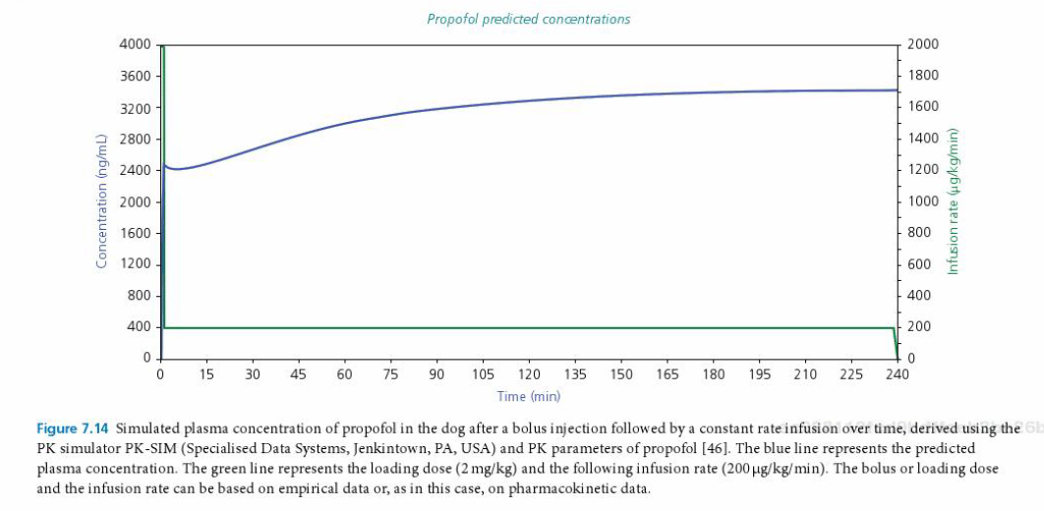
    - RCI (rate-controlled infusion)
      - Continually adjusting rate (usually downwards) to avoid accumulation based on patient's plane of anesthesia and monitoring variables
  - Pharmacokinetic-dependent
    - Using plasma drug elimination kinetics to change infusion over time
      - Plasma steady state reached after 4-5 elimination half-lives (even with initial bolus)
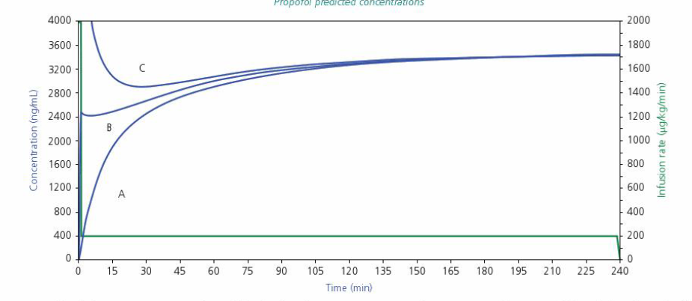

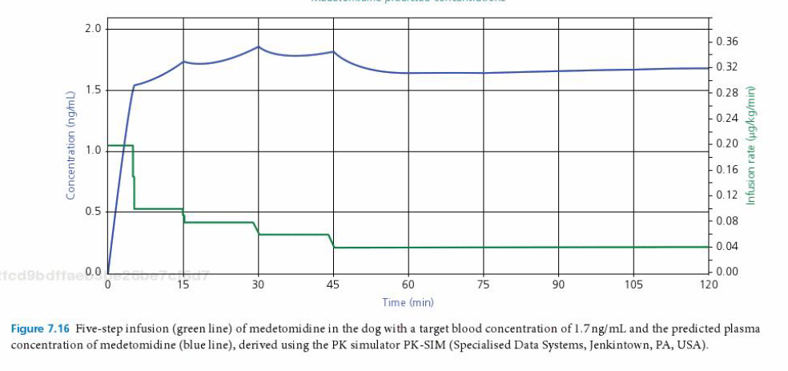

Drug interactions
- Physicochemical interactions
  - Usually when two incompatible drugs are mixed together in vitro
    - Changes solubility, chemical stability, chelation, reduction, oxidation
- Pharmacokinetic interactions
  - Interactions during absorption, distribution, elimination or biotransformation
    - Such as epi with lidocaine to decreased systemic absorption
  - Interactions during biotransformation are most clinically relevant
    - Alterations in hepatic metabolism
- Pharmacodynamic interactions
  - Modification of the response of the body to one or more concomitantly administered drugs
    - Alterations of receptor sensitivity or affinity directly or indirectly (at different site)
Adverse drug reactions
- Undesired effects and inefficacy, relative to the expected effects after drug administration
  - Dose-related
  - Non-dose related
  - Dose and time related
  - Time related
  - Withdrawal
  - Unexpected inefficacy
Drug Metabolism
- Metabolism of drugs or biotransformation occurs in two phases
  - Phase I - conversion of a fat-soluble compound into water-soluble for renal clearance or addition of chemically reactive site to molecule to allow conversion
    - Usually performed by cytochrome P450 isoenzymes
  - Phase II - conjugation reactions - attach the exogenous compound covalently to substrate which increases molecular weight and water solubility of complex

Questions

- After approximately how many elimination half-lives does a drug achieve plasma steady state?
  - 2-3
  - 3-4
  - 4-5
  - 5-6
- You draw up diazepam and methadone in the same syringe. You observe precipitation of white crystals. Which of the following characterizes what you have observed?
  - Adverse drug reaction
  - Pharmacodynamic interaction
  - Physicochemical interaction
  - Pharmacokinetic interaction
- True/False: The main benefit of continuous rate infusion over intermittent bolus injections is reduced time of recovery after anesthesia
- True/False The conversation of a lipophilic molecule to a hydrophilic molecule by P450 is considered an example of phase I drug metabolism
- True/False: Giving a loading bolus of a drug followed by a CRI decreases time to plasma steady state

Answers
- After approximately how many elimination half-lives does a drug achieve plasma steady state?
  - 2-3
  - 3-4
  - 4-5
  - 5-6
- You draw up diazepam and methadone in the same syringe. You observe precipitation of white crystals. Which of the following characterizes what you have observed?
  - Adverse drug reaction
  - Pharmacodynamic interaction
  - Physicochemical interaction
  - Pharmacokinetic interaction
- True/False: The main benefit of continuous rate infusion over intermittent bolus injections is reduced time of recovery after anesthesia
- True/False: The conversation of a lipophilic molecule to a hydrophilic molecule by P450 is considered an example of phase I drug metabolism
- True/False: Giving a loading bolus of a drug followed by a CRI decreases time to plasma steady state

