Take-home messages
- Two main types of ventilators are compressed gas powered (two-circuit systems) that have bellows and electronic piston (one-circuit systems)
- Main mechanisms of alterations between desired tidal volume and actual delivered tidal volume include patient and system compliance, leaks, and fresh gas flow (mostly for smaller patients)
- Bag size for a patient not on mechanical ventilation should be approximately 50-200mls/kg

Anesthetic equipment
- Reservoir bag
  - Provides compliant area for gas for patient
  - Should be 50-200ml/kg
    - If bag is too large, there may be a delay in changes in anesthetic gas concentration and patient plasma concentration or difficult to see breathing movements in bag
- Adjustable pressure-limiting valve (pop-off valve)
  - Allows gas to escape circuit
- CO2 absorber
  - Consist of a base that allows absorption and salt formation with acid (CO2)
Ventilators
- Major Control Variable
  - Pressure or volume control
- Driving force
  - Electric powered piston
    - “Single circuit ventilator”
  - Compressed gas powered
    - “Dual circuit ventilator”
    - Two chambers exist, one that fills with compressed gas (usually 100% O2) surrounding a bellows that gets compressed and delivers gas to patient
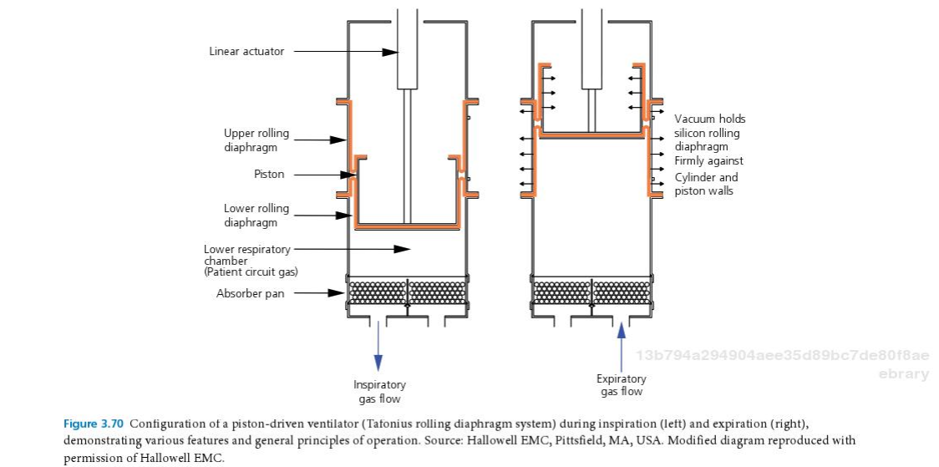
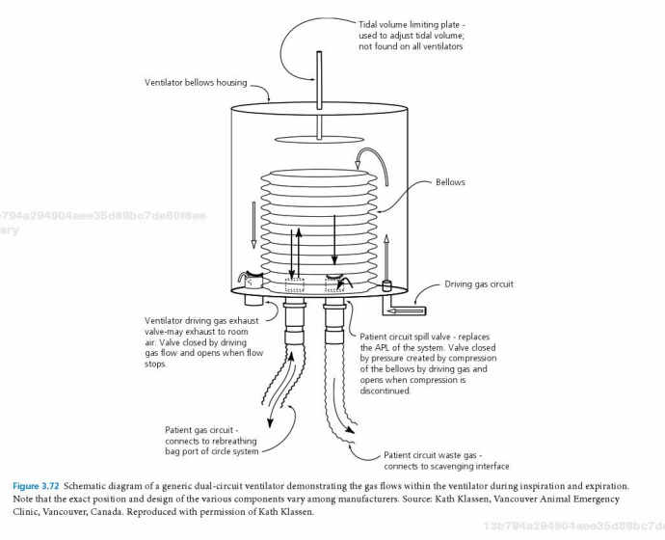
- Factors that affect delivered tidal volume (compared to set tidal volume)
  - Fresh gas flow
    - If set too high in very small patients, can contribute to tidal volume delivered to patient
  - Compliance and compression volumes
    - Increased system compliance will decrease amount of gas delivered to patient
    - Increased patient compliance will increase amount of gas delivered to patient
  - Leaks in system
    - Around ET tube
    - Side-stream gas flow monitors (NICO)
    - Pneumothorax
    - Etc…

Questions

- Name 3 factors that can cause a difference between preset tidal volume and actual tidal volume when using a mechanical ventilator. Describe the difference (i.e. Patient’s tidal volume will be greater/less than expected tidal volume)
- Name 2 downsides to having a reservoir bag that is >200mls/kg

Answers
- Name 3 factors that can cause a difference between preset tidal volume and actual tidal volume when using a mechanical ventilator. Describe the difference (i.e. Patient’s tidal volume will be greater/less than expected tidal volume)
  - Leak (will cause actual tidal volume to be lower than set volume)
  - Increased machine compliance (will cause actual tidal volume to lower than set)
  - Increased patient compliance (will cause actual tidal volume to be higher than set)
  - Increased fresh gas flow rate (will cause actual tidal volume to be higher than set)
- Name 2 downsides to having a reservoir bag that is >200mls/kg
  - Cannot see movement in bag when patient breaths
  - Delay in changes of vaporizer settings to % anesthetic delivered

