Opioid Receptors
- Located throughout the body
  - Brain, Spinal Cord, CRTZ, GI tract, Synovium, urinary tract, leukocytes, uterus, etc…
- G-protein coupled receptors
- Mu
- Kappa
- Delta
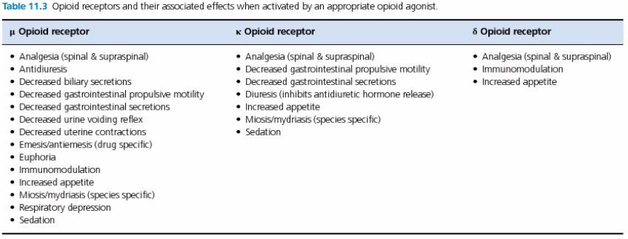Opioid Pharmacokinetics
- Most undergo extensive first pass hepatic metabolism, limiting oral bioavailability
- Buprenorphine is available transmucosally in cats, but not in dogs
  - Works less is swallowed
- Lipophilic
- Work mainly in CNS for analgesia
  - Drugs removed from CNS by P-glycoprotein efflux pumps
    - MDR1 mutant animals may be more sensitive to opioids
    - Plasma half-life is typically longer than effective duration
- Chloramphenicol can significantly decrease metabolism of methadone in dogs
- Easily cross placental barrier
Tolerance, dependence, withdrawal
- Rare in pets
- Most likely to be observed with patients on long term opioids (>7 days) that are given full or partial reversal
  - Lethargy, anorexia, nausea, vomiting, aggression, muscle twitching or muscle weakness
Opioid Pharmacology
- Decrease excitatory neurotransmitters and hypopolarize nociceptors resulting in decreased transmission within spinal cord
- Systemic administration is better at decreasing C-fibers (dull aching pain) vs A-delta (sharp pain)
  - May not be enough alone for surgical pain
Non-analgesic effects
- Opioids can produce excitability initially, but this usually wears off within a few minutes
- They can also produce more prolonged hypersensitivity, thrashing, ataxia, vocalization
- Respiratory depression
  - Dose dependant
  - Usually not serious on their own
    - Exacerbated by other anesthetic agents or intracranial disease
  - Large overdose (20-60 mcg/kg fentanyl IV) can cause ‘wooden chest’
    - Decreased inspiratory and increased expiratory neuron activity resulting in intercostal and abdominal muscle contraction causing chest wall rigidity
    - Can also cause pharyngeal obstruction due to vocal fold closure

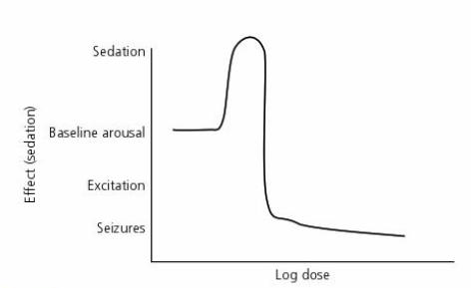

- Opioids act directly at cough center in medulla via both mu and kappa receptors
  - Independent of analgesic effect
  - Can increased ET tube tolerance
- Opioids can cause modest bradycardia but CO is maintained by increased SV
- Morphine (as well as to a much lesser extent, other opioids) can cause mast cell degranulation when given IV quickly
- Vomiting is from delta receptor stimulation in CRTZ
  - Can also have antiemetic effects that occur later with increased doses
    - Fentanyl, torb and methadone have more antiemetic effects
  - SQ or IM produce vomiting more frequently
- Ileus caused by opioid influence on mesenteric plexus neurotransmitters
  - Increases fluid absorption from colon and can help with diarrhea
  - More pronounced when combined with alpha 2 agonist
  - Loperamide is opioid that doesn’t cross BBB (unless there is MDR1 abnormality) and can be used to decrease diarrhea
- Urinary retention is not common with IV opioids, but is frequent with epidural opioids
- Thermal regulation
  - Dogs can become mild to moderately hypothermic with opioids
  - Cats can become hyperthermic up to 5 hours after extubation when opioids are used during anesthesia
    - Reduction of hyperthermia can be accomplished with naloxone
- Immunomodulation
  - Opioids have mild immunosuppressive effects on natural killer cells and lymphocytes, however pain also produces these effects, so the alleviation of the pain is likely to be more protective than detrimental
Specific Drugs
- Morphine
  - Full mu, some kappa at higher doses
  - Less lipophilic than others, so good for epidurals
  - Causes histamine release in dose dependant fashion
  - Lag of 5-15 minutes for effects even if given IV
  - SC and IM dose is same as IV
  - Short effects (1-2 hours)
  - Can be given to puppies as young as 2 days old with minimal respiratory depression
  - Dose is much lower for cats (0.1-0.25mg/kg)
- Hydromorphone
  - Full mu
  - Causes more hyperthermia in cats than other opioids
- Fentanyl
  - Transdermal patches have variable absorption in cats, but tend to start working in 12 hours and last 4 days
  - Dogs take ~24 hours for full effect and only last about 48 hours.
  - Remifentanil is derivative that is metabolized by plasma esterases
    - Plasma half life is 6 minutes
    - No Boluses!
- Methadone
  - Also has NMDA antagonist effects
  - Metabolism inhibited by during metabolism of chloramphenicol
  - Can have synergistic effects with some other mu opioids like morphine
- Meperidine
  - Has more significant histamine release than morphine, has serotoninergic effects and is a negative inotrope
- Hydrocodone
  - Variably metabolized to hydromorphone when given orally
  - Oral analgesic effects are unknown
- Codeine
  - Only 4% bioavailable for dogs
  - However, codeine-6-glucuronide may be an active metabolite and provide opioid effects
- Buprenex
  - Partial agonist
  - CAN work transmucosally in dogs but maybe less effective than cats
  - Simbadol is a once daily SC buprenorphine for cats for postoperative pain (licensed for up to 3 days)
- Butorphanol
  - Mu antagonist, kappa agonist
  - Can produce antitussive and sedative effects orally, but no analgesic effects
  - Limited analgesic effects parenterally
  - May have increased effects in MDR-1 mutants
- Tramadol
  - Activity as analgesic is mainly dependant on metabolism to O-desmethyltramadol, which dogs do to a very limited amount
    - Cats actually make a good amount of this, so effective in cats!
  - Chronic administration at constant doses will have decreasing plasma concentrations
  - Serotonergic effects
  - Large safety margin
- Naloxone
  - Competitive antagonist mostly at mu, but some kappa and delta
- Methylnaltrexone
  - Peripheral antagonist only (excluded from BBB)
  - May help with GI and other side effects without stopping analgesia

Questions

1. True/False: Dogs with the MDR-1 gene mutation can be more sensitive to opioid effects?

2. True/False: Buprenorphine has good bioavailability when given enterally in cats?

3. Which of the following opioid medications can be used to control diarrhea without risks of sedation from central nervous system effects?
- Loperamide
- Buprenorphine
- Methylnaltrexone
- Tramadol

4. Which of the following opioids has the shortest serum half life?
- Fentanyl
- Methadone
- Morphine
- Remifentanil

5. True/False: Standard doses of hydromorphone will cause a reliable, transient decrease in cardiac output?

Answers

1. True/False: Dogs with the MDR-1 gene mutation can be more sensitive to opioid effects?

2. True/False: Buprenorphine has good bioavailability when given enterally in cats?

3. Which of the following opioid medications can be used to control diarrhea without risks of sedation from central nervous system effects?
- Loperamide
- Buprenorphine
- Methylnaltrexone
- Tramadol

4. Which of the following opioids has the shortest serum half life?
- Fentanyl
- Methadone
- Morphine
- Remifentanil

5. True/False: Standard doses of hydromorphone will cause a reliable, transient decrease in cardiac output?

