Main Points:

- Learn the ASA classification system
- Pediatric animals are more susceptible to anesthetic agents, hypothermia, prolonged recovery time, and hypotension than adult animals
- Geriatric animals have higher risks of mortality with anesthesia and are more susceptible to anesthetic drugs and have prolonged recovery times compared to adults.

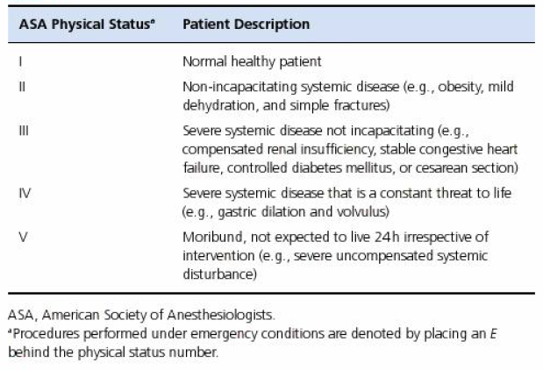
General Anesthesia
- Muscle relaxation
- Unconsciousness
- Amnesia
- Analgesia

Neonatal/Pediatric Anesthesia
- Difference between adults and young animals
  - Hypoalbuminemia
    - Greater free, active portion of protein bound drugs (maybe, but seems not to be the case)
      - Ketamine, barbiturates, etomidate, NSAIDS
  - More permeable BBB
    - Increase brain activity of drugs
  - Increased Body water:weight ratio
  - More centralized, fixed circulating volume
    - Higher susceptibility to hypovolemia
  - Lower hepatic enzymatic activity for first 3-4 weeks (up to 12 weeks) of age
    - Decreased hepatic biotransformation ability
  - Lower GFR for 2-3 weeks of life
    - Decreased ability to regulate overhydration or volume overload
  - Lower Active tubular secretion for first 4-8 weeks of life
    - Increases half life for actively secreted drugs such as diazepam
  - Higher metabolic rate increasing oxygen consumption
    - Require higher minute ventilation
      - Quicker response to inhalant drugs
  - Decreased ventricular compliance and minimal cardiac reserve
    - Adults can increase CO by 300%
    - Neonates by only 30%
  - Immature sympathetic nervous system
    - Decreased ability to increase heart rate and contractility
  - Poor vasomotor control
    - Decreased hypotension-induced baroresponse
  - Decreased pulmonary functional reserve
    - Risk of hypoxia during short times of apnea
  - Higher susceptibility to hypothermia
    - Cannot vasoconstrict, high surface area:body mass ratio
- Specific anesthetic considerations
  - Fluid therapy must be increased as neonates/pediatrics have higher daily fluid requirements (60-180ml/kg/day)
    - Greater body surface area, decreased renal concentrating ability, higher percentage body water, higher resp rates and losses

Geriatric Anesthesia
- Mortality risk is 7x that of dogs/cats under 12 years old
- Geriatric changes
  - Increased endogenous norepi levels, but decreased receptor affinity and receptor attrition
    - Reduced stress response
  - More dependant on volume to maintain CO than younger animals
  - Decreased pulmonary elasticity, closing volume is increased, leading to air-trapping and VQ mismatch and decreased Pa02
  - 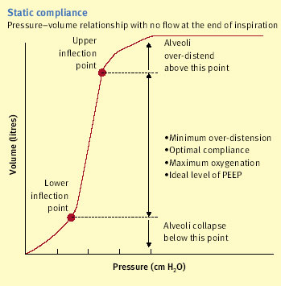
- Neuronal changes result in decreased receptor affinity for neurotransmitters and lower anesthetic agent requirement
- Kidney changes
  - Loss of GFR with age due to loss of nephrons
  - Decreased responsiveness to ADH reduced renal blood flow
    - Regulation of intravascular volume is compromised
    - Longer half life of renal-excreted drugs
- Liver changes
  - Decreased hepatic blood flow, although enzyme function is conserved
  - Overall hepatic mass reduction impairs clearance of drugs
- Other
  - Decreased volume of distribution
    - Quicker onset and lower dose of drugs
  - Increase Fat:muscle ratio = longer clearance of lipid soluble drugs

Questions:
- Name 3 reasons that pediatric/juvenile patients have higher daily fluid requirements than adults of the same breed.
- Explain why a geriatric animal may benefit from higher levels of PEEP during ventilation than a young-adult dog of the same age/breed/sex/disease process.
- On average, a healthy adult dog can increase their cardiac output buy up to ____% during times of stress, while a neonatal animal would only be about increase their cardiac output by _____%.
- Dogs have a decreased GFR for the first ______ weeks of life and a decreased tubular secretory ability for the first _____ of life.
  - 1-2 week; 2-3 weeks
  - 2-3 weeks; 1-2 weeks
  - 2-3 weeks; 4-8 weeks
  - 12-16 weeks; 2-6 weeks
- You are presented with “Rainbow” Smith, a dog to be placed under anesthesia. It is a 6 year old female intact german pudelpointer that has been diagnosed with a pyometra and septic abdomen. She is still BAR and her mean arterial pressure is 100 on a norepinephrine CRI (@ 0.2mcg/kg/min). She has received antibiotics and IV fluids, as well as pain medications and is standing in her cage, but still appears quite uncomfortable. She has had a history of hip dysplasia, but no other major disease history. based on the current information, what is her ASA classification?
  - I
  - III
  - IV
  - V

Answers:
- Name 3 reasons that pediatric/juvenile patients have higher daily fluid requirements than adults of the same breed.
Greater body surface area, decreased renal concentrating ability, higher percentage body water, higher resp rates and losses

- Explain why a geriatric animal may benefit from higher levels of PEEP during ventilation than a young-adult dog of the same age/breed/sex/disease process.
Decreased pulmonary elasticity, closing volume is increased, leading to air-trapping and VQ mismatch and decreased Pa02

- On average, a healthy adult dog can increase their cardiac output buy up to ____% during times of stress, while a neonatal animal would only be about increase their cardiac output by _____%.
300, 30
- Dogs have a decreased GFR for the first ______ weeks of life and a decreased tubular secretory ability for the first _____ of life.
  - 1-2 week; 2-3 weeks
  - 2-3 weeks; 1-2 weeks
  - 2-3 weeks; 4-8 weeks
  - 12-16 weeks; 2-6 weeks
- You are presented with “Rainbow” Smith, a dog to be placed under anesthesia. It is a 6 year old female intact german pudelpointer that has been diagnosed with a pyometra and septic abdomen. She is still BAR and her mean arterial pressure is 100 on a norepinephrine CRI (@ 0.2mcg/kg/min). She has received antibiotics and IV fluids, as well as pain medications and is standing in her cage, but still appears quite uncomfortable. She has had a history of hip dysplasia, but no other major disease history. based on the current information, what is her ASA classification?
  - I
  - III
  - IV
  - V

