Lumb and Jones –Chapter 4 Monitoring Anesthetized Patients
- Monitor: depth of anesthesia, cardiovascular and pulmonary consequences of anesthetic agents, temperature
- Anesthetic depth
  - Goals: lack of awareness/recall/pain/movement; avoidance of problems associated with anesthesia (cardiovasc and pulmonary)
  - Depends on : amount of anesthetics in the brain, magnitude of surgical/environmental stimulation, underlying conditions that have CNS depressant effects (hypothermia, hypotension)
  - Stages
    - I: awake
    - II: starts with unconsciousness; excitement; cessation of sponatenous movement; onset of a regular pattern of breathing
    - III:surgical stage
      - Plane 1: Light
      - Plane 2: Light-medium ** goal
      - Plane 3: Deep-medium
      - Plane 4: Deep - extreme CNS depression and respiratory arrest
  - ** Animals lose consciousness (awareness) LONG BEFORE they lose spontaneous movement and physiologic responses; physiologic response to surgical stimulation defines a patient as being light but not necessarily TOO light
  - **There is no obligatory correlation between level of anesthesia and physiologic consequence of anesthesia – can be light, apneic, hypotensive and hypoxemic
  - Spontaneous movement/reflex movement = reliable sign of light level of anesthesia
  - Increase in HR, BP, breathing rate in response to surgical stimulation = reliable sign of light or light-medium plan but not reliable guides to depth of anesthesia – physiologic parameters are more useful to characterize physiologic status rather than depth of anesthesia
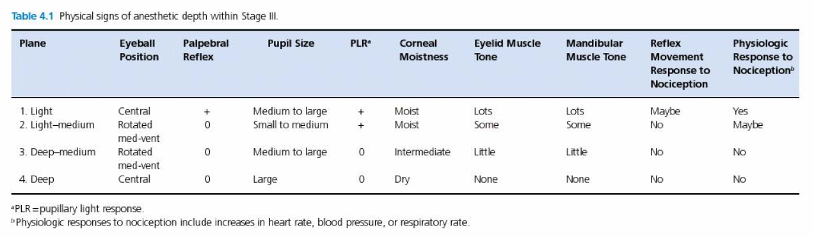
  - Ketamine: eyeball does not rotate
  - Lacrimation: decreases and stops with depth

- EEG
  - Low-amplitude, high frequency wave pattern (awake) high-amplitude, low frequency (during anesthesia) to burst suppression (intermittent period of electrical silence) to persistent electrical silence (deep)
- Cardiovascular system
  - When bradycardia should be treated –?? - when about 20-30% below low normal or any evidence of poor CO, BP, tissue perfusion
  - When tachycardia should be treated - ?? – when evidence of poor CO, BP, tissue perfusion
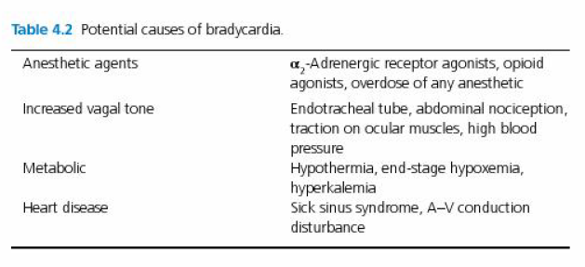
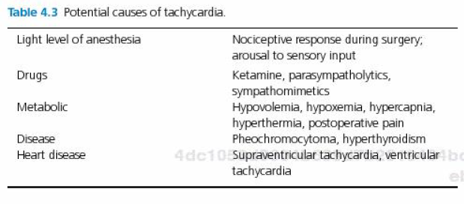
  - Arterial blood pressure
    - Determined by blood volume and wall tone
    - Blood volume is balance between cardiac output and diastolic run-off (inflow – outflow); diastolic run-off is determined by vasomotor tone
    - Systolic pressure determined by SV and arterial system compliance
    - Diastolic pressure determined by vasomotor tone (run-off) and HR
    - MAP = area under the pulse pressure waveform
      - The most physiologically important; represents the average upstream pressure for tissue perfusion and the average afterload to the heart
    - NIBP techniques tend to underestimate SBP, to overestimate BP in hypotensive patients and to exhibit wider variability comparted with direct BP
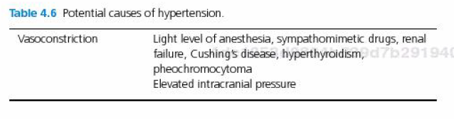
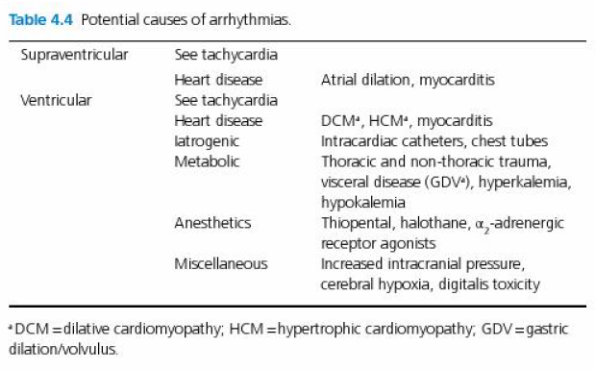
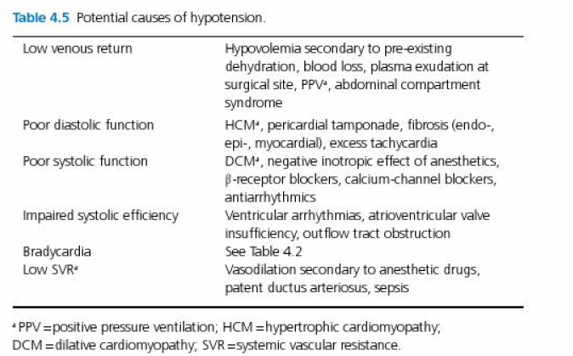
  - Cardiac preload
    - In vitro: muscle stretch prior to muscle contraction
    - In vivo = stress = (ventricular pressure x ventricular wall thickness)/ventricular diameter
    - Assumed that preload proportional to end diastolic ventricular volume
    - End-diastolic diameter (echo); diameter of caudal vena cava (xrays)
    - Jugular vein distension
    - CVP= surrogate of LV preload
  - Central venous pressure
    - Luminal pressure of the intrathoracic vena cava
    - Peripheral pressure is HIGHER than CVP (otherwise no flow)
    - Relationship between central blood volume and venous tone
      - Central blood volume determined by venous return and CO
    - Changes in pleural pressure affect luminal pressure w/in anterior vena cava
    - Normal 0-10 cmH₂O

    - Marker of circulating BV even though it is not per se a measure of preload (it is a measure of preload PRESSURE)
    - Poor predictor of SV or CO
  - Mean systemic filling pressure
    - = the system-wide equilibrated pressure after a cardiac arrest (10-15 mmHg)
    - Very similar to postcapillary venous pressure in an animal with a beating heart
    - Flow (or venous return) = (Pmsf – CVP)/venous resistance
  - Thoracic blood flow impairment
    - PPV impeded IT venous return, diastolic filling of the heart, SV
    - Magnitude of decrement in SV can be assessed by decrease in: 1)systolic BP, 2)mean BP, 3) pulse pressure (systolic – diastolic), 4) digital evaluation of PQ (area under the pulse pressure waveform) or 5)plethysmographic monitoring of the area under the pulse pressure waveform
  - SV
    - EDV-ESV
    - Can be calculated by measuring the flow velocity through aortic valve (known diameter) or CT or MRI
    - Tall, wide, bounding pulse = large SV
    - Narrow, thready pulse = small SV
  - Cardiac output
    - See previous BR sessions
  - Oxygen content, delivery, consumption
    - Anesthesia typically decreases CO and DO₂, reduces metabolic O₂ consumption by direct and indirect (hypothermia) depression of metabolic rate (which offsets the problem of decreased DO₂)
    - When DO₂ decreases, O₂ extraction increases (delivery-independent oxygen consumption)
    - With further decreases in DO₂ decreases in VO₂ tissue hypoxia (delivery dependent oxygen consumption)
    - Point at which oxygen consumption transitions from delivery independent to delivery dependent = point of critical oxygen delivery
      - This point is INCREASED with all anesthetics (dose-related) and occurs at a lower oxygen extraction ratio – suggesting impaired tissue oxygen extraction
      - Effect on critical oxygen delivery attributed to the manner in which anesthetics disturb peripheral blood flow
      - Ketamine DOES NOT increase critical oxygen delivery significantly
    - Hemoglobin invariably decreases intraop from anesthetic induced vaso- and splenic dilation, admx of fluid, blood loss
  - Myocardial contractility
    - Intrinsic rate and force of muscle fiber shortening in a no-load situation; heart is never unloaded so myocardial contractility is influenced by its inherent force of contraction, preload augmentation and afterload impedance
    - Afterload is the impedance to muscle contraction and the generation of SV; weight that the muscle must lift (in vitro); systolic wall stress ((ventricular pressure x radius)/muscle thickness))
  - Fractional shortening: (EDD-ESD)/EDD; normal 25-45% in dogs; 30-55% in cats
  - Ejection fraction: SV/EDV
  - Velocity of circumferential fractional shortening is calculated as FS/ET; where ET = ejection time (time from initial opening of the aortic valve until its closure; a surrogate marker of ET might be from the initial upstroke of the arterial pulse pressure waveform to the depth of the dicrotic notch
  - Systemic vascular resistance and tissue perfusion
    - SVR = (MAP-CVP)/CO x 80
      - X 80 to convert units to dyn.s/cm⁵
      - Can divide by CI to have SVRI
      - Normal 1800-2100 dyn.s/cm⁵/m² to 2500-300 with moderate hypovolemia
    - Metabolic markers of tissue perfusion
      - A-V oxygen differences
        - CO is inversely proportional to (CaO₂ – CmvO₂)
          - CO = oxygen consumption/(CaO₂ – CmvO₂)
        - CaO₂ – CmvO₂ is a global marker of the increased oxygen extraction that occurs when DO₂ decreases
        - Oxygen extraction: (CaO₂ – CmvO₂)/ CaO₂
    - Venous-arterial PCO₂ gradient
      - CO = carbon dioxide production/( CmvCO₂ – CaCO₂)
      - Carbon dioxide content can be calculated but since CO₂ is so soluble, measured PmvCO₂ and PaCO₂ can be used direct without converting to content
      - When CO decreases and tissue perfusion decreases, and CO₂ production continues at its previous level, there will be an increase in venous CO₂
  - Lactate and metabolic acidosis
    - Measure of poor tissue oxygenation
    - Blood lactate is a global measure that disproportionately overweights large tissue masses and may not be a sensitive acute measure of oxygen deficiency in tissues that have low mass but high oxygen demand (brain, kidneys)
  - Tissue PO₂, PCO₂, pH
    - Poor perfusion decreased PO₂, pH and increased PCO₂ (tissue)
    - Tissue PO₂ can be measured with catheter-tipped PO₂ electrodes or with transcutaneous sensors
    - Gastric tonometry: based on the fact that as tissue PCO₂ increases in malperfusion states, the CO₂ diffuses into the lumen of the stomach in direct proportion to its accumulation in the gastric tissues.
      - Normal is < 50 mmHg or less than 10 mmHg above PaCO₂
      - Measure also gradient PgCO₂ – PaCO₂
        - It takes about 20 min for tissue PCO₂ to equilibrate with PaCO₂
    - Sublingual capnometry
  - Microvascular imaging
    - To evaluate microcirculation
  - Breathing rate, rhythm, effort
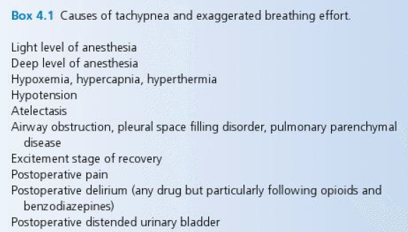
    - Physiologic deadspace – anatomic and alveolar : ranges between 30-50% of tidal volume
      - Will be higher with rapid, shallow breathing and lower with slow, deep breathing
      - = Vd/Vt = (PaCO₂ – PmeCO₂)/(PaCO₂-PiCO₂)
        - Vd: deadspace volume
        - Vt: tidal volume
        - PmeCO₂: mixed expired PCO₂
        - PiCO₂: inspired PCO₂
      - Vt-Vd= Valv
      - A high measured total minute ventilation in combination with a normal PaCO₂ = increased deadspace ventilation
    - Compliance: expired tidal volume divided by change in pressure that it took to generate the tidal volume
  - PCO₂
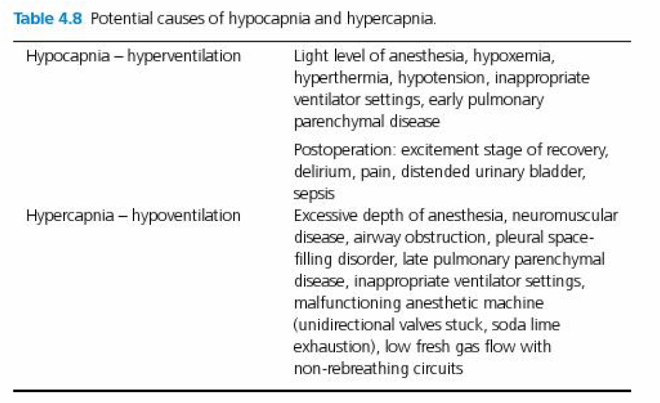
  - Hypoxemia
      - Low FiO₂
      - Hypoventilation
      - Venous admixture
        - When venous blood get from the right side to the left side of the circulation w/out being properly oxygenated
        - Normal lung: < 5%
          - Low V/Q
            - Small AW narrowing, fluid along walls of the lower Aws or epithelial edema impaired ventilation
            - Increased BF
          - Small airway and alveolar collapse with perfusion (0 V/Q)
            - Accumulation of AW fluids
            - In lower regions of the lung 2nd to atelectasis
            - Need to “uncollapse” AW by increasing AW or transpulmonary pressure
          - Diffusion defects
            - The flat type I pneumocytes have to be damaged by inhalation or inflammatory injury. In the healing process, the thick, cuboidal type II pneumocytes proliferate substantital diffusion defect until type OO pneumocytes mature into type I.
          - Anatomic R-to-L shunts
        - In pulmonary parenchymal disease, lungs often fail in their ability to oxygenate the blood prior to failing in their ability to remove carbon dioxide.
          - CO₂ more soluble than O₂
          - Alveolar-capillary units that are working relatively well can easily compensate for those that are working relatively poorly with respect to CO₂ elimination but not for O₂ intake, because of the location on their respective dissociation curves where the action occurs.
          - PCO₂:CO₂ content relationship is fairly linear over a wide range of clinically relevant PCO₂ values
          - Alveoli that are working more normally can very effectively lower capillary CO₂
          - The portion of the PO₂:O₂ content relationship above a PO₂ above 80 mmHg is fairly flat
          - Alveoli that are working normally can hyperventilate and increase PAO₂ but they cannot increase blood O₂ content enough to compensate for poorly functioning alveoli in any significant way
      - Reduced venous O₂ content 2nd to low CO or sluggish peripheral BF (shock) or high O₂ extraction by tissues (seizures)
    - Normally venous blood fully arterialized in about 1/3 of the normal pulmonary transit time
    - When the venous O₂ content is very low it takes more oxygen and more time for the capillary blood to be arterialized (fully oxygenated). This lowers the PAO₂ and therefore PaO_{2.} PaO₂ will further be decreased if equilibration time exceeds transit time.
    - Oxygenation index: (mean airway pressure x % inspired oxygen)/PaO₂
  - Hypothermia
    - Depression of muscular activity, metabolism, hypothalamic thermostatic mechanisms
    - Increased heat loss: evaporation of surgical scrub solutions from the skin surface, infusion of room temperature fluids, contact with cold surfaces, evaporation of surface fluid from an exposed body cavity
    - Can impair immune function, altered enzymatic kinetics, affect coagulation and hemostasis
    - 90-94F: reduced anesthetic requirements; recovery is prolonged. Shivering still occurs in most animals
    - 82-86F: marked CNS depressant effect; no shivering; atrial arrhythmias; O₂ consumption reduced to about 50% of normal; HR and CO to about 35-40% of normal; BP to 60% of normal; cerebral metabolism to 25% of normal
    - 77-80F: prolongation of PR, wide QRS, increased myocardial automaticity, decreased tissue DO₂ anaerobic metabolism; blood viscosity is 200% of normal
    - 72-74F: v fib
  - Hyperthermia
    - Cell damage starts to occur at body temperatures above 108F, when DO₂ can no longer keep pace with increased metabolism and O₂ consumption

Questions
- During anesthesia for a surgical procedure, what stage and plane do you aim for?

- At which body temperature shivering does not occur and rewarming is necessary?
  - 95F or less
  - 93F or less
  - 91F or less
  - 86F or less

- With increasing depth of anesthesia, which will be lost/affected the first?
  - Spontaneous movement
  - Consciousness
  - Control of cardiopulmonary responses
  - Thermoregulation

- True or False – A central position of the eyeball indicates a light plane of anesthesia. You must increase the depth of anesthesia before starting surgery.

- The EEG of an animal will be characterized by a wave pattern with _______ amplitude and ______ frequency.
  - Low, Low
  - Low, High
  - High, High
  - High, Low

Questions & Answers
- During anesthesia for a surgical procedure, what stage and plane do you aim for?
Stage III (surgical), plane II (light-medium)

- At which body temperature shivering does not occur and rewarming is necessary?
  - 95F or less
  - 93F or less
  - 91F or less
  - 86F or less

- With increasing depth of anesthesia, which will be lost/affected the first?
  - Spontaneous movement
  - Consciousness
  - Control of cardiopulmonary responses
  - Thermoregulation

- True or False – A central position of the eyeball indicates a light plane of anesthesia. You must increase the depth of anesthesia before starting surgery. False – can also be central with deep plane of anesthesia

- The EEG of an animal will be characterized by a wave pattern with _______ amplitude and ______ frequency.
  - Low, Low
  - Low, High
  - High, High
  - High, Low

