Lumb and Jones – Chapter 31
Physiology, Pathophysiology, and Anesthetic Management of Patients with Gastrointestinal and Endocrine Disease
- In patients with pancreatic diseases (diabetes mellitus, pancreatitis, insulinoma) – think about monitoring blood glucose. Insulin might need to be adjusted in diabetic patients preoperatively and dextrose and/or regular insulin must be available – see table below. Cardiovascular effects of autonomic diabetic neuropathy (dysrhythmia, hypotension) have been documented in people. In a study, diabetic dogs had lower cardiac vagal tone than healthy dogs. Glucagon is useful to manage perioperative hypoglycemia in patients with insulinoma. Alpha-2 agonist can lead to hypoinsulinemia and hyperglycemia.
- In patients with adrenal gland disease:
  - Addison: think about management of hypoglycemia, hypotension, electrolytes disturbances, hypovolemia. May need extra GC than their usual dose.
  - Cushing: can hypoventilated due to muscle weakness (diaphragm), fat deposition, enlarged abdomen. Post-op adrenalectomy: may need steroids, monitor Na:K
  - Pheochromocytoma:
    - Prolonged medical management before surgery
      - Phenoxybenzamine (alpha-blockade) for hypertension
      - Beta-blocker for tachycardia (not w/out alpha-blockade first) unopposed vasoconstriction worse hypertension
    - Avoid drugs with sympathomimetic activity
- Patients with thyroid/parathyroid gland disease
  - Hypothyroidism – slow metabolism; bradycardia, hypotension, hypothermia.
  - Hyperthyroidism – increased metabolism: tachycardia, hypertension, increased myocardial work.
  - Thyroid neoplasia – think about possible AW obstruction/AW invasion or compression
  - Hyperarathyroidism – think calcium management
    - For hypercalcemia: fluid, furosemide, saline, bisphosphonates, steroids, calcitonin
    - Consider starting calcitriol preop (3-5d) to prevent post-op hypocalcemia
    - ECG changes associated with hypercalcemia: bradycardia, prolonged PR interval, widened QRS, shortened QT
- Most significant perianesthetic complications associated with GI: pulmonary aspiration, esophagitis, postoperative ileus. Gastroesophageal reflux is common but complications associated with it are less common. Prolonged fasting times have been associated with increased risk of reflux and lower gastric pH
Pancreas
Diabetes Mellitus
- Well regulated diabetes dogs, BG measured w/in 1 hour of insulin admx = 150-250 mg/dL; when close to 150 likely to become hypoglycemic later when fasted
- 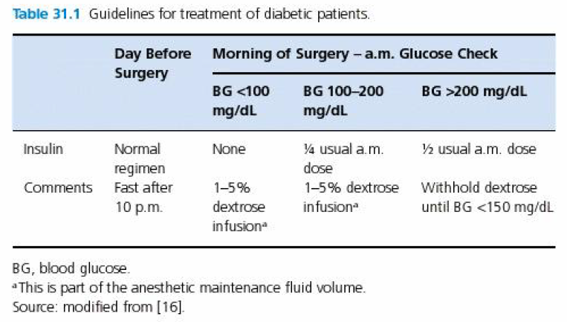
- No absolute drug contraindications in diabetic patients
- Frequent BG monitoring
- Goal is to maintain between 15-250 mg/dL
  - >250 (dogs) or > 300 (cats) mg/dL likely to promote glycosuria and diuresis
    - Remember: renal threshold for glycosuria in dogs = 200; cats = 250
    - Consider giving regular insulin (at 20% patient’s usual dosage of long-acting insulin)
- DM is a risk factor for hypertension in dogs
- In people – cardiovascular effects of autonomic diabetic neuropathy are well characterized (dysrhythmias, hypotension)
- Diabetic dogs had lower cardiac vagal tone compared to healthy dogs
Veterinary Record 2007;161:83-88

Insulinoma
- Maximum 8h fasting
- Target BG: 50-60 mg/dl (frequently tolerate resting BG of 30-40 w/out CS)
- Glucagon to manage perioperative hypoglycemia: bolus 50 ng/kg then 5-40 ng/kg/min
- Frequent BG monitoring
  - Maintain w/in range that prevented CS associated with neuroglycopenia
  - Careful during tumor manipulation insulin spikes
  - Avoid hyperglycemia as well
- Alpha-2 agonists: inhibitory effect on the pancreatic beta cells and suppression of plasma insulin concentration – can be advantageous
- Transient hyperglycemia post-op (atrophy of normal pancreatic beta cells that remain after partial pancreatectomy) – insulin might be needed
- If mets: likely persistent hypoglycemia

Pancreatitis
- Careful with alpha-2 agonists hypoinsulinemia and hyperglycemia

Adrenal gland
Hypoadrenocorticism
- *In healthy patients: cortisol production increases by 5-10 fold after major surgery*
- Controlled HOAC patients should received an extra dose of steroid before anesthesia in addition to their normal daily dose; post-op additional GC admx as needed
- Unstable HOAC patients needing anesthesia/surgery: correct electrolytes, hypoglycemia, metabolic acidosis, prerenal azotemia, hypovolemia
- Etomidate: careful? – inhibits 11-beta-hydroxylase (enzyme necessary for synthesis of cortisol) for 2-6h
- Can become hypotensive under GA and non responsive to usual therapy (remember: low GC decreased vascular sensitivity to catecholamines)

Hyperadrenocorticism
- Trilostane or mitotane – may lack adq functional adrenorcortical reserve and may not handle stressful anesthetic/surgical events appropriately
  - ACTH stim? Between 2-5 mcg/dL = well controlled
- Predisposition to hypertension and thrombus formation
- Cortisol-secreting tumor of the adrenal gland: evaluate extent of local vascular invasion
- No specific anesthetic protocol indicated or contraindicated
- Careful with NSAIDS –if high endogenous cortisol
- Hypoventilation due to respiratory muscle weakness, increased abdominal fat, hepatomegaly and bladder distension
- Post-op adrenalectomy: dex SP 0.05-0.1 mg/kg IV (to prevent development of HOAC); monitor Na:K ratio

Pheochromocytoma
- Unpredictable tachyarrhythmias and hypertension
- Prolonged medical management to stabilize before surgical excision of tumor
  - Alpha-blockade: goal = reduce catecholamine-induced hyperT
    - Phenoxybenzamine: long-acting, non competitive, alpha-1 with some alpha-2 antagonist activity; for 1-2 weeks before surgery
      - Started at 0.25 mg/kg q12h, usually gradually increased up to 2.5 mg/kg q12h over 2 weeks
      - In a study: does no decrease frequency/severity of perioperative hyperT but improved mortality rate likely from decreased vasoC and improved IV volume
  - Atrial and ventricular tachycardia (less often AVBs) can occur
    - Management of severe tachyC preop: beta-blocker
      - Propranolol or atenolol
      - Better results when alpha blockade started first because beta blockade alone may lead to unopposed alpha-receptor mediated vasoC exacerbation of hypertension
  - Rarely bradycardia of vagal origin (due to hypertension)
  - 3rdAVB: myocardial damage, AV nodal fibrosis (chronic catecholamines exposure)
  - Chronic sympathetic stimulation and vasoC may IV depletion
- Avoid drugs with sympathomimetic or vagolytic effects
  - Anticholinergic, ketamine – not good choices
  - Desflurane: sympathetic stimulation
- Morphine, atracurium – not good choices; may provoke histamine release catecholamines release
- Thiobarbiturates, halothane: risk of ventricular arrhythmias (especially if high catecholamines)
- ACE: may complicate tx for hypotension (especially if on phenoxybenzamine)
- Nitroprusside = tx of choice for management of severe hypertension; potent, rapid onset, short duration; alternative: phentolamine (short acting competitive alpha-adrenergic antagonist and direct vasoD)
- MgSO₄ in people to manage hypertension and arrhythmias during anesthesia? Inhibits release of catecholamines, reduces sensitivity of alpha-adrenergic receptors to catecholamines, direct vasoD, antiarrhythmic effects
- Tachyarrhythmias: lidocaine, beta-antagonists
- Surface-induced hypothermia to a temperature of 89.6°F has been advocated for patients with a pheo that invades the great vessels, to protect vital organs from reduced oxygen delivery during temporary vascular occlusion
- Intraop and postop hypotension following tumor excision is common
  - Decreased catecholamines
  - VasoD from residual alpha-blockade caused by phenoxybenzamine
  - Impaired sympathetic reflexes
  - Hypovolemia
    - Tx: reduction of inhalants, reduction or D/C nitroprusside or phentolamine, IVFT, vasopressors are used to treat refractory hypotension – if tx with phenoxbenzamine less responsive to pressors – vasopressin may be necessary
    - Monitor BG post op (drop in BG when catecholamines drop)
    - Bilateral adrenalectomy: GC and mineralocorticoids

Thyroid gland
Hypothyroidism
- Untreated: reduced metabolic rate and may recovery more slowly from sedation/anesthesia
- Myxedema coma – rare: hypotension, bradycardia, hypoventilation, hypothermia, decreased LOC
- Muscle weakness: compromised ventilation
- Bradycardia/hypotension: anticholinergics, IVFT, positive inotropes
- Slow rewarming if hypothermic
- Myxedema coma may require IV therapy with L-thyroxine post-op
- Short-acting drugs that require minimal or no metabolism are often preferred
  - Opioids, BZD,propofol, inhalants
Hyperthyroidism
- tachycardia, hypertension, increased myocardial work
- Careful if received atenolol, amlodipine, ACEI in the tx of hypertension as they may hypotension intraop
- ACE: reduces sensitivity of the myocardium to catecholamines and blocks alpha-adrenergic receptors (may help decrease the occurrence of catecholamine-induced arrhythmias and counteract hypertension) – careful if on hypotensive medications or has cardiomyopathy; careful if obstructive cardiomyopathy increases gradient across the LVOT worsening obstruction (alpha-2 agonist can be used as an alternative if dynamic LVOT obstruction if systolic function is not reduced)
- Opioids: generally slow HR and decrease myocardial oxygen consumptiom
- Avoid ketamine: stimulates sympathetic output, may cause increase in HR and decrease in ventricular filling
- Increased metabolic rate increased oxygen & glucose demand and carbon dioxide production prone to hypoxemia and hypercapnea when ventilation is compromised
- If cardiomyopathy: usually concentric; decreased ventricular compliance and chamber size diastolic dysfunction. Goal: optimize ventricular filling by preventing stress and maintaining normal to low HR

Thyroid neoplasia
- Think possible AW obstruction/difficult intubation/respiratory signs
- Careful with meds that can produce intense muscles relaxation (alpha-2 agonists) as they can exacerbate AW obstruction
- Be ready for tracheostomy
- Post-op complications: hemorrhage, edema with tracheal compression, uni or bilateral damage to the recurrent laryngeal nerve, inadvertent damage to or removal of the PTH gland
- Monitoring of iCa

Parathyroid gland
HyperPTH
- Primary – tx: surgical parathyroidectomy; complications: post-op hypocalcemia (withdrawal of PTH-secreting tissue and remaining non-adenomatous glands have atrophied due to chronic hypercalcemia) – Tx: calcitriol, calcium
- Tx of hypercalcemia: 0.9% NaCl, furosemide, steroids, calcitonin, bisphosphonates
  - Severe life-threatening hypercalcemia: sodium bicarbonate IV slow bolus promotes binding of calcium to albumin
- Presumption that higher magnitude of preop hypercalcemia leads to more severe atrophy of the remaining PTH glands and increased likelihood of postop hypocalcemia?
  - Preop Tx (3-5d) with calcitriol to prime the gut for increased calcium absorption – monitor calcium and D/C if calcemia worsens
- Hypercalcemia (chronic) can lead to CKD; might be difficult to Dx due to low USG and azotemia owing to diuretic effects of hypercalcemia – keep well hydrated
- ECG changes: bradycardia, prolonged PR interval, widened QRS, shortened QT
  - When you give calcium: monitor for bradycardia and shortening of QT
- Oral calcitriol and calcium post-op
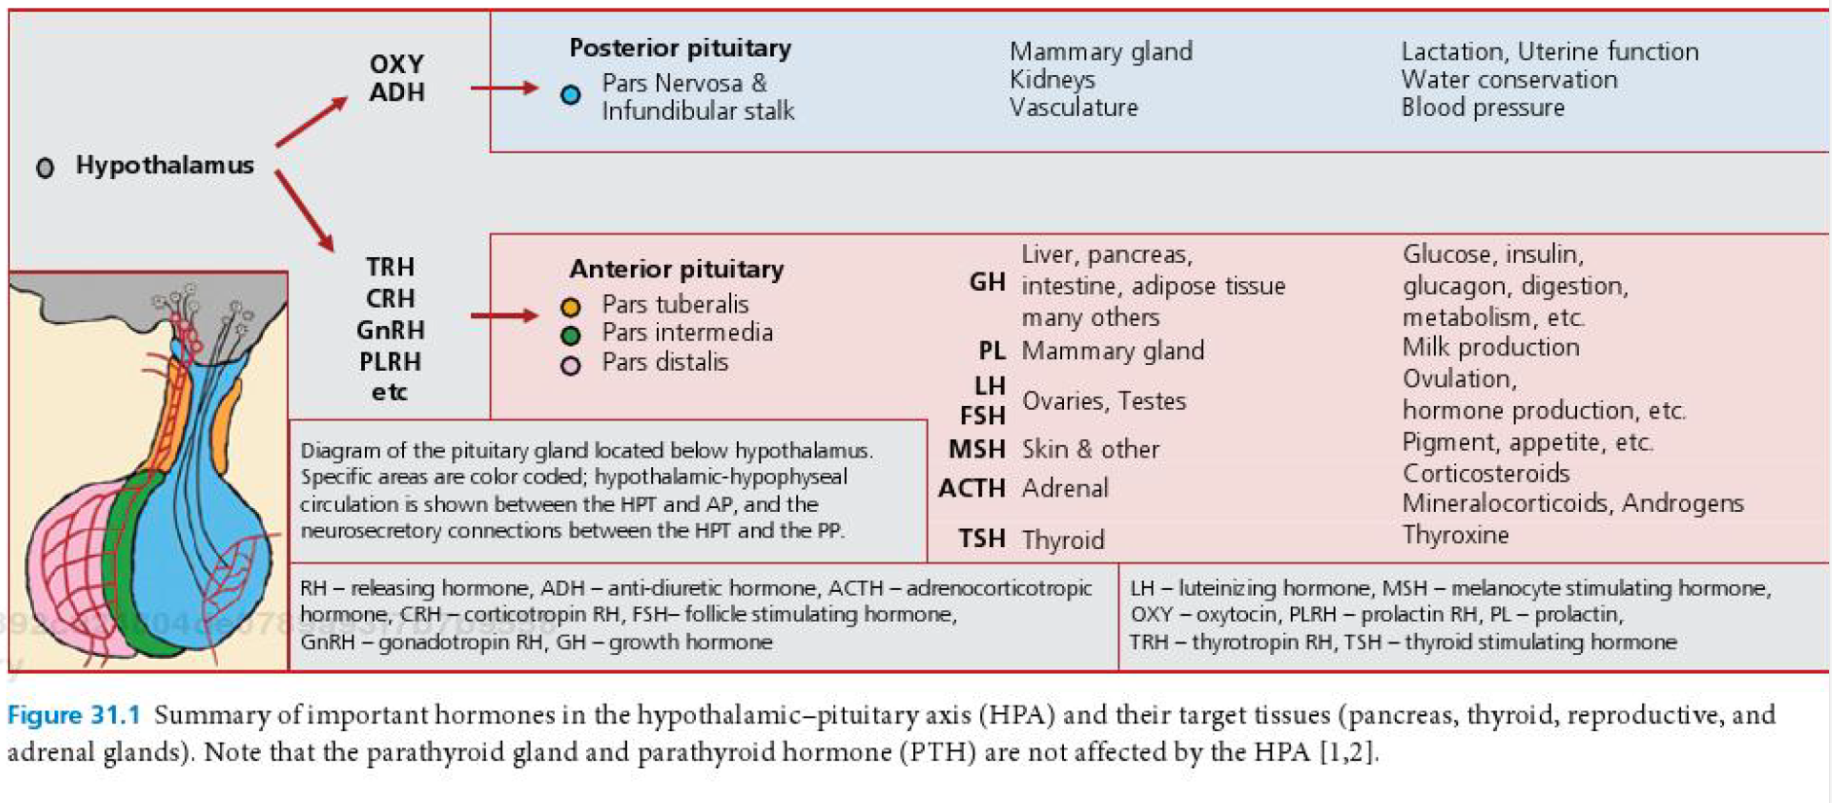

Effects of anesthetic agents on GI function
- Most significant perianesthetic complications associated with GI: pulmonary aspiration, esophagitis, postoperative ileus
- Nausea and vomiting
  - Humoral pathway stimulated by blood borne substances that affect CRTZ
    - Dopamine, serotonin, alpha-2 adrenergic receptors
  - Neural pathway activates vomiting center
    - NT: histamine, acetylcholine, dopamine, serotonin, NK-1 (substance P)
  - Mucosal irritation and damage or distension of the GIT tissues release of serotonin and/or stimulation of vagal afferent receptors
- Opioids can lead to vomiting, generally after first dose; may also produce antiemesis – thought to occur when increased # of opioids receptors in the VC are stimulated
- Vomiting reflex is not abolished until stage III/plane 2
- More vomiting with alpha-2 agonists and mu-opioids in cats than dogs – especially higher doses
- ACE has mild antiemetic effect (dopamine antagonism in the CRTZ)
- Gastroesophageal reflux occurs when intagastric pressure exceeds or equals the lower esophageal sphincter pressure, and the barrier pressure normally present between the 2 areas is lost; IA and IT pressure also contribute to lower esophageal sphincter pressure and the incidence of GER; LES = functional sphincter; primarily controlled by the parasympathetic nervous system but numerous NT and hormones are involved in regulation of LES tone; more GER with intraabdominal and orthopedic procedures in dogs; metoclopramide (high dose: 1 mg/kg bolus than 1 mg/kg/h CRI) decreases the incidence but does not completely prevent reflux; usually GER in dogs develop fairly soon following induction (before 30 min); pharyngeal stimulation may be a factor as it decreases both upper and lower esophageal pressure
- Prolonged fasting times have been associated with increased risk of reflux and lower gastric pH – gastric volume not really different and pH higher in dogs fed canned food at ½ their daily energy requirement and fasted 3h vs 10h

QUESTIONS
- You diagnose a patient with pheochromocytoma. His blood pressure is 230 mmHg and his HR is 160 bpm. Which of the following would be the best choice for the management of his blood pressure
  - Phentolamine
  - Phenoxybenzamine
  - Benazepril
  - Nitroprusside

- The surgeons are performing an adrenalectomy on a dog diagnosed with pheochromocytoma. The dog blood pressure is 260 mmHg. The ECG shows a supraventricular tachycardia. What would be a contraindication of esmolol administration for the management of SVT?

- Name possible changes that could be seen on the ECG of a patient with hypercalcemia?

- True or False – Metoclopramide (2 mg/kg/h) has been reported to successfully prevent gastroesophageal reflux in anesthetized dogs.

QUESTIONS & ANSWERS

- You diagnose a patient with pheochromocytoma. His blood pressure is 230 mmHg and his HR is 160 bpm. Which of the following would be the best choice for the management of his blood pressure
  - Phentolamine
  - Phenoxybenzamine
  - Benazepril
  - Nitroprusside
In a retrospective study, dogs treated with phenoxybenzamine prior to surgery had a significantly lower (13%) mortality rate compared with untreated dogs (48%). Proposed mechanisms: Reversal of vasoconstriction and hypovolemia (permits intravascular volume expansion), control fluctuations of blood pressure and heart rate during anesthesia, improvement in the frequency and severity of hypertensive episodes before hospitalization for surgery.
Herrera, M.A., Mehl, M.L., Kass, P.H., Pascoe, P.J., Feldman, E.C. and Nelson, R.W. (2008), Predictive Factors and the Effect of Phenoxybenzamine on Outcome in Dogs Undergoing Adrenalectomy for Pheochromocytoma. Journal of Veterinary Internal Medicine, 22: 1333–1339

- The surgeons are performing an adrenalectomy on a dog diagnosed with pheochromocytoma. The dog blood pressure is 260 mmHg. The ECG shows a supraventricular tachycardia. What would be a contraindication of esmolol administration for the management of SVT?
If the patient was not given alpha-blocker prior. Administration of beta-blocker without prior administration of alpha-blocker can lead to unopposed vasoconstriction and worse hypertension

- Name possible changes that could be seen on the ECG of a patient with hypercalcemia?
Bradycardia, prolonged PR, wide QRS, short QR

- True or False – Metoclopramide (2 mg/kg/h) has been reported to successfully prevent gastroesophageal reflux in anesthetized dogs.
In a prospective study, the high dose of metoclopramide (bolus loading dose of 1.0 mg/kg, IV, followed by continuous infusion at a rate of 1.0 mg/kg/h) was associated with a 54% reduction in relative risk of developing GER.

