Lumb and Jones – Chapter 3 Anesthesia Equipment
Key Points
- Oxygen therapy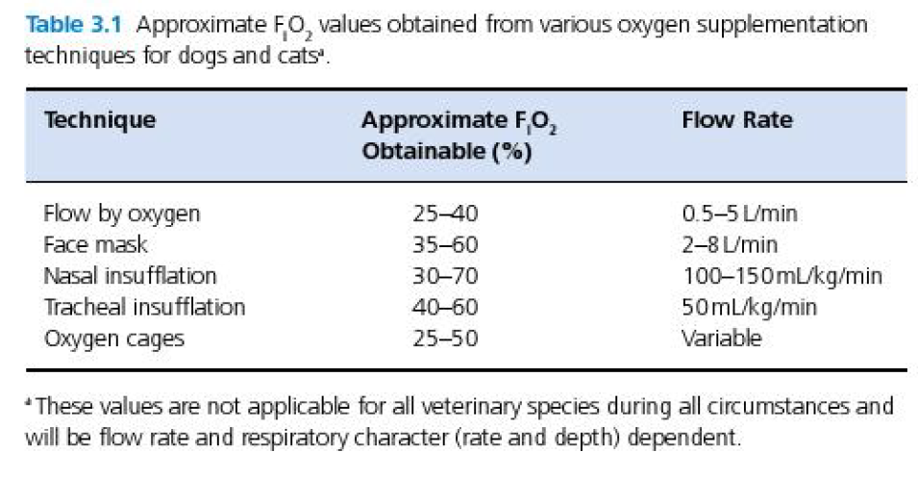
- ETT: high-volume, low-pressure cuffs are preferred to minimize the risk of ischemic tracheal injury – the pressure exerted by the cuff on the tracheal wall is similar to the intracuff pressure.Tracheal wall pressures > 48 mmg may impede capillary blood flow ( ischmiec tracheal damage); < 18 mmHg may potentially increase the risk of aspiration
  - Cuff monitor to inflate high-volume, low-pressure cuffs
  - Leak test (inflate the cuff until a leak is no longer audible while maintaining AW pressure of 20-30 cmH₂O)
- Supraglottic airway devices
  - Simpler, faster to place than ETT in some species
  - Do not require laryngoscope
  - Do not enter the larynx or trachea
  - Form a seal around the glottis
  - Does not produce greater leakage of anesthetic gases

Endotracheal tubes
- Cuffed Murphy-type
- Magill-type (no Murphy hole)
- Cole-type
- Guarded tube
- Self-sealing endotracheal tube
- High-volume, low pressure cuffs are preferred
  - Pressure exerted on tracheal wall by the cuff approximately = intracuff pressure
  - Tracheal wall pressure > 48 mmHg decreased capillary blood flow; < 18 mmHg risk of aspiration
  - Cuff monitor to inflate cuff or leak test (inflating the cuff until a leak is no longer audible while maintaining AW pressures of 20-30 cmH₂O)
- Endotracheal tubes for isolating one lung
  - Indications: improving surgical conditions for various thoracic procedures (thoracoscopy), control of contamination or hemorrhage, when unilateral pathology…
    - Double lumen tube
    - Bronchial blocker
    - Long standard ETT as an endobronchial tube
Supraglottic airway devices
- Aka laryngeal mask airways
- May be simpler and faster to place than ETT in some species
- Do not require use of a laryngoscope
- Do not enter the larynx or trachea
- Form a seal around the glottis
- Not associated with greater leakage of anesthetic gases
Laryngoscopes
- MacIntosh – curved blade
- Miller – straight blade
Oxygen administration
- If patient objects to mask so vigorously, the increase in oxygen consumption associated with restrain may nullify the benefits of greater FiO₂
- With a tight fitting mask, higher flow rates of oxygen tend to produce greater FiO₂ values and less rebreathing of expired carbon dioxide
- A loose-fitting mask that allows room air to be entrained can be used but will reduce FiO₂
- Nasal insufflation – relatively high flow rate; patient inspires oxygen and room air: the relative proportions of each being determined primarily by the oxygen flow rate and the rate of gas flow during inspiration
  - Tip positioned in the nasopharynx
  - Tube should ideally have several fenestrations to minimize jetting lesions from developing in the nasopharyngeal mucosa
  - Changing the catheter to the opposite nasal passage every 1-2 days have beend recommended to prevent pressure necrosis, jet lesions, and accumulation of mucus
  - Bilateral nasal insufflation – up to 80% FiO₂ at 200 ml/kg/min
- Tracheal insufflation
  - Catheter through the nares into the trachea
- Oxygen cages
  - 30-60% O₂; may require flow as high as 15 L/min
  - For small animals: recommendations –
    - Flow rates of oxygen: < 10 L/min
    - Temperature: 22°C (71.6°F)
    - Cage humidity: 40-50%
- Oxygen toxicity
  - Endothelial damages, destruction of alveolar cells, increased microvascular permeability edema, hemorrhage, congestion; alveolar type II and fibroblast proliferation fibrosis
    - Length of time that a patient’s PaO₂ is elevated may be MORE predictive of oxygen toxicity than the duration of exposure to high FiO₂
    - Guidelines: PaO₂ of 70 mmHg as an endpoint of oxygen therapy, use lowest FiO₂ possible to achieve PaO₂ of 70 and do not use FiO₂ >0.6 for longer than 24h

Questions
- Name oxygen supplementation techniques the maximal FiO₂ that can be reached with each technique

- Describe how to do a “leak test”.

- Which of the following patient is the most likely to suffer from the side effects of oxygen toxicity
  - Patient A: FiO₂ = 40% and PaO₂ = 130 mmHg for 10 hours
  - Patient B: FiO₂ = 65% and PaO₂ = 77 mmHg for 10 hours

- Name alternative techniques that could be use in the case of difficult ETT placement

Questions & Answers
- Name oxygen supplementation techniques and the maximal FiO₂ that can be reached with each technique
Oxygen chamber: 50-60%
Nasal insufflation: 70% (up to 80% with bilateral nasal insufflation)
Flow-by oxygen: 40%
Face mask: 60%
Tracheal insufflation: 60%

- Describe how to do a “leak test”.
Place ETT and connect ETT to breathing tube
Connect a syringe filled with air to the pilot balloon and inflate the cuff while listening for a leak
At the same time an assistant applies and maintains AW pressures of 20-30 cmH₂O by compressing the reservoir bag (pop-off valve is closed)
Stop inflating the cuff when a leak is no longer audible

- Which of the following patient is the most likely to suffer from the side effects of oxygen toxicity
  - Patient A: FiO₂ = 40% and PaO₂ = 130 mmHg for 10 hours
  - Patient B: FiO₂ = 65% and PaO₂ = 77 mmHg for 10 hours
Length of time that a patient’s PaO₂ is elevated may be MORE predictive of oxygen toxicity than the duration of exposure to high FiO₂

- Name alternative techniques that could be use in the case of difficult/impossible ETT placement
Supraglottic airway devices
Tracheostomy
Nasotracheal intubation
Wire- or tube-guided techniques (antegrade or retrograde)
Endoscope-guided techniques

