Lumb and Jones – Chapter 28
Physiology, Pathophysiology, and Anesthetic Management of Patients with Neurologic Disease

General anesthesia: drug-induced, reversible state characterized by amnesia, unconsciousness, analgesia, immobility and muscle relaxation.
- Most anesthetic agents exert their depressive effects by acting at different sites in the brain and spinal cord while the primary targets of local-regional anesthetic agents are the peripheral sensory receptors, afferent and efferent peripheral nerve fibers, and the spinal cord.

3 meninges (dura mater, arachnoidea, pia mater) form different spaces: subarachnoid space (between pia mater and arachnoidea), subdural space (between arachnoidea and dura mater), and epidural space (between dura mater and ligamentum flavum)
- Subarachnoid space contains CSF
- Vessel-rich epidural space contains fat and connective tissue
- BBB: anatomic and enzymatic separation that isolates cerebral blood from most brain parenchyma and CSF
  - Located at the choroid plexus, brain parenchymal vessels, subarachnoid vessels, and arachnoid membrane
  - Composed of cells connected by tight junctions (restrict intercellular diffusion; force solute exchange through the cells)
  - BBB permeability can be increased by intracranial hypertension, inflammation, osmotic disruption…
- CSF provides hydromechanical protection of the CNS, plays a prominent role in brain development, and influences neuronal functioning via regulation of interstitial fluid homeostasis
  - Produced under enzymatic control of carbonic anhydrase predominantly by choroid plexuses in the lateral, third, and fourth ventricles; 0.02 ml/min (cats) and 0.05 ml/min (dogs)
  - Distributed in the ventricles, spinal cord central canal and subarachnoid spaces
  - Compared to plasma ultrafiltrate: higher concentrations of Na+, Cl-, Mg²⁺, and lower concentrations of glucose, proteins, amino acids, K+, bicarbonate, phosphate – same tonicity as plasma
  - Drainage: absorption via cranial and spinal arachnoid villi into venous outflow system and via cranial and spinal nerve sheaths or via adventitia of cerebral arteries into lymphatic outflow systems
  - Flow dynamics and pressure depends on: arterial pulse wave, respiratory waves, posture, jugular venous pressure, physical effort
    - Hypotension, decrease in CPP, increase in ICP: reduction in CSF formation
    - Admx of diuretics (CA inhibitor or furosemide), mannitol, corticosteroids: reduction in CSF formation
    - Ketamine, halothane: may increase CSF formation
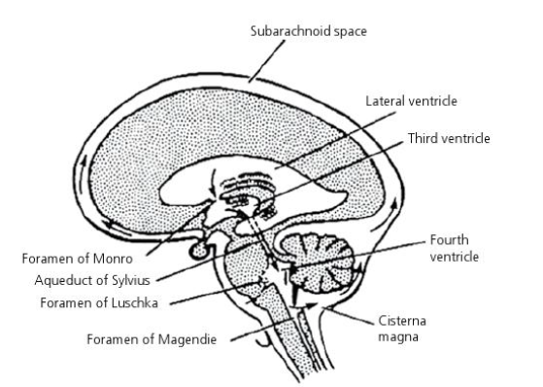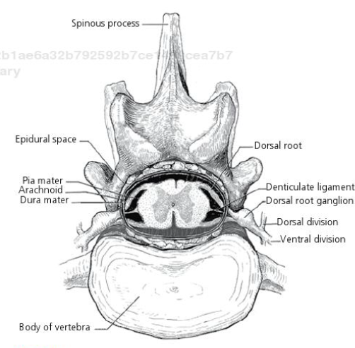

See pages 561-563 for review of nervous system anatomy

Cerebral metabolism
- High cellular energy demands (ATP from aerobic glucose oxidation)
- No oxygen and minimal glucose and glycogen substrate reserves
- Low concentrations of high-energy phosphate compounds
  - Brain is highly dependent upon adequate blood flow or minute-to-minute delivery of O₂ and glucose
  - Mean global cerebral metabolic rate for O₂ (CMRO₂) in awake human brain: 3.0-5.5 ml/100g/min
    - 60% for external work (EEG)
    - Healthy normothermic brain: 40% (isoelectric EEG)
      - = basal metabolism for maintaining neuronal and glial cell integrity, including the energy requirements for maintaining ionic gradients, biosynthesis, axonal transports
      - Higher doses of anesthetic agents and hypothermia basal metabolic state
  - At surgical level of anesthesia, CMRO₂ decreases by 36-45%; EEG slowing and burst suppression pattern appears at approximately 60% of the normal CMRO₂
    - Thiopental: offers neuroprotection in pathologic state associated with hypoxia because reduces O₂ requirement
    - Decrease in CMRO₂ is non-linear for isoflurane; the point at which the decline in the rate of CMRO₂ slows coincides with the change in EEG voltage
    - Functional and basal portion of the CMRO₂ is affected differently by general anesthetics and hypothermia
  - Increasing doses of thiopental or isoflurane will reduce the function portion of total CMRO₂ only
  - Hypothermia reduces both functional and basal CMRO₂
  - Isoflurane possesses some unique properties at it may produce isoelectric EEG pattern at clinically relevant concentrations; produces dose-related decreases in CMRO₂ but once EEG isoelectricity (and hence basal CMRO₂ have been reached), further increases in isoflurane concentrations are not associated with further decreases in CMRO₂; cerebral metabolic energy profile remains normal at EEG isoelectricity, suggesting that high concentrations of isoflurane are w/out toxic effects on oxidative phosphorylation (iso relatively safe even in hypotensive patients)
  - BZD decrease CBF and CMRO₂
  - Although global CMRO₂ is relatively stable, regional changes in CMRO₂ are continually occurring in the brain of awake organisms
    - Because the coupling of CMRO₂ and CBF, activation of one brain region will result in both increased metabolism and BF while simultaneous decreases may occur in unstimulated regions; the net result will be a stable global CMRO₂ and any meaningful increase or decrease in global CMRO₂ in the awake brain should be viewed as pathologic in origin (seizures, stroke)
  - Volatile agents but not barbiturates, etomidate, midazolam, may uncouple the tight relationship between CBF and CMRO₂ increased BF despite a dose-related decrease in CMRO₂; volatile tend to attenuate autoregulation and at higher doses autoregulation may be lost (CBF passively dependent upon CPP)

Cerebral blood flow
- Normal mean global CBF in humans: 45-65 ml/100g/min
- Cerebral circulation includes 2 types of arteries: 1) conducting vessels and penetrating vessels
  - Conducting: non-resistance vessels – carotid, vertebral, occipital, spinal artery with their major/minor branches
  - Penetrating (nutrient arterioles) enter the brain parenchyma at right-angles to the surfaces vessesl; resistance vessels; site of primary CBF autoregulation
- Vessels receive autonomic innervation: neurogenic tone is not essential to normal CBF regulation
- Wide opening of the jaw (cats) using spring-held mouth gag may increase the risk of postanesthetic neurologic deficits, cortical blindness and hearing deficits – maximally opened mouth in cats may be associated with disrupted CBF and reduced direct BF to the retina or inner ear, most likely caused by stretching of the vasculature of the maxillary artery and adjacent muscles – temporalis, masseter, pterygoid muscles

Cerebral blood flow autoregulation
- = multifactorial process that maintains constant CBF despite changes in systemic blood pressure and CPP over a wide range
- CPP = difference between brain arteries and veins
- CBF autoregulation enables the brain to match blood supply with metabolic demand (regionally and globally)
- Autoregulation is usually intact during light levels of anesthesia, but may be impaired or abolished during deep anesthesia
- Volatile tend to attenuate autoregulation up to a point when CBF becomes passively dependent upon CPP
- Lower limit (MAP): 60 mmHg; upper limit: 130-150 mmHg; beyond theses limits CBF becomes primarily flow dependent
- Decrease in MAP below lower limit decreased CBF and increased arteriovenous O₂ difference
- At MAP of 40: cerebal ischemia, mental impairment, hyperventilation, dizziness
- CPP can theoretically decrease by approximately 30% before the lower limit of autoregulation is reached
- When MAP is above upper limit BF exceeds the ability of the cerebral vasculature to constrict pronounced increase in CBF cause forced dilation or arterioles disruption of BBB and edema and/or hemorrhage
- Constancy of CBF is achieved by an active vascular response thus rendering CBF directly proportional to CPP and inversely proportional to CVR.
  - CPP = MAP – ICP
- An increase in perfusion pressure will elicit arteriolar constriction and a decrease in CPP is followed by arteriolar dilation; it is most likely that CBF autoregulation results from myogenic responses of smooth muscle cells of the arteriolar wall to the stretch caused by the distending transmural pressure rather than activation of the autonomic nerve fibers
- Thin-walled, valveless cerebral veins drain blood into relatively thick-walled dural sinuses. The site of entry of cerebral vein into a dural sinus anatomically presents a relatively fixed orifice significant resistance to flow
- In chronic arterial hypertension, the cerebral vessels adapt to higher perfusion pressure by hypertrophy of the vessel wall, which in turn displaces the autoregulatory curve to the right. Chronically hypertensive patients tolerate a high arterial pressure much better than do normotensive patients
  - Displacement of the autoregulatory curve to the right also means that the lower limit is shifted to the right, which increases the risk of ischemia during systemic hypotension
  - Chronically hypertensive patients do not tolerate the same acceptable lower limits for arterial blood pressure as normotensive patients
- During hypovolemic hypotension, CVR will increase increase in vessel tone displacement of the autoregulatory curve to the right lower limit of CBF autoregulation and lowest tolerated pressure are increased: brain ischemia will develop at higher perfusion pressure than during pharmacologically induced hypotension where CVR is decreased
- Critical CBF = blood flow below which cerebral ischemia occurs
  - As CBF decreases, a flow is reached below which cortical electrical function is abolished
  - In normothermic/capnic/lightly anesthetized patients: critical ischemic threshold of CBF is in the range of 16-20ml/100g/min
  - Lower: massive efflux of K+ from and a Ca²⁺ influx into damaged cells
- Variations in PaCO₂ exert the most profound influence on CBF regulation. While hypercapnia can cause pronounced cerebral vasodilation, extreme hypocapnia can cause cerebral vasoconstriction
- Around normal PaCO₂ CBF changes by about 4% (2 ml/100g/min) for each 1 mmHg change in PaCO₂
- CO₂ reactivity is mediated by pH variations in the CSF surrounding the arterioles; pH of CSF depends on tension of freely diffusible CO₂ and the CSF bicarbonate concentration
  - Homeostasis
  - Increase in PaCO₂ (brain) is followed by increase in CBF
- Long-term hyperventilation produces a state of moderate hypocapnia but, as a result of adaptation (normalization) of CSF pH and consequently of CBF to the lower PCO₂ value, hyperventilation-induced vasoC will be of limited effect; however ventilation at values of < 25 mmHg is not recommended (decreased CVF to such low value that the ischemic threshold for sustaining normal neuronal function can be reached)
- Moderate changes in PaO₂ during moderate arterial hypoxemia or arterial hyperoxemia do not exert a measurable influence on CBF; an increase in CBF is not seen until PaO₂ decreases to below 50 mmHg; which is the same value below which progressive brain tissue lactic acidosis appears
  - Anoxia or anoxia/hypercapnia may constitute pronounced cerebral vasoD
- CBF autoregulation can be abolished by trauma, brain tumor, apoplexy, noxious stimuli (hypoxia and lactic acidosis)
- VasoD or complete vasomotor paralysis induced by lactic acidosis can readily over-ride the autoregulatory constrictor response to perfusion pressure increase; any increase in MAP will increase CBF and result in cerebral hyperperfusion
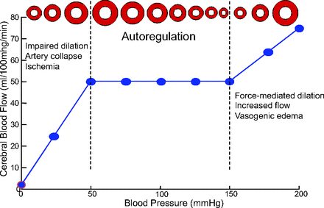

Luxury perfusion of paradoxical response to PaCO₂
- Transient cardiac arrest, TBI, brain tumor, meningitis can cause inadequate cerebral perfusion and hypoxia severe tissue lactic acidosis, vasomotor paralysis, increased ICP
- Vasomotor paralysis can occur w/in ischemic areras, around a tumor, in areas of infarction or distal to vascular occlusions.
- This means that loss of CBF autoregulation will not be restricted to the center of pathologic conditions but will also include surrounding areas with marginal perfusion
- Because of the loss of vessels’ ability to respond to changes in either perfusion pressure or PaCO₂, CBF is passively dependent on perfusion oressure. In this circumstance, normal or elevated perfusion pressure can produce BF that is supernormal relative to the metabolic needs = luxury perfusion syndrome
- If CVR decreases in non-ischemic, normal regions of the brain (isoflurane anesthesia), blood may be shunted away from the area of vasomotor paralysis; this shunting is termed = intracerebralsteal syndrome
- An increase in CVR in normal cerebral regions will shunt blood into areas of vasomotor paralysis = inverse steal or Robin Hood syndrome

Spinal cord blood flow
- Maintained by autoregulation w/in certain MAP limits (60-150mmHg)
- Hypoxia produces vasoD that overrides both the autoregulation and PaCO₂ effects on spinal cord BF
- Canine spinal cord BF increases sharply when PaO₂ declines to 60 mmHg and reaches a maximum at PaO₂ of 30-40 mmHg
- Hypercapnia produces a significant increase in spinal cord BF and essentially abolishes autoregulation
- While hypoxia and hypercapnia markedly increase total spinal BF, the distribution of flow to gray and white matter will not be affected by changes in PaO₂ and PaCO₂, respectively
  - Gray is vulnerable to damage by ischemia, owing to high metabolic rate of neurons and associated high BF requirements

General anesthesia
- Most volatile and injectable agents: act at different GABA_{A} receptor subunits: beta2 produces sedation, beta3 produces hypnosis
- Anesthetic dose requirements for immobility are higher than those for producing unconsciousness
- Volatile and injectable concentrations sufficient to produce loss of consciousness decreased cerebral metabolism by about 40-60% from awake state

Neurologic monitoring and testing
EEG
- Surface electrical signals represent the summation of the activity of millions of neurons in cerebral cortex and result from excitatory and inhibitory postsynaptic potentials
- EEG amplitude and frequency are modulated by afferent inputs from sensory-specific thalamic nuclei serving as gates between peripheral receptors and the cortex, and by epicenters w/in cerebral cortex
- EEG activity associated with consciousness is generated from pacemaker neurons w/in ARAS and mediated and modulated through thalamic connections
  - Frequency of pacemaker neurons: 8-12 Hz
  - In the awake state: consciousness is maintained by circulating activity among ARAS, intralaminar nuclei and cerebral cortex
- During induction and maintenance of anesthesia, the progressive decrease in EEG frequency content (slowing) will be indicated by a shift from low-voltage, fast-wave pattern to a high-voltage, slow-wave pattern
- Dose-dep changes in EEG activity along with an increase in anesthetic depth were clearly demonstrated for many anesthetic agents; as depth increases, the predominant EEG pattern is characterized by a decrease in beta activity and a concomitant increase in both alpha and delta activity increase in total power, relative power in delta and theta frequency bands, decrease in alpha and beta power, decrease in median frequency and spectral edge frequency
- Very deep level of anesthesia are indicated by flat periods interspersed with periods of alpha and beta activity (burst suppression pattern), followed by a complete loss of electrical discharge (isoelectricity or electrical silence)
  - Burst suppression indicates a non-specific reduction in cerebral metabolic activity
- EEG responses evoked by surgical stimuli: noxious stimuli my cause EEG desynchronization, indicated by replacement of predominant high-voltage slow wave activity by low-voltage, fast-wave activity, and increases in MF, SEF, power band ratios (theta/delta, alpha/delta, beta/delta) – during inadequate level of anesthesia
- EEG synchronization or paradoxical arousal is another form of EEG activation, which represents the opposite alteration in the cortical discharge in response to noxious stimulation (EEG slowing instead of increase in frequency content)
- Goal of intraop EEG monitoring: maintenance of high-voltage, slow-wave EEG pattern, avoid changes in the EEG pattern in response to noxious stimulation
Evoked potentials
Bispectral index
Narcotrend index
Entropy
Index of consciousness
Cerebral state index
EMG

Management of selected nervous system disease states
BRAIN TUMOR, TBI, ICH/increased ICP
- Periop assessment of neurological status: mentation, pupil size, reaction
- Documentation of signs of increased ICP: vomiting, papilloedema, pupillary dilation
- Periop blood pressure measurement (adq CPP)
- Euglycemia or slightly increased BG (?)
- Avoid periop anemia
- Allow/produce mild hypothermia
- IC space = brain tissue (80-85%), CSF (7-10%), blood (5-8%); ICP = pressure caused by these 3 components w/in non-distensible IC space; Monroe-Kelly hypothesis states that for ICP to remain normal, a change in volume (increase) in any of the 3 components must be matched by a decrease in another
- Signs: hypertension, bradycardia, respiratory irregularity = Cushing reflex
- Ideal CPP = ? Ideal lower pressure limit for CBF autoregulation in patients with cerebral disorders = ?; CPP > 60 -70 mmHg; ICP = 10-15 mmHg; MAP > 80 mmHg may be required for adequate cerebral perfusion
- Adq sedation and analgesia
- Improved cerebral venous drainage (15-30° head elevation)
- Mannitol, hypertonic saline
- Anesthesia induced with thiopental, etomidate, propofol
- NMBA for intubation (atracurium, vecuronium)
- Regional cerebral oxygen saturation monitoring – near-infrared spectroscopy (decrease in rSO₂ by > 20 % of baseline value)
- After TBI, brain may increase metabolic activity, which is often a ramification of glutamate release and excitotoxicity; euglycemia or hypoglycemia may not be adq for substrate delivery to compensate for hypermetabolic brain state
Seizures
- Marked increased in CMRO₂, CBF and potential risk for asphyxia in spontaneously breathing patients
- Increases in cerebral energy requirements, ABP, brain ECF K+ concentration, ECF osmolality have been discussed as CBF-increasing factors during seizures
- An increase in cerebral PvO₂ indicates that the accelerated utilization and production of ATP changes the balance between the initial (glycolytic) and final (oxidative) breakdown of glucose, suggesting that hypoxia may not be the predominant cause of lactic acidosis
- AEDs exert antiseizure activity by:
  - Reducing inward voltage-gated positive current (Na+, Ca²⁺)
  - Increasing inhibitory NT activity (GABA)
  - Decreasing excitatory NT activity (glutamate, aspartate)
- Isoflurane, desflurane, barbiturates, propofol: for refractory seizures
- Ketamine – antiseizures properties in some species
- SE needs to be controlled rapidly in order to avoid loss of CBF autoregulation, cerebral hypoxia, cerebral edema, ICH
Acute spinal cord injury
- Initial trauma often followed by secondary injury from molecular and biochemical changes associated with initial trauma (loss of spinal BF autoregulation, excessive release of excitatory NT, IC calcium accumulation, inflammation)
Myelomalacia
- Ischemic or hemorrhagic necrosis that occur as a sequel to acute spinal cord injury
- Neuronal anoxia/hypoxia
- Embolization, thrombi, space-occupying lesions (disk, tumor, abscess), pronounced vasoC, decreased spinal perfusion pressure and/or spinal venous congestion
Myasthenia gravis
- ME regurgitation aspiration pneumonia
- Rapid ET intubation, esophageal suctioning, antiemetics/prokinetics, avoid nausea/vomiting
- May have abnormal response to NMBAs; relatively resistant to succinylcholine (insufficient depolarization) and very susceptible to non-depolarizing NMBAs
- Myasthenic crisis can occur with emotional stress, pain, surgery: complication of myasthenia gravis characterized by worsening of muscle weakness, resulting in respiratory failure that requires intubation and mechanical ventilation; most common precipitant= infection
- Anticholinesterase (pyridostigmine) periop in MG patients – may interfere with metabolism of substrates of cholinesterase enzymes (mivacurium); not a problem if does not use NMBAs
- NMBAs should be monitor with TOF
Imaging modalities
- Postmyelographic complications: bradycardia, asystole, seizures, hyperthermia, exacerbation of pre-existing CNS dysfunction, hyperesthesia, vomiting, aseptic meningitis, transient apnea
- Iohexol and iopamidol – less neurotoxic
- Good subarachnoid puncture, good aseptic technique, slow injection of contrast medium, adq hydration, postmyelographic contrast medium removal
- MRI – more accurate

QUESTIONS
- Draw the cerebral blood flow autoregulation curve (identify the x axis and y axis with the correct units) and indicate what would be the effect of hypovolemic hypotension.

- TRUE or FALSE: CBF autoregulation results from activation of autonomic nerve fibers depending on the PaCO₂

- TRUE of FALSE: In a patient anesthetized with isoflurane, presence of an isoelectric EEG pattern indicates that anesthesia is too deep; isoflurane concentration should be decreased.

- An increase in CBF is not seen until PaO₂ decreases to below ____ mmHg; which is the same value below which progressive brain tissue lactic acidosis appears

- ____% of CMRO₂ is for external work and ____% is for basal metabolism
  - 30%/70%
  - 70%/30%
  - 40%/60%
  - 60%/40%

QUESTIONS & ANSWERS
- Draw the cerebral blood flow autoregulation curve (identify the x axis and y axis with the correct units) and indicate what would be the effect of hypovolemic hypotension.
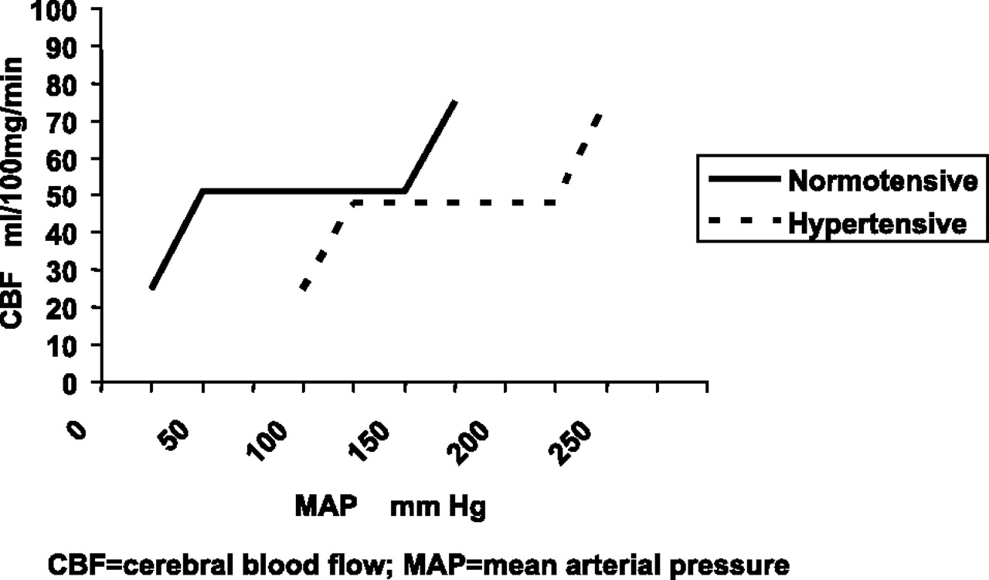

- TRUE or FALSE: CBF autoregulation results from activation of autonomic nerve fibers depending on the PaCO₂
False: It is most likely that CBF autoregulation results from myogenic responses of smooth muscle cells of the arteriolar wall to the stretch caused by the distending transmural pressure rather than activation of the autonomic nerve fibers

- TRUE of FALSE: In a patient anesthetized with isoflurane, presence of an isoelectric EEG pattern indicates that anesthesia is too deep; isoflurane concentration should be decreased.
False: Isoflurane possesses some unique properties at it may produce isoelectric EEG pattern at clinically relevant concentrations; produces dose-related decreases in CMRO₂ but once EEG isoelectricity (and hence basal CMRO₂ have been reached), further increases in isoflurane concentrations are not associated with further decreases in CMRO₂

- An increase in CBF is not seen until PaO₂ decreases to below 50% mmHg; which is the same value below which progressive brain tissue lactic acidosis appears

- ____% of CMRO₂ is for external work and ____% is for basal metabolism
  - 30%/70%
  - 70%/30%
  - 40%/60%
  - 60%/40%

