Lumb and Jones – 5th edition – Chapter 16 Inhalation Anesthetics

- Gas versus vapor
  - Gas (N₂O) = exists in its gaseous form at room temperature and sea level pressure
  - Vapor = gaseous state of a substance that at ambient temperature and pressure is a liquid (all the contemporary anesthetics except N₂O); supplied as volatile liquid
- Methods of description
  - Quantities of inhalation anesthetic agent are usually characterized by pressure (mmHg), concentration (vol %)* or mass (mg or g)
  - Pressure: a mixture of gases in a closed container will exert a pressure on the walls of the container – the individual pressure of each gas = partial pressure (Dalton’s law of partial pressure: the total pressure of a mixture of gases is equal to the sum of the partial pressures of all the gaseous substances present)
  - Avogadro’s principle: equal volume of gases under the same conditions of temperature and pressure contain the same number of molecules (6.0226 x 10²³ per gram molecular weight)
  - Density: absolute value of mass (g) per unit volume (ml or L)
  - Specific gravity: relative value; ratio of the weight of a unit volume of one substance to a similar volume of water (for liquid) or air (for gas or vapors)
- Vapor pressure
  - Change in state from liquid to gas = vaporization (or evaporation)
  - In a closed container that is kept at constant temperature: equilibrium is reached whereby there is no further loss of molecules to the gas phase (the # of molecules leaving and returning to the liquid phase are equal) = gas phase is saturated
  - Molecules of a vapor exert a force per unit area or pressure (mmHg); the pressure that the vapor molecules exert when the liquid and vapor phases are in equilibrium is known as the vapor pressure
  - Vapor pressure of an anesthetic is a measure of its ability to evaporate (volatility of the agent)
    - Must be sufficient to provide enough molecules in the vapor state to produce anesthesia at ambient temperature
  - Saturated vapor pressure: maximum concentration of molecules in the vapor state that exists for a given liquid at each temperature (which lead to a saturated vapor concentration at a specific ambient pressure) – depends on temperature
    - The greater the vapor pressure, the greater concentration of the drug deliverable
    - When temperature of the liquid increases, more molecules escape the liquid phase (increased vaporization) the greater the # of molecules in the vapor phase results in a greater vapor pressure and vapor concentration.
  - Boiling point
    - The temperature at which the vapor pressure of the liquid is equal to the atmospheric pressure
    - The boiling temperature decreases with increasing altitude because the vapor pressure does not change but the barometric pressure decreases
    - Desflurane’s boiling point is near room temperature
- Properties determining methods of administration
  - Boiling point
  - Liquid density (specific gravity)
  - Vapor pressure
- Calculation of Anesthetic Concentration Delivered by a vaporizer
  - Saturated vapor pressure of most volatile is so high that the maximal concentration of anesthetic attainable is above the range needed/safe.
  - Use of a vaporizer to control concentration delivered
  - Purpose of the vaporizer: to dilute the vapor generated from the liquid anesthetic with O₂.
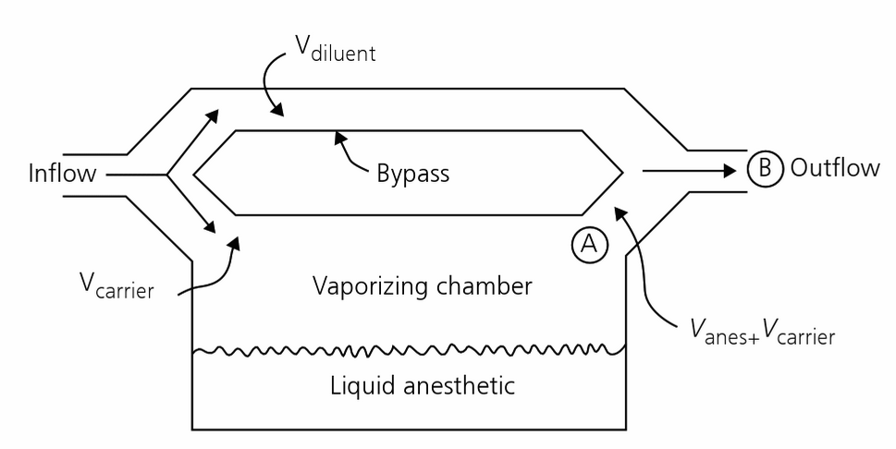
  - % anesthetic = flow of anesthetic from the vaporizing chamber/total gas flow
    - = volume agent/total gas
    - Total gas= volume diluent + volume agent + volume carrier
- Properties influencing drug kinetics
  - Solubility
    - Molecules of gas that overlie a liquid surface are in random motion and some penetrate the liquid surface. After entering the liquid, they intermingle with the molecules of the liquid (gas dissolves in the liquid). There is a net movement of the gas into the liquid until equilibrium is established between dissolved gas and the undissolved portion above the liquid (the # of molecules entering the liquid = # leaving). The gas molecules w/in the liquid extert the same pressure or tension that they exert in the gas phase.
    - The total # of molecules of a given gas dissolving in a solvent depends on the chemical nature of the gas, the partial pressure of the gas, the nature of the solvent, and the temperature.
      - Henry’s law: V = S xP (where V = volume of gas, P = partial pressure of gas, S = solubility coefficient of gas in the solvent at specific temperature)
    - W/in the body, there is a partition of anesthetic gases between blood and body tissues in accordance with Henry’s law
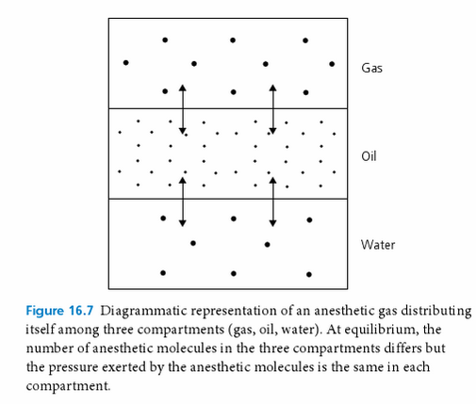
    - *The amount of gas that goes into solution depends upon the temperature of the solvent – less gas dissolves as temperature increases.
    - The extent to which a gas will dissolve in a solvent is expressed in solubility coefficient. With inhalation anesthetics, solubility is most commonly measured and expressed as partition coefficient.
    - Partition coefficient: concentration ratio of an anesthetic in the solvent and the gas phases; it thus describes the capacity of a given solvent to dissolve the anesthetic gas (how the anesthetic will partition itself between the gas and the liquid after equilibrium has been reached)
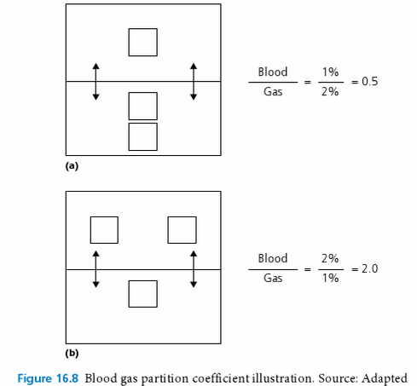
    - Many factors influence anesthetic agent solubility – temperature*, nature of the solvent
    - Blood/gas partition coefficient
      - Means for predicting speed of anesthetic induction, recovery, changes of depth
      - Greater partition coefficient = more soluble in blood (greater it will take to saturate the blood)
      - More soluble (greater partition coefficient) = longer time for induction, longer time for recovery
    - Oil/gas partition coefficient
      - Describes the ratio of the concentration of anesthetic in oil and gas phases at equilibrium
      - Correlates directly with anesthetic potency
    - Highly soluble: methoxyflurane
    - Poorly soluble: N₂O, desflurane, sevoflurane - rapid equilibration
    - Intermediate: isoflurane, halothane
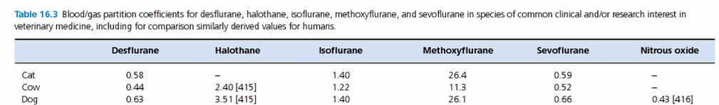
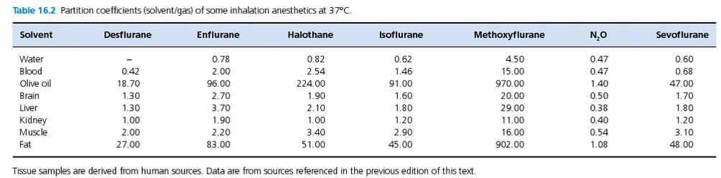
- Pharmacokinetics: Uptake and Elimination of inhalation anesthetics
  - Aim in admx an inhalation anesthetic is to achieve an adequate partial pressure of anesthetic in the CNS to cause a desired level of CNS depression
  - Anesthetic depth varies directly with P_{anes} in brain tissue
  - Inhalation anesthetics move down a series of partial pressure gradients from regions of higher tension to those of lower tension until equilibrium is reached
  - The brain has a rich blood supply – the anesthetic in arterial blood rapidly equilibrates with brain tissue - usually P_{a}Anes = P_{A}Anes = P_{brain}Anes
- Anesthetic uptake
  - The P_{A} of an anesthetic is a balance between anesthetic input (delivery to alveoli) and anesthetic loss (uptake by blood and body tissues) from the lungs
  - Rapid rise of P_{A} is associated with rapid induction or change in anesthetic depth
  - Increased alveolar delivery:
    - Increased inspired anesthetic concentration
      - Increased vaporization of agent
      - Increased vaporizer dial setting
      - Increased fresh gas inflow
      - Decreased gas volume of patient breathing circuit
    - Increased alveolar ventilation
      - Increased minute ventilation
      - Decreased dead-space ventilation
  - Decreased removal from the alveoli
    - Decreased blood solubility of anesthetic
    - Decreased cardiac output
    - Decreased alveolar-venous anesthetic gradient
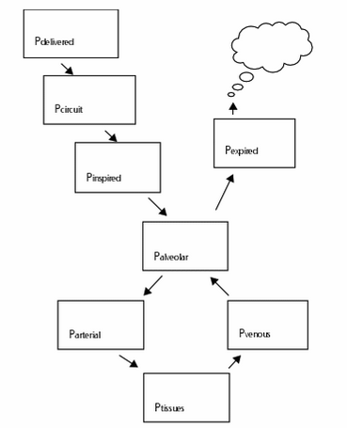
  - Increased cardiac output (like high solubility) delays the alveolar rise of P_{anes} and slows the induction of anesthesia
  - Tissues such as the brain, heart, hepatoportal system, kidneys = 10% of the body mass that normally receive about 75% of the total blood flow each minute; these highly perfused tissues equilibrate rapidly with arterial anesthetic partial pressure; skin and muscle represent 50% of the body but receive only about 15-20% (saturation of these tissues takes hours); fat receives only a small % of blood flow; saturation is very slow (all anesthetics are more soluble in fat than other tissue groups).
  - *With time, the highly perfused tissues (brain, kidneys, heart, liver) equilibrate with incoming blood so that ¾ of the total blood flow returning to the heart has the same anesthetic partial pressure as it had when it left the lungs (equilibration); thus further uptake from the lung is decreased
- Anesthetic elimination
  - Recovery results from elimination from CNS; requires clearance in alveolar anesthetic partial pressure (concentration), which in turn fosters a decrease in arterial, then in CNS anesthetic partial pressure
  - Alveolar ventilation, CO, agent solubility influence recovery
- Biotransformation
  - Most inhalation anesthetics are not chemically inert; they undergo metabolism in the liver*, kidney, intestinal tract
  - Sevoflurane: 2-5% metabolized
  - Isoflurane: 0.2% metabolized
Key points:
- Partition coefficient (blood/gas – speed; oil/gas - potency)
- Solubility

- The minimum alveolar concentration (MAC)
  - MAC = minimum alveolar concentration of an anesthetic at 1 atm that produces immobility in 50% of subjects exposed to a supramaximal noxious stimulus
  - =ED₅₀ (effective dose₅₀)
  - Anesthetic potency is inversely related to MAC
    - Potency = 1/MAC
  - MAC is inversely related to oil/gas PC (recall that oil/gas PC is directly related to potency)
    - Low potency: high MAC, low oil/gas PC
    - High potency: low MAC, high oil/gas PC
  - MAC represents alveolar concentration (not inspired or delivered)
  - MAC is defined in volumes percent of 1 atm and represents an anesthetic partial pressure at the anesthetic site of action (partial pressure will always be the sane but the concentration at MAC may vary depending on ambient pressure conditions)
  - MAC is determined in healthy animals under lab conditions w/out other drugs/circumstances
  - MAC values (%) in cats (sea level)
    - Iso: 1.28-2.21 (1.63)
    - Sevo: 2.58-3.07
    - Halothane: 0.99-1.19
    - Desflurane: 9.79-10.27
    - Nitrous oxide: 255
  - MAC values (%) in dogs (sea level)
    - Iso: 1.28-1.50 (1.28)
    - Sevo: 2.10-2.36
    - Halothane: 0.86-0.93
    - Desflurane: 7.2-10.3
    - Nitrous oxide: 188-297
  - N₂O is usually administered with another more potent agent to reduce the concentration of the 2nd agent necessary for anesthesia
  - MAC is NOT affected by
    - BP > 50 mmHg, atropine, glycopyrrolate, duration of anesthesia, gender, hyper or hypokalemia, metabolic acid-base change, PaO₂ > 40 mmHg, PaCO₂ 15-95 mmHg
  - MAC is INCREASED by
    - Amphetamine, ephedrine, and hyperthermia
  - MAC is DECREASED by
    - Other inhaled anesthetic agents, ketamine, lidocaine, thiopental, acepromazine, DZP, medetomidine, fentanyl, midazolam, morphine, BP < 50 mmHg, hyponatremia, hypothermia, PaO₂ < 40 mmHg, PaCO₂ > 95 mmHg, pregnancy
Key points:
- MAC
- Potency = 1/MAC

- Actions and toxicity of the volatile inhalation anesthetics on body systems
  - CNS
    - General anesthesia, immobility, hemodynamic and endocrine unresponsiveness to noxious stimulation
    - MOA and sites remain unknown
    - Decrease cerebral metabolic rate and O₂ consumption
    - No change or increase* CBF (vasodilation – direct anesthetic action on sm) increase in brain blood volume and ICP (halothane > iso > sevo)
    - Decrease CPP (by decreasing MAP)
    - Loss of cerebrovascular autoregulation (through action on NO synthase, cyclo-oxygenase and adenylate cyclase)
  - RESPIRATORY
    - Depression
    - Decrease spontaneous ventilation, RR, minute ventilation, alveolar ventilation ( increased PaCO₂; dose-related)
    - Depressed response to increased PaCO₂ (direct action on medullary and peripheral chemoreceptors)
    - Bronchodilation
    - Minimal AW irritation (unless high%)
    - Surgery and noxious stimulation may result in sufficient CNS stimulation to lessen the ventilatory depression
  - CARDIOVASCULAR
    - Dose-dep
    - Decrease CO – minimal with the newer volatile anesthetics at clinically useful concentrations (in fact they preserve CO by reduction in SVR); if SVR is maintained, the direct effect of volatile agents on CO is often a decrease in SV due to depression in myocardial contractility
    - HR increase (iso, sevo, desflurane, halothane) in dogs – often remain constant over a range of clinically useful concentrations in the absence of noxious stimulation (vagolytic activity in dogs?)
    - Arrhythmias – by increasing the automaticity of the myocardium – halothane; less/none with newer; iso and sevo are least arrhythmogenic
    - Change the distribution of BF
    - Dose-dep decrease in ABP (decrease in SV and/or PVR)
  - KIDNEYS
    - Dose-related decrease in GFR, RBF
    - Reduction in renal function influenced by hydration and hemodynamics
    - Healthy animals: rapidly reversed after anesthesia
    - Methoxyflurane = the most nephrotoxic (release of free fluoride polyuric AKI)
    - Sevoflurane: biotransformation inorganic fluoride; little potential for nephrotoxicity as a result of defluorination
    - Sevoflurane: degradation by CO₂ absorbents (soda lime and Baralyme; contained NaOH or KOH) Compound A; can cause renal injury and death in rats; rare
  - LIVER
    - Depression of hepatic function
    - Hepatocellular damage
    - Direct or indirect, transient or permanent effects
    - Inhibition of drug-metabolizing capacity in the liver
    - Reduce hepatic BF and O₂ delivery
      - Iso is the most likely to better maintain liver O₂ delivery; sevo similar.
    - Halothane: 2 forms; one mild self-limiting; one fulminant (immune-mediated?)
  - MUSCLES
    - Malignant hyperthermia – iso, sevo can initiate MH, halothane is the most potent triggering agent

QUESTIONS

- Define partition coefficient

- Would you prefer a low or high blood:gas PC in a critically ill patient? Explain why.

- Given you response in 2, which agent would you choose (isoflurane, sevoflurane, halothane or methoxyflurane)?

- Define minimum alveolar concentration
- Match the MAC % with the appropriate agent for dogs. Included are nitrous oxide, isoflurane, desflurane, methoxyflurane, halothane and sevoflurane. Which agent is most potent?
Agent
MAC % | 0.23 | 0.87 | 1.3 | 2.3 | 7.2 | 188

QUESTIONS & ANSWERS
- Define partition coefficient
PC is a measure of solubility. It is the concentration ratio of an anesthetic in the solvent and the gas phases; it thus describes the capacity of a given solvent to dissolve the anesthetic gas (how the anesthetic will partition itself between the gas and the liquid after equilibrium has been reached)

- Would you prefer an agent with a low or high blood:gas PC in a critically ill patient? Explain why.
A low blood:gas PC
Because it will provide a faster speed of anesthetic induction and recovery and faster change of anesthetic depth if needed

Blood-gas solubility coefficients provide a means for predicting the speed of anesthetic induction, recovery, and change of anesthetic depth. Higher the blood:gas PC = higher solubility in blood. Higher solubility = slower speed of induction and recovery and slower change of anesthetic depth.

- Given you response in 2, which agent would you chose (isoflurane, sevoflurane, halothane or methoxyflurane)?
Sevoflurane (0.66) vs isoflurane (1.40)

- Define minimum alveolar concentration
MAC is the minimum alveolar concentration of an anesthetic at 1 atm that produces immobility in 50% of subjects exposed to a supramaximal noxious stimulus.

- Match the MAC % with the appropriate agent for dogs. Included are nitrous oxide, isoflurane, desflurane, methoxyflurane, halothane and sevoflurane. Which agent is most potent?

Agent | Methoxyflurane | Halothane | Isoflurane | Sevoflurane | Desflurane | N₂O
MAC % | 0.23 | 0.87 | 1.3 | 2.3 | 7.2 | 188

