Local Anesthetics
- Reversibly block the generation and propagation of electrical impulses in nerves, causing sensory and motor blockade

Molecular Mechanism of Action
- Primarily ion channel blockers
  - Mainly voltage-gated Na+ channel
  - K+ and Ca+ (lower affinity)
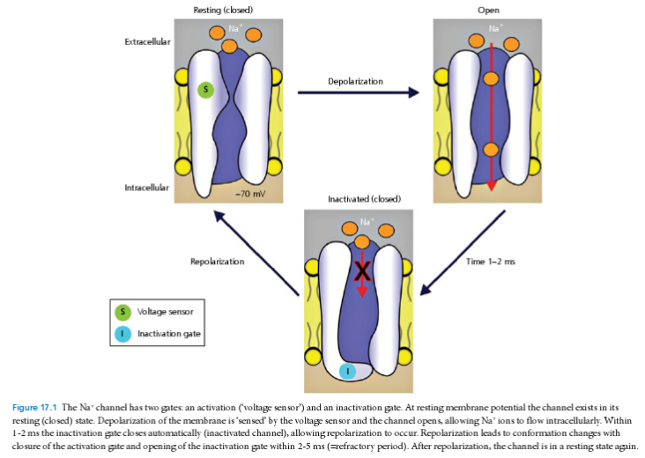

Na Channel Blockade
- Involves the blockade of inward Na+ currents through voltage-gated Na channels – impeding mb depolarization and nerve excitation and conduction
- Na channel is composed of approx. 2000 aminoacids (α-subunit) that traverse the cell mb several times – these form the channel’s pore and gating apparatus
- α-subunit consists of 4 domains (DI-DIV), each with six helical segments (S1-S6)
- Binding site for local anesthestic, antiarrythmic and anticonvulsant drugs is located on the DIV S6 segment of the α-subunit
  - Modulated-receptor hypothesis: high binding affinity for Na channel in its open and inactivated state
    - Lipid soluble drugs enter and leave the receptor via hydrophobic regions of the mb
    - Less lipid soluble drugs pass via a hydrophilic region (inner channel pore) – only open when the channel gates are open, causing a cumulative binding of local anesthetics
  - Guarded-receptor hypothesis: receptor for local anesthetics is located inside the channel and drugs bind to it with constant affinity, channel needs to be open for the receptor to be accessed by the drug, increasing the frequency of stimulation increases the number of open Na channels – increasing the binding of local anesthetics

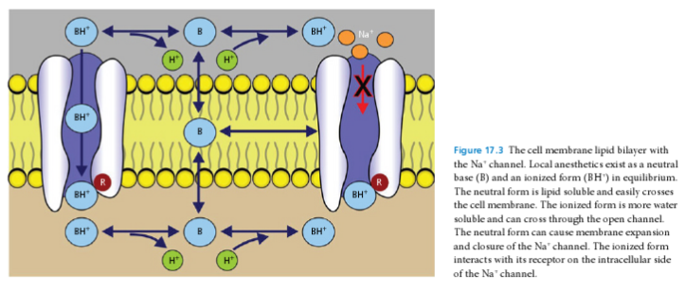

Mechanism of Blockade of Neural Tissue
- Epidural, Intrathecal or Systemically
  - K+ and Ca+ channels inhibition at level of the dorsal horn of the spinal cord – affecting the neuroprocessing of sensory information
  - Nociceptive transmission from dorsal horn through inhibition of Substance P binding and increased intracellular Ca+
  - Inhibits glutamatergic transmission in the dorsal horn, reduces NMDA and Neurokinin-mediated postsynaptic depolarization

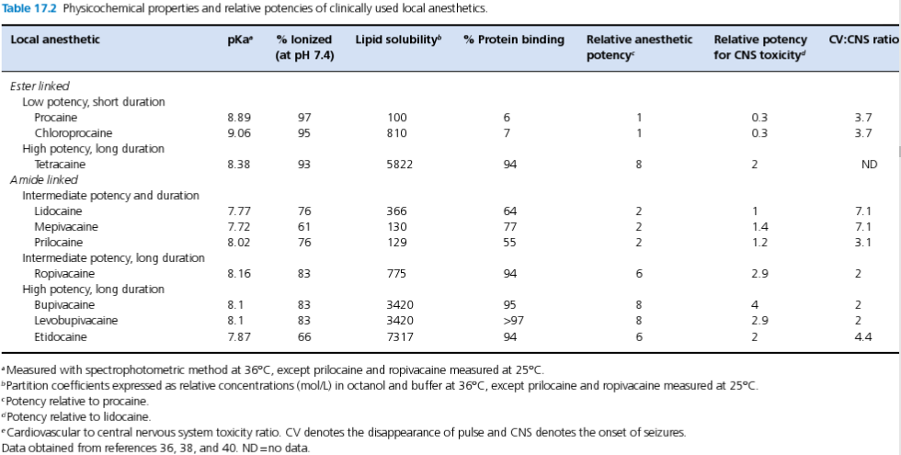

Lipid solubility in the main determinant of local anesthetic potency, however may delay onset of action while increasing the duration of effect
Degree of protein binding influences activity of local anesthetics, only the unbound, free fraction is pharmacologically active, higher protein binding is associated with increased duration of action

Pharmacokinetics
- Absorption: Systemic absorption depends on
  - Vascularity of injection site
  - Intrinsic lipid solubility
  - Vaso-activity of the agent
  - Dose administered
  - Vasoconstrictive additives
  - Pathophysiologic state of the patient
- Distribution
  - Vd 6.7 L/Kg
  - First pass pulmonary uptake
  - Bind primarily to α-1 acid glycoprotein (AAG) and lesser extent albumin
  - Cross placenta, milk
- Metabolism
  - Ester-linked local anesthetics - Ester hydrolysis by plasma pseudocholinesterases present in liver, rbc and synovial fluid
  - Amide-linked local anesthetics – metabolized in liver by microsomal enzymes
- Excretion
  - Ester-linked local anesthetics - urine
  - Amide-linked local anesthetics – urine and bile
- Factors affecting pharmacokinetics and activity
  - Elimination half-life is longer in pediatric patients
  - Increased nerve sensitivity in pregnancy – faster onset
  - Hepatic disease can decrease the rate of metabolism of amide-linked drugs, single doses do not need dose reduction, repeated doses and CRI need to be dose reduced to avoid accumulation and toxicity
  - Decreased hepatic flow (general anesthesia, decreased cardiac output, cardiac disease – decreased hepatic clearance
  - Renal failure –accumulation and toxicity
  - Diabetes mellitus – increases hepatic clearance
  - Temperature – lidocaine is potentiated by cooling

Questions
- Where is the main site of action of local anesthetics when administered as an epidural?
- Dorsal Horn
- Ventral Horn
- Intermediate horn
- Dorsal root ganglia

- Which of the following disease processes may require a higher CRI dose of local anesthetics to achieve desired effects on a dog?
- Renal disease with decreased GFR
- Synthetic liver failure
- Hypothermia
- Diabetes mellitus

- Which of the following channels is not effected by local anesthetics?
- Potassium
- Magnesium
- Sodium
- Calcium

Answers

- Where is the main site of action of local anesthetics when administered as an epidural?
- Dorsal Horn
- Ventral Horn
- Intermediate horn
- Dorsal root ganglia

- Which of the following disease processes may require a higher CRI dose of local anesthetics to achieve desired effects on a dog?
- Renal disease with decreased GFR
- Synthetic liver failure
- Hypothermia
- Diabetes mellitus

- Which of the following channels is not effected by local anesthetics?
- Potassium
- Magnesium
- Sodium
- Calcium

