Cardiovascular compensatory mechanisms to shock
- Rapid shallow breathing promotes venous return
- Release of renin from kidney due to increased sympathetic tone
  - goes on to produce AT2, potent vasoconstriction, increased PVR
- Epi from adrenals cause vasoconstriction
- Arteriolar constriction leads to decreased capillary hydrostatic pressure and net shift of fluids into vasculature
- Glycogenolysis in liver from epi and norepi increases BG
  - Increase in BG will increase blood osmolarity and further shift fluid balance towards vasculature

Decompensation
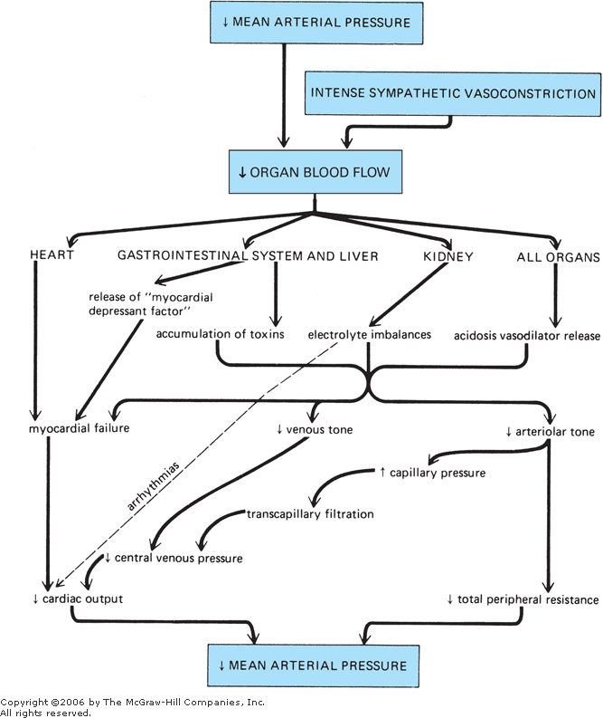

Cardiac Disturbances
- Coronary Artery Disease
  - In humans, plaques of lipid develop within walls of arteries, narrowing lumen and decreasing blood flow, especially to coronary arteries
  - Some evidence that platelet aggregation and clotting function may be abnormal in atherosclerotic coronary arteries and the danger of thromboemboli is enhanced
- Chronic heart failure -systolic dysfunction
    - vs acute heart failure (cardiogenic shock)
  - Lower than normal cardiac function curve
    - Reduced cardiac output at any given filling pressure
  - Heart failure induces cellular changes
    - reduced calcium sequestration by the sarcoplasmic reticulum and upregulation of sarcolemmal Na/Ca exchanger
      - this leads to low intracellular calcium levels for excitation-contraction coupling
    - Low affinity of troponin for calcium
    - altered metabolism from fatty acid to glucose oxidation
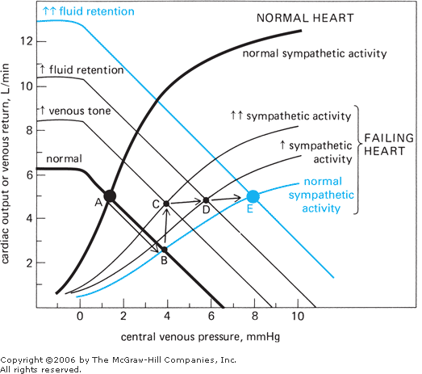
    - impaired aerobic metabolism and decreased energy production by myocytes
  - A = Normal cardiac output with normal venous tone and fluid balance
  - B = Cardiac Failure with normal venous tone and fluid balance
  - C = Sympathetic activation due to low arterial pressure leads to venous vasoconstriction and ‘auto fluid bolus’
    - SAP will likely be close to normal due to arterial vasoconstriction as well
  - Compensatory mechanisms including RAAS will move cardiac output from point C to D to E (as sympathetic tone decreases as well)
    - reduced sympathetic tone is important for multiple reasons, including reduced myocardial oxygen demand
- Additional consequences of being at ‘point C’
  - Chronic high central venous pressures cause chronically increased end-diastolic volume (cardiac dilation).
    - Initially this helps due to starling's law
    - Increased total wall tension is needed to generate pressure within an enlarged ventricle
      - T = P x r
    - With high venous pressure you get:
      - transcapillary fluid filtration
      - edema formation
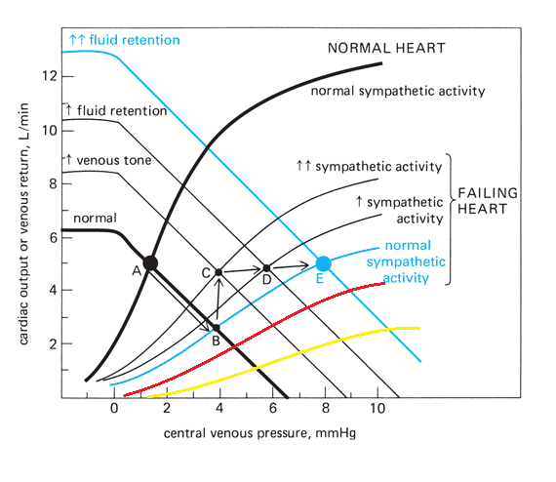
      - congestion
  - Red = more severe heart disease, Yellow = most severe
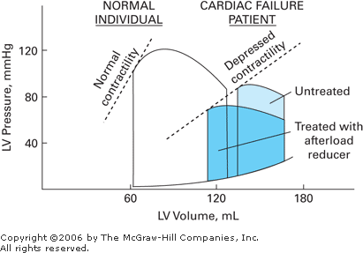
For this graph:
Movement along the X-axis is stroke volume (when going from right to left on the top of the curve)

Diastolic dysfunction
- Stiffened heart during diastole
- normal increases in end-diastolic pressure do not produce as good end-diastolic volumes
- Possible causes:
  - delayed monocyte relaxation early in diastole due to slow cytosolic calcium removal
  - inadequate ATP levels required to disconnect the myofilament cross-bridges rapidly
  - residual, low grade cross bridge cycling during diastole due to calcium leaking from the sarcoplasmic reticulum
  - increased myofibrillar passive stiffness due to alterations in the myofibrillar protein titin
  - decreased cardiac tissue passive compliance due to extracellular remodeling, collagen cross-linking, and other extracellular matrix protein alterations.

Hypertension
- Structural changes occur in the left heart and arterial vessels in response to hypertension
  - hypertrophy of muscle cells, thickening of walls of ventricle and resistance vessels
  - function loss due to increases in connective tissue and loss of elasticity
- Increased peripheral vascular resistance
  - rarefaction - decreased density of microvessels
  - pronounced structural adaptation that occur in the peripheral vascular bed
  - continuously increased activity of the vascular smooth muscle cells
  - increased sensitivity and reactivity of the vascular smooth muscle cells to external vasoconstrictor stimuli
  - diminished production of endogenous vasodilator substances
- Blood pressure-regulating reflexes become adapted to regulate blood pressure at higher than normal levels
- Disturbances in renal function contribute importantly to the development and maintenance of primary hypertension
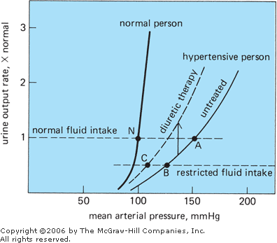
  - Higher than normal arterial pressure is required to produce normal urinary output in hypertension
- Mounting evidence that kidney is inciting cause

