Lange Cardiovascular physiology

Chapter 4 – The Electrocardiogram
- P, QRS, T (atrial depolarization, ventricular depolarization, ventricular repolarization)
- Period of time from initiation of P to beginning of QRS = PR interval; time for an AP to spread through atria and AV node
- PR segment: no voltage; atrial muscle is depolarized (plateau phase of AP), ventricular cells are resting and electrical field set up by the AP progressing though the AV node is not intense enough to be detected
- ST segment: no electrical potentials measured because no rapid changes in membrane potential are occurring (atrial cells are in resting phase, ventricular cells are in the plateau of AP); myocardial injury or inadequate blood flow can produce elevations or depression in the ST segment
- QT interval: approximates the duration of the ventricular depolarization (ventricular systole)
- Einthoven’s triangle
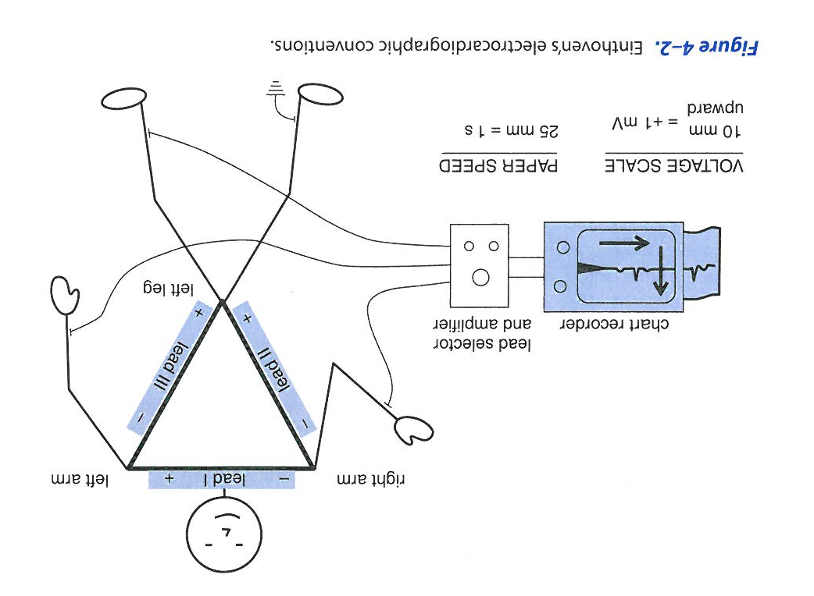
- The cardiac impulse after having arisen in the SA node is spreading as a wavefront of depolarization through the atrial tissue; at each point along this wavefront of electrical activity, a small charge separation exists in the extracellular fluid between polarized membranes (positive outside) and depolarized membranes (negative outside). Thus the wavefront may be thought of as a series of individual electrical dipoles; each dipole is oriented in the direction of local wavefront movement. Total net dipole (large black arrow) is created by the summed contributions of all the individual dipoles distributed along the wavefront depolarization. The salty ECF acts as a conductor allowing net dipoles generated on the surface of the heart muscle to be recorded by electrodes on the surface of the body.
- The net dipole is oriented in the general direction of the wavefornt movement
- Its magnitude is determined by:
  - How extensive the wavefront is (how many cells are simultaneously depolarizing at the same time)
  - The consistency of orientation between individual dipoles (dipoles with opposite direction cancel each other)
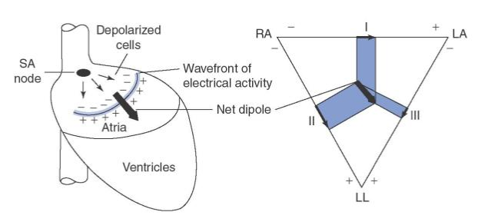
  - The net dipole (above) causes the lower-left portion of the body to be generally positive with respect to the upper-right portion; this dipole will cause positive voltage on all 3-limb leads.
- Dipole parallel to a lead: large voltage; dipole nearly perpendicular to a lead: small voltage
- Net cardiac dipole continually changes in magnitude and orientation during the course of atrial depolarization
- P wave terminates when the wave of depolarization reaches the nonmuscular border between the atria and the ventricle and the number of individual dipoles becomes very small. Cardiac impulse is still being slowly transmitted through the AV nodes but the electrical activity in the AV node involves so few cells that it generates no detectable net cardiac dipole (so that’s why no voltages are measured for a brief period following the P wave)
- Net dipole reappers when depolarization completes its passage through the AV node, enters Purkinje system and spreads through ventricle. Ventricular depolarization starts at the IV septum and in the endocardial layers at the apex of the ventricles then depolarization is spread outward and upward

- Rapid and large changes in the magnitude and direction of the net cardiac dipole that exists during ventricular depolarization cause the QRS complex

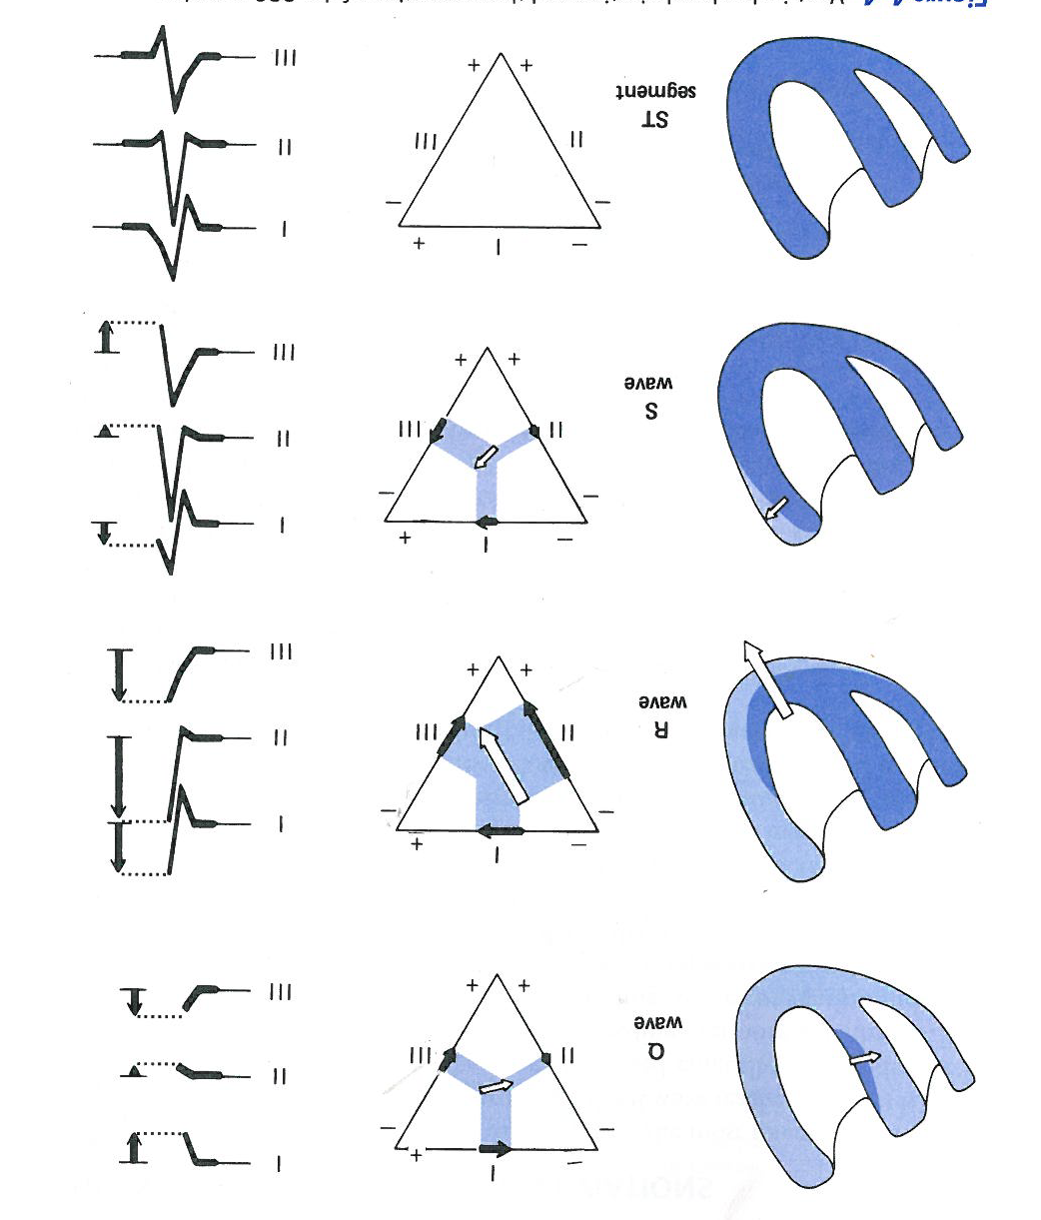
- Initial ventricular depolarization usually occurs on the left side of the IV septum
- The bottom row of diagrams in Figure 4–4 shows that during the ST segment, all ventricular muscle cells are in a depolarized state. There are no waves of electrical activity moving through the heart tissue. Consequently, no net cardiac dipole exists at this time and no voltage differences exist between points on the body surface. All electrocardiographic traces will be flat at the isoelectric (zero voltage) level.
- T wave is normally positive on lead II as is the R wave. This indicates that the net cardiac dipole generated during ventricular repolarization is oriented in the same general direction as that which exists during ventricular depolarization. This may be somewhat surprising since the individual dipoles generated along a wavefront of repolarization have exactly the opposite polarity as those that exist along a wavefront of depolarization. Recall that the last ventricular cells to depolarize are the first to repolarize. The wavefront of electrical activity during ventricular repolarization tends to retrace, in reverse direction, the course followed during ventricular depolarization. The combination of reversed individual dipole polarity and reversed wavefront propagation pathway during ventricular repolarization would be a positive T wave recorded on lead II. The T wave is broader and smaller than the R wave because the repolarization of ventricular muscle cells is less well synchronized than is their depolarization.
- The orientation of the cardiac dipole during the most intense phase of ventricular depolarization = mean electrical axis of the heart.
  - An indicator of whether or not ventricular depolarization is proceeding over normal pathways.
  - Left axis deviation : displacement of the heart to the left, hypertrophy of the left side, loss of electrical activity in the right
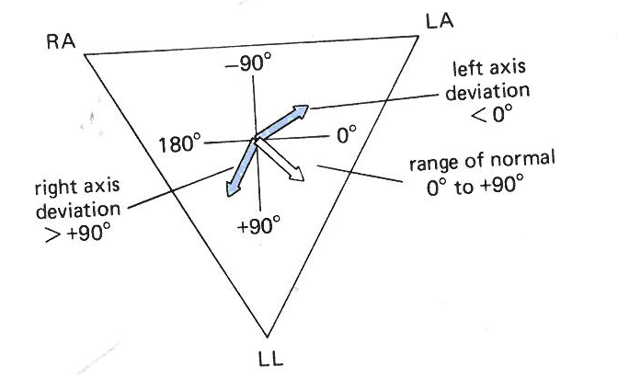
  - Can be determined from the electrocardiogram.
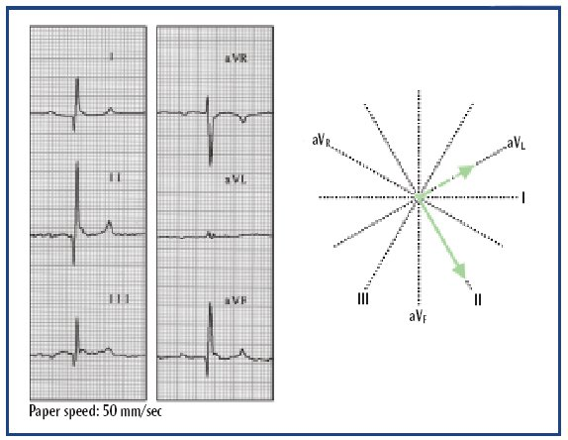
The mean electrical axis can be easily identified when an isoelectric lead is present. Examination of this ECG indicates that lead aV_{L} is isoelectric. Lead II is perpendicular to aV_{L} and is predominantly positive. Therefore, the mean electrical axis is normal at +60 degrees.
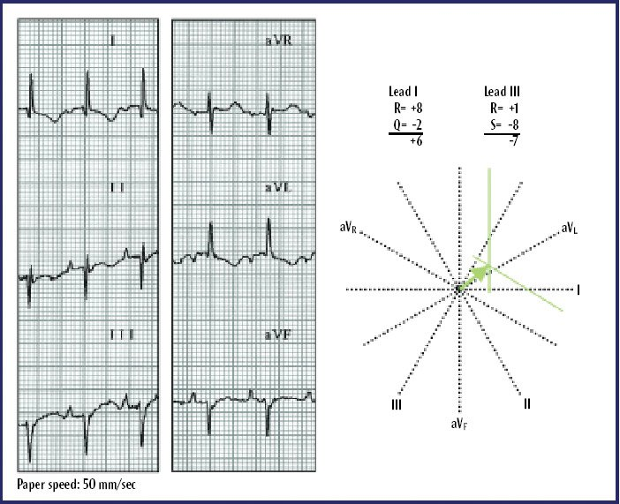
The mean electrical axis can be identified by graphing the net deflections of leads I and III. The positive deflections of the R waves are measured from the baseline (P-R segment). The negative deflections of the Q and S waves are similarly measured from the baseline. Perpendicular lines are drawn at +6 for lead I and -7 for lead III. Where the two perpendicular lines intersect is the mean electrical axis.
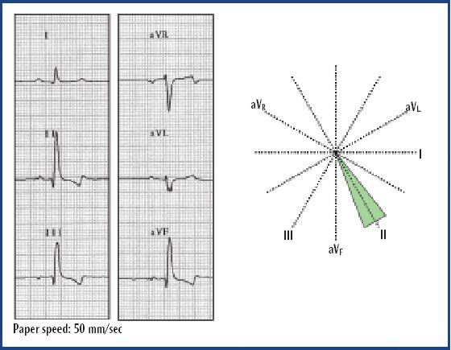
The approximate location of the mean electrical axis can be found by identifying the lead with the tallest R wave. The mean electrical axis will be within 30 degrees of the positive pole of this lead. In this ECG, lead II has the tallest R wave, indicating that the mean electrical axis is normal.
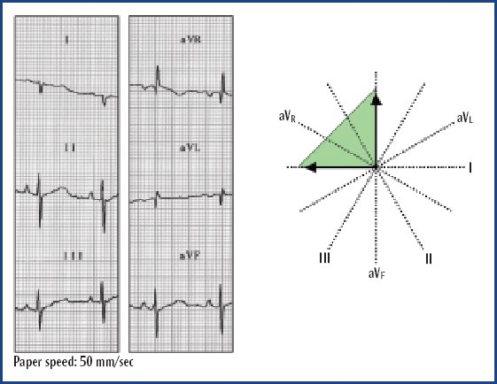
The mean electrical axis can be approximated by determining the quadrant that it lies within. In this ECG, lead I is negative, so the mean electrical axis must lie either in the upper or lower right quadrant. Lead aVF is also negative, so the mean electrical axis is in the upper right quadrant.

- The Standard 12-Lead Electrocardiogram
  - Three of these are the bipolar limb leads I, II, and III
  - The other nine leads are unipolar leads.
    - Three of these leads are generated by using the limb electrodes. Two of the electrodes are electrically connected to form an indifferent electrode while the third limb electrode is made the positive pole of the pair. Recordings made from these electrodes are called augmented unipolar limb leads.
    - Other six leads : These potentials are obtained by placing an additional (exploring) electrode in six specified positions on the chest wall. The indifferent electrode in this case is formed by electrically connecting the limb electrodes. These leads are identified as precordial or chest leads and are designated as V1 through V6
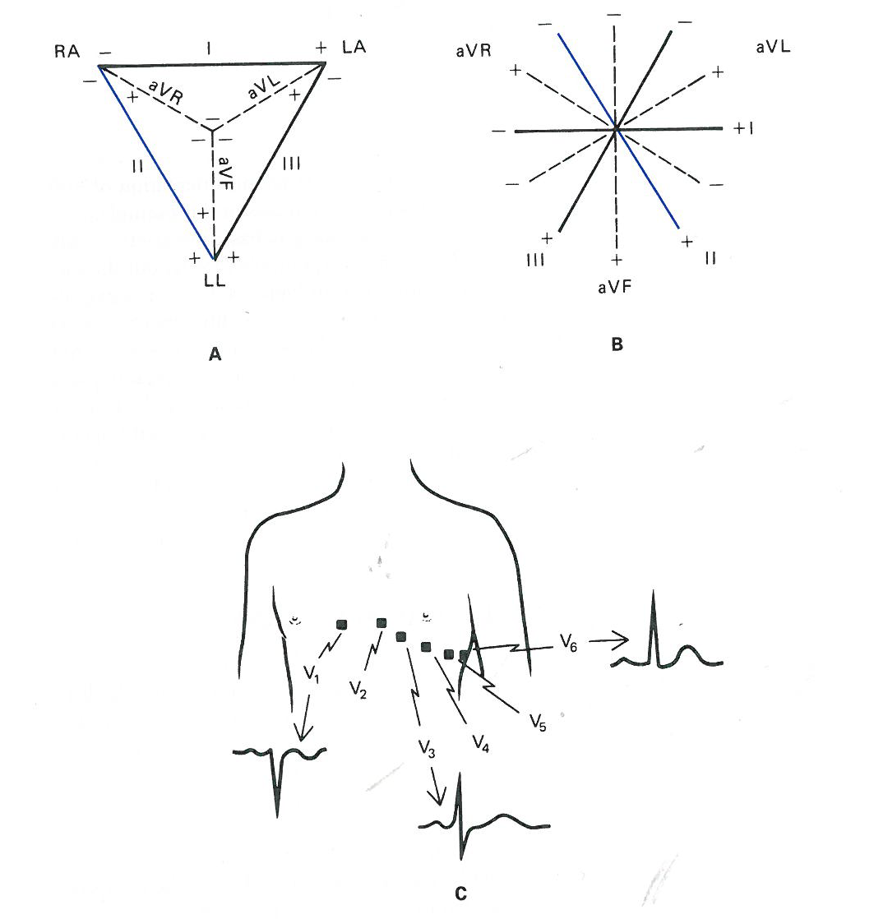
- The electrocardiogram is a record of the voltage changes that occur on the surface of the body as a result of the propagation of the action potential through the heart during a cardiac cycle.
- There are standardized conventions used for recording electrocardiograms.
- The magnitude and direction of the net dipole formed by the wavefront of the action potential at any instant in time can be deduced from the magnitude and orientation of the electrocardiographic deflections.
- The mean electrical axis describes the orientation of the net dipole at the instant of maximum wavefront propagation during ventricular depolarization.
- The standard 12-lead electrocardiogram is widely used to evaluate cardiac electrical activity and consists of a combination of bipolar and unipolar records from limb electrodes and chest electrodes.

QUESTIONS

- A decrease in AV nodal conduction velocity will
  - Decrease HR
  - Increase P wave amplitude
  - Increase the PR interval
  - Widen the QRS complex
  - Increase the ST segment duration

- The P wave on lead aVR on a normal ECG will be
  - An upward deflection
  - A downward deflection
  - Not detectable
  - Highly variable

- If the R wave is upright and equally large on leads I and aVF, what is the mean electrical axis of the heart ?

Answers :
1. c
2. b According to the standard ECG polarity conventions, the P, R, and T waves will normally all be downward deflections on lead aVR.
3. According to the electrocardiographic conventions, the electrical axis is at 45° and falls within the normal range (in the patient's lower left quadrant). The smallest amplitude deflection will occur on the lead to which the electrical axis is most perpendicular. Lead III and lead aVL are both within 15° of being perpendicular to 45° and therefore will have equally small deflections.

