LUPUS ERYTHEMATOSUS
- TRIAD
  - Etiology
    - Genetic factors
      - GSD
    - Hormonal factors
      - Unclear if sex bias exists
    - Environmental factors
      - UV light (UVA and UVB cause nuclear damage to basal cells nuclear antigen expression on the cell surface antibody and cell-mediated damage to epidermal cells), drugs, infective agents
  - Ethiopathogenesis
    - T-cell dysfunction
      - Lymphopenia is a feature of SLE
      - Cytotoxic/suppressor CD8+ cells are primarily affected; normal helper CD4+ activity
    - Polyclonal B-cell activation
      - B-cell overactivity, hypergammaglobulinemia, polyclonal activation
    - Cytokines
      - Th2 (humoral immunity) > Th1 (cell-mediated immunity and cytotoxicity)
      - Overproduction of IL-10
  - Pathogenesis
    - Immune complex-mediated damage
    - Direct damaging effects by autoantibodies
    - Functional effects of autoantibodies
Genetic/hormonal/environmental factors immune dysregulation large numbers of autoantibodies.

Diversity of antibodies/cross-reactivity with other autoantigens wide spectrum of CS

Damage to tissue bearing autoantigen or cross-reacting antigen
- Directly
- AB interfere with the function of the antigen
- Immune complex deposition
- Complement activation

SYSTEMIC LUPUS ERYTHEMATOUS (SLE) IN THE DOG
- Multisystem disease, varying signs, one or more signs simultaneously (the more the signs, the poorer the prognosis)
- No age, no sex predisposition, GSD overrepresented
- Insidious onset
- Dermatologic signs
  - 40-50% of cases
  - Variable: pruritic seborrheic dermatitis, mucocutaneous ulceration, loss of pigment (nose, periocular), erythema, crusting, alopecia, photosensitization, footpad lesions appearing as vasculitis-like lesions
  - SYMMETRY of the lesions
- Joint disease
  - 40-90% of cases
  - Arthritis is symmetrical, multiarticular, nondeforming, nonerosive
  - Sudden or insidious onset
  - Swollen and painful joints
  - XRAYS: minimal changes apart from ST swelling
- Hematologic changes
  - 30-60% of cases: anemia (IM or chronic disease)
  - 10-25%: thrombocytopenia
  - Leucopenia (*lymphopenia) or leukocytosis
- Renal disease
  - Glomerulonephritis (proliferative membranous glomerulonephritis)
  - Proteinuria in 50% of cases
- Ulcerative stomatitis
  - Buccal mucosa, hard/soft palate, tongue : 10-20% of cases
- Serositis
  - Pleuritis/pericarditis: 5-10%
- Neurologic signs
  - Polyneuropathy, convulsions, behavioral changes
- Other
  - Fever: 60-90% of cases (cyclical) – NOT antibiotic responsive, steroids responsive
  - Mild to moderate LNpathy, splenomegaly
- Serologic findings
  - SLE classically associated with autoantibodies to nuclear antigens
    - ANA by immunofluorescence = preferred test for routine use
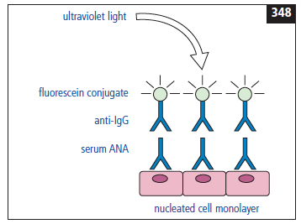
    - Positive titers found in normal dogs and in dogs with chronic disease (microbial/parasitologic)
  - People: ANA has activity against dsDNA
  - Dogs: testing for anti-dsDNA is no longer employed; anti-ssDNA is of no value
    - Histones (nucleoproteins associated with DNA)
      - Antihistone antibodies is highly correlated with a positive diagnosis of SLE (H4, H3, H2A, H2B)

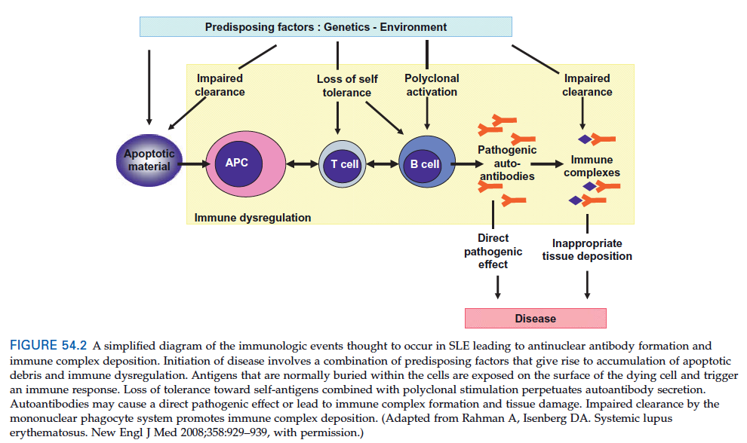
- Other antibodies:
  - Anti-extractable nuclear antigens (HnRNP = heterogenous nuclear ribonucleoprotein G)
- Diagnosis
  - Histopathology
    - Interface dermatitis (dermo-epidermal junction)
  - Direct immunofluorescence or immunohistochemistry linear deposits of immunoglobulin and complement at the dermo-epidermal junction
  - Dx of exclusion
  - Criteria for Diagnosis of Canine SLE – adapted from American Rheumatism Association Criteria
    - At least 4; if 3: probable SLE (or if polyarthritis and positive ANA)
    - Criteria: erythema, discoid rash, photosensitivity, oral ulcers, arthritis, serositis, renal disorders, neurologic disorders, hematologic disorders, immunologic disorders, ANA
- Clinical management
  - Oral glucocorticoids – pred 2-4 mg/kg/day, +/- azathioprine, chlorambucil
  - Plasmapheresis
  - Levamisole: anthelminthic drug, used as an immunoadjuvant that stimulates T cell responses. Probably enhances suppressor cell function.
  - Prognosis: guarded

SYSTEMIC LUPUS ERYTHEMATOUS (SLE) IN THE CAT
- 50% of cases have dermatologic manifestations (seborrheic skin disease, exfoliative erythroderma, erythema, crust, scaling lesions, SYMMETRICAL, *face and ears*)
- Glomerulonephritis, hemolytic anemia – 50% of cases
- Neuro signs more commonly seen in cats vs dogs – 50% of cases
- Fever, LN, thrombocytopenia, buccal or mucocutaneous ulcers
- Same diagnostic criteria used for the dog; high titers ANA in cats with feline viral diseases; interface dermatitis
- Corticosteroids, +/- chlorambucil, cyclophosphamide
- Guarded prognosis

DISCOID LUPUS ERYTHEMATOSUS
- Cats: rare, rare nasal involvement, more face and ears
- Dogs: Relatively benign, UV light
  - Depigmentation of nose, loss of normal cobblestone architecture, erythema, scaling, erosions, ulceration, crusting
  - Lesions at the junction between nasal planum and haired skin, along ventral or medial aspects of alar folds, sometimes ears, periocular region
  - DX: histopath: similar to SLE, immunofluorescence, immunohistochemistry, ANA usually negative
  - DDX: dermatomyositis, uveodermatologic syndrome, contact dermatitis, SLE
  - Prognosis: good
  - TX: avoid UV, steroids, tetracycline-niacinamide, vitamin E, E.F.A., tacrolimus, topical corticosteroids

VESICULAR CUTANEOUS LUPUS ERYTHEMATOSUS
- Shetland sheepdogs, rough collies
- Ulcerative lesions, ventrum, focal to confluent serpiginous areas of ulceration
- Interface dermatitis
- Middle-aged to older, summer, UV, mucocutaneous jct often affected, concave aspect of pinnae/buccal mucosa, painful, NONpruritic
- DX: IHC, IF, ANA negative
- TX: steroids, +/- azathioprine, antibiotic when extensive ulceration present

EXFOLIATIVE CUTANEOUS LUPUS ERYTHEMATOSUS
- Autosomal recessive
- Young adult
- Scaling, alopecia (muzzle, pinnae, dorsal trunk limbs, ventral trunk), +/- ulceration, crustin, LN, fever
- Pain
- Thrombocytopenia in 25% of cases
- Interface dermatitis, involvement of sweat and sebaceous glands (similar to sebaceous adenitis), ANA negative
- TX: steroids, difficult to manage long-term, IVIG (people)
- PX: guarded

QUESTIONS
- What are the 3 categories of factors that may contribute to the immune dysregulation that may lead to the development of lupus?

- Which of the following is the most common presenting sign in canine SLE?
  - Mucocutaneous ulcerations
  - Polyarthritis
  - Anemia
  - Glomerulonephritis

- True or False: Neurologic signs are seen more commonly in cats with SLE than in dogs with SLE

QUESTIONS & ANSWERS
- What are the 3 categories of factors that may contribute to the immune dysregulation that may lead to the development of lupus? Environmental, genetic, hormonal

- Which of the following is the most common presenting sign in canine SLE?
  - Mucocutaneous ulcerations
  - Polyarthritis
  - Anemia
  - Glomerulonephritis

- True or False: Neurologic signs are seen more commonly in cats with SLE than in dogs with SLE

