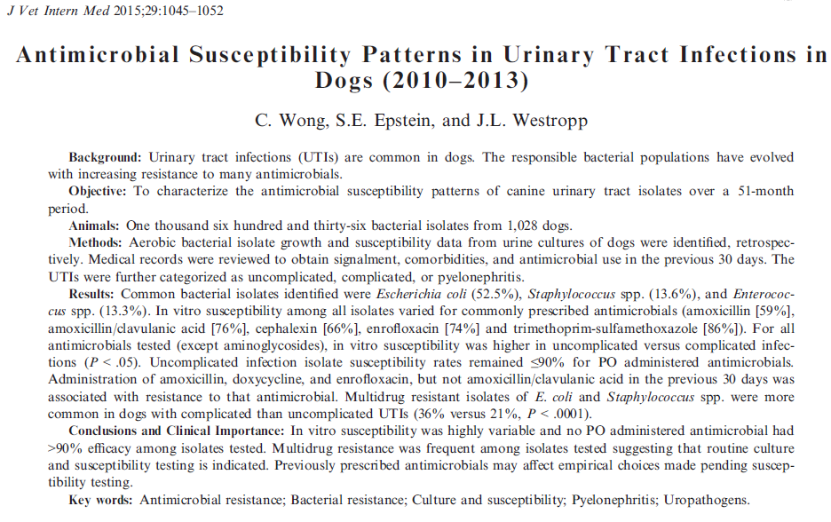
Design: Retrospective Study

Setting: Davis University

Population: 1636 bacterial cultures from 1028 dogs

Intervention:
- Positive urine cultures with susceptibilities were identified between 2010-2013
- They were classified into uncomplicated, complicated or pyelonephritis
- Antimicrobials given within the past 30 days were recorded

Results/Outcome:
- 64.3% were >7yr old, 30.4% between 1-7 years, 5.2% <1yr, 74% females (66.5 % spayed females)
- 64.6% were considered complicated UTIs, 35.5% uncomplicated, 7.7% pyelonephritis
- Most common comorbidities: immune suppression 34.7%, renal disease 30.4%, anatomic abnormalities 25.3%
- 68.9% were gram negative (94% enteric), E. coli was the most common isolate, then Staphylococcus
- Complicated UTIs and pyelonephritis were more likely to be resistant to Amoxi/Clavulanic

Take Home Message:
- Routine culture and susceptibility is recommended in all cases suspicious of UTI
- If patient has been on antibiotics in the past 30 days, drug resistance is likely

14% of dogs will have a UTI in their lifetime. Incidence in females is 26.6% and 6.2% in males.
Urinary Tract Infection Classification:
- Simple Uncomplicated: sporadic bacterial infection in a healthy individual
- Complicated: UTI in the presence of an anatomic or functional abnormality, or in the presence of a comorbidity that predisposes to an infection, recurrent infection or treatment failure, pyelonephritis
Empirical antibiotic treatment is common, urine cultures should be performed if possible as they may guide antimicrobial choice, and decrease antimicrobial resistance.
Multi Drug Resistance: resistance to ≥3 antimicrobial classes

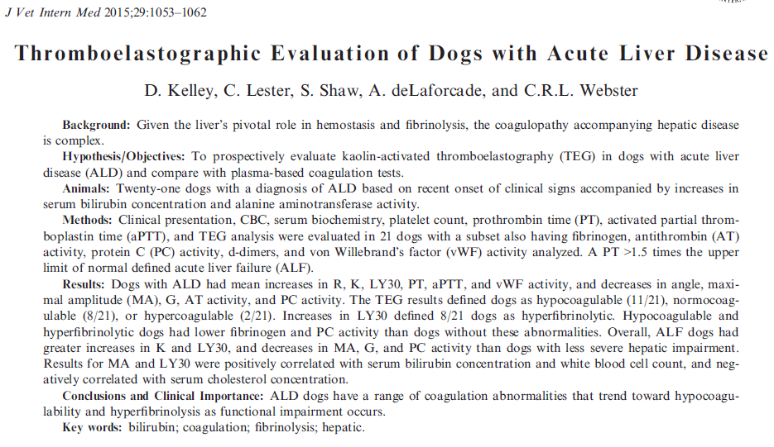
Design: Prospective Study

Setting: Tufts University

Population: 21 dogs with ALD (DX by clinical signs and acute increase in bilirubin and ALT)
- Inclusion Criteria: acute onset clinical signs <1 month, ↑Bili, ↑ALT >3x normal
- Exclusion Criteria: drugs (steroids, NSAIDs, Fish oil, Vit K, antiplatelet, anticoag), comorbidities with coagulation derangements
- Acute Liver Failure: defined as ALD + PT >1.5x

Intervention:
- At admission: CBC, Chemistry, TEG, platelet count, hemostatic testing

Results/Outcome:
- ALD dogs had ↓ platelet count and AT activity, and ↑ PT/aPTT and vWF activity
- All dogs had ↑ Bili, ALT, AST
- ALD dogs had ↓ angle, MA and G and significant ↑ in R and LY30
- Most dogs were found to be hypocoagulable (11/21) or normocoagulable (8/21) on TEG
- TEF was discordant with conventional coag testing 25% of the time
- ↑ WBC correlated with LY30, suggesting inflammation affects the hyperfibrinolytic state
- Limitations: heterogenous etiologies, few liver biopsies were performed

Take Home Message:
- ALD dogs tend to be hypocoagulable and have hyperfibrinolysis
- ALD dogs should have a TEG evaluated if available for transfusion decision
- Plasma based Coag tests overestimate ↓ coagulation in early ALD
Liver is involved in hemostasis (synthesis, clearance of procoagulants, anticoagulants and regulators of fibrinolysis).
- In humans, patients with acute liver disease (ALD), unless PT/PTT are markedly prolonged, these are not considered accurate predictors of bleeding. These may lead to overestimating bleeding risk for FNA or liver biopsy and lead to administration of costly and potentially harmful plasma transfusions.
- ALD patients are considered to balance their coagulation appropriately, they decrease synthesis of procoagulants factors balanced by their loss of anticoagulants.
- In the face of comorbidities such as infection, SIRS or neoplasia, this balance may shift.
- Hypercoagulability in ALD in humans has been associated with increases in fibrinogen concentration and evidence of endothelial dysfunction
TEG evaluation has been used to guide transfusion requirements and has been shown to decrease use of blood products, increase patient survival in humans and is more reliable than PT in predicting GI rebleeding and sepsis-induced hypocoagulability.
TEG:
- R: measure of initial fibrin formation
- K: clot formation time
- Angle: rapidity of fibrin cross-linking
- MA: clot firmness
- LY30: % clot lysis 30 min after MA is reached
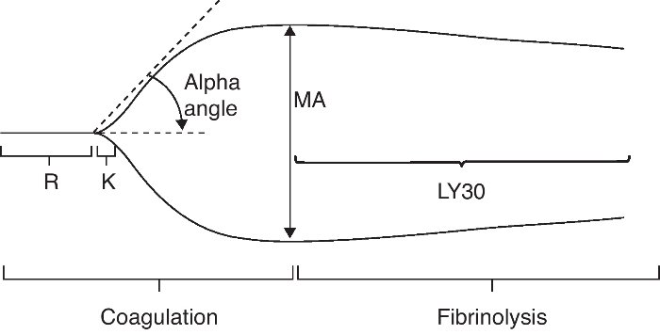

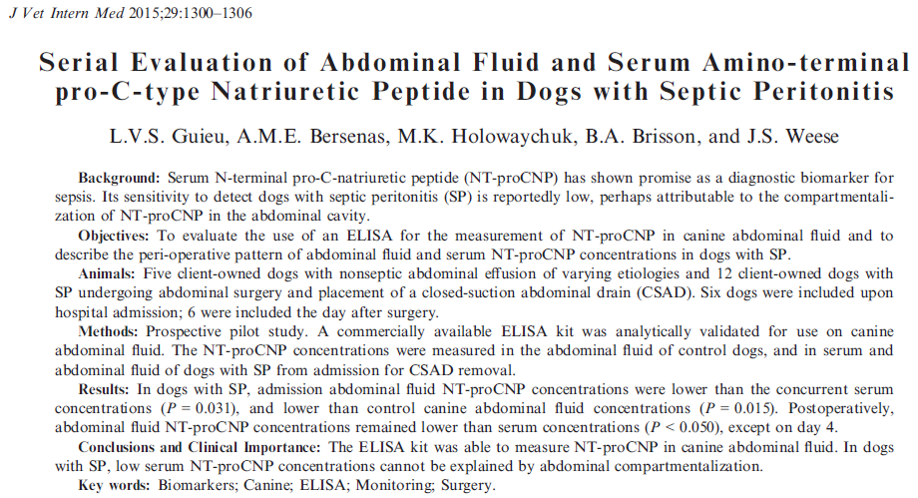

Design: Prospective Pilot Study

Setting: University of Guelph

Population: 5 dogs with non-septic abdominal effusion, 12 dogs with septic abdomen

Intervention:
- Control group: dogs with non-septic abdominal effusion, effusion was collected for testing
- Septic peritonitis dogs that underwent abdominal surgery and placement of closed-suction abdominal drain (CSAD), effusion was collected on presentation and every day until drain removal
- NT-proCNP commercial ELISA kit was used to evaluate effusion and serum

Results/Outcome:
- Septic abdomen dogs had lower abdominal NT-proCNP than serum and control dogs
- Previous abdominal sx (66%), antibiotics on board (83%) may affect these values
- Lower effusion rates had ↑ NT-proCNP, as day progressed these values increased, dilutional effect?

Take Home Message:

- NT-proCNP can be measured on abdominal effusion, more studies are needed to know the importance of these values in potential sepsis, cardiac and liver disease
- Abdominal compartmentalization was not identified
Amino-terminal Pro-C-type Natriuretic Peptide (NT-proCNP) is a stable product of the cleavage of C-type natriuretic peptide (CNP), which is a biomarker for sepsis.
- NT-proCNP participates in vascular homeostasis, modulates inflammation in vascular walls
- Secretion is enhanced by LPS, pro-inflammatory cytokines (TNFα, IL-1β)
- May be useful to predict sepsis in trauma and critically ill patient
- NT-proCNP cutoff of 10.1 pmol/L to differentiate dogs with heterogeneous sources of sepsis with noninfectious SIRS (NSIRS), sensitivity 65%, specificity 89%
- Dogs with septic peritonitis had low serum NT-proCNP compared to NSIRS or healthy dogs, this may be due to NT-proCNP being concentrated in the abdominal effusion rather than in the blood stream – “Compartmentalization”
- Cardiac and Liver disease has shown to have higher serum NT-proCNP, in this study the controls which had higher values had cardiac disease, liver tumor and portosystemic shunt

