JVECC - april


Key Points:
- No major prognostic indicators were found
- Survival rate for recurrent septic peritonitis is 44%
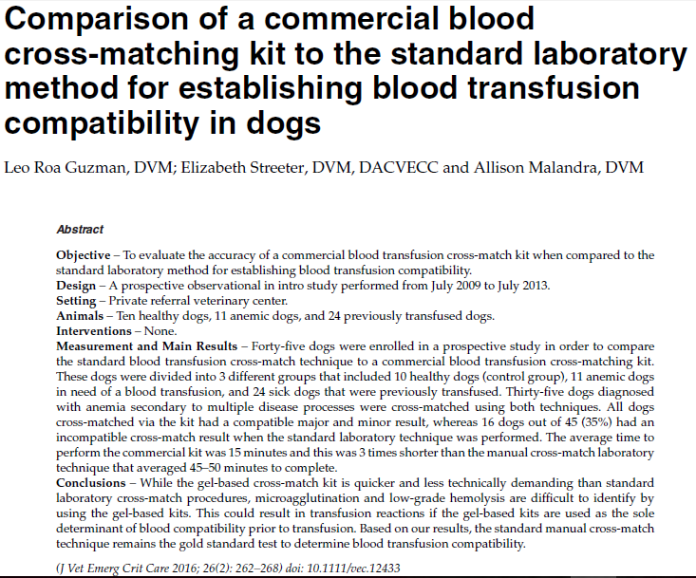
Key Points:
- Sixteen dogs out of 45 (35%) had some degree of agglutination that was not observed on the commercial crossmatch kit; suggesting there was not good agreement for the results between the standard laboratory cross-match and the commercial kit cross-match

