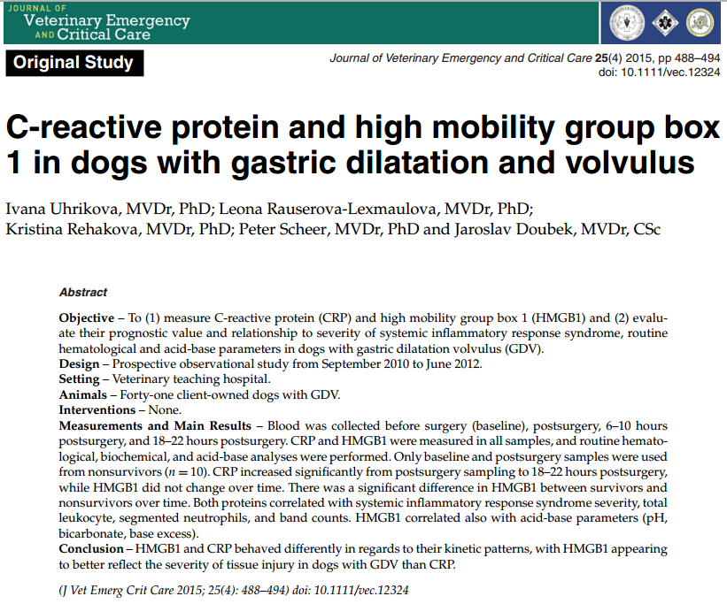
Key points:
- One mechanism of inflammation and damage is binding to TLR4, which mediates HMGB1-dependent activation of macrophage cytokine release.
- CRP binds to the phosphocholine expressed on the surface of dead or dying cells and some bacteria. This activates the complement system, promoting phagocytosis by macrophages, which clears necrotic and apoptotic cells and bacteria. Results in elevated levels of IL-6
- Initial HMGB1 values may be reflective of the degree of tissue damage found at surgery. Both parameters correlated only mildly with SIRS severity at the admission

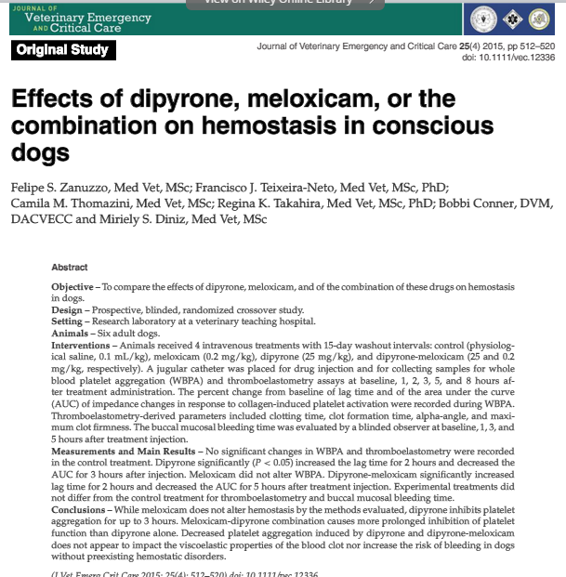
Key Points:
- Meloxicam did not inhibit whole blood platelet aggregometry
- Should not majorly affect risk of bleeding in normal patients

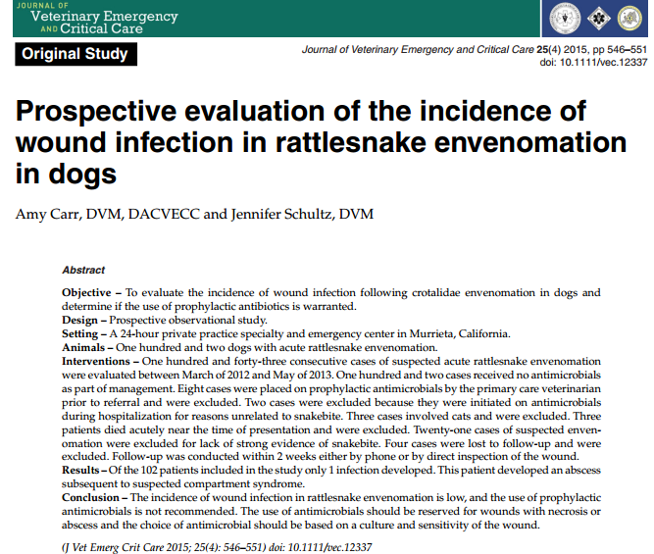

Key Points:
- 102 dogs included in a prospective study
- None received antimicrobials
- Only 1 patient developed an abscess at the bite site. Suspect secondary to compartment syndrome and necrosis at that area.

