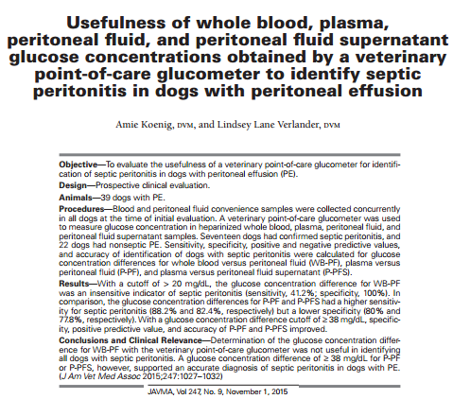
- 100% Sensitivity and Specificity for diagnosing septic abdomen via glucose uses laboratory BG analyzers, NOT POC tests
- When POC test is used, 100% specificity remains, but sensitivity drops to 41.2%
- Using plasma instead of whole blood and 38mg/dL difference improves sensitivity, specificity, PPV, and NPV
  - This due to the fact that cells in whole blood interfere with POC analyzers

