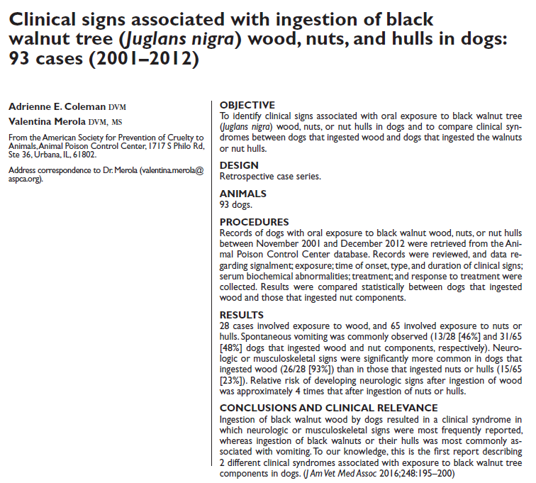
- Black walnut trees (Juglans nigra) are commonly found throughout eastern North America.
- November 2001 - December 2012, 93 dogs, 28 (30%) dogs ingested black walnut wood or wood shavings, and 65 (70%) ingested the walnuts or hulls.
- 100% of the dogs showed clinical signs
- Time to onset of clinical signs ranged from 0.17 to 19 hours after the exposure was observed
- Vomiting, if present, <1 hour after exposure.
- Neurologic or musculoskeletal signs in 93%, associated to ingestion of black walnut wood
- Vomiting was more associated with black walnuts and walnut hull
- Mechanism of Action: unknown, “Juglone” extract can produce sedation in fish, rats, rabbit, also a known substrate for growth of tremorgenic mycotoxins
- Good prognosis with or without treatment

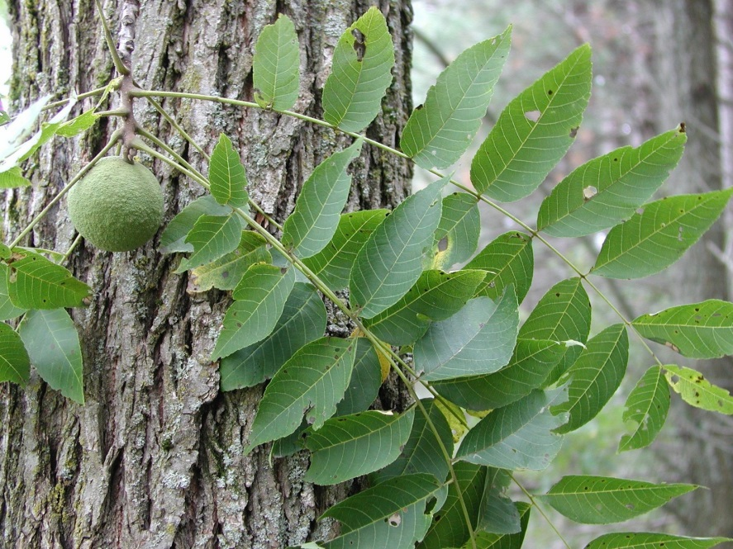

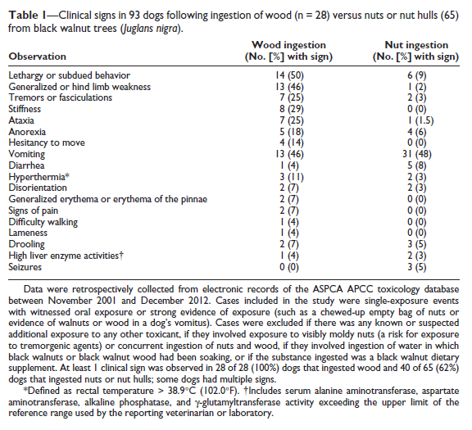

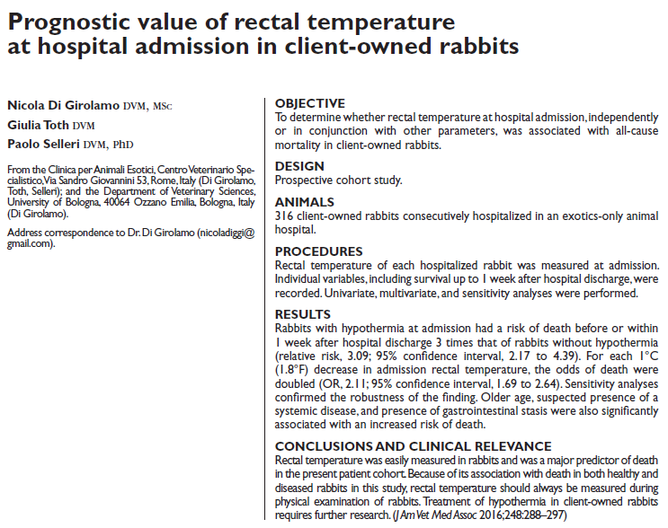
- Primary outcome of interest was the presence of an association between rectal temperature and all-cause mortality (defined as death before or within 1 week after
hospital discharge)
- After bunny was acclimated, bunny was cradled on its back with the hind end supported, and a second operator inserted the thermometer
- (>100.4° and <103.8°F) was considered normal, hypothermia was defined as a rectal temperature 37.9°C, predictor of death
- 2 other factors were associated with mortality, suspicion of systemic disease and no defecation noted in > 12hr, which doubled the odds of dying compared to those that had defecated within 12hr
- Hyperglycemia has also been associated with poor outcome in bunnies, hyponatremia <129, increases mortality by 2.3 fold

