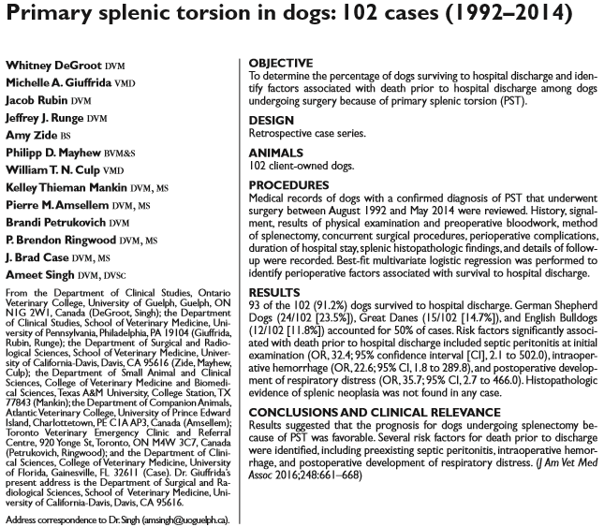

- Primary Splenic Torsion (PST) occurs when spleen roatates around the gastroplenic and phrenicosplenic ligaments, usually male large or giant, deep chested dogs (Great Danes, GSD)
- Acute PST: severe abdominal pain, weakness, cardiovascular collapse
- Chronic PST: vomiting, lethargy, weakness, abdominal pain, hematuria, diarrhea
- Cause: unknown, maybe due to absence or weakness of splenic ligaments or acquired laxity from surgery or GDV
- Gastropexy is recommended after splenectomy from PST
- On presentation: 70% palpable splenomegaly, 30% hemoperitoneum, 22% hypovolemic shock, 8% septic peritonitis, 10% VPCs
- Most common complications: Anemia 13%, VPCs 12%
- Three perioperative risk factors were identified as increasing the risk of death prior to hospital discharge (presence of septic peritonitis at initial examination, intraoperative hemorrhage, and postoperative development of respiratory distress)
- Coagulation parameter monitoring for DIC is recommended
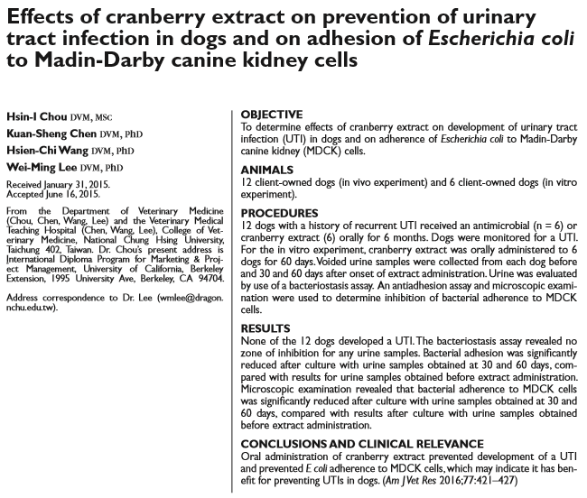
- E. coli have proteinaceous macromolecules (fimbrae) that facilitate adhesion of bacteria to uroepithelial cells
- In vitro and in vivo studies indicate that cranberry products prevent bacterial adhesion to cells in the wall of the urinary tract
- Bacteriostasis assay revealed no inhibition zone around the urine samples and negative control sample, whereas the positive control sample (enrofloxacin) had an antibacterial effect (diameter of inhibition zone > 30 mm), indicated 2 possibilities: the concentration of bacteria was too high for the cranberry extract to inhibit growth, or the urine samples from dogs receiving cranberry extract had no bacteriostatic activity
- Cranberry compounds act as receptor analogues and bind to the fimbriae of E coli, which competitively inhibits their adhesion and may also reduce adhesion capabilities, reducing fimbrial length and density, or inducing other morphological change
- Decreases risk of antimicrobial resistance and superinfection in patients with E.coli UTI

