Intraventricular Conduction Defects or Ventricular Aberrancy
- Bundle of His divides into left and right bundle branches
- Left bundle branch further divides into anterior and posterior fascicles
- Most common in dogs:
  - Right bundle branch block (RBBB)
  - Left bundle branch block (LBBB)
- Most common in cats:
  - Left anterior fascicular block (LAFB)

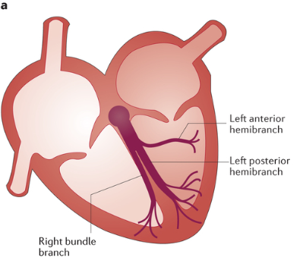
Right Bundle Branch Block
- Depolarization of the left ventricle occurs normally
- Depolarization of the right ventricle is either slow or not present producing a prolonged complex
ECG Characteristics
- QRS is prolonged, deep
- Slurred S waves in I, II, III and aVF
- Positive in aVR and aVL
- Differential is right ventricular enlargement
- MEA is to the right
- Sometimes a split second heart sound (S2) may be heard from delayed closure of pulmonic valve
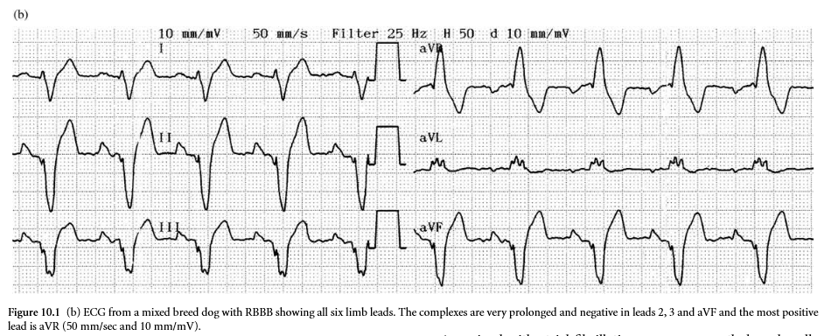
Left Bundle Branch Block
- Depolarization of the right ventricle occurs normally
- Depolarization of the left ventricle is either slow or not present producing a prolonged complex
ECG Characteristics
- QRS is prolonged, deep
- Positive waves in I, II, III and aVF
- Negative in aVR and aVL
- Differential is left ventricular enlargement

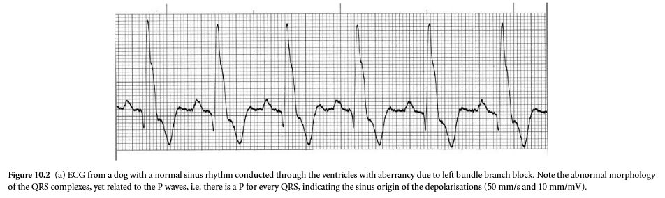

Left Anterior Fascicular Block
- Occurs due to failure of conduction through the anterior fascicle of the left bundle branch
- Not uncommon in cats, rare in dogs
ECG Characteristics
- QRS is normal
- Tall R waves in I, aVL
- Deep S waves (>R waves) in II, III, and aVF
- MEA is to the left
- In cats afib may be concurrent with fascicular block
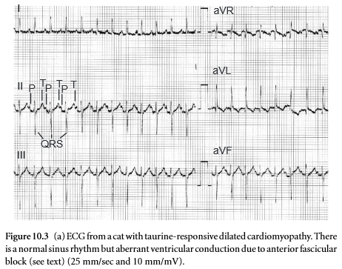

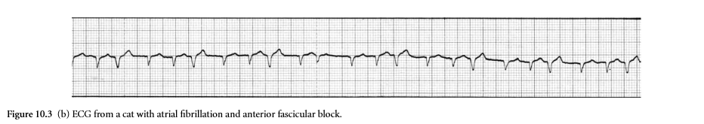

Intermittent Ventricular Aberrancy
- Occurs when a supraventricular premature depolarization reaches the bundle branch before one or other has fully repolarized (usually the right bundle branch), resulting in a functional block
- QRS is premature and bizarre in shape, mimicking a VPC
- SVT with aberrant ventricular contraction can mimic V tach – this is called Broad Complex Tachycardia

ECG Characteristics
- QRS is bizarre, prolonged and premature
- RBB morphology
- Similar to a VPC
- A preceding p wave (may be hidden by previous T wave) can help confirm it is a supraventricular complex
- Sounds like premature beat, pulse deficits

