Inhibitors of the renin-angiotensin-aldosterone system
- ACE inhibitors act on the crucial enzyme that generates angiotensin II and mediates the breakdown of bradykinin
- 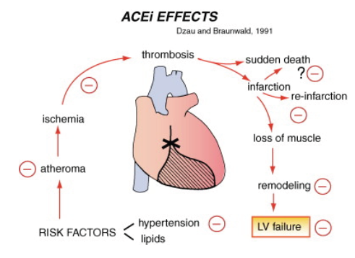
- Angiotensin II is formed from its precursor, a decapeptide angiotensin I, by the activity of the ACE
- ACE activity is found chiefly in the vascular endothelium of the lungs, but occurs in all vascular beds, including the coronary arteries
- Angiotensin I originates in the liver from angiotensinogen under the influence of the enzyme renin, a protease that is formed in the renal juxtaglomerular cells
- Classic stimuli to the release of renin include
  - (1) impaired renal blood flow as in ischemia or hypotension
  - (2) salt depletion or sodium diuresis
  - (3) β-adrenergic stimulation
- ACE not only converts angiotensin I to angiotensin II, but also inactivates the breakdown of bradykinin
- Not all angiotensin II is generated by ACE. Non-ACE pathways, involving chymaselike serine proteases, can also form angiotensin II, but their exact role is still the subject of controversy
- Occupation of the angiotensin II receptor stimulates the phosphodiesterase (called phospholipase C) that leads to a series of signals that activate a specialized enzyme, protein kinase C, that in turn evokes the activity growth pathways that stimulate ventricular remodeling
- There are at least two angiotensin II receptor subtypes, the AT-1 and AT-2 receptors
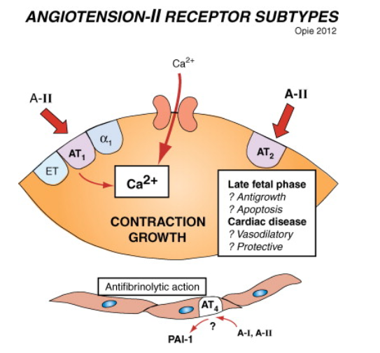
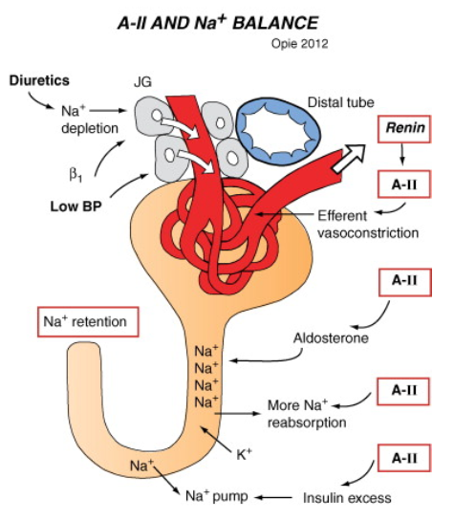
- Aldosterone, released either in response to angiotensin II or to stimulation by adrenocorticotropic hormone (ACTH) or increased potassium, has major effects on electrolyte balance
- Aldosterone acts on the distal tubule to retain sodium and excrete potassium by inhibition of sodium-potassium exchange
- Water is retained with sodium
Enalapril
- In people Enalapril is approved for hypertension, heart failure, and to decrease the development of overt heart failure in asymptomatic patients with LV dysfunction
- Approximately 60% of the oral dose is absorbed with no influence by meals
- Enalapril is deesterified in the liver and kidney to the active form, enalaprilat
- Cough is most common side effect in people, as for all ACE inhibitors
Benazepril is rapidly converted to an active metabolite, benazeprilat, with an elimination half-life of 22 hours in people.
Questions:
- Classic stimuli to the release of renin include …… list 3

- What are the major stimuli for release of aldosterone

Answers
- Classic stimuli to the release of renin include …… list 3
  - (1) impaired renal blood flow as in ischemia or hypotension
  - (2) salt depletion or sodium diuresis
  - (3) β-adrenergic stimulation
- What are the major stimuli for release of aldosterone
  - Aldosterone, released either in response to angiotensin II or to stimulation by adrenocorticotropic hormone (ACTH) or increased potassium

