Clinical Management if Immune-Mediated Skin Diseases
- Immune mediated dermatoses have different prognoses, it is important to make a specific diagnosis
- Most diseases require more, stronger or a combination of drugs to put them into remission and less to keep the disease in remission

Phases of Treatment of Immune-Mediated Dermatoses
- Induction Phase
  - Goal is to stop inflammation and suppress immunologic attack against skin
  - Higher doses are normally needed
  - If induction therapy is not effective in a timely manner for the drug, treatment should be changes

- Transition Phase
  - Tapering drugs to minimize long term side effects, cost and risk of adverse reactions
  - This should be done when the disease and its side effects are controlled
  - Medications are slowly tapered until there is recurrence of clinical signs
  - If no recurrence is seen, case may be cured

- Maintenance Phase
  - Reached after recurrence or exacerbation of the disease
  - Medications are raised again to induce remission, these are the lowest dose that maintains the disease in remission
  - Tapering occurs after 1 year of maintenance

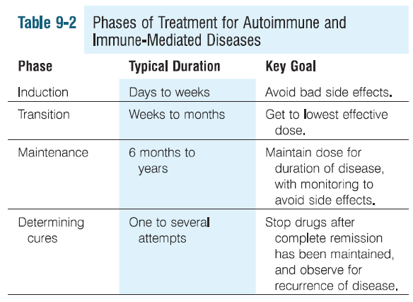
Drugs for Immune-Mediated Dermatoses
Azathioprine 50 mg/m² or 1.5-2.5 mg/kg PO q 24 hours initial dose
- Antagonizes purine metabolism → interferes with DNA and RNA synthesis
- Affects rapidly proliferating cells, greatest effect on cell mediated immunity and T lymphocyte-dependent antibody synthesis
- Toxicity: anemia, leukopenia, thrombocytopenia, vomiting, diarrhea, hypersensitivity reactions, pancreatitis, elevated ALKP, rash and alopecia
- 90% cases develop mild anemia and lymphopenia that does not require discontinuation of the drug
- Cats are more susceptible to toxicity (fatal leukopenia and thrombocytopenia)
- Long term has been associated to demodicosis, recurrent bacterial pyoderma or dermatophytosis in 10% cases
- CBC q 2 weeks initially, until patient’s condition is stable, the CBC q 4 months for 3 months, then CBC/Chem q 6 months
- Usually given with glucocorticoids
- Indications: pemphigous foliaceous

Chlorambucil 0.1-0.2 mg/kg PO q 24-48hr
- Alkylates and cross-links DNA during all phases of the cell cycle, inducing DNA damage
- Toxicity: myelosuppresion (rare), vomiting and diarrhea with daily doses (improves q EOD), alopecia and delayed hair growth after clipping
- Poodle and Kerry Blue Terriers are at higher risk for toxicities
- CBC q 2-4 weeks
- Takes several weeks to produce beneficial effects, tapering to EOD or less after
- Usually given with glucocorticoids in the induction phase
- Indications: Pemphigus complex, bullous pemphigoid, discoid and systemic lupus erythematosus, immune-mediated vasculitis, cold agglutinin disease, lymphocyte and plasma cell malignancies

Colchicine 0.03 mg/kg PO q 24 hours
- Alkaloid, suppresses neutrophil chemotactic and phagocytic functions by disrupting microtubule assembly and elongation
- Increases cAMP and inhibits lysosomal degranulation
- Inhibits immunoglobulin secretion, IL-1 production, histamine release
- Do NOT use with NSAIDs as may cause bone marrow suppression
- Do not use with Azathioprine and Chlorambucil, cytochrome P450 inhibitors, P-glycoprotein pump inhibitors
- Indications: Epidermolysis bullosa acquisita, junctional epidermolysis bullosa, amyloidosis, Shar-Pei fever syndrome
Cyclophsophamide
- Alkylating agent, inhibits mitosis by intervening with DNA replication and RNA transcription and replication
- Lymphocytes are very sensitive, more effective on B cells than T cells
- Suppresses antibody production
- Toxicity: hemorrhagic cystitis (30% dogs for more than 2 months therapy, may be decreased with concurrent furosemide therapy), bladder fibrosis, teratogenesis, infertility, alopecia (cats may lose whiskers), poor hair growth, nausea, GI inflammation, immunosuppression, myelosuppresion.
- Used alone or in combination with other immunosuppressives
- Usually used in the induction phase, takes month to work

Mycophenolate Mofetil 10-20 mg/kg PO, IV q 12 hours
- Inhibits novo purine synthesis, suppresses T and B lymphocytes maturation
- Induces T cell apoptosis, decreases IL-1 expression
- Toxicity: myelosuppresion, nausea, vomiting, diarrhea, immunosuppression, pyoderma, malassezia infection
- Indications: canine pemphigus foliaceous

Tetracycline and Niacinamide
- Tetracycline: anti-inflammatory and immunomodulatory , suppreses in vitro lymphocyte blastogenic transformation and antibody production, inhibition of MMP, downregulation of cytokines, suppression of leukocyte chemotaxis, inhibition of lipase and collagenases, etc.
- Niacinamide: block antigen IgE induced histamine, prevent degranulation of mast cells, cytoprotectant by blocking inflammatory cell activation and apoptosis
- Indications: use in combination for discoid lupus erythematosus, pemphigusfoliaceous, idiopathic onychodystrophy, G shep metatarsal fistulae, sterile panniculitis, sterile granulomatous/pyogranulomatous dermatitis, vasculitis

Questions
- An 8 year old SF Shar Pei presents to the ER for superficial bite wounds on the right fore limb. The wounds are superficial and the remainder of her physical exam is unremarkable. She has a previous history of swollen hocks, recurrent fevers and is on Colchicine, however has not had any of these signs in several months. What considerations should you have for her treatment and recheck plan?

- T or F: Cats are very susceptible to azathioprine toxicity, they can develop fatal anemia and thrombocytopenia

- Name the 3 phases of treatment of immune mediated diseases

Questions
An 8 year old SF Shar Pei presents to the ER for superficial bite wounds on the right fore limb. The wounds are superficial and the remainder of her physical exam is unremarkable. She has a previous history of swollen hocks, recurrent fevers and is on Colchicine, however has not had any of these signs in several months. What considerations should you have for her treatment and recheck plan?

NSAIDS can interact with Colchicine, use alternative pain meds.
Colchicine is immunosuppressive, broad spectrum antibiotics (amoxi/clavulanic) may be better than cefazolin
Recheck with rDVM within a week to monitor if additional antibiotics are needed, and if recurrence of shar pei fever, since can be triggered by stress

T or F: Cats are very susceptible to azathioprine toxicity; they can develop fatal lymphopenia and thrombocytopenia

Name the 3 phases of treatment of immune mediated diseases:
- Induction
- Transition
- Maintenance

