Hypertrophic Cardiomyopathy
Disease of the ventricular myocardium (primarily LV), characterized by mild to severe thickening (concentric hypertrophy) of the papillary muscles and ventricular walls.
Signalment
- 6 months – 16 years
- Males > Females
- Maine Coons – simple autosomal dominant trait
- Other likely breeds; Persian, British Shorthair, Norwegian Forest, Ragdoll, Turkish van and Scottish fold
- Domestic cats however are the most commonly identified – de novo mutation/unknown disease process
Clinical Signs and Presenting Complaints
- Tachypnea
- Dyspnea
- Pulmonary edema
- Pulmonary effusion
- Thromboembolism
- Sudden death
Pathophysiology
- Primary unknown etiology (secondary causes may include hyperthyroidism and hypertension)
- Enlarged papillary muscles and a thick LV myocardium with a normal to small LV chamber
- Changes can be (mild, moderate, severe) or (symmetrical, asymmetrical)
- Severity produces increased chamber stiffness
- Blood flow to thickened myocardium is compromised →myocardial ischemia → cell death → replacement fibrosis→ more chamber stiffness → diastolic dysfunction
- Stiff chamber causes increased diastolic intraventricular and LA pressure → enlarged LA → CHF
- Concentric hypertrophy → decreased afterload due to decrease in end-systolic volume, often to zero (cavity obliteration)
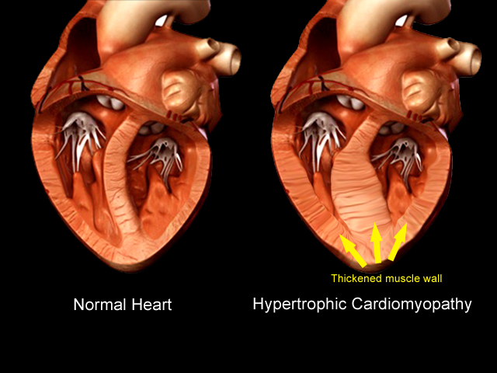
- Systolic Anterior Motion of the mitral valve can be produced in these cases due to abnormal papillary muscle orientation and other unexplained factors
- SAM produces a dynamic subaortic stenosis that increases systolic intraventricular pressure in mid to late systole, present in 67% HCM cats
- Dynamic subaortic stenosis increases the velocity of blood flow through the subaortic region producing turbulence → septal leaflet is pulled toward the interventricular septum, leaving a gap on the mitral valve producing mild to moderate mitral valve regurgitation
- SAM → common cause of murmur in HCM cats
https://www.bing.com/videos/search?q=systolic+anterior+motion+cat&&view=detail&mid=793B41DFF5ECA51975EB793B41DFF5ECA51975EB&FORM=VRDGAR
- Pleural effusion is common in feline heart failure: proposed mechanism is through increased pulmonary vein pressure that leads to increased visceral pleural veins → pleural effusion
Echocardiography
- Several different two dimensional views should be examined and wall thickness during diastole should be from the thickest region or regions should be measured
- M-mode may miss regional thickening unless guided by two dimensional
- Enlarged left atrial indicates increased LV end-diastolic pressure
- Thrombus may be noted in the LA
- SAM can be noted on two-dimensional, M-mode or color Doppler
- Diastolyic dysfunction may be documented using Doppler tissue imaging and measures of transmitral flow and relaxation time
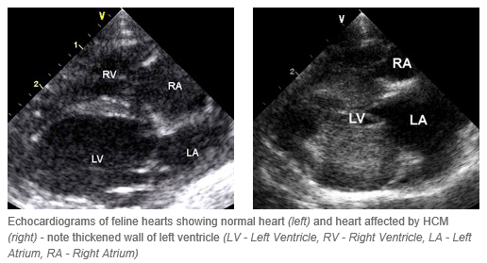
https://www.youtube.com/watch?v=KvUFb4qZwmw

Therapy
- Diuretics i.e. furosemide, ACE inhibitors
- Rate control i.e. atenolol
- Calcium channel blockers i.e. diltiazem
Prognosis
- Asymptomatic cats with mild to moderate hypertrophy and no LA enlargement have a good long-term prognosis 4-6 years
- Cats in heart failure→ median survival time 3 months, if respond well to treatment may be longer
- Aortic thromboembolism→ poor prognosis, median survival time 2 months
- Sudden death can always occur

Questions
- T or F: All cats with HCM have a murmur

- Explain how systolic anterior motion of the mitral valve occurs

- If a patient presents with 1st time CHF due to HCM, what prognosis and complications should be discussed with the owner?

- Why does pleural effusion occur in cats with heart failure?

Questions
- T or F: All cats with HCM have a murmur Only if they have SAM

- Explain how systolic anterior motion of the mitral valve occurs and how frequently this occurs in cats
Due to abnormal papillary muscle orientation, a dynamic subaortic stenosis occurs, increasing velocity and turbulence, this leads to pulling of the septal leaflet producing mild to moderate mitral regurgitation. Occurs in 67% of cats with HCM

- If a patient presents with 1st time CHF due to HCM, what prognosis and complications should be discussed with the owner?
Median survival time is 3 months, however may be longer if responds to treatment.
Complications are recurrent heart failure, arterial thromboembolism and sudden death

- Why does pleural effusion occur in cats with heart failure?
Increased pulmonary vein pressure leads to increased visceral pleural veins → pleural effusion

