Gastrointestinal Protectants

Histamine-2 Receptor Antagonists and Proton Pump Inhibitors

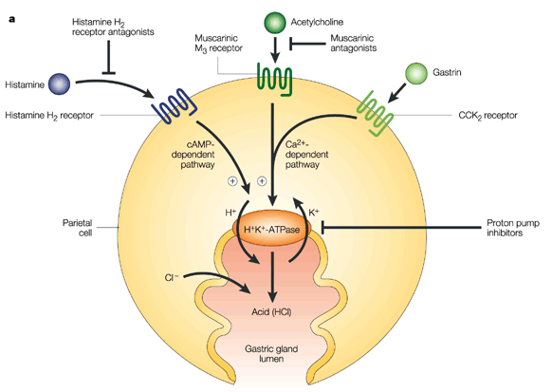

Histamine-2 Receptor Antagonists
 | Dose | Pro-kinetic | Side Effects | Onset | Comments
Cimetidine | 5-10 mg/kg IV, IM, SQ, PO q6-8hr | - | -Increases half-life of many drugs by decreasing hepatic metabolism (ie: Benzodiazepines, β-blockers, Ca channel blockers, lidocaine, metronidazole, theophylline, etc) | Immediate | -Inhibits hepatic P-450  -Metabolized by liver  - Used in Acetaminophen toxicity  -Decrease hepatic blood flow by 20%
Ranitidine | Dogs: 0.5-2 mg/kg IV or 1-4 mg/kg PO q 8-12h  Cats: 2.5 mg/kg IV or 3.5 mg/kg PO q 8-12h | + | -IV may cause apathy, nausea and vomiting | Immediate | -Metabolized by liver  -Been shown to not be useful in cats
Famotidine | 0.5-1 mg/kg IV, IM, SQ, PO q 12-24h | - | -May cause IMHA in uremic cats  -May be associated to thrombocytopenia in humans (platelet antibodies) | Immediate | -Most potent  -Longest acting  -Excreted unchanged in urine
Nizatidine | Dogs: 2.5-5 mg/kg PO q 24h | + | ----- | Immediate | -Excreted unchanged in urine
Lafutidine | ? | ? | ? | Immediate | -Nitric-oxide mediated and histamine independent mechanisms  -Mucosal protective action by capsaicin-sensitive sensory nerves*
*Capsaicin-sensitive nerve fibers protect gastrointestinal mucosa by modulation of mucosal blood flow and mucus secretion. When the gastric epithelium is exposed to acid or irritant, one of the most rapid and important responses is an increase in mucosal blood flow. The aim of this hyperemic response is to remove, dilute and buffer any injurious agent or acid. This is mediated by primary sensory afferent neurons, if the mucosal barrier is disturbed or disrupted in the presence of acid, the acid reaching the lamina propria stimulates spinal afferents. This stimulation will result in Calcitonin Gene Related Peptide (vasodilator and transmits pain) and NO formation inducing hyperemia in the gastro-duodenal mucosa and HCO₃⁻ secretion.
Proton Pump Inhibitors
 | Dose | Side Effects | Onset | Comments
Omeprazole | 1-2 mg/kg PO q 12 h | -Oral compound contains Xylitol  - Increases half-life of many drugs by decreasing hepatic metabolism (ie. Clopidogrel, benzodiazepines, cyclosporine) | Reaches 30% of maximal effect in 24 hour, maximal effect in 2-5 days | -Inhibits hepatic P-450  -Omeprazole equine paste has been successfully used in dogs and cats  -Fragmented tablets do not affect drug absorption  -May cause diarrhea  -Dose dependent inhibition of CNS fluid
Pantoprazole | 1 mg/kg IV q 12h | -May cause hypersensitivity | Reaches 30% of maximal effect in 24 hour, maximal effect in 2-5 days | -May have effects on Giardia and Trichomonas in vitro  - Proven to achieve goals better than q24h
Lansoprazole | 1 mg/kg IV q 24h | -May cause hypersensitivity | Reaches 30% of maximal effect in 24 hour, maximal effect in 2-5 days | ----
Esomeprazole | 0.5-1 mg/kg IV q 24h | -May cause hypersensitivity | Reaches 30% of maximal effect in 24 hour, maximal effect in 2-5 days | ----
Dexlansoprazole | ? | -May cause hypersensitivity | Reaches 30% of maximal effect in 24 hour, maximal effect in 2-5 days | ----

Take Home Message:
- PPI alone achieves acid suppression as quickly as PPI + H2 blocker in combination
- PPI achieve a better acid suppression, since it blocks the proton pump directly
- Omeprazole and Pantoprazole should be used q 12h

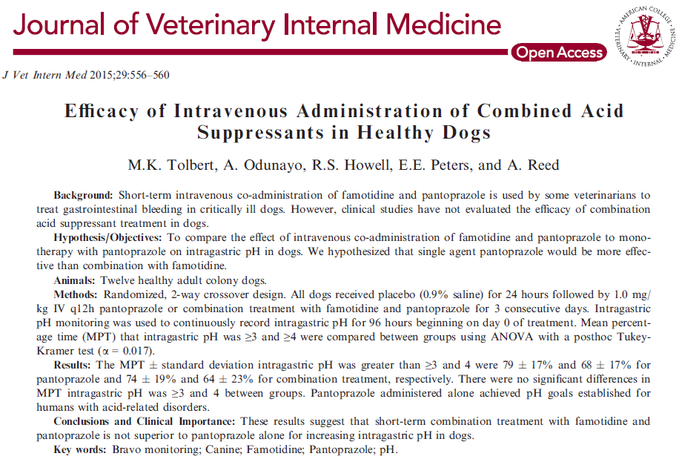
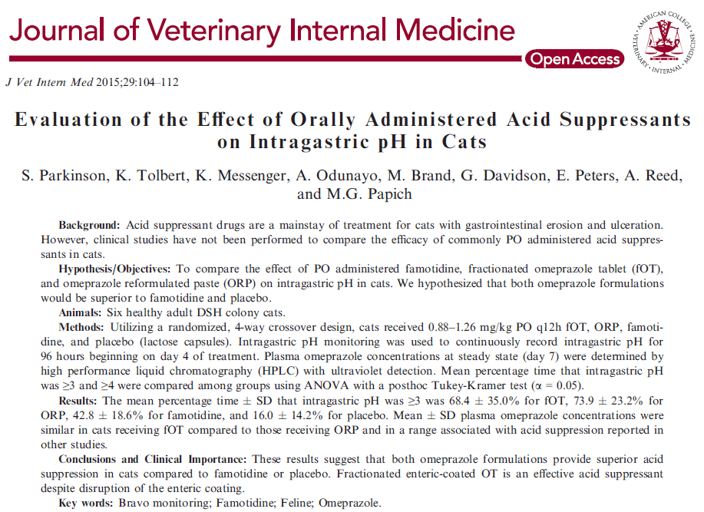
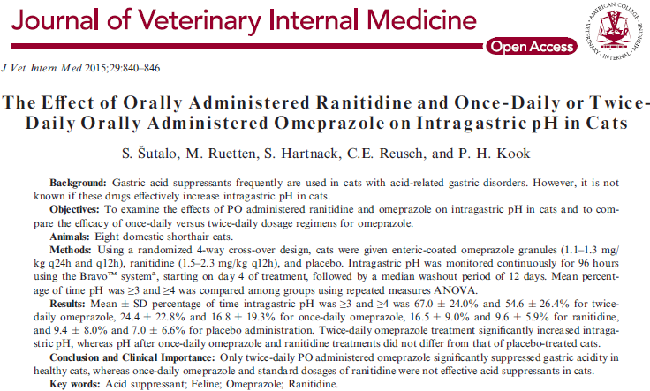

Questions
- Cimetidine can be used to decrease metabolism of _____________ toxicity due to inhibition of ______________.

- Famotidine can produce which of the following side effects:
  - Diarrhea
  - Thrombocytopenia
  - Immune Mediated Hemolytic Anemia
  - B and C
  - All of the above

- T or F: H2 blockers have an immediate onset, hence should always be started with PPI to achieve a faster acid suppression

- Production of HCL is produced in ___________ cells and is stimulated by ____________, ______________ and _______________.

- The proton pump exchanges protons (H+) for __________.

Answers
- Cimetidine can be used to decrease metabolism of Acetaminophen toxicity due to inhibition of hepatic P-450.

- Famotidine can produce which of the following side effects:
  - Diarrhea
  - Thrombocytopenia
  - Immune Mediated Hemolytic Anemia
  - B and C
  - All of the above

- T or F: H2 blockers have an immediate onset, hence should always be started with PPI to achieve a faster acid suppression, PPI have been shown to work just as quickly alone than in combination with H2 blockers

- Production of HCL is produced in Parietal cells and is stimulated by Histamine, Acetylcholine and Gastrin.

- The proton pump exchanges protons (H+) for K+.

