Gastrointestinal Physiology
Physiologic Anatomy of the Gastrointestinal Wall
- Intestinal wall is composed of the following layers from outer surface inward: (1) the serosa, (2) a longitudinal smooth muscle layer, (3) a circular smooth muscle layer, (4) the submucosa, and (5) the mucosa.
- Gastrointestinal smooth muscle functions as a syncytium.
- In the longitudinal muscle layer, the bundles extend longitudinally down the intestinal tract; in the circular muscle layer, they extend around the gut.
- Within each bundle, the muscle fibers are electrically connected with one another through large numbers of gap junctions
- Signals that initiate muscle contractions can travel readily from one fiber to the next within each bundle but more rapidly along the length of the bundle than sideways.

Electrical Activity of Gastrointestinal Smooth Muscle
- The smooth muscle of the gastrointestinal tract is excited by almost continual slow, intrinsic electrical activity along the membranes of the muscle fibers.
- This activity has two basic types of electrical waves: (1) slow waves and (2) spikes
Slow waves
- Most gastrointestinal contractions occur rhythmically, and this rhythm is determined mainly by the frequency of so-called “slow waves” of smooth muscle membrane potential
- Certain smooth muscles within segments of the gastrointestinal tract aboral to the esophagus undergo rhythmic depolarization caused by variations in conductance of sodium and calcium across the cell membrane at regular intervals.
- They are known as the interstitial cells of Cajal.
- Depolarization waves may occur 16–20 times each minute in the stomach, the rate of these slow waves decreases in the small intestine and there may be just two to three slow waves of depolarization per minute in the colon. (Veterinary not Human, See Duke’s animal physiology)
Spike potentials
- True action potentials
- They occur automatically when the resting membrane potential of the gastrointestinal smooth muscle becomes more positive than about −40 millivolts (the normal resting membrane potential in the smooth muscle fibers of the gut is between −50 and −60 millivolts)
- The higher the slow wave potential rises, the greater the frequency of the spike potentials, usually ranging between 1 and 10 spikes per second
- In gastrointestinal smooth muscle fibers, the channels responsible for the action potentials are somewhat different; they allow especially large numbers of calcium ions to enter along with smaller numbers of sodium ions and therefore are called calcium-sodium channels.
Resting membrane
- Factors that depolarize the membrane—that is, make it more excitable—are (1) stretching of the muscle, (2) stimulation by acetylcholine released from the endings of parasympathetic nerves, and (3) stimulation by several specific gastrointestinal hormones.
- Important factors that make the membrane potential more negative—that is, hyperpolarize the membrane and make the muscle fibers less excitable—are (1) the effect of norepinephrine or epinephrine on the fiber membrane and (2) stimulation of the sympathetic nerves that secrete mainly norepinephrine at their endings.
Calcium Ions and Muscle Contraction
- Smooth muscle contraction occurs in response to entry of calcium ions into the muscle fiber.
- The slow waves do not cause calcium ions to enter the smooth muscle fiber (only sodium ions).
- Therefore, the slow waves by themselves usually cause no muscle contraction.
- Instead, it is during the spike potentials, generated at the peaks of the slow waves, that significant quantities of calcium ions do enter the fibers and cause most of the contraction.
Neural Control of Gastrointestinal Function—Enteric Nervous System
- The enteric nervous system is composed mainly of two plexuses
  - 1) an outer plexus lying between the longitudinal and circular muscle layers, called the myenteric plexus or Auerbach’s plexus
  - 2) An inner plexus, called the submucosal plexus or Meissner’s plexus, that lies in the submucosa.
- The myenteric plexus controls mainly the gastrointestinal movements, and the submucosal plexus controls mainly gastrointestinal secretion and local blood flow.
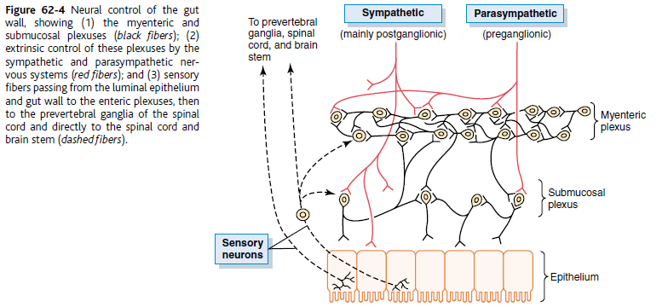
- The cell bodies of the submucosal plexus (Meissner’s plexus) lie within the submucosa below the tunica mucosa. The cell bodies of the myenteric plexus (Auerbach’s plexus) lie between the inner circular smooth muscle layer that stretches around the circumference of the intestine and the outer longitudinal smooth muscle cells that runs parallel the length of the intestine.
- Because the myenteric plexus extends all the way along the intestinal wall and because it lies between the longitudinal and circular layers of intestinal smooth muscle, it is concerned mainly with controlling muscle activity along the length of the gut.
- When this plexus is stimulated, its principal effects are
  - 1) increased tonic contraction, or “tone,” of the gut wall;
  - 2) increased intensity of the rhythmical contractions;
  - 3) slightly increased rate of the rhythm of contraction; and
  - 4) increased velocity of conduction of excitatory waves along the gut wall, causing more rapid movement of the gut peristaltic waves.
- The myenteric plexus should not be considered entirely excitatory because some of its neurons are inhibitory; their fiber endings secrete an inhibitory transmitter, possibly vasoactive intestinal polypeptide
- The submucosal plexus, in contrast to the myenteric plexus, is mainly concerned with controlling function within the inner wall of each minute segment of the intestine.
Types of Neurotransmitters Secreted by Enteric Neurons
- (1) acetylcholine and (2) norepinephrine.
- Others are (3) adenosine triphosphate, (4) serotonin, (5) dopamine, (6) cholecystokinin, (7) substance P, (8) vasoactive intestinal polypeptide, (9) somatostatin, (10) leu-enkephalin, (11) met-enkephalin, and (12) bombesin.
- Acetylcholine most often excites gastrointestinal activity.
- Norepinephrine almost always inhibits gastrointestinal activity. This is also true of epinephrine, which reaches the gastrointestinal tract mainly by way of the blood after it is secreted by the adrenal medullae into the circulation
Autonomic Control of the Gastrointestinal Tract
- Parasympathetic stimulation increases activity of the enteric nervous system.
- The cranial parasympathetic nerves are almost entirely in the vagus nerves
Gastrointestinal Reflexes
- 1. Reflexes that are integrated entirely within the gut wall enteric nervous system. These include reflexes that control much gastrointestinal secretion, peristalsis, mixing contractions, local inhibitory effects, and so forth.
- 2. Reflexes from the gut to the prevertebral sympathetic ganglia and then back to the gastrointestinal tract. These reflexes transmit signals long distances to other areas of the gastrointestinal tract, such as signals from the stomach to cause evacuation of the colon (the gastrocolic reflex), signals from the colon and small intestine to inhibit stomach motility and stomach secretion (the enterogastric reflexes), and reflexes from the colon to inhibit emptying of ileal contents into the colon (the colonoileal reflex).
- 3. Reflexes from the gut to the spinal cord or brain stem and then back to the gastrointestinal tract. These include especially
  - 1) reflexes from the stomach and duodenum to the brain stem and back to the stomach—by way of the vagus nerves—to control gastric motor and secretory activity;
  - 2) pain reflexes that cause general inhibition of the entire gastrointestinal tract
  - 3) defecation reflexes that travel from the colon and rectum to the spinal cord and back again to produce the powerful colonic, rectal, and abdominal contractions required for defecation (the defecation reflexes).
Hormonal Control of Gastrointestinal Motility
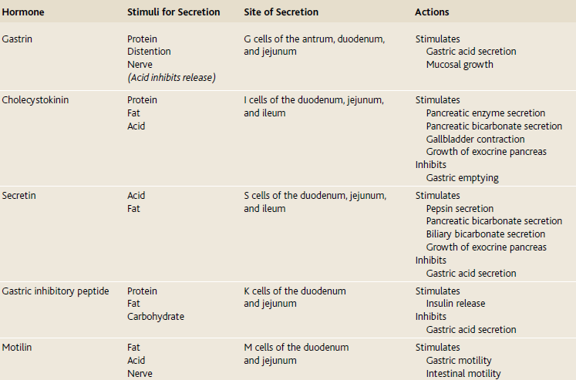

Questions:
1) __________ exist between muscle cells that form a syncytium. These structures allow ion fluxes to pass freely from one cell to another within the syncytium.

2) How does vasoactive intestinal peptide affect the lower esophageal sphincter?

3) How does gastrin affect the lower esophageal sphincter?

4) List the 2 muscle layers of the small intestine.

5) True or False: slow waves by themselves usually cause no muscle contraction.
Instead, it is during the spike potentials, generated at the peaks of the slow waves, that significant quantities of calcium ions do enter the fibers and cause most of the contraction.

6) Fill in the table
Hormone | Stimulus for Secretion | Site of Secretion | Action
Gastrin | Protein  Distension  Vagus nerve stimulation
Cholecystokinin | Digestive products of fat, fatty acids, and  monoglycerides in the intestinal contents  Protein as well and low pH
Secretin | response to acidic gastric juice emptying into the duodenum from the pylorus of the stomach
Gastric inhibitory protein | mainly in response to fatty acids and amino acids but to a lesser extent inresponse to carbohydrate.
Motilin | Primarily during fasting (Vagus)  Ph  Fat

Questions With answers:
1) _____Gap Junctions_____ exist between muscle cells that form a syncytium. These structures allow ion fluxes to pass freely from one cell to another within the syncytium.

2) How does vasoactive intestinal peptide affect the lower esophageal sphincter?
Loosens
3) How does gastrin affect the lower esophageal sphincter?
Tightens
4) List the 2 muscle layers of the small intestine.
Circular and longitudinal

5) True or False: slow waves by themselves usually cause no muscle contraction.
Instead, it is during the spike potentials, generated at the peaks of the slow waves, that significant quantities of calcium ions do enter the fibers and cause most of the contraction.

6) Fill in the table
Hormone | Stimulus for Secretion | Site of Secretion | Action
Gastrin | Protein  Distension  Vagus nerve stimulation | G cells in the antrum of the stomach | 1) stimulation of  gastric acid secretion and 2) stimulation of growth of the gastric mucosa.
Cholecystokinin | Digestive products of fat, fatty acids, and  monoglycerides in the intestinal contents  Protein as well and low pH | I cells in  the mucosa of the duodenum and jejunum and ileum | Stimulates  Pancreatic enzyme secretion  Pancreatic bicarbonate secretion  Gallbladder contraction  Inhibits  Gastric emptying
Secretin | response to acidic gastric juice emptying into the duodenum from the pylorus of the stomach | S” cells in the mucosa of  the duodenum | Stimulates  Pepsin secretion  Pancreatic bicarbonate secretion  Biliary bicarbonate secretion  Inhibits  Gastric acid secretion
Gastric inhibitory protein | mainly in response to fatty acids and amino acids but to a lesser extent inresponse to carbohydrate. | K cells of the duodenum  and jejunum | Stimulates  Insulin release  Inhibits  Gastric acid secretion
Motilin | Primarily during fasting (Vagus)  Ph  Fat | M cells of the duodenum  and jejunum | Stimulates  Gastric motility  Intestinal motility

