GLAUCOMAS
KEY POINTS
- Glaucomas can be primary, secondary, congenital. Primary (PCGA) is the most common type in dogs; secondary is the most common type in cats.
- CS: pain, edema, hyperemia, mydriasis, unresponsive pupil, blindness
- Treatment: if visual decrease IOP (by decreasing AH production and/or increasing AH outflow) – eventually: surgical disease (cyclodestructive and/or filtering techniques); if non-visual: control of pain (enucleation, evisceration, chemical ablation)

= Group of diseases characterized by the neurodegenerative disorder of retinal ganglion cells and optic nerve, leading to blindness

IOP: Balance between AH production and AH outflow
AH is produced by nonpigmented epithelium of ciliary bodies – 3 mechanisms
1) Diffusion
2) Ultrafiltration
3) Active secretion
*Carbonic anhydrase is responsible for the formation of bicarbonate and its active transport across ciliary epithelium; H₂O + CO₂ HCO₃⁻ + H⁺; CA 60-75% of AH
*Sodium is the major ion transported from blood to AH (Na+/K+/ATPase); water follows by diffusion and ultrafiltration
Outflow: Conventional (iridocorneal angle – pectinate ligaments, trabecular meshwork, aqueous angular plexus, episcleral veins)
Outflow: Nonconventional (uveoscleral - from the base of the ciliary muscle, through tissues in and around the uvea sclera)
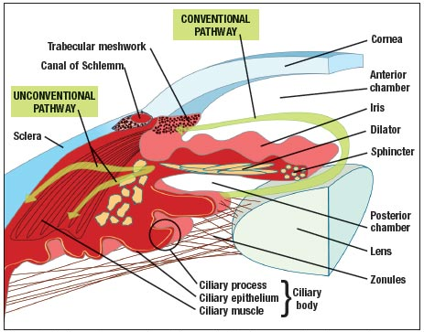
*The common final event to all types of glaucoma is the eventual degeneration of the optic nerve head (glaucoma optic neuropathy) – IOP. Other components suspected in the progression of GOP: defects in microcirculation, oxidative stress, excitotoxic amino acids, mechanical stretching and axonal degeneration to retinal cells
Congenital Glaucoma
- At birth or few weeks to months later
- Rare
- Genetic defects abnormal anterior chamber and trabecular outflow pathways

Primary Glaucoma (not related to any other concurrent ocular disorder)
- Most common presentation in dogs
- Bilateral but usually not simultaneously
- Hereditary predisposition in several breeds
- Most common type: closed angle – Cocker and Basset
- 4-10 yo; acute presentation, female*
- Open angle: less common – Beagle and Norwegian Elkhounds
  - Progressive accumulation of basement membrane-like material in the ECS of trabecular meshwork impairment to suppression of outflow
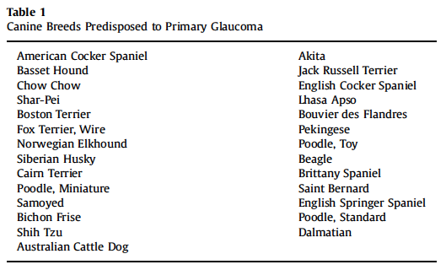

Secondary Glaucoma (preexistent intraocular disorder)
- Most common type in cats
- Unilateral
- Usually more slowly progressive
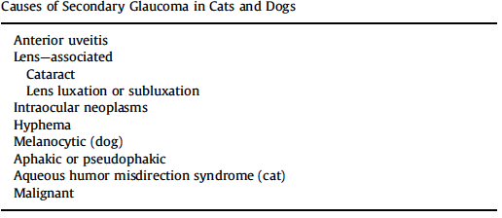
Early noncongestive: early stages of POAG and narrow-angle glaucoma; insidious; IOP 25-30 mmHg
Acute congestive: sudden and severe spikes of IOP 50-70 mmHg; PCAG; dramatic CS
Chronic glaucoma: advanced stages, extensive ocular damages, blindness

Clinical Signs
- POAG: slow progression, subtle signs, mild mydriasis, episcleral injection, corneal edema
- PCAG: moderate/transient spikes in IOP compensatory mechanisms back to normal; at some point mechanisms are overwhelmed persistent severe elevation in IOP; severe pain, red eye, blepharospasm, epiphora, corneal edema, mid-range to dilate pupils, unresponsible to light, vision may already be compromised (depending on IOP and duration)
  - Fundus: mild papilledema, infarct (peripapillary areas of chorioretinal degeneration)
- Chronic: dull, chronic discomfort, less redness (no conjunctival hyperemia), severe episcleral vessels injection, corneal edema, buphthalmos, Haab’s striae (rupture of Descemet), blindness, pupils dilated and unresponsive, possible lens luxation
  - Fundus: diffuse retinal degeneration, tapetal hyperrefflectivity, fading/absent vessels, optic nerve cupping
- **Cats: slowly progressive, no signs of corneal edema, conjunctival hyperemia initially, vision maintained for longer time, often presented with chronic disorder with buphthalmos, edema, mydriasis, episcleral vessels injection, lens luxation or subluxation, retinal degeneration, blindness

Diagnostics
- Applanation or rebound tonometry (applanation tonometers tend to underestimate IOP as IOP increases)
- Gonioscopy
- Other advanced tests by ophthalmologist

Treatments
- If vision can be maintained/recovered: IOP control and neuroprotection
- If vision is lost: QoL; pain control, prevention of corneal complications
- Safe IOP for dogs with overt glaucoma and on medical tx should not exceed 20 mmH
- PCAG: ultimately a surgical disease
- Primary glaucoma: start prophylactic medical tx in the contralateral visual eye
- Medical tx: to increased AH outflow and/or to decreased AH production
- Goal is to decrease IOP < 20 mmHg ASAP
- PGAs + CAIs; repeat 2-3 times every 10 minutes
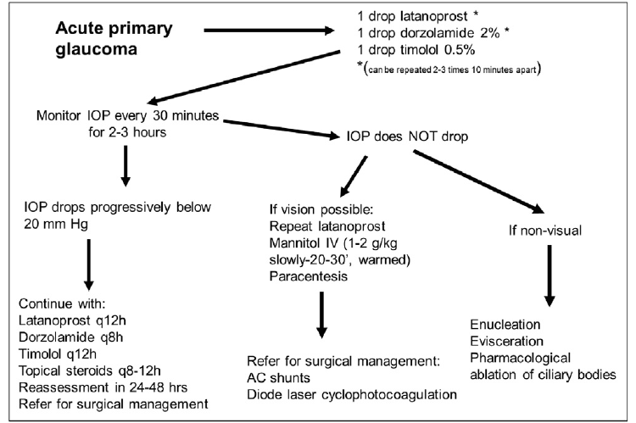
- Evaluate for presence of menace, dazzle, PLR (consensual) – be aggressive if one is present or if increase in IOP is acute and fairly recent because vision might be restored – paracentesis, mannitol
- If vision is absent and irreversibly lost: salvage procedures of ocular pain
- Prophylactic tx: dorzolamide + steroid q12h, IOP q3-4 mo
- Secondary glaucoma: tx underlying ocular disorder
- *Cats share with human patients a predisposition to steroid-induced ocular hypertension (5-10 mmHg after topical application)
- *Cosopt: dorzolamide + timolol *Trusopt: dorzolamide *Timoptic: timolol
Agent | MOA | Indication | Side effects | Other
CA inhibitors  2% Dorzolamide  1% Brinzolamide | Decrease production AH through inhibition of CA | All types | Systemic: acidosis, GI, panting, lethargy, hypokalemia (cats*)  Topical: discomfort (dorzo*), hypersensitivity keratitis (ulcerative or not) | q.8-12h  Max effect w/in 5 d (dogs)
Beta-blockers  0.5% Timolol | ?  Alter adrenergic neuronal control of AH formation | All types | Systemic absorption  Bradycardia, bronchospasm, hypotension | miosis (bilateral: dogs, treated eye: cats)
Parasympathomimetics  Demecarium bromide | Increase conventional outflow  Supp. of acetylcholinester. | POAG in dogs | Breakdown of blood-ocular barrier; CI in 2nd glaucoma from uveitis | miosis  q.12h  n/e in cats
Prostaglandin analogs  Latanoprost  Bimatoprost  Travoprost | MMP-mediated remodeling of extracellular matrix of the ciliary body muscle  Increase AH outflow (both pathways)  Decrease AH production | All types primary  Certain 2nd | Conjunctival hyperemia  Miosis (not if lens lux)  Disrupt BOB (careful with uveitis) | q.12h  Not effective in cats  Topical AI can reduce effect
Osmotic agents  Mannitol | Increase osmolality of ECF thus inhibiting ultrafiltration process and shrink vitreous body |  |  | Less likely to penetrate eye if BOB disrupted  Decreased effect if severe inflamm.  Peak w/in 1-2h, last 6h
Surgical management of glaucomas
- For visual patients: goal is to decrease IOP
  - Decrease AH production
  - Increase AH outflow
- Mostly for patients with primary glaucoma or 2nd glaucoma because of lens disorder
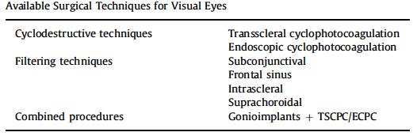
- Cyclodestructive techniques: selective damage to the ciliary body epithelia, most commonly through delivery of diode laser energy; melanin present in the ciliary body epithelium is the target; absorption of this energy photocoagulation and destruction of the ciliary bodies decreased IOP production; TSCP not recommended in cats
- Filtering techniques: gonioimplants to allow AH to be diverted from anterior chamber to different venues, most commonly subconjunctival space

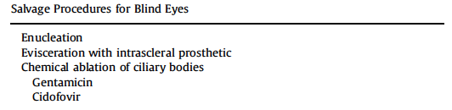
- US is always recommended before evisceration and prosthesis
- Gentamicin and cidofovir cause irreversible damage to ciliary bodies with decrease/suppression of AH production = chemical ablation
  - US before

QUESTIONS
- You are treating a dog that is presented for acute primary glaucoma. Which of the following is the best first treatment?
  - Mannitol
  - Paracentesis
  - Timolol
  - Dorzolamide
  - Latanoprost

- The main goal in the treatment of acute primary glaucoma is to decrease the IOP to values less than _____ as soon as possible
  - 30
  - 25
  - 20
  - 15

- Name ocular disorder that can lead to secondary glaucoma.

- Which of the following drug is appropriate in a dog with glaucoma and uveitis?
  - Dorzolamide
  - Demecarium
  - Latanoprost
  - Mannitol

- You are treating a dog with glaucoma. He has no menace, no dazzle, his pupil is mydriatic and consensual PLR is negative. What are recommendations?

QUESTIONS & ANSWERS
- You are treating a dog that is presented for acute primary glaucoma. Which of the following is the best first treatment?
  - Mannitol
  - Paracentesis
  - Timolol
  - Dorzolamide
  - Latanoprost

- The main goal in the treatment of acute primary glaucoma is to decrease the IOP to values less than _____ as soon as possible
  - 30
  - 25
  - 20
  - 15

- Name ocular disorder that can lead to secondary glaucoma.
Cataract, lens luxation, uveitis, hyphema, intraocular neoplasm

- Which of the following drug is appropriate in a dog with glaucoma and uveitis?
  - Dorzolamide
  - Demecarium
  - Latanoprost
  - Mannitol

- You are treating a dog with glaucoma. He has no menace, no dazzle, his pupil is mydriatic and consensual PLR is negative. What are recommendations?
Salvage procedure for pain control – enucleation, evisceration with prosthesis (after US) or chemical ablation with gentamicin or cidofovir.
Dogs most commonly have primary glaucoma which is often bilateral –start prophylactic medication in the contralateral visual eye: dorzolamide with dexamethasone q12h and check IOP q.3-4 mo.

