Fossum, pg 1101 – 1103

- Complications of Fracture Healing
  - Delayed Union
    - Fractures that heal more slowly than anticipated
    - Most long bone fractures have radiographic evidence of bone bridging the fracture lines by 12 weeks
    - Signs of progressive bone activity are visible on sequential radiographs, and bone union is anticipated, but not ensured
    - As long as implants are adequate and remain intact, with strict activity supervision, no additional surgery will be needed
    - Contributing factors:
      - Systemic status of the patient (malnutrition and anemia)
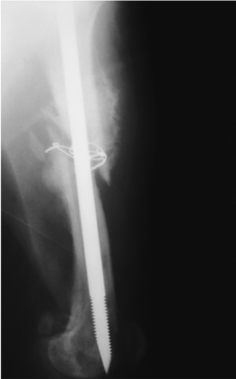
      - Nature of the trauma (high-energy fractured diaphysis with extensive soft tissue injury and possibly open fractures)
      - Local host postinjury response (inadequate cellular response for healing)
      - Fracture management (poor decision making, large fracture gaps, unstable implants, or implants that are too rigid, and radiation therapy)
      - Pharmacologic factors (steroids, NSAIDs).
  - Nonunion
    - Arrested fracture repair, requiring surgical intervention to create an environment conducive to bone healing
    - Lack of activity on sequential radiographs
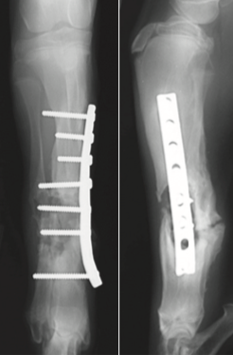
      - Vascular non-union: a lucent line through fractures (representing cartilage and fibrous tissue), ineffective callus formation at the fracture site
      - Hypertrophic nonunions: vascular nonunions with large amounts of nonbridging callus
      - Atrophic nonunions: biologically inactive pseudoarthroses
        - No evidence of bone reaction at fracture sites, and bone ends appear sclerotic
    - Most are a result of poor decision making and technical failure on the part of surgeons, rather than biologic failures attributable to the patient
      - Instability at the fracture site is the most common reason for nonunion
  - Osteomyelitis
    - An inflammatory condition of bone and the medullary canal
    - Periosteal and endosteal bone formation, and bone resorption
      - +/- loose or broken implants and nonviable bone fragments (sequestra)
    - Most common cause is bacterial infection, promoted by:
      - Instability at the fracture and the bone implant interfaces
      - Open fractures
      - Vascular compromise
      - Tissue ischemia
  - Malunion
    - Anatomic bone alignment was not achieved or maintained during healing
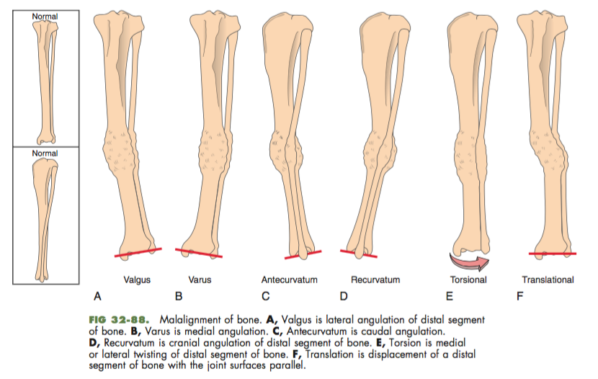
    - Should be treated with corrective osteotomy if it adversely affects the animal’s ability to ambulate

Fossum, pg 1050-1053
- Fracture Support
  - Unstable injuries should be coapted to reduce further soft tissue injury and increase patient comfort
  - External splints:
    - Provide temporary limb support
    - Primary means of fracture stabilization
    - Soft tissue and bone immobilization
      - Enhance patient comfort
      - Prevent further soft tissue damage from sharp bone fragments
      - Minimize swelling (enhances visualization and palpation of anatomic landmarks during surgery)
    - Most complications associated with external splints are minor
      - Swelling of limb distal to splint
      - Splint slippage
      - Skin abrasions
    - Serious complications may occur
      - Fracture nonunion
      - Loss of a limb from ischemic necrosis
    - Fractures or luxations below the elbow and stifle joint are best managed with a soft padded bandage +/- additional support
    - Fractures above the elbow or stifle joint are more difficult to coapt…
  - Robert Jones bandage
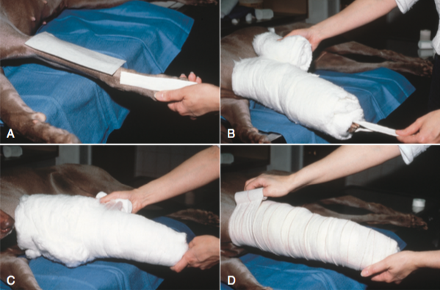
    - The original Robert Jones bandage used commercially available, 12-inch, rolled cotton that was liberally applied to the limb to a thickness of 4 to 6 inches
    - Modified Robert Jones bandages use less cotton, but still provide compression
    - Thick cotton layer provides mild compression of soft tissue and immobilizes fractures without causing vascular compromise
    - RJs help eliminate dead space after surgery
    - ***sufficient compression will cause the bandage to sound like a ripe watermelon when tapped with a finger
- Metal spoon splints (metasplints)
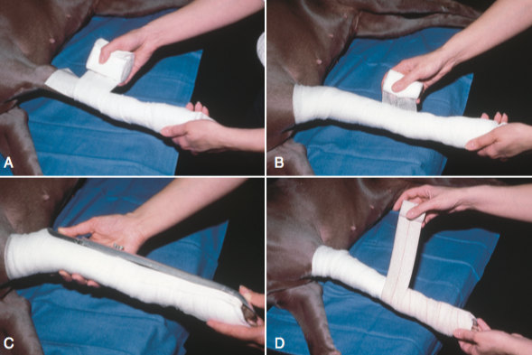
  - Provide support to injuries of the distal radius and ulna, carpus or tarsus, metacarpus or metatarsus, and phalanges
  - Used for ancillary support of internal fixation devices or as a primary means of fixation when the patient fracture- assessment score indicates minimal stress and rapid healing
  - Commercially available in aluminum or plastic in a variety of lengths and sizes
- Soft padded bandages
  - Used when excessive compression of the tissue is not desired
  - +/- use of a lateral splint made of fiberglass casting material
    - Reinforce the bandage
    - Prevents the bandage from folding as the limb is used
- Spica splints
  - Temporary splints to immobilize humeral or femoral fractures
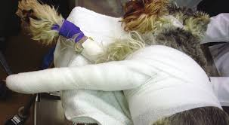
  - Rarely used as a primary means of stabilization unless the fracture is nondisplaced and the fracture-assessment score indicates that rapid bone union will occur

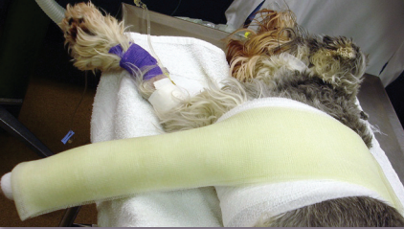

- Ehmer slings
  - Prevent weight bearing of the pelvic limb
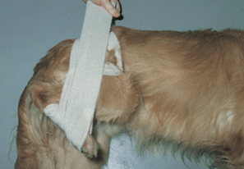
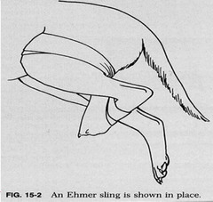
  - Most commonly used to support the closed or open reduction of hip luxations

- Velpeau slings
  - Prevent weight bearing and provide some stability to the proximal forelimb
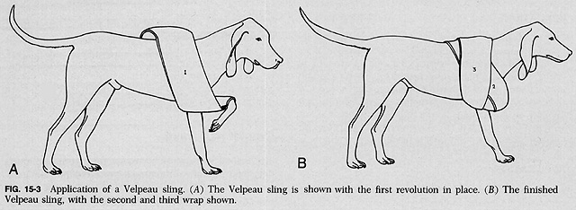
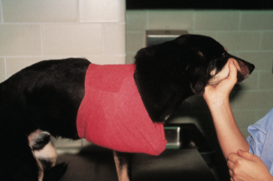
  - Most often used to help maintain closed or open reduction of medial shoulder luxations and to support scapular fractures

