Fracture Reduction
Reduction: defined as the process of either reconstructing fractured bone fragments to their normal anatomic configuration or restoring normal limb alignment by reestablishing normal limb length and joint alignment while maintaining spatial orientation of the limb.
Techniques must overcome muscle contraction and fracture fragment overriding:
- Closed reduction: without surgically exposing fractured bones
  - Preserves soft tissue and blood supply, faster healing
  - Decreased risk of infection
  - Reduced operating time
  - Disadvantage: Accurate reconstruction is difficult

- Open Reduction: surgical approach to expose fractured bone segments and hold in position with implants
  - Direct visualization and contact can facilitate anatomic fracture reconstruction
  - Direct placement of implants
  - Stronger fracture fixation
  - Bone grafts can be used to enhance bone healing
  - Disadvantages: increased surgical trauma, increased risk of bacterial contamination

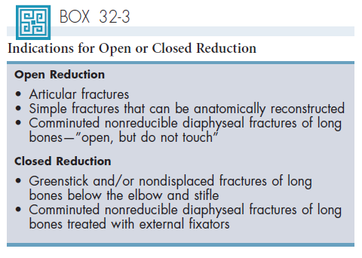

Direct Reduction:
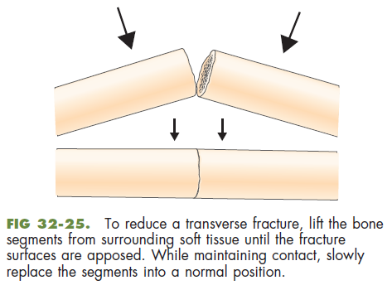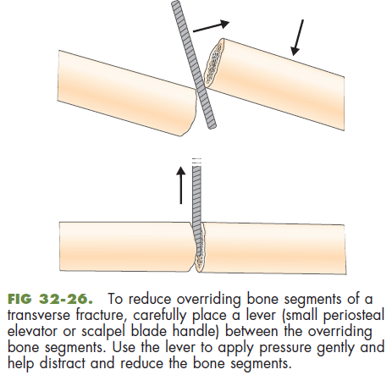
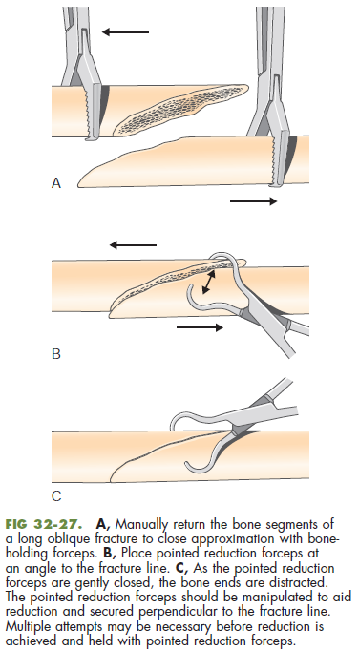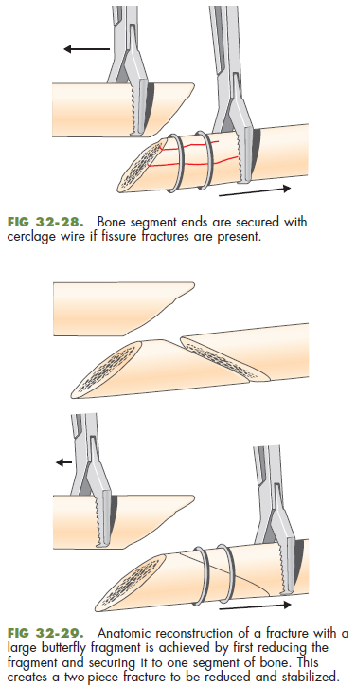

Indirect Reduction:
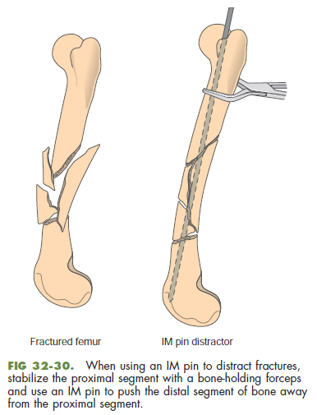

Questions:
- Indicate if Open or Closed reduction is needed for the following cases:
  - 6 month SF Italian greyhound, fell from owner’s arm, radiographs show non-displaced radial fracture
  - 4 year NM Labrador Retriever, hit by car, several lacerations, non-ambulatory right hind limb, radiographs show non displaced pelvic fracture and right acetabular fracture and luxation
  - 8 year NM DSH, unknown trauma, outdoor cat, comminuted femoral fracture
  - 12 year NM Rottweiler, fell down stairs, simple mid diaphyseal humeral fracture

Questions:
- Indicate if Open or Closed reduction is needed for the following cases:
  - 6 month SF Italian greyhound, fell from owner’s arm, radiographs show non-displaced radial fracture Closed
  - 4 year NM Labrador Retriever, hit by car, several lacerations, non-ambulatory right hind limb, radiographs show non displaced pelvic fracture and right acetabular fracture and luxation Open
  - 8 year NM DSH, unknown trauma, outdoor cat, comminuted femoral fracture Open
  - 12 year NM Rottweiler, fell down stairs, simple mid diaphyseal humeral fracture Open

