Common Suture Patterns – Fossum Page 69-76
- Types of suture
  - Appositional
    - Bring tissue into close approximation (similar to normal)
  - Everting
    - Turn tissues outward
  - Inverting
    - Turn tissues inward
- Subcutaneous and Subcuticular
  - Meant to eliminate dead space and lessen skin suture tension
- Interrupted Suture Patterns
  - Simple interrupted
    - Side A, Side B
    - Knot should be offset so that it does not rest on top of the incision
    - Started 2-3mm from skin edge
    - Appositional
      - Too much tension turn into inverting
  - Horizontal Mattress
    - Side A, Side B, Side B, Side A
    - 6-8mm advancements
    - Separated by 4-5mm
  - Cruciate Pattern
    - Side A, Side B, Side A, Side B
    - Two simple interrupted placed parallel
  - Vertical Mattress
    - Side A far, Side B far, Side B near, Side A near
    - About 4-5mm between near and far
    - Stronger than horizontal for high tension
  - Halsted
    - Side A (in and out), Side B (in and out), Side B (in and out), Side A (in and out)
    - Very precise apposition, but infrequently used
  - Gambee
    - Side A, Side A (up into muscularis), Side B (down from muscularis), Side B
    - For intestinal apposition
    - May reduce wicking out of intestines
Suture type | Simple Interrupted | Horizontal Mattress | Cruciate Pattern | Vertical Mattress
Pros | Quick, failure of single suture does not compromise integrity | Relieves high tension | Can relieve low to moderate tension less suture than interrupted | Relieves high tension (better than horiz mattress)  Less disruption of blood supply than horiz
Cons | More time than continuous, more foreign material (knots) in wound | Can cause eversion | Less knots = failure causes bigger problem | Time consuming
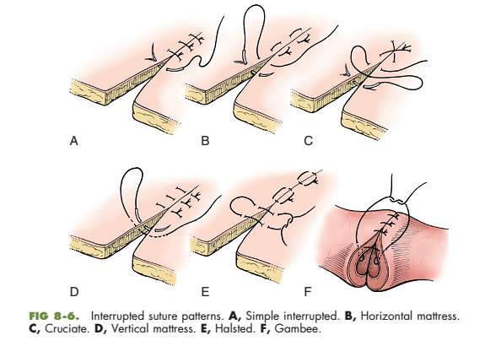
- Continuous Patterns
  - Simple continuous
    - Side A, Side B, knot, Side A, B, A, B, etc…
  - Ford interlocking
    - Variation of simple continuous
  - Lembert
    - Side A serosa far, Side A muscularis, Side A serosa near, Side B serosa near, Side B muscularis, Side B serosa Far, Side A serosa Far, etc…
  - Connell and Cushing
    - Difference is Connell penetrates mucosal side, but Cushing does not
      - Not a big difference with quickly absorbing suture
Pattern | Simple Continuous | Ford Interlocking | Lembert
Pros | Quick, Maximum tissue apposition, more fluid and air tight than interrupted | Good Apposition, some insurance against broken knots | Inverting for hollow viscous
Cons | Relying on only 1 knot | Difficult to remove  Lots of suture
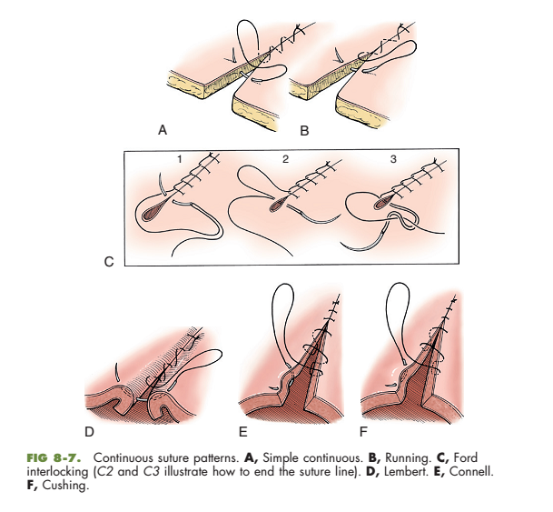
- Tendon Sutures
  - Three loop pulley
    - Biomechanically superior to other tendon patterns
  - Bunnell
    - Not commonly used because it is difficult to place and may disrupt tendon microcirculation
  - Far near near far
    - For flat tendonds
    - 5mm from severed end on Side A to 2mm from severed end on Side B to 2mm on Side A to 5mm on Side B
    - Minimal blood flow discruption

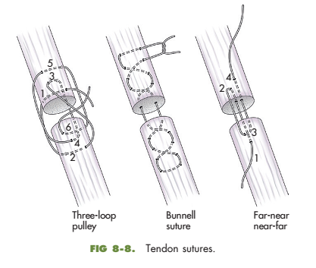

Questions:
Name an acceptable suture pattern for each of the following and state the rationale behind your choice
1. Patient with large full thickness skin laceration over stifle – stable under anesthesia
2. Closing bladder wall – only suture material available is non-absorbable
3. Patient with skin laceration over shoulder – unstable under anesthesia

