Erythema Multiforme (EM)
1. Cause and Pathogenesis
- In dogs reported triggering factors
  - Drugs: TMS, penicillins, cephalosporins (most reported association)
  - Idiopathy
  - Bacterial infections
  - Pneumocystic pneumonia
  - Parvovirus and possibly herpesvirus
  - Food
  - Neoplasia
- In cats majority of cases related to drug reactions
  - Herpes has also been associated

- Exact pathogenesis not known
- In dogs EM is thought to represent a host specific cell mediated hypersensitivity reaction directed toward some antigenic stimulus
- Alteration of keratinocyte (by drugs or infectious agents) might be a primary factor in disease pathogenesis
  - Upregulation of adhesion molecules ICAM-1 and MHC II through production of IFN-gamma and TNF-alpha by CD8+ and CD4+ T lymphocytes

2. Classification Schemes
- In humans there is distinction between EM and SJS/TEN
  - Typical target lesion and raised atypical target lesions associated with diagnosis of EM and herpesvirus
  - Flat lesions associated with SJS/TEN due to drug eruptions

- In vet med no strict definition for target lesion
  - Even when classification scheme was adapted for use in dogs

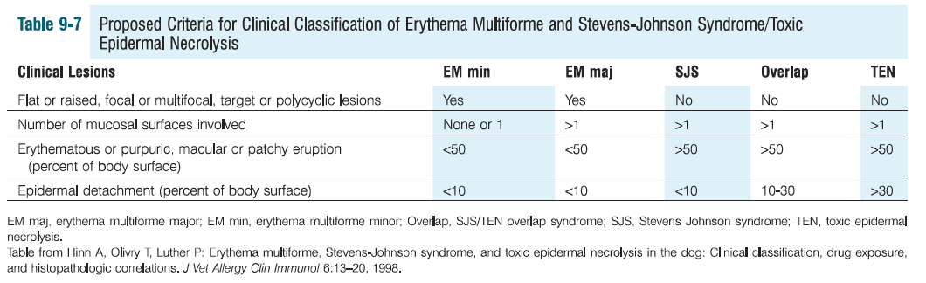

- EM major: severe, more mucosal involvement, +/- malaise or pyrexia
- EM minor: mild, acute onset of lesions including target lesions involving extremities, no fever or prodromal symptoms, if there is mucosal involvement it is mild and limited to oral cavity

3. Clinical Features
- Uncommon in dogs and cats
- Skin lesions in dogs and cats characterized by an acute symmetrical onset
  - Most commonly erythematous macules or slightly elevated papules that spread peripherally and clear centrally
  - Other lesions described include urticarial plaques and vesicles, and bullae resulting in ulcers
  - Oral ulcers often hemorrhagic and coated by greyish white pseudomembranes of necrotic epithelium and fibrin

- Dogs
  - Lesions occasionally painful (~23%), rarely pruritic
  - Ventrum (axilla and groin), mucucutaneous junctions, oral cavity, pinnae, footpads
  - Old dog EM involves face and ears
- Cats
  - Lesions predominantly ulcerative and crusted. Also vesiculobullous
  - Trunk and mucocutaneous junctions most commonly affected

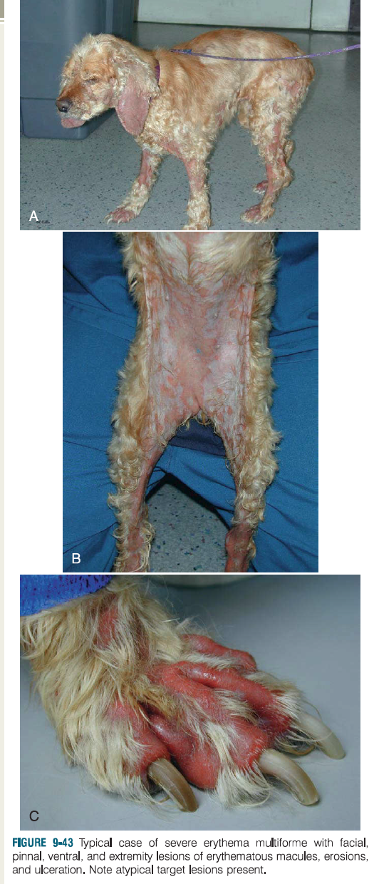
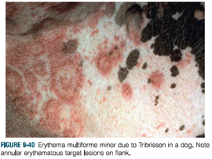

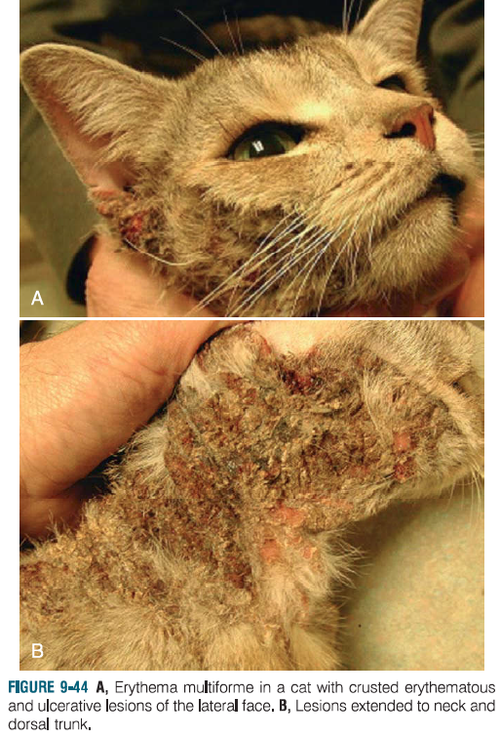

4. Diagnosis
- ddx for ‘atypical’ target lesions: bacterial folliculitis, dermatophytosis, demodicosis, urticarial, other vesicular and pustular disorders
- Definitive diagnosis requires classic target lesion or a raised atypical target lesion and supportive skin biopsy (to diagnose apoptotic disorder)
  - Most typical EM finding is keratinocyte apoptosis with lymphocyte satellitosis
- Identify underlying cause
  - PCR for presence of virus in the skin (i.e. herpes, parvo)
  - Thorough history of exposure to drugs
  - Diet trial
  - Idiopathic cases more common in old dog EM

5. Clinical Management
- Correct underlying cause if possible
- When trigger factors can be eliminated usually resolves within 3 weeks
- Immunosuppressive drugs have been used (glucocorticoids, azathioprine, cyclosporine)
- IVIG – effective in some life threatening cases

Questions
- Name three reported triggering factors for EM in dogs
- Which is the most common triggering factor for EM reported in dogs?
- Which parts of the body does old dog EM typically involve?

