- Choosing when to treat
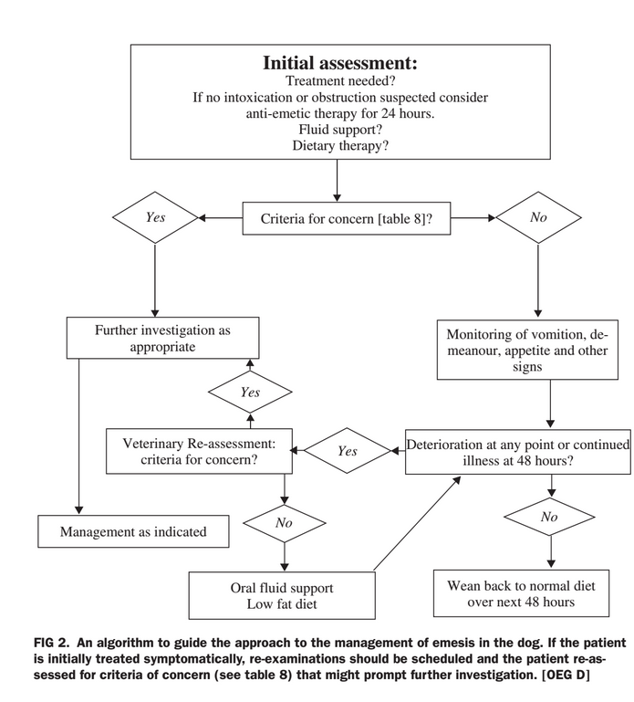
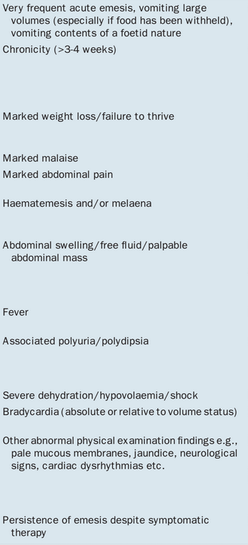
  - 89% of dogs with signs of vomiting had resolution within 2 days.

- Ideal anti-emetic
  - Act both centrally and peripherally
  - Minimal cardiovascular effects
    - vomiting patients may be hemodynamically compromised
  - Wide therapeutic index
    - due to frequent concurrent liver or kidney disease
  - Few CNS effects
    - increased risk of aspiration
  - Lack of motility effects
    - especially predisposing to ileus
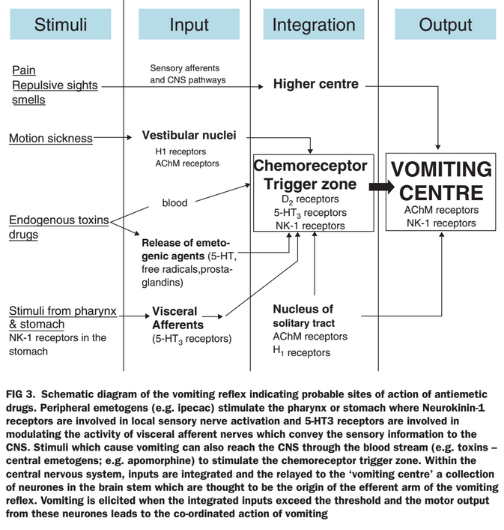

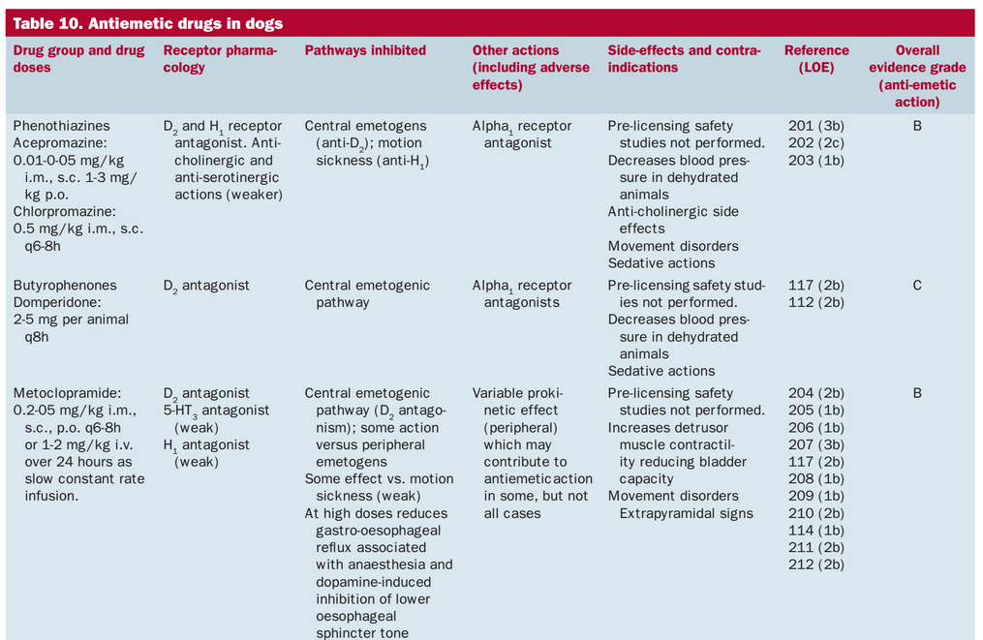
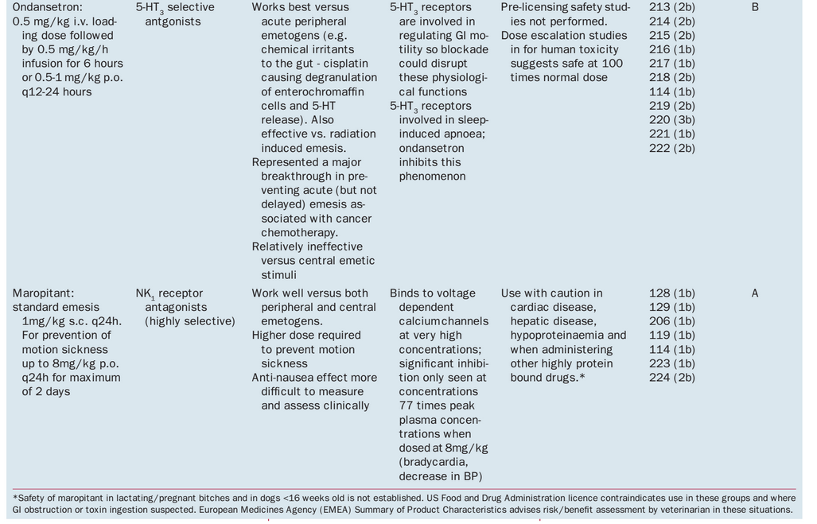

- Clinical Trials of antiemetics limited
  - Most with maropitant
    - Showed that it is better than metoclopramide
    - Showed that is effective for motion sickness
    - Showed that it is effective in chemotherapy induced emesis
- Dietary Management
  - Hospitalized patients
    - Enteral is preferred over parenteral
      - Emesis is one of the main complications with enteral nutrition
        - both as a barrier and as a result
      - Experimental studies show that enteral nutrition is superior to parenteral is pancreatitis and gut-barrier function
    - Enteral is preferred to NPO in parvovirus
      - Randomized control trial
      - 30 dogs - 15/15 given early enteral nutrition via NE tube survived vs 13/15 NPO until emesis stopped group
      - Early EN also showed more rapid improvement clinically
    - Enteral is preferred to parenteral in clinical HGE
      - Dogs grouped into early enteral feeding and parenteral nutrition
        - enteral consisted of syringe feeding with cottage cheese based, hydrolyzed diet with pancreatic enzyme pre-incubation
      - Dogs with early enteral vomited on day 2 (first day of feeding) often, but improved over subsequent days
        - 10/10 survival
      - Parenteral nutrition
        - 7/9 survival
  - Outpatients
    - Re-feeding vs NPO
      - Little evidence to support either
      - Children with gastroenteritis - Sanhu (2001) review recommended early feeding
  - Monitoring
    - Outpatients
      - Re-present dogs if no improvement, especially after a maximum of 48 hours
- Chemotherapy induced emesis
  - Anticipated vomiting
    - Pavlovian, but very unlikely in dogs
  - Acute vomiting
    - within 24 hours of chemo
      - CRTZ stimulation by chemotherapeutic agent or peripheral stimulation by cytotoxic agents
  - Delayed vomiting
    - 1-5 days post-chemo
    - Multifactorial
      - Decreased intestinal motility
      - Release of intestinal hormones
      - Accumulation of metabolites of cytotoxic agents
        - especially platinums
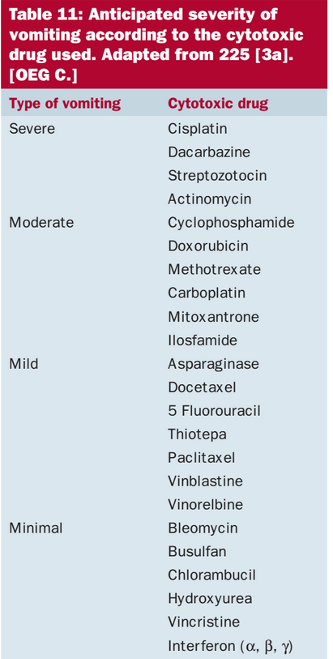
Bonus material:

Cats:
bioavailability
32% (oral) and 75% (subcutaneous)
Halflife:
1.84 ± 0.58 h (intravenous), 1.18 ± 0.27 h (oral) and 3.17 ± 0.53 h (subcutaneous)

Dogs:
Bioavailability
10% oral
Halflife
0.5h

