Emesis in dogs: a review
- Vomiting (or emesis) = forceful expulsion of content from stomach and intestines; defense mechanism
- Associated with motion sickness, some drugs, various disease processes
- Emetic center within the reticular formation of the medulla oblongata of the brainstem
  - Composed of number of nuclei responsible for initiating vomiting
  - Close proximity to the nucleus tractus solitarius of the vagus nerve and the CRTZ
  - Several different receptors (adrenergic, 5HT-1, NK-1)
    - Activated indirectly through humoral pathway by bloodborne substances activating the CRTZ or other pathways leading directly to the emetic center.
- Chemoreceptor trigger zone (CRTZ)
  - Located in the area postrema at the base of the 4th ventricle, dorsal surface of the medulla oblongata; no BBB
    - Even more receptors (NK-1, 5HT-3, ENK, adrenergic, dopaminergic, muscarinic, histaminergic)
- Vestibular system
  - Vestibular nuclei (VIII) in brainstem
  - Contains H₁ and AChM receptors
  - Vestibular stimulation passes through the CRTZ before activating the emetic center (dog)
- Higher center
- Peripheral sensory receptors
  - Gastrointestinal tract
    - Mechanoreceptors and chemoreceptors
    - Inflammatory or cytotoxic factors enterochromaffin cells serotonin (5-HT) and substance P activation of vagal afferent pathways (5HT₃ and NK₁ receptors)
    - Sympathetic afferent pathway
    - Glossopharyngeal afferent pathway

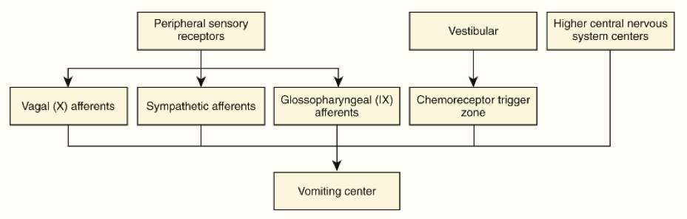

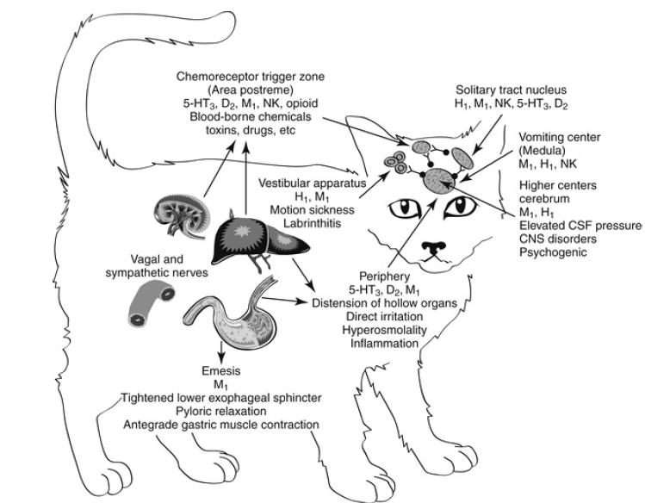

- The reflex of vomiting
  - Control by the emetic center
  - 3 phases
    - Prodromal: nausea and hypersalivation
    - Retching
    - Expulsion
  - Nerves that are implied: vagal and phrenic nerves, parasympathetic nerves to the salivary glands, somatic motor nerves to abdominal muscles.
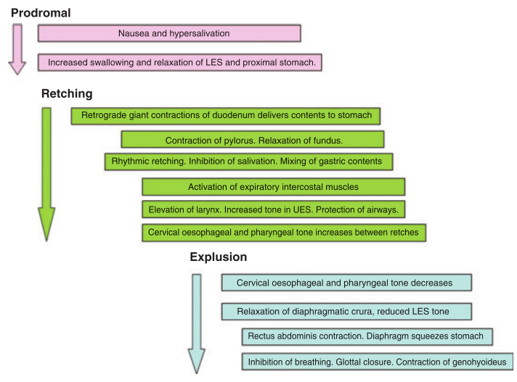
  - Can be triggered peripherally and controlled centrally by the emetic center; possible concomitant activation of the CRTZ
- Consequences and complications of vomiting
  - Nausea and loss of appetite (and eventually malnutrition)
  - Loss of GI fluid and electrolytes dehydration, hypovolemic shock, acid-base and electrolytes disturbances
  - Aspiration pneumonia
- Clinical assessment
  - Distinction between vomiting (nausea, hypersalivation and abdominal muscle contractions) vs regurgitation (passive)
- Diagnostic approach
  - Term acute gastritis is a misnomer (to describe a syndrome of acute and self-limiting vomiting); because gastric inflammation is not proven by histopathology
- Treatments
  - Supportive care: correction of fluid, acid-base and electrolytes imbalance
  - To treat or not - antiemetic: may be desirable for elimination of toxics, risk of masking significant CS, delay in diagnosis, combined with prokinetic effect if FBO
  - Antiemetic
    - Symptomatic treatment for a clinical manifestation of a wide spectrum of diseases
    - Ideal drug will prevent both central and peripheral stimuli of the vomiting centre
    - Therapeutic index
    - Minimal effect on cardiovascular system
    - Minimal effect on CNS
    - Absence of prokinetic effect (in general; some exceptions: chronic gastritis)
    - Few antiemetics have been subjected to rigorous testing; lack of evidence to support the efficacy of many of them.
      - Butorphanol moderately effective in controlling vomiting in dogs with lymphoma treated with cisplatin
      - Acepromazine decreases opioid-induced vomiting when used as part of pre-med protocol
      - Maropitant is better than metoclopramide in preventing vomitings (lower number of dogs that vomited, and less vomiting events)
      - Maropitant prevents chemotherapy-induced vomiting and decreases sign of nausea
      - Maropitant prevents motion sickness
  - Nutrition in vomiting patients
    - In patients
      - Studies evaluation EN vs PN in veterinary patients with GI tract disease are limited
      - Controlling vomiting to allow earlier EN and decreases associated morbidity (translocation, infection, earlier discharge, survival)
      - EN better than PN for dogs with acute pancreatitis
      - EN in parvovirus enteritis: improved survival, earlier clinical improvement, more rapid improvement in demeanor, appetite, diarrhea, and vomiting, weight gain, improved intestinal barrier function.
      - Better survival in dogs with HE vs PN
    - Out patients
      - People: early feeding; not withholding food; no study in veterinary patients
      - Dietary characteristic: unknown; highly digestible
      - Monitoring: no more than 24 hours antiemetic; and reassess. Keep an eye on appetite, demeanor, diarrhea.
- Emesis in cancer patients
  - Nausea and vomiting
    - Localization of the tumor: GI, liver, pancreas
    - Paraneoplastic syndrome (mast cell tumor, APUDoma)
    - Treatment: chemo, RT, surgery
  - Chemotherapy-induced emesis
    - Anticipated vomiting
      - Pavlov-like type of reflex
      - High center
      - Treat BEFORE with antiemetic
      - Rare in animals..
    - Acute vomiting
      - W/in 24 hours
      - Central (CRTZ) stimulation or peripheral stimulation
      - ** with cytotoxic drugs
    - Delayed vomiting
      - 1-5 days after treatment
      - Complex, multifactorial
        - Decreased GI motility
        - Alteration of mucosa and release of serotonin and NE
        - Reduction of urinary cortisol excretion
        - Accumulation of metabolites of cytotoxic agents (platinum) CRTZ
    - Severe/moderate vomiting
      - Cisplatin
      - Dacarbazine
      - Streptozotocin
      - Actinomycin
      - Cyclophosphamide
      - Doxorubicin
      - Methotrexate
      - Carboplatin
      - Mitoxantrone

