Fossum p. 1225 – Chapter 34 – Closed versus Open Joint Reduction

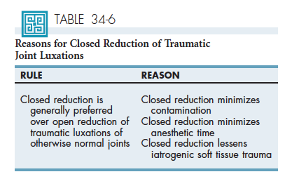
- Closed is preferred whenever possible
- Promotes rapid healing
- Contraindications: hip dysplasia, congenital elbow luxation, fractures, ST interposition

Tobias p. 725-727 – Chapter 53 – Traumatic Luxation of the Elbow Joint
- Uncommon dogs; Rare cats – bone conformation and strong muscular and ligamentous structures surrounding elbow
  - Anconeal process interlocks in the olecranon fossa preventing luxation unless joint flexed > 45 degrees
  - Large size of humeral trochlea prevents medial displacement of radius/ulna: > 90% of the luxation are laterally oriented
  - Fracture of distal humerus or proximal radius/ulna more common
  - Fracture of proximal ulna and radial head luxation = Monteggia fracture
- From rotational forces
- At least the lateral collateral ligament is transected (dogs); both medial and lateral collateral ligaments transected (cats) – experimental study; traumatic elbow luxation can be associated with elongation rather than disruption of the ligaments
  - Disruption of joint capsule, rupture/avulsion of collateral ligament(s), articular cartilage damage
  - Origins of the extensor or flexor muscles may be ruptured or avulsed from the humeral condyle (severe injury)
Diagnosis
- Recent trauma (chronic is unusual)
- NWB
- Antebrachium in abduction and external rotation, elbow joint in slight flexion
- Swelling, pain, crepitus
- Lateral epicondyle of humerus less distinct, radial head and olecranon are laterally displaced
- Look for chest injury, evaluate neuro function, vascularization
- Xrays: CrCd view (lateral* or medial displacement of radius/ulna; antebrachium may be displaced proximally owing to contracture of triceps brachii)
  - Look for fracture (avulsion, articular), OA (chronic luxation or preexisting disease)
Treatment
- GA – analgesia and muscle relaxation (NMB, regional analgesia)
- Closed: acute luxation of a joint that appears to be otherwise normal
- Campbell’s test = to assess collateral ligament: elbow and carpus 90 degrees flexion (anconeal process is positioned caudally to the olecranon fossa; rotational stability relies primarily on collateral ligaments)

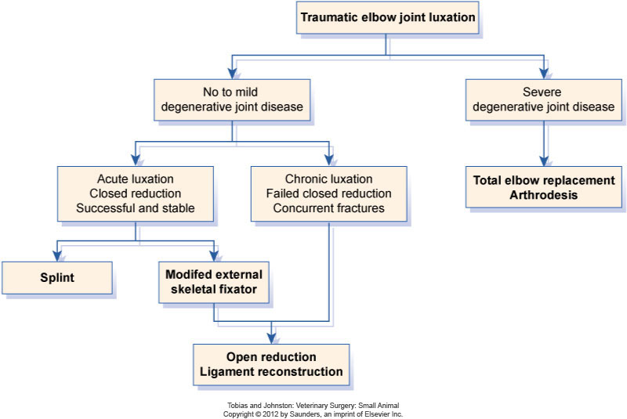

Tobias p. 1215-1220 – Chapter 76 – Open Wounds
Definitive wound care
- Under GA – in stable patients
- Wound preparation
  - Aseptic preparation
  - Clip
  - Clean/flush: warm, sterile, balanced electrolyte solution
    - Normal saline: slightly hypoosmolar; cytotoxic to fibroblast in vitro
    - BES: no in vitro cytotoxicity
    - Additional of antiseptic: questionable
      - Because goal is to MECHANICALLY removed contaminants
      - Noncytotoxic concentrations should be used:
        - 0,05%-0, 1% chlorhex (1:40 of 2%)
          - Diacetate form precipitates in saline
          - Scrub contained a detergent = cytotoxic
        - 0,1-0,01% of povidone-iodine (1:100-1:1000 of 10%)
        - Hydrogen peroxide – Dakin solution – acetic acid
          - Poor spectrum
          - Cytotoxic
- Wound debridement
  - To remove foreign material, contaminated, devitalized, necrotic tissue
  - Contaminants inflammation
  - Devitalized tissue medium for microbial growth
  - GOOD exploration
    - Puncture wounds: incision near or over the wound to expose underlying tissue damage and contamination
  - Layered Debridement
    - Sequential removal of devitalized tissue at the surface of the wound, progressing to wound depths
      - Conservative approach
      - For extensive wound not amenable to excision
      - Repeated debridement may be necessary
      - Goal: to have a well-vascularized wound bed to support wound healing
      - Cortical bone, fat, fascia = not well vascularized
        - Penetration of cortical bone in multiple sites with a small pin (forage) allows vascular medullary canal to communicate with wound bed
        - Excess fat should be removed; intact fascia debrided
      - Excessive debridement may delay healing (*cats): reduction of blood perfusion, granulation, contraction, epithelialization, total healing
  - Nonsurgical debridement
    - Enzymatic or chemical agents that dissolve collagenous tissue and cause superficial sloughing of debris/devitalized tissue (trypsin, collagenase, papain, urea)
    - Enzymatic: take time to have an effect, $, non selective
      - For chronic, indolent, non healing wounds – when surgical debridement non possible
    - Non enzymatic debridement
      - Hypertonic saline: hyperosmotic effect draws exudate and debris and reduces edema; can dehydrate normal tissue if application is prolonged; dehydration of microorganisms, cidal and inhibitor effect on their growth
      - Honey: antimicrobial effects not only explained by hyperosmolality
        - Glucose oxidase in honey acts on glucose hydrogen peroxide at very low concentration (0,003%); HP then oxidized and oxygen-derived free radicals that damage m-o; cytotoxicity reduced by antioxidants present in honey
        - Contains phytochemicals (antibacterial substances made up of phenols and organic acids)
        - Medical-graded honey rated according to its inhibin number
          - Inhibin # = amount of dilution to which honey will retain its antibacterial activity
        - Reduction of inflammation (antioxidant)
        - Facilitation of wound healing (stimulation of B and T lymphocytes proliferation, phagocytic activity, cytokines release)
        - Effectiveness is however equivocal – meta-analysis of 19 RCTs – wound selection? Maybe better for acute?
The effectiveness of honey is based on four principles. Its high osmolality is bactericidal. The high osmolality also reduces edema and attracts macrophages. Honey has hydrogen peroxidase which is also bacteriocidal. Finally, phytochemicals (in Manuka honey) are believed to be antimicrobial through an unknown mechanism. Honey has been shown to be effective against a wide variety of Gram-positive and negative organisms (including S. marcescens, E. coli, P. aeruginosa, and Candida spp.). The downside of honey is primarily associated with its mode of action. Hydrogen peroxidases are inactivated by light and should not be stored in clear containers. The enzyme is also degraded by heat, so pasteurization can decrease the bactericidal affects. Unpasteurized honey can contain clostridial spores, though irradiation is an option for sterilization. – IVECCS 2010

      - Sugar
Has similar mechanisms of action. The high osmolality is bactericidal, and the high osmolality reduces edema and attracts macrophages. Additionally, simple sugars provide a cellular energy source and encourage granulation bed formation. Granulated sugar is placed into the wound cavity in a layer 1-cm thick and covered with a thick dressing to absorb fluid drawn from the wound. The sugar dressing should be changed once daily or more frequently whenever “strike-through” is seen on the bandage. During the bandage change, the wound should be liberally lavaged with warm saline or tap water. Sugar dressings may be used until granulation tissue is seen. – IVECCS 2010

    - Wet-to-Dry bandages
      - Mechanical debridement – no longer standard of care
        - Non selective debridement
        - Dry rapidly, adhere to wound
        - Require repeated moistening and reapplication
          - Dry wound surface will inhibit epithelialization
        - Can macerate the wound edges
        - Can leave lint or fiber residue in the wound
        - Can remove normal tissue
        - Can destroy healthy epithelial cells
        - Should never be applied to healthy granulating wound
    - Maggots
      - Secrete digestive enzymes to dissolve necrotic tissue
      - Maggots of the Green box fly – Lucilia sericata - do not damage healthy dermis and SQ – but can destroy healthy epithelium
- Moist wound healing
  - Current standard of care for open wound management = fostering a moist wound environment to facilitate debridement, granulation, and epithelialization
  - Moisture facilitates autolytic wound debridement by keeping cellular and cytokine-rich exudate at the surface of the wound
  - Application of hydrophilic dressings
    - Different absorptive capacity among dressings; selection based on the rate of wound exudate production
    - Dry to minimally exudative
      - Exogenous moisture can be provided: water-based hydrogel dressing
        - Hydrogel directly applied and covered by semi-occlusive dressing
        - Hydrogel-impregnated dressing
    - Mildly to moderately exudative
      - Hydrocolloid sheet
      - Polyurethane foam
      - Maltodextran polymer
        - They are dry on contact but are very hydrophilic; rapidly imbibe wound exudate to form a gelatinous layer
    - Heavily exudative
      - Colloidal dressings containing calcium alginate
        - Alginate dressings enhance granulation (alginate = hydrophilic agent from seaweed)
      - Also alginate dressings impregnated with silver (= broad spectrum atm agent)
      - Hypertonic saline dressings
- Topical ATM agents
  - Topical ATB ointment
    - Bacitracin zinc, neomycin sulfate, polymyxin B
    - Poor systemic absorption
    - For midly contaminated wounds
    - May enhance wound epithelialization by keeping wound moist and protected rather than having any direct effect on healing
  - Slow-release silver dressings
    - Honey might be better than 1% silver sulfadiazine for burns
    - Now nanoparticles slow release silver-impregnated dressings and ionic silver-impregnated dressings
    - Silver dressing may lead to formation of green-mucoid exudate
    - Antibacterial activity
- Bioscaffolds and synthetic matrix dressings
  - Provide substrate for extracellular matrix formation
  - Bioscaffolds: stimulate matrix deposition, angiogenesis, epithelialization (collagenous and growth factor content)
    - More for chronic indolent wounds
  - Synthetic matrix dressings (collagen and collagen/oxidized regenerated cellulose dressings)
    - Competitive substrates for MMP-2, MMP-9, and bacterial collagenase
    - Favor wound balance toward tissue inhibitor of MMP which allow proliferation of extracellular matrix
  - Porcine small intestinal submucosa; hydrolyzed bovine collagen dressings
    - No positive effects in acute wounds in dogs vs semi-occlusive non-adherent dressing
- Chitosan
  - Co-polymer of glucosamine derived from chitin-rich crab shell
    - Enhances function of inflammatory cells
    - Increases granulation
    - Increases neovascularization
    - No commercial dressings available at this time
- Growth factor-containing agents
  - rhPDGF-BB containing ointment – no report of controlled use in vet
- Negative-pressure wound therapy
  - =Local application of subatm pressure across a wound
  - Coarse, open cell (400-600 μm pore) foam
  - Drainage tube placed above the foam
  - Foam and tubing covered by occlusive dressing (complete seal)
  - Tubing connected to semiportable mechanical unit that applies constant negative (suction) pressure
  - Promotes wound perfusion, reduces edema, stimulates granulation, decreases bacterial colonization, removes exudate
  - Tissue perfusion decreases with the amount of suction applied (increase in tissue pressure); influenced by tissue type (-125 mmHg; -75 for grafts)
  - Anecdotal reports; systemic reviews have not found evidence-based benefits

Questions

1. True of False: During traumatic elbow luxation, radius/ulna are most commonly displaced in a medial direction – Justify your answer

2. What is a Monteggia fracture?

3. Complete: Presence of glucose oxidase in honey acts on glucose and leads to the production of _________________________.

4. Which of the following can be used to irrigate a wound?
A. Tap water
B. 1% povidone-iodine
C. 0,3% hydrogen peroxide
D. 0,5% chlorhexidine

5. You are treating a 5-year-old male neutered Labrador that has been hit by a car. He has a large, severely contaminated wound on his left hindlimb. You perform the initial debridement and irrigation of the wound and covered it with a semi-occlusive non-adherent dressing. Because of the degree of inflammation observed, you expect a moderate amount of exudate. Which of the following dressing is the most appropriate in that case?
A. Bacitracin zinc, neomycin sulfate, polymyxin B impregnated dressing
B. Hydrogel-impregnated dressing
C. Hydrocolloid dressing
D. Colloidal dressing containing calcium alginate

Questions & Answers

1. False: During traumatic elbow luxation, radius/ulna are most commonly displaced in a medial direction – Large size of humeral trochlea prevents medial displacement of radius/ulna; > 90% are laterally displaced

2. What is a Monteggia fracture?
Proximal ulna fracture with luxation of radial head

3. Complete: Presence of glucose oxidase in honey acts on glucose and leads to the production of hydrogen peroxide.

4. Which of the following can be used to irrigate a wound?
A. Tap water
B. 1% povidone-iodine 0,01-0,1%
C. 0,3% hydrogen peroxide poor spectrum; cytotoxic
D. 0,5% chlorhexidine 0,05-0,1%

5. You are treating a 5-year-old male neutered Labrador that has been hit by a car. He has a large, severely contaminated wound on his left hindlimb. You perform the initial debridement and irrigation of the wound and covered it with a semi-occlusive non-adherent dressing. Because of the degree of inflammation observed, you expect a moderate amount of exudate. Which of the following dressing is the most appropriate in that case?
A. Bacitracin zinc, neomycin sulfate, polymyxin B impregnated dressing
B. Hydrogel-impregnated dressing
C. Hydrocolloid dressing
D. Colloidal dressing containing calcium alginate

