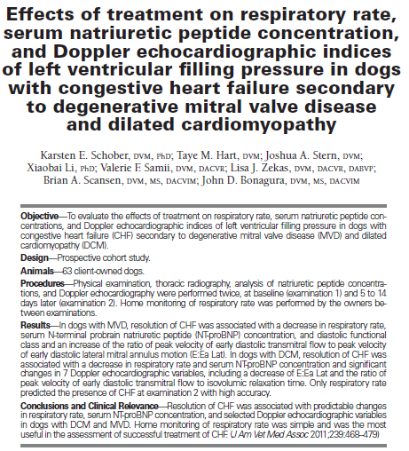
Key Points:
- Evaluated the simple variable respiratory rate, laboratory tests measuring concentrations of circulating natriuretic peptides, and relatively more complicated Doppler echocardiographic variables of left ventricular filling
- Goal was to quantify changes in these variables that would be associated with successful treatment of CHF and to recommend clinically applicable decision thresholds
- In dogs with MVD, resolution of CHF is associated with a consistent decrease in respiratory rate and less predictively a decrease in serum NT-proBNP concentrations and Doppler echocardiography–derived diastolic functional class
- In dogs with DCM, resolution of CHF is associated with a consistent decrease of respiratory rate and serum NT-proBNP concentration and with changes in multiple Doppler echocardiographic variables, including E:IVRT

