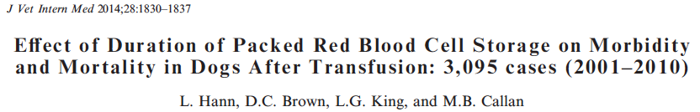

Retrospective study investigating 3,095 dogs that received 5,412 PRBC units to determine if duration of PRBC storage has an effect on morbidity and mortality in dogs after transfusion.
- The most common reason for RBC transfusion was hemorrhage (n = 2,103, 68%), with neoplasia (n = 766), trauma (n = 285), and surgical blood loss (n = 249) being the most frequent underlying causes of hemorrhage

- Duration of PRBC storage does not appear to be a major contributing factor to mortality in the overall canine population. However, longer duration of PRBC storage may negatively impact outcome in dogs with immune-mediated hemolytic anemia, thus warranting further investigation with prospective studies.
- Longer duration of PRBC storage was associated with development of new or progressive coagulation failure and thromboembolic disease (TED).
- There was no association between duration of PRBC storage and survival for all dogs overall.
- For dogs with hemolysis, 90% of which had immune-mediated hemolytic anemia, longer duration of PRBC storage was a negative risk factor for survival. For every 7 day increase in storage, there was a 0.79 lesser odds of 30 day survival
  - Transfusion of older PRBCs may activate the endothelium by release of free hemoglobin or potential harmful mediators that accumulate during storage (eg, microparticles, isoprostanes), resulting in platelet consumption, activation of coagulation factors, and thrombotic events.
- Specific mechanism or mechanisms by which transfusion of older, stored RBCs may increase morbidity and mortality is not yet known
  - Potential mediators include the accumulation of microparticles in RBC units during storage, release of free hemoglobin, and increased plasma concentration of nontransferrin bound iron (NTBI) after rapid clearance of storage-damaged RBCs by the reticuloendothelial system.

- The shelf-life of refrigerator stored PRBCs varies depending on the anticoagulant and preservative solution used, but typically is 35 and 42 days for canine and human PRBCs, respectively.

- Increasing patient age and pretransfusion plasma lactate concentration also were found to be negative risk factors for survival of dogs with hemolysis

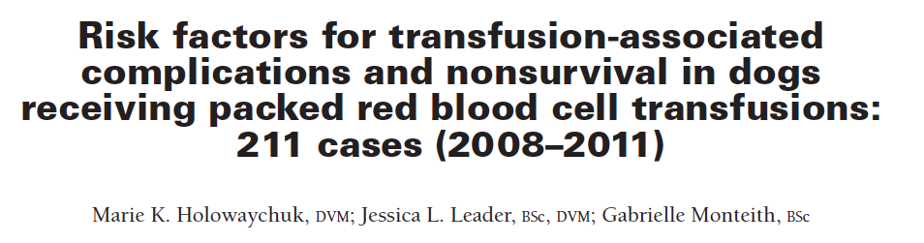

Objective - To determine whether the number, volume, or age of transfused packed RBC
units; volume of other blood products; or pretransfusion PCV was a risk factor for transfusion- associated complications or nonsurvival in dogs
Retrospective study

- Administration of larger doses of other non–packed RBC blood products was a risk factor for transfusion-associated complications.
- A higher pretransfusion PCV and larger dose of packed RBCs administered were risk factors for nonsurvival.
  - Use of a higher pretransfusion PCV to trigger the administration of packed RBC units, resulted in admistering a larger total dose of packed RBCs than would otherwise be given with a more conservative transfusion trigger
- Dose (mL/kg) of other blood products administered was a risk factor for transfusion-associated complications.
  - For every other blood product transfusion, the risk of transfusion- associated complications increased almost 3-fold.
  - Non packed rbc units transfused included whole blood, FFP, or platelets concentrate, which all contain a larger quantity of plasma and protein than a prbc unit and have a greater propensity for causing immunologic reactions unrelated to rbc incompatibilities
- Mean age of packed RBC units, number of packed RBC units > 14 days old, and age of oldest packed RBC unit administered were not identified as risk factors for transfusion-associated complications or nonsurvival. Study was underpowered to evaluate this.

The shelf-life of refrigerator stored PRBCs varies depending on the anticoagulant and preservative solution used, but typically is _____ and _____ days for canine and human PRBCs, respectively.
- 14 and 20 days
- 25 and 30 days
- 35 and 42 days
- 40 and 50 days

Hemoglobinemia, hemoglobinuria, and rectal temperature > 39.0o C refers to which of the following reacitons?
- Febrile nonhemolytic reaction
- Acute hemolytic reaction
- Anaphylactic reaction
- Delayed reaction

Which of the following were risks for non-survival?
- volume and age of transfused packed RBC
- lower pretransfusion PCV
- higher pretransfusion PCV and larger dose of packed rbcs administered
- age of transfused packed RBCs

True or False. Transfusion of other (non–packed RBC) blood products WAS a risk factor for transfusion-associated complication

True or False. Transfusion-associated complications WERE identified as a risk factor for nonsurvival.

The shelf-life of refrigerator stored PRBCs varies depending on the anticoagulant and preservative solution used, but typically is _____ and _____ days for canine and human PRBCs, respectively.
- 14 and 20 days
- 25 and 30 days
- 35 and 42 days
- 40 and 50 days

Hemoglobinemia, hemoglobinuria, and rectal temperature > 39.0o C refers to which of the following reacitons?
- Febrile nonhemolytic reaction
- Acute hemolytic reaction
- Anaphylactic reaction
- Delayed reaction

Which of the following were risks for non-survival?
- volume and age of transfused packed RBC
- lower pretransfusion PCV
- higher pretransfusion PCV and larger dose of packed rbcs administered
- age of transfused packed RBCs

True or False. Transfusion of other (non–packed RBC) blood products WAS a risk factor for transfusion-associated complication

True or False. Transfusion-associated complications WERE identified as a risk factor for nonsurvival.

