ECHOCARDIOGRAPHY CHAPTER 11
- Gives info about cardiac structure, dimensions, and function
- Different types of echocardiography
  - M-mode
  - 2D
  - 3D
  - Doppler echocardiography – spectral, tissue Doppler imaging
- M-mode
  - Depicts linear dimension plotted against time
  - ONE PLANE only
  - +: excellent time resolution for measurement of cardiac dimensions at precise time points
  - - : sampling area is very limited; gives little information about changes in cardiac size or shape in other dimensions, or about specific lesions; difficult technique
  - Can be used for:
    - LA:Ao_{M-mode}
    - M-mode LV diameter
- 2D
  - Sector scan that produces tomographic slices through the heart
  - Provides numerous different imaging planes
  - Can show abnormalities of cardiac size, shape, lesions.
  - Different views:
    - Right parasternal long-axis (4 chamber and 5 chamber)
    - Right parasternal short axis (papillary muscle level, mitral valve level, aortic valve level, pulmonary artery level)
    - Left apical (4 chamber, 5 chamber, 2 chamber)
    - Left cranial (tricuspid valve, aorta, pulmonary artery)
- Doppler echocardiography
  - ** Doppler principle: frequency of reflected US waves is changed if the reflecting target is moving towards or away from the source
  - **The beam of US waves MUST be parallel with the direction of the moving target (i.e. blood flow)
  - Gives information about velocity of BF (spectral)
    - Velocity displayed as a velocity-time graph
    - Blood flow away from transducer: below the baseline
    - Blood flow towards the transducer: above the baseline
    - Pulsed wave (PW): very limited area of BF is sampled
    - Continuous wave (CW): BF is sampled along the entire length of the cursor; higher velocities can be displayed; range ambiguity: the exact location of the high velocity flow along the cursor cannot be determined from the spectral signal
    - ** Simplified Bernoulli equation:
Pressure gradient (mmHg) = 4 x velocity²
  - Direction and timing of BF can be depicted in color (color Doppler)
    - Blue: away ; Red: towards
    - Aliasing: high velocities; reversal of color (red to blue. blue to red)
  - Myocardium velocity can also be recorded (tissue Doppler imaging)
Chambers Measurements
- * Left heart – partly because the left heart is an easier shape to quantify than the right; most important acquired diseases primarily affect the left heart
- Measurements should be taken from at least 3 cardiac cycles and averaged
- LA:
  - M-mode or 2D
- LV
  - M-mode or 2D
  - Normal canine RI are problematic because of the range in BW and conformation – ratio indices, Cornell method, breed-specific values
Systolic Function
- Fractional shortening = the percentage change in LV diameter in systole
  - M-mode obtained from short-axis
  - Timing:
    - LVDd measured at end-diastole at the start of QRS
    - LVDs measured at peak septal motion
  - FS = (LVDd-LVDs)/LVDd x100 ; cats: 30-50%; dogs: 25-50%
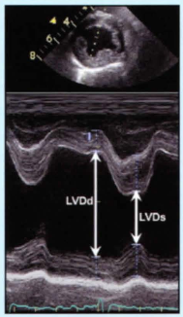
- Mitral E-point to septal separation (EPSS)
  - M-mode
  - To measure maximal opening of the mitral valve in diastole by measuring the distance between the septum and early opening (E-point) of the anterior mitral valve leaflet (EPSS)
  - This distance is increased with systolic dysfunction; large dogs: < 7 mm
  - !! Avoid oblique view
  - Timing:
    - Peak opening of mitral valve in early systole
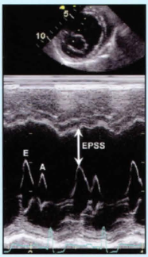
- Left ventricle end-systolic volume index
  - ESV can be normalized to BSA; ESVI = ESV/BSA ≤ 30 ml/m²
  - Timing: ESV at smallest LV dimensions before mitral valve opens
  - Trace endocardial border from septal mitral valve annulus to lateral wall mitral valve annulus
  - Vital to obtain true apex
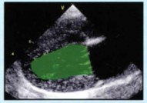

- Ejection fraction
  - The percentage change in LV volume during systole can be calculated from the volumes measured from a right parasternal long-axis view
  - Should not be derived from volumes estimated from M-mode measurements
  - When calculated from 2D images, EF more accurately assesses global systolic function
  - Timing:
    - EDV after mitral valve closes before systole
    - ESV: at smallest LV dimensions before mitral valve opens
  - EF% = (EDV- ESV)/EDV x 100; dogs = 50-65%
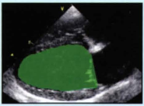
- Systolic time intervals
  - Uses the timing of ejection with respect to electrical activation
  - The interval between the beginning of the Q and the onset of ejection of blood into the aorta (the pre-ejection period; PEP) can be divided by the duration of aortic ejection (the ejection time; ET) to give the systolic time interval = PEP/ET
  - This ratio is increased with systolic dysfunction and can be measured from the spectral Doppler flow signal with a concurrent ECG; dogs = 0.24-0.38
  - Timing:
    - PEP: from start of QRS to onset of aortic ejection
    - ET: duration of aortic spectral Doppler flow signal
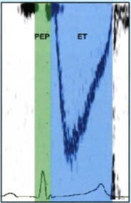
Questions
- You are evaluating a 5 year old male neutered Labrador. You obtained the following echocardiographic values: LVDd = 4.7 cm; LVDs = 3.1 cm; IVSd = 1.0 cm; LVFWd = 1.0 cm; LA = 2.7 cm; Ao=2/6 cm/
What is his fractional shortening? Is that normal? Which view do you use to evaluate FS?

- When do you measure the LVDs?
  - At the onset of the QRS
  - At the end of the QRS
  - At the onset of the T wave
  - At the peak of the T wave

- True or False: In spectral Doppler, if the beam is not align perfectly parallel with blood flow, the peak velocity will be overestimated.

Questions & Answers
- You are evaluating a 5 year old male neutered Labrador. You obtained the following echocardiographic values: LVDd = 4.7 cm; LVDs = 3.1 cm. What is his fractional shortening? Is that normal?
FS = (4.7-3.1)/4.7 x 100 = 34%; normal; Short-axis view, right parasternal window (midventricular region) M-mode

- When do you measure the LVDs?
  - At the onset of the QRS - diastole
  - At the end of the QRS
  - At the onset of the T wave
  - At the peak of the T wave

- False: In spectral Doppler, if the beam is not align perfectly parallel with blood flow, the peak velocity will be underestimated

