DUKE’S CHAPTER 27: PHYSIOLOGY OF SKELETAL MUSCLE

Terminology
Origin of a skeletal muscle is the least moveable end of a muscle
Insertion of a skeletal muscle refers to the most moveable end

Flexor skeletal muscle is on the side of the limb that decreasing the joint angle when activated
Extensors are located on the side of the limb that increasing the joint angle
Adductors are muscles that pull a limb toward the median plane
Abductors pull a limb away from the median plane.

Structure
Skeletal muscle fibers can be classified into three types:
- Red or dark (type I; slow twitch) – large amounts of myoglobin, capillaries and mitochondria to support greater oxidative metabolism (needed for sustained flight or other activities of this nature).
- White or pale (type II; fast twitch) - react rapidly and with short duration. Composed of large fibers with great strength of contraction. Extensive sarcoplasmic reticulum for rapid release of energy via the glycolytic process.
- Intermediate - characteristics between those of red and white fibers.

Organization of the connective tissue components
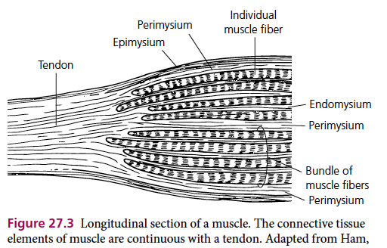

A muscle fiber refers to the skeletal muscle cell.

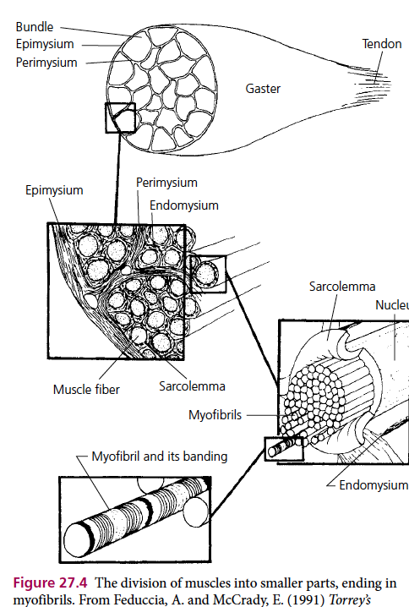

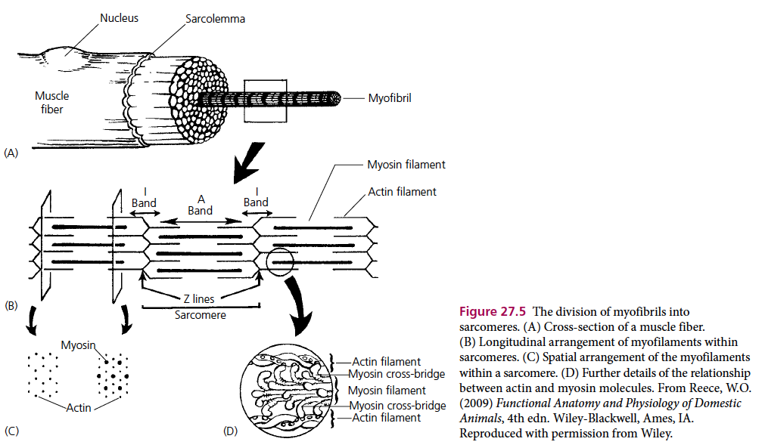

Ratio of actin to myosin is 2:1

The sarcotubular system is composed of two separate tubule sets:
- Sarcoplastic reticulum are the tubules arranged parallel to the myofibrils and encircle them.
- T tubules are arranged at right angles/transversely to the myofibrils.

The principal function of the sarcotubular system is to provide a means for conduction of an impulse from the surface of the muscle fiber to its innermost aspects.

The sarcoplasmic reticulum is an important storage site for calcium ions.

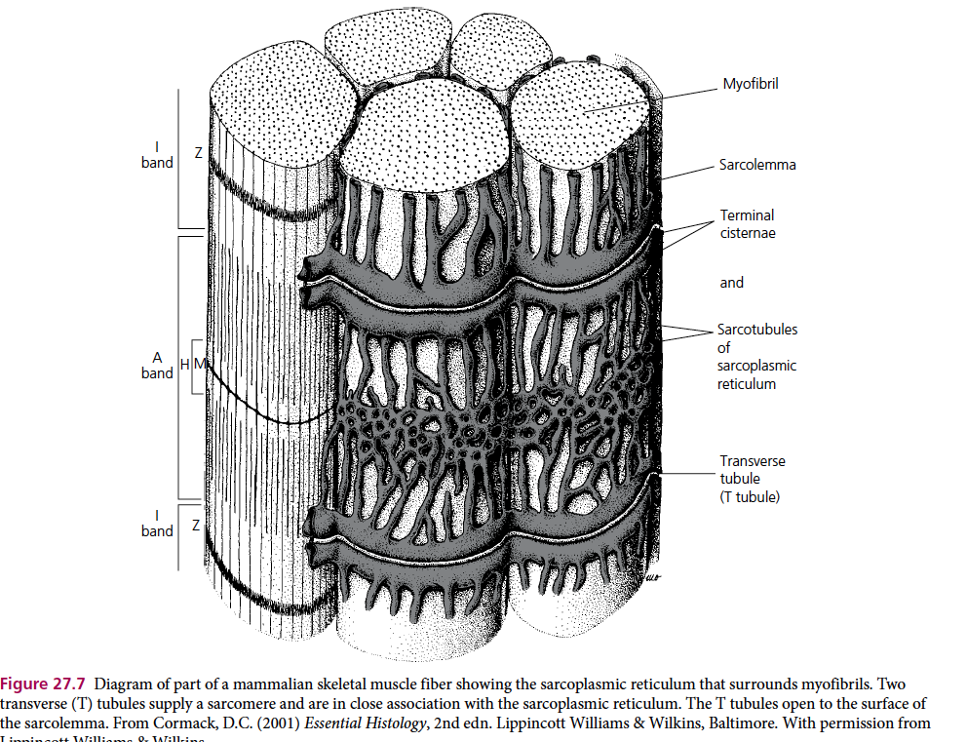

Neuromuscular junction and depolarization of muscle fibers
The terminal branch of a motor neuron makes contact with a skeletal muscle fiber at the neuromuscular junction.

When calcium ions enter the terminal bulb of an axon, calcium ion concentration increases 10-100 times. Calcium ions trigger the binding of synaptic vesicles to the plasma membrane of the terminal bulb and the release of Ach into the synaptic cleft.

Acetylcholine is the neurotransmitter that is stored in the membrane bound vesicles within the terminal branch of the axon.

The signal that causes depolarization moves from the sarcolemma into the T tubes sarcoplastic reticulum myofibrils and every sarcomere in the myofibril.

Skeletal muscle contraction
The actin filament has three major components: (i) actin, (ii) tropomyosin, and (iii) troponin.

Active sites (places where myosin cross‐bridges attach) are located on the actin strands and are normally covered by the tropomyosin strands. When calcium ions bind to the troponin complex, a conformational change occurs between the actin and tropomyosin strands that causes the active sites to be uncovered.
The uncovered sites allows attachment of myosin cross‐bridge heads to active sites on actin.

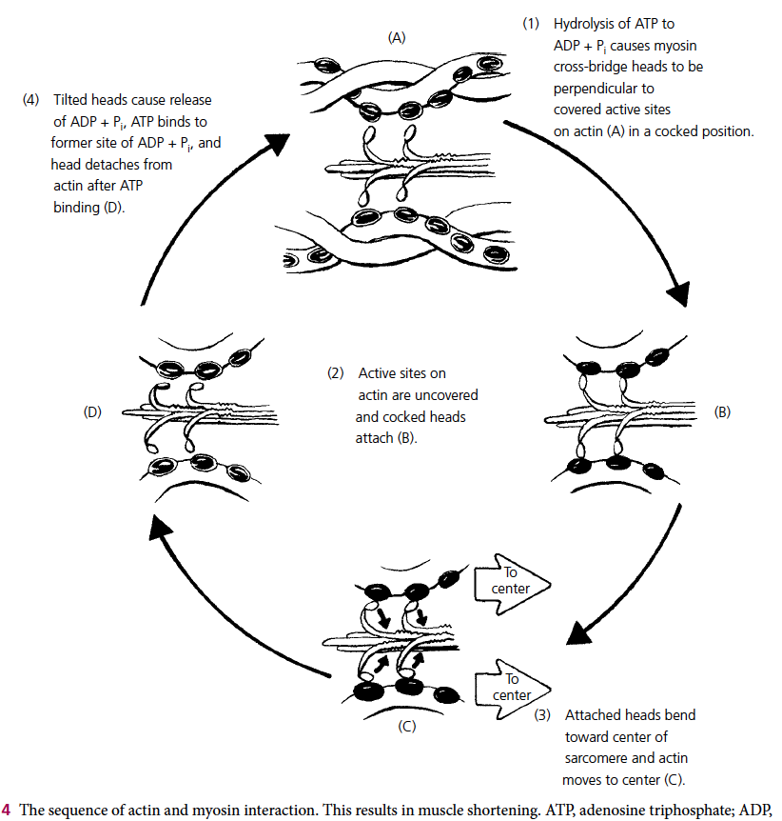

Sequence of actin and myosin interaction
(A) ATPase of the myosin crossbridge heads hydrolyzes ATP to ADP and inorganic phosphate (Pi)
Energy from the hydrolysis of ATP “cocks” the heads so that they increase their angle of attachment and become perpendicular to the active sites of the actin myofilaments.

(B) After depolarization of the sarcotubular system, calcium ions diffuse from the sarcoplasmic reticulum into myofibrils and bind to the troponin complexes actin myofilaments are uncovered.
The “cocked” myosin heads bind with active sites of actin.

(C) Binding with actin causes conformational changes in the cross‐bridge heads and they bend toward the cross‐bridge arms (toward the center of the sarcomere), pulling actin with it.

(D) Tilting of the cross‐bridge heads causes release of ATP and Pi and sites on the heads are exposed for binding of new ATP.
The binding of new ATP causes detachment of myosin crossbridge heads from actin myofilaments.

The process is repeated when the next neuromuscular transmission causes depolarization of the sarcotubular system.
Repetition of the process causes the actin myofilaments to be pulled further into the center, shortening the sarcomere.

Questions
1. The sarcotubular system:
a) Is located within muscle fibers but outside of myofibrils
b) Is a system within each of the myofibrils
c) Has no direct communication with extracellular fluid
d) Consists of a nerve fiber and the muscle fibers that it innervates

2. Conduction of depolarization from the surface of a muscle fiber to its inner aspects is accomplished by which of the following?
a) Neuromuscular junction
b) Actin filaments
c) Endomysium
d) Sarcotubular system

3. The calcium released from the sarcoplasmic reticulum begins the contraction process by:
a) “Cocking” the myosin filament cross‐bridge heads
b) Rephosphorylating ADP
c) Exposing actin filament cross‐bridge binding sites
d) Facilitating ACh release from the neuromuscular junction

4. Myosin cross‐bridge heads detach from actin active sites when the cross‐bridge heads bind:
a) Calcium
b) ATP
c) Creatine phosphate
d) ADP + Pi

5. Explain how hypocalcemia in the bitch after whelping causes puerperal tetany.
Answers
1. The sarcotubular system:
a) Is located within muscle fibers but outside of myofibrils
b) Is a system within each of the myofibrils
c) Has no direct communication with extracellular fluid
d) Consists of a nerve fiber and the muscle fibers that it innervates

2. Conduction of depolarization from the surface of a muscle fiber to its inner aspects is accomplished by which of the following?
a) Neuromuscular junction
b) Actin filaments
c) Endomysium
d) Sarcotubular system

3. The calcium released from the sarcoplasmic reticulum begins the contraction process by:
a) “Cocking” the myosin filament cross‐bridge heads
b) Rephosphorylating ADP
c) Exposing actin filament cross‐bridge binding sites
d) Facilitating ACh release from the neuromuscular junction

4. Myosin cross‐bridge heads detach from actin active sites when the cross‐bridge heads bind:
a) Calcium
b) ATP
c) Creatine phosphate
d) ADP + Pi

5. Explain how hypocalcemia in the bitch after whelping causes puerperal tetany.
In the bitch, there is a deficit of calcium ions, the voltage‐gated Ca2+ and Na+ channels become more permeable to sodium ions, and inward flow of sodium changes the membrane potential, thereby requiring a stimulus of lesser magnitude to depolarize. The nerve fiber becomes more excitable, discharging repetitively, rather than remaining in the resting state, causing tetanic muscle contractions.

Cell types | Resting potential
Skeletal muscle cells | −95 mV^{[4]}
Smooth muscle cells | –60 mV
Astroglia | –80 to –90 mV
Neurons | –60 to –70 mV
Erythrocytes | –9 mV
Photoreceptor cells | –40 mV

