Secretions of the Small Intestine
Brunner’s glands: located in proximal duodenum, between pylorus and papilla of Vater
- Secrete alkaline (contains HCO3-) mucus in response to :
  - Tactile or irritating stimulus of duodenal mucosa
  - Vagal stimulation (increases Brunner’s glands secretion and stomach secretion)
  - GI hormones (especially secretin)
- Function: protect duodenal wall from acidic gastric juices
- Inhibited by sympathetic stimulation (ie: stress)
Crypts of Lieberkühn: located on the entire surface of the small intestine, between the intestine villi. Surface of the crypt is covered by rapid reproducing epithelium (life cycle 5 days) made up from 2 types of cells:
- Goblets cells: secrete mucus which lubricates and protects the intestinal surface
- Enterocytes: secrete large quantities of water and electrolytes and then reabsorb this fluid with the end product of digestion. Produces 1800 mL/day of secretions with a pH of 7.5-8.0. Regulated by local enteric nervous reflexes triggered by tactile or irritative stimuli. Contains digestive enzymes:
  - Peptidase: to split peptides into aminoacids
  - Sucrase, Maltase, Isomaltase and lactase: to split disaccharides into monosaccharides
  - Lipase: to split neutral fats into glycerol and fatty acids
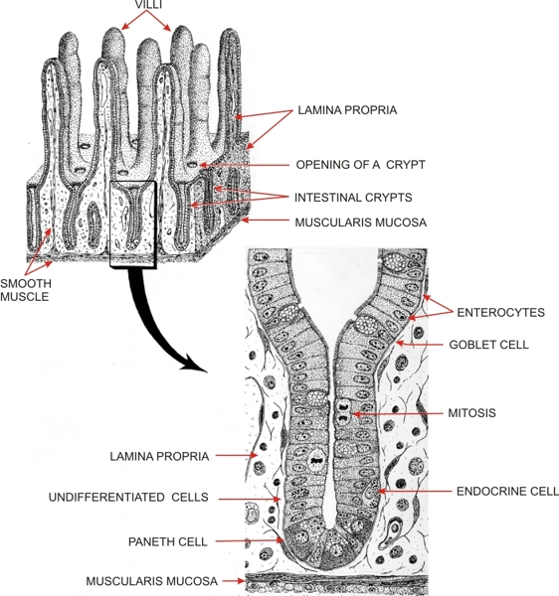
http://audilab.bmed.mcgill.ca/HA/HAimage/dig_fig_29_e.jpg
Secretions of the Large Intestine
Mucus Secretion:
- Mucous cells in Crypts of Lieberkühn secrete mucus which contains HCO3- secreted by non-mucus secreting epithelial cells.
- Rate of mucus secretion is stimulated by:
  - Tactile stimulation of epithelial cells in large intestine
  - Local nervous reflexes to mucous cells in the Crypts of Lieberkühn
  - Parasympathetic stimulation through pelvic nerves in the distal 2/3 of the large intestine, which also leads to increased peristalsis
- Function of mucus:
  - Protects intestinal wall from excoriation
  - Provides adherent to hold fecal matter together
  - Protects intestinal wall from bacterial activity
  - Provides an alkaline barrier from acids in feces
Response to Irritation:
- If irritation ocurrs (ie: enteritis), mucosa secretes extra large quantities of water and electrolytes in addition to the normal alkaline mucus.
- This dilutes the irritating factors and causes rapid movement of feces towards the anus diarrhea.
- This leads to loss of water and electrolytes as well as washing out irritant factors and promoting a quicker recovery.

Digestion and Absorption in the Gastrointestinal Tract
Hydrolysis: Specific enzymes in the GI tract return hydrogen and hydroxyl ions from water to separate molecules into smaller molecules.
R”-R’+H₂O ----Digestive enzyme- R”OH+R’H
- Carbohydrates are made up by polysaccharides and disaccharides
  - hydrolysis monosaccharides
- Fats are triglycerides made up by 3 fatty acids and 1 glycerol
  - Hydrolysis individual fatty acids
- Proteins are aminoacids linked by peptide linkages
  - Hydrolysis individual aminoacids

Carbohydrates in diet:
- Sucrose: disaccharide (cane sugar)
- Lactose: disaccharide in milk
- Starches: large polysaccharides in non-animal foods
- Cellulose: unable to digest by humans
- Less frequent carbohydrates: amylose, glycogen, alcohol, lactic acid, pyruvic acid, pectins, dextrins.
Mouth:
- Saliva contains the enzyme Ptyalin (α-amylase) secreted by parotid glands, this hydrolyzes starches to maltose.
Stomach:
- Starch digestion continues in the stomach for 1 hr until food is mixed with stomach secretions and salivary amylase is blocked.
Duodenum:
- Pancreatic amylase (+ potent α-amylase) mixes with chyme in the duodenum and continues carbohydrate digestion.
- Enterocytes contain 4 enzymes (lactase, sucrose, maltase, α-dextrinase), these break up carbohydrates to water-soluble monosaccharides that can be absorbed into portal blood.
- Carbohydrate digestion produces 80% glucose and 10% of each fructose and galactose.
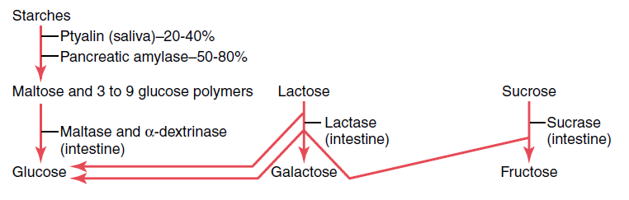
Proteins in diet:
Stomach:
- Stomach juices contain the enzyme Pepsin that cause protein and collagen digestion, pepsin is most active in an acidic pH, between 2.0-3.0 and inactivate when above 5.0.
- Pepsin produces 10-20% protein digestion to convert them to proteoses, peptones and polypeptides.

Duodenum and Jejunum:
- Proteolytic enzymes (trypsin, chymotrypsin, carboxypolypeptidase and proelastase) from pancreatic secretion produce the majority of protein digestion.
  - Trypsin and Chymotrypsin split protein molecules into small polypetides.
  - Carboxypolypeptidase cleaves individual aminoacids from the carboxyl ends of polypeptides.
  - Proelastase is converted into Elastase, which digests elastin fibers that hold meat together.
- Microvilli in the brush border of enterocytes produce Peptidases (Aminopolypeptidase and Dipeptidase), these split larger polypeptides into tripeptides and dipeptides and a few amino acids and then these are transported through the microvilliar membrane into the enterocyte.
- Enterocyte cytosol enzymes break these down to amino acids and then are passed onto the blood stream.
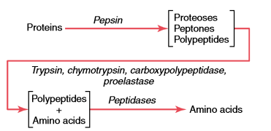
Fats in diet:
- Triglycerides are composed of glycerol and 3 fatty acid side chains, which are the main fat constituent of animal origin diet, with phospholipids, cholesterol and cholesterol esters present in small quantities.
Mouth:
- Lingual lipase, produced by lingual glands and swallowed by saliva starts 10% of fat digestion.
Stomach:
- Emulsification of fat is the breakdown of fat globules to small sizes available to water-soluble enzymes.
- Starts by agitation in the stomach to mix fats with products of stomach digestion.
Duodenum:
- Emulsification of fat continues with Bile which contains Bile Salts and Lecithin which have water-soluble polar portions and remaining fat soluble molecules.
- These fat soluble molecules dissolve in the surface layer of the fat globules, and the water soluble polar portions decrease the interfacial tension of fat making it soluble as well.
- When these are then agitated in the small bowel they can be broken up into small particles.
- Pancreatic Lipase digests triglycerides within 1 minute of contact and produces free fatty acids and 2-monoglycerides.
- Enteric Lipase is an additional lipase from enterocytes, although it is usually not needed.
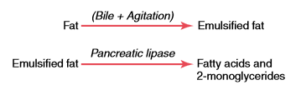
- Bile salts produce Micelles in water, which are spherical globules made up of 20-40 bile salt molecules encompassing a fat globule in the middle. This allows the fat globule to be transported and then absorbed into the blood stream and not be reattached to other fatty acids.
- Bile salts are then released back to the chyme once the free fatty acids are absorbed and reutilized to “ferry” more fatty acids.
- Cholesterol ester hydrolase and Phospholipase A hydrolyze cholesterol and phospholipids which are then “ferried” to be absorbed by bile salts.

Questions:

- Crypts of Lieberkühn are located on the entire surface of the _______ intestine. They are made up of 2 types of cells. ________cells that secrete mucus and ___________ that secrete digestive enzymes, water and electrolytes.

- Rate of mucus secretion in the large intestine is stimulated by:
  - Tactile stimulation of epithelial cells
  - Local nervous reflexes to mucous cells in the Crypts of Lieberkühn
  - Parasympathetic stimulation through pudendal nerves in the proximal 1/3 of the large intestine
  - a, b
  - All of the above

- Carbohydrates digestion produce _____% galactose, _____% fructose and ____% glucose.

- True or False: Micelles are formed to transport free fatty acids, cholesterol and phospholipids to the blood stream and to prevent the free fatty acids from reversing the hydrolysis

- Match the enzyme to its proper substance:

Elastase
Pepsin
Pancreatic Amylase Sucrose
Lactase Protein
Sucrase Lactose
Ptyalin Maltose
Chymotrypsin Starch
Maltase Fatty Acids
Pancreatic Lipase
α-Dextrinase
Enteric Lipase
Trypsin

Answers:

- Crypts of Lieberkühn are located on the entire surface of the Small intestine. They are made up of 2 types of cells. Goblet cells that secrete mucus and Enterocytes that secrete digestive enzymes, water and electrolytes.

- Rate of mucus secretion in the large intestine is stimulated by:
  - Tactile stimulation of epithelial cells
  - Local nervous reflexes to mucous cells in the Crypts of Lieberkühn
  - Parasympathetic stimulation through pelvic nerves in the proximal 2/3 of the large intestine
  - a, b
  - All of the above

- Carbohydrates digestion produces 10% galactose, 10% fructose and 80% glucose.

- True or False: Micelles are formed to transport free fatty acids, cholesterol and phospholipids to the blood stream and to prevent the free fatty acids from reversing the hydrolysis

- Match the enzyme to its proper substance:

Elastase
Pepsin
Pancreatic Amylase Sucrose
Lactase Protein
Sucrase Lactose
Ptyalin Maltose
Chymotrypsin Starch
Maltase Fatty Acids
Pancreatic Lipase
α-Dextrinase
Enteric Lipase
Trypsin

