Digestion and Absorption in the Gastrointestinal Tract
Hydrolysis: Specific enzymes in the GI tract return hydrogen and hydroxyl ions from water to separate molecules into smaller molecules.
R”-R’+H₂O ----Digestive enzyme- R”OH+R’H
- Carbohydrates are made up by polysaccharides and disaccharides
  - hydrolysis monosaccharides
- Fats are triglycerides made up by 3 fatty acids and 1 glycerol
  - Hydrolysis individual fatty acids
- Proteins are aminoacids linked by peptide linkages
  - Hydrolysis individual aminoacids
Carbohydrates in diet:
- Sucrose: disaccharide (cane sugar)
- Lactose: disaccharide in milk
- Starches: large polysaccharides in non-animal foods
- Cellulose: unable to digest by humans
- Less frequent carbohydrates: amylose, glycogen, alcohol, lactic acid, pyruvic acid, pectins, dextrins.
Mouth:
- Saliva contains the enzyme Ptyalin (α-amylase) secreted by parotid glands, this hydrolyzes starches to maltose.
Stomach:
- Starch digestion continues in the stomach for 1 hr until food is mixed with stomach secretions and salivary amylase is blocked.
Duodenum:
- Pancreatic amylase (+ potent α-amylase) mixes with chyme in the duodenum and continues carbohydrate digestion.
- Enterocytes contain 4 enzymes (lactase, sucrose, maltase, α-dextrinase), these break up carbohydrates to water-soluble monosaccharides that can be absorbed into portal blood.
- Carbohydrate digestion produces 80% glucose and 10% of each fructose and galactose.
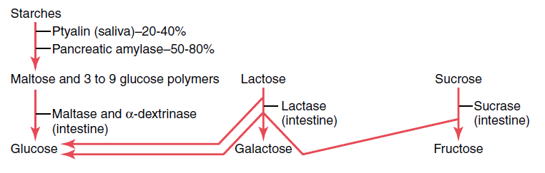
Proteins in diet:
Stomach:
- Stomach juices contain the enzyme Pepsin that cause protein and collagen digestion, pepsin is most active in an acidic pH, between 2.0-3.0 and inactivate when above 5.0.
- Pepsin produces 10-20% protein digestion to convert them to proteoses, peptones and polypeptides.
Duodenum and Jejunum:
- Proteolytic enzymes (trypsin, chymotrypsin, carboxypolypeptidase and proelastase) from pancreatic secretion produce the majority of protein digestion.
  - Trypsin and Chymotrypsin split protein molecules into small polypetides.
  - Carboxypolypeptidase cleaves individual aminoacids from the carboxyl ends of polypeptides.
  - Proelastase is converted into Elastase, which digests elastin fibers that hold meat together.
- Microvilli in the brush border of enterocytes produce Peptidases (Aminopolypeptidase and Dipeptidase), these split larger polypeptides into tripeptides and dipeptides and a few amino acids and then these are transported through the microvilliar membrane into the enterocyte.
- Enterocyte cytosol enzymes break these down to amino acids and then are passed onto the blood stream.
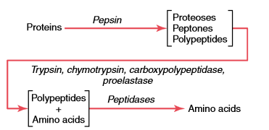

Fats in diet:
- Triglycerides are composed of glycerol and 3 fatty acid side chains, which are the main fat constituent of animal origin diet, with phospholipids, cholesterol and cholesterol esters present in small quantities.
Mouth:
- Lingual lipase, produced by lingual glands and swallowed by saliva starts 10% of fat digestion.
Stomach:
- Emulsification of fat is the breakdown of fat globules to small sizes available to water-soluble enzymes.
- Starts by agitation in the stomach to mix fats with products of stomach digestion.
Duodenum:
- Emulsification of fat continues with Bile which contains Bile Salts and Lecithin which have water-soluble polar portions and remaining fat soluble molecules.
- These fat soluble molecules dissolve in the surface layer of the fat globules, and the water soluble polar portions decrease the interfacial tension of fat making it soluble as well.
- When these are then agitated in the small bowel they can be broken up into small particles.
- Pancreatic Lipase digests triglycerides within 1 minute of contact and produces free fatty acids and 2-monoglycerides.
- Enteric Lipase is an additional lipase from enterocytes, although it is usually not needed.
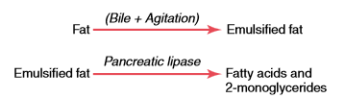
- Bile salts produce Micelles in water, which are spherical globules made up of 20-40 bile salt molecules encompassing a fat globule in the middle. This allows the fat globule to be transported and then absorbed into the blood stream and not be reattached to other fatty acids.
- Bile salts are then released back to the chyme once the free fatty acids are absorbed and reutilized to “ferry” more fatty acids.
- Cholesterol ester hydrolase and Phospholipase A hydrolyze cholesterol and phospholipids which are then “ferried” to be absorbed by bile salts.

- True or False: Carbohydrates are almost completely converted to maltose and other small glucose polymers before passing beyond the duodenum and upper jejunum.
- Carbohydrates digestion produce _____% galactose, _____% fructose and ____% glucose.

