Diagnostic Evaluation of the Pancreas
Signalment, History and Risk Factors
- Middle-aged or older
- Miniature Schnauzer, Yorkshire Terrier, Cocker Spaniel, Cavalier King Charles Spaniel, Collies and Boxers
- Risk factors: obesity, endocrinopathies (hyperadrenocorticism, hypothyroidism, diabetes mellitus), drug administration (KBr, phenobarbital, azathioprine, L-asparaginase, meglumine antinmonite: anti-leischmaniasis), hypertriglyceridemia >850 mg/dL, dietary indiscretion, abdominal surgery.
- Older cats more likely to develop chronic pancreatitis, DSH and Siamese may be at higher risk.
Clinical Signs and Physical Exam Findings
- No pathognomonic findings
- Anorexia, weakness, vomiting, diarrhea and or abdominal pain
- Dehydration, abdominal pain, icterus, fever or hypothermia, icterus, bleeding, ascites, as well as severe systemic complications (cardiovascular shock, DIC or multi-organ failure)
- Cats the most common signs are anorexia and lethargy.
Routine Clinical Pathology
- Not useful for definitive diagnosis, however useful to exclude other diseases and to assess overall condition
- Often normal in mild cases
- Coagulopathies and DIC may be seen in severe cases
- Elevated liver enzymes and hyperbilirubinemia are common
- Pre-renal azotemia is variable and associated with dehydration
- Other common findings: hypoalbuminemia, hypertriglyceridemia, hypercholesterolemia, hypokalemia, hyponatremia, hypochloremia, hypocalcemia (> common in cats)
Clinical Enzymology
Serum Pancreatic Lipase Immunoreactivity Concentration (Spec cPL/Spec fPL)
- Multiple sources- pancreatic, hepatic, gastric
- Pancreatic lipase is exclusive of pancreatic acinar cells and different from other lipases
- Immunoassays specifically quantify lipases based on their unique structure (i.e.: pancreatic)
- During pancreatitis, pancreatic lipase leaks from acinar cells and enters circulation in larger quantities.
- May detect pancreatic pathology, not necessarily exclusive to pancreatitis
- SNAP cPLI, useful to rule out
Serum Amylase and Lipase Activities
- Multiple sources- pancreatic, hepatic, gastrointestinal, renal, neoplastic
- Both increase during pancreatitis
- Not useful
Trypsin-Like Immunoreactivity
- Measures trypsinogen (inactive preform of trypsin) and trypsin in serum
- During pancreatitis, trypsinogen and trypsin leaks and enters circulation in larger quantities
- Short half-life, Increase quickly, but decrease to normal ranges after 3 days (48 hr. cats) of disease induction
- Cleared by glomerular filtration, hence renal disease can produce falsely elevated TLI
- Also may be increased in lymphoma and IBD
Diagnostic Imaging
Abdominal Radiography
- Possible increased soft tissue opacity, decreased serosal detail in right cranial abdomen (local peritonitis)
- Still considered first step diagnostic test
Abdominal Ultrasound
- Imaging method of choice, highly dependent on experience and quality of instrumentation
- Hypoechoic areas (necrosis or fluid accumulation), hyperechoic mesentery (peripancreatic fat necrosis), enlargement or irregularities of the pancreas, dilation of the pancreatic or biliary duct, abdominal effusion.
- FNA may also be a useful diagnostic tool
- Caution to not over interpret
Other Imaging Modalities
- Contrast-enhanced computed tomography, very sensitive in humans, unclear in animals
- Endoscopic retrograde cholangiopancreatography, endoscopic ultrasonography have varying results and require training and equipment
Histopathology
Direct Visualization during Exploratory Laparotomy or Laparoscopy
- Peripancreatic fat necrosis, pancreatic hemorrhage, dull granular capsular surface
- Changes may not always be present

Biopsy
- Gold Standard, histopathologic scoring systems have been proposed for dogs and cats
- Patients may not be stable enough to go to surgery
- Expensive, invasive
- If biopsies are done, consider hepatic and intestinal biopsies as well

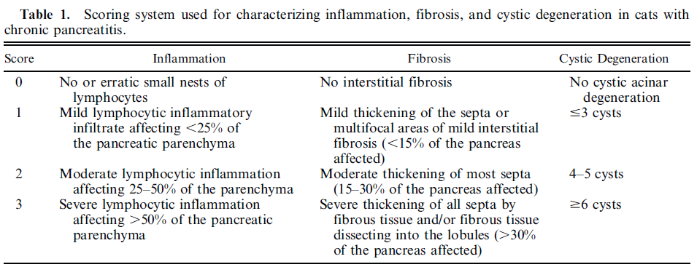
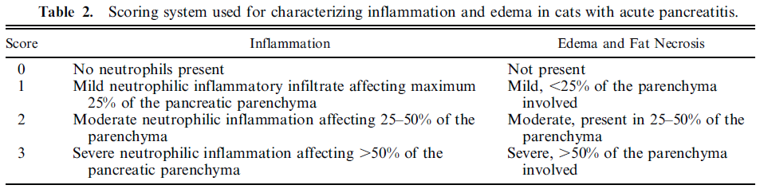
De Cock, H. E. V., et al. “Prevalence and histopathologic characteristics of pancreatitis in cats.” Veterinary Pathology Online 44.1 (2007): 39-49.

Cytology
- Minimally invasive, generally safe
- Acute pancreatitis: hypercellularity, intact and degenerate neutrophils, degenerate pancreatic acinar cells
- Chronic pancreatitis: small number of lymphocytes and neutrophils, low cellularity (replacement of normal pancreatic tissue for fibrotic tissue)
- Normal cytology does not rule out pancreatitis
Assessment and Prediction of Severity of Pancreatitis
- Severity of a pancreatitis episode is determined by the events that occur within the first 24 to 48 hr. of the episode- reflected through clinical, clinicopathologic and imaging findings to predict severity
- Markers such as C-reactive protein, serum interleukin-6 and plasma and urine trypsinogen activation peptide may be useful but require more investigation
- In people there are also a variety of scores and there in no consensus and which one is better
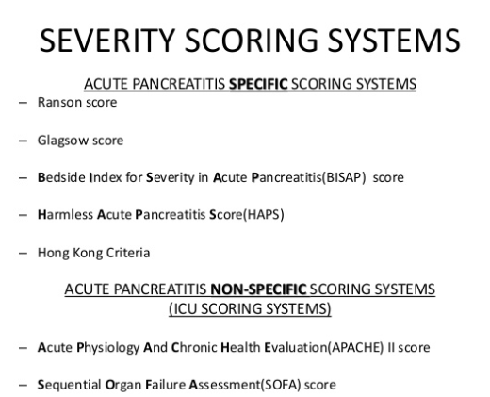

Diagnostic | Change(s) Expected with Pancreatitis | Diagnostic Utility Specificity/Sensitivity (if available) | Diagnostic Limitation(s) | Species Specific Considerations (if any)
Serum Lipase Activity | Elevated (dogs) | Dog: Sens 73%, Spec 55%  Cat: low | -Affected by renal clearance  -shown to be markedly increased in some dogs with acute enteritis, gastro-enteritis, liver disease, and renal failure  -Increases from administration of Dex SP  -can be normal in some patients with pancreatitis | May be normal in cats with pancreatitis
Serum Amylase Activity | Elevated (dogs) | Dog: Sens 62%, Spec 57%  Cat: low | -Affected by renal clearance  -can be normal in some patients with pancreatitis | May be normal in cats with pancreatitis
SerumTLI | Elevated (<40% dogs with pancreatitis) | Dogs: Sens 33%, Spec 65%  Cat: Sens 28-64%, Spec 82% | -Affected by renal clearance  -may have decreased by the time of sampling  -test result turnaround is long | May be normal in cats with pancreatitis
cPLI | Elevated | Dogs: Sens 66-77%, Spec 93%  Cat: Sens 67%, Spec 91% | -Affected by renal clearance | fPLI and cPLI
SNAP PLI | Positive (colorimetric, 200 ug/L sensitivity) | Dogs: Sens 91-94%, Spec 60-77% | -SNAP requires a visual assessment by the operator  -Affected by renal clearance | fPLI and cPLI
Pancreatic Elastase-1 (cPE-1) | Elevated in Acute  Decreased in Chronic  (dogs) | Dog: cPE-1 >17.24 ng/ml, Sens 61.4%, Spec 91.7% | -Limited availability  -Limited clinical experience
Trypsinogen Activation Peptide (TAP) | Elevated, Peak within 1–2 days and then are rapidly degraded. | More sensitive and specific than amylase  dipstick test for the detection of urinary  trypsinogen has been shown to be a specific and accurate screening test, with a negative result ruling out AP with a high degree of certainty  Cat: Sens 100%, Spec 81% | -Unreliable after 3-4 days  -Expensive, not widely available  -In plasma failure to detect appreciable levels in dogs with  mild pancreatitis  -Can be increased with kidney disease
AUS | enlarged hypoechoic pancreas (edema, hemorrhage, necrosis), pseudocysts, abscesses, dilation of pancreatic and biliary ducts, peritonitis, and peritoneal fluid | Dog: Sens 68%  Cat: Sens 62-80%, Spec 67-88% | -Poor visualization of pancreas from gas interference from GI tract  -Obese patients may be difficult to diagnose  -Expertise required | Challenging in cats due to small organ size
CT | Peri-pancreatic inflammation  Diffuse or focal pancreatic edema  Poor definition and heterogeneity of gland  Fluid collections  Necrosis  Thickening of peri-renal fascia | -High sensitivity in humans (75-80%), not proven to be better than US in dogs and cats  -Severity can be correlated with a CT severity  index (CTSI)  -Poor sensitivity in cats, 2/10 cats with proven pancreatitis had CT changes | -Low availability, -High cost  -Expertise required for appropriate  interpretation  -Anesthesia | Contrast-enhanced CT (CECT) is gold standard in humans
Pancreatic FNA | Neutrophilic inflammation, necrosis, acinar epithelial cells must be present | Unknown | -Hemorrhage -Ultrasound guided  -lack of inflammation does not rule out pancreatitis  -Disease may be focal and can be missed
Pancreatic BX | Peripancreatic fat necrosis, neutrophilic  pancreatic infiltration, pancreatic  necrosis, acinar cells present | Gold Standard | -Pancreatic histological changes can be unevenly distributed, lesions may be missed  -Changes may not correspond with clinical severity  -Anesthesia  -Hemorrhage | Biopsy changes consistent with pancreatitis can be seen in normal cats

Sources:
Steiner JM et al. diagnosis of pancreatitis. Vet Clin Small Anim 33 (2003):1181-1195
Allen HS et al. Serum and urine concentrations of trypsinogen-activation peptide as markers for acute pancreatitis in cats. Can J of vet red 2006; 70:313-316.
Jensen et al Nutritional Management of Acute Pancreatitis in Dogs and Cats JVECC 2014
Mansfield et al Specificity and sensitivity of serum canine pancreatic elastase-1 concentration in the diagnosis of pancreatitis JVDI 2011
Mansfield, C. Acute Pancreatitis in Dogs: Advances in Understanding, Diagnostics, and Treatment. Topics in Compan An Med 27 (2012) 123-132
Trivedi et al Sensitivity and Specificity of Canine Pancreas-Specific Lipase (cPL) and Other Markers for Pancreatitis in 70 Dogs with and without Histopathologic Evidence of Pancreatitis JVIM 2011
Haworth MD et al. Diagnostic accuracy of the SNAP and Spec canine pancreatic lipase tests for pancreatitis in dogs presenting with clinical signs of acute abdominal disease. JVECC 24(2) 2014, pp135-143
McCord K et al. A multi-institutional study evaluating the diagnostic utility of Spec cPLI and SNAP cPLI in clinical acute pancreatitis in 84 dogs. JVIM 2012, 26:888-896

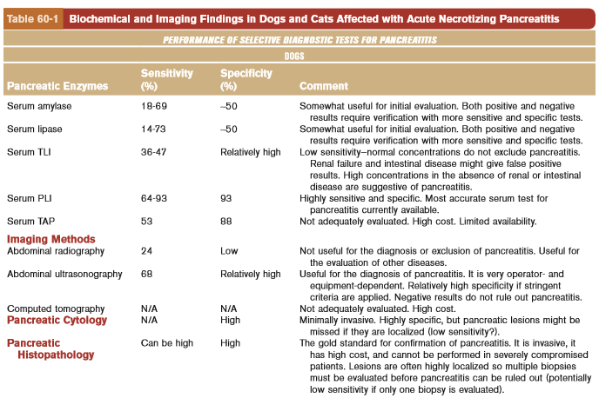
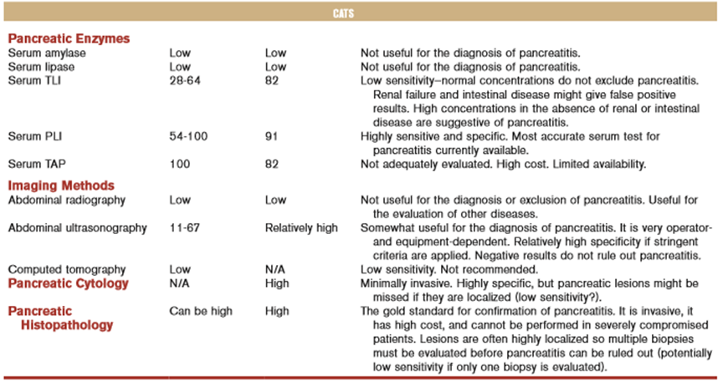
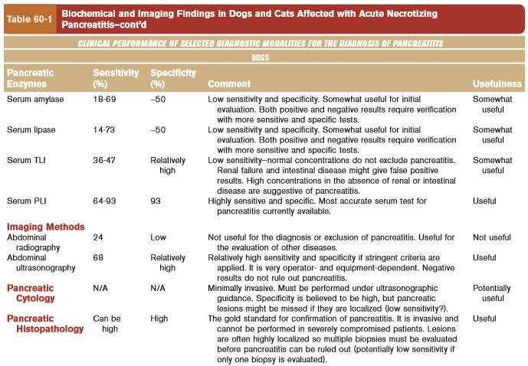
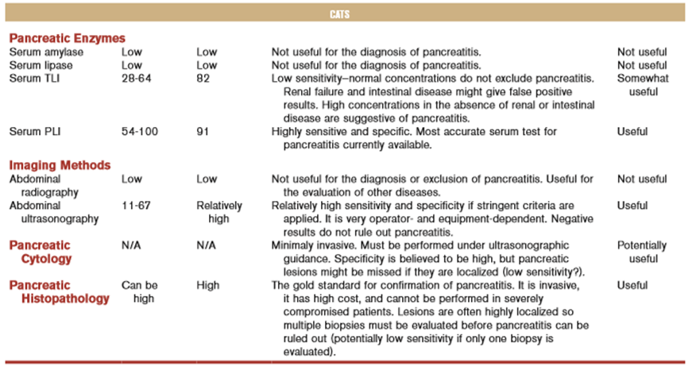

Questions:
- Which of the following drugs does NOT predispose to pancreatitis?
  - Phenobarbital
  - L-asparginase
  - Heparin
  - Azathioprine
  - Potassium Bromide

- What is the Gold Standard diagnostic tool for pancreatitis?

- What is normally observed on abdominal ultrasound in patient with pancreatitis?

- Which of the following is CORRECT?

  - Serum lipase can be falsely low in azotemic patients
  - TLI takes up to 3 days to become elevated in acute pancreatitis
  - Pancreatic cytology is the gold standard diagnostic tool
  - Pancreatic lipase is exclusive of pancreatic acinar cells and different from other lipases
  - Pancreatitis severity scores for dogs have been developed and should be used

- T or F: Pancreatitis should be diagnosed based on a conjunction of clinical, clinicopathologic and imaging signs.

Answer:
- Which of the following drugs does NOT predispose to pancreatitis?
  - Phenobarbital
  - L-asparginase
  - Heparin
  - Azathioprine
  - Potassium Bromide

- What is the Gold Standard diagnostic tool for pancreatitis?
Pancreatic biopsy
- What is normally observed on abdominal ultrasound in patient with pancreatitis?

Enlarged hypoechoic pancreas (edema, hemorrhage, necrosis), hyperechoic cranial mesentery, pseudocysts, abscesses, dilation of pancreatic and biliary ducts, peritonitis, and peritoneal fluid

- Which of the following is CORRECT?
  - Serum lipase can be falsely elevated in azotemic patients
  - TLI takes up to 3 days to decrease in acute pancreatitis, is acutely elevated
  - Pancreatic biopsy is the gold standard diagnostic tool
  - Pancreatic lipase is exclusive of pancreatic acinar cells and different from other lipases
  - Pancreatitis severity scores for dogs have NOT been developed and should be used

- T or F: Pancreatitis should be diagnosed based on a conjunction of clinical, clinicopathologic and imaging signs.

