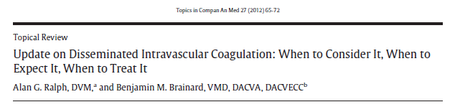
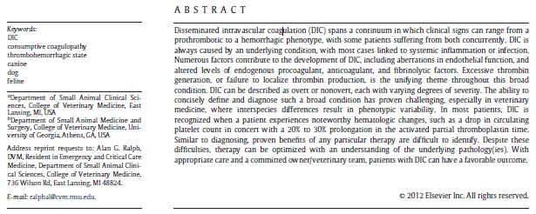
Mechanisms of DIC Pathogenesis: DIC is closely related to significant systemic inflammation, infection and neoplasia.
- Tissue Factor (TF) Activation and Thrombin Generation
  - All coagulation in vivo is initiated by TF from endothelial disruption → Thrombin generation → Formation of cross-linked fibrin
  - TF can also be expressed on endothelial surfaces exposed to inflammatory cytokines (TNF-α, interleukin-1 or endotoxin)
  - TF is also expressed from monocytes/macrophages when stimulated by these same cytokines
- Endothelium
  - Normal state is antithrombotic, helping to maintain normal blood flow
  - Widespread endothelial activation is part of the host response in sepsis and becomes prothrombotic
  - Endothelial barrier = vascular endothelial cells + glycocalyx, these are responsible for regulating vasomotor tone, preventing aberrant thrombus formation and maintain organ perfusion.
  - In inflammatory states and hemorrhagic shock the glycocalyx is damaged by ↓ microvascular perfusion, TNF-α and hypoxia, leading to the loss and shedding of the glycocalyx, this loss leads to fluid extravasation and edema formation
  - Endothelial cells become activated by cytokines, thrombin, bradykinin, histamine, vascular endothelial growth factor (VEGF) → release vWF → induces platelet aggregation and thrombocytopenia
- Endogenous Inhibitors of Coagulation (Natural Anticoagulants)
  - DIC affects the 3 main anticoagulant systems
  - Activated Protein C (APC): Thrombin + Thrombomodulin (TM) converts protein C to APC, during inflammation, cytokines ↓ the expression of TM , hence ↓ APC, decrease in dogs in the 1st 2 days of hospitalization
  - Antithrombin (AT): inhibits thrombin, fXa and fIXa, it is ↓ due to consumption and ↓ production (negative acute phase protein) and degradation by elastase from neutrophils, decrease in dogs in the 1st 2 days of hospitalization, non survivors tend to have a lower AT
  - Tissue Factor Pathway Inhibitor (TFPI): released from endothelium, binds and inhibits TF-VIIa complex and fXa → preventing extrinsic pathway coagulation, exogenous TFPI may prevent mortality in early human studies, unclear of the benefits in veterinary medicine.
- Fibrinolysis
  - Protective step to prevent vascular occlusion leading to microvascular thrombosis and organ damage
  - Plasminogen is incorporated and bound to thrombin during clot formation
  - Tissue-specific plasminogen activator (tPA) is released from the endothelium and activate the plasminogen to plasmin, then cleaving fibrin
  - This cleavage leads to production of degradation products D-dimers
  - Plasminogen activator inhibitor-1 (PAI-1), is a tPA inhibitor and balances fibrinolysis, inflammation can lead to increased tPA and PAI-1
Causes of DIC: Any disease process that increases prothrombotic factors, decreases endogenous anticoagulants, causes endothelial dysfunction, or leads to defects in fibrinolysis can trigger DIC in small animals.

Diagnosis of DIC: Scientific Subcommittee of the International Society of Thrombosis and Haemostasis divided DIC into:
- Overt DIC (uncompensated): advanced state, marked consumption of coagulation factors and platelets and is usually hemorrhagic
- Nonovert DIC (compensated): coagulation is activated but still have antithrombotic elements, they are not hemorrhagic and are at high risk of thrombosis
DIC in vet med has been diagnosed based on a clinical condition that may induce DIC and 2 or more of the following:
- Thrombocytopenia
- Prolonged aPTT
- Prolonged PT
- Prolonged Thrombin clot time
- Hypofibrinogenemia
- Decreased AT
- Elevated markers of fibrinolysis (FDP, D-dimers)
- Erythrocyte fragmentation of blood smear
The more of these parameters evaluated the greater the specificity, these are aimed at markers of consumption and will not identify nonovert DIC.
DIC scoring systems are being developed using fibrinogen, PT, aPTT and D-dimer which may predict the probability of DIC. Author recommends that for now DIC be suspected if:
- Sudden drop in platelets
- Mild prolongation (20-30%) aPTT
- Patient at risk for systemic inflammation
Nonovert diagnosis may benefit from newer coagulation tools such as quatification of thrombin-antithrombin complexes, TEG (considering that anemia, thrombocytopenia and elevated fibrinogen may affect results). Ultimately for now clinical signs and suspicion may be the only way to obtain an early diagnosis.
Treatment of DIC: Treat underlying cause MOST important
- Overt DIC: most common patient that we treat
  - FFP 10-20 ml/kg
  - Cryoprecipitate is there is fibrinogen deficiency and smaller volume is required
  - Always reassess PT/aPTT after to evaluate if more is needed
  - pRBC or whole blood may be needed to maintain oxygen delivery and improve anemia, however are not routinely recommended for patients who are not bleeding
  - Platelets may be warranted if bleeding cannot be controlled due to thrombocytopenia
- Nonovert DIC:
  - Unclear when thromboprophylaxis should be started
  - Normally started when the risks of thrombosis are greater than the risk of medications

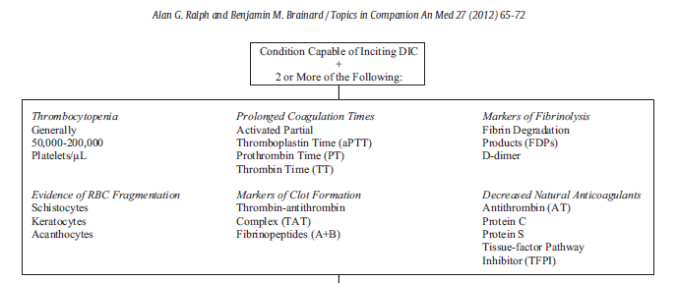
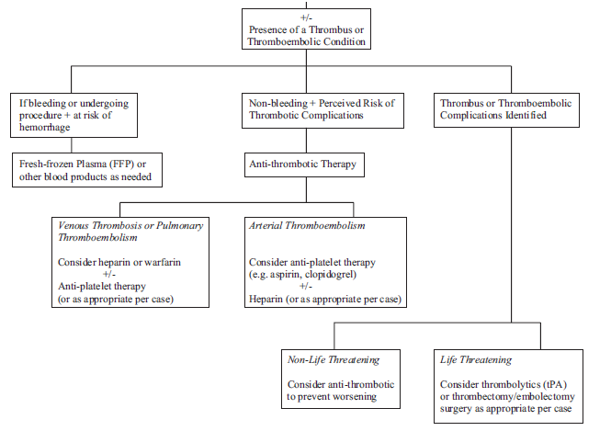

Questions:
- According to this author, which 3 developments in a patient may lead us to suspect DIC:

- Name 4 mechanisms involved in the development of DIC

Questions:
- According to this author, which 3 developments in a patient may lead us to suspect DIC:
  - Sudden drop in platelets
  - Mild prolongation (20-30%) aPTT
  - Patient at risk for systemic inflammation

- Name 4 mechanisms involved in the development of DIC
  - Tissue Factor Activation and Thrombin Generation
  - Endothelium Damage
  - Natural Anticoagulants
  - Fibrinolysis

