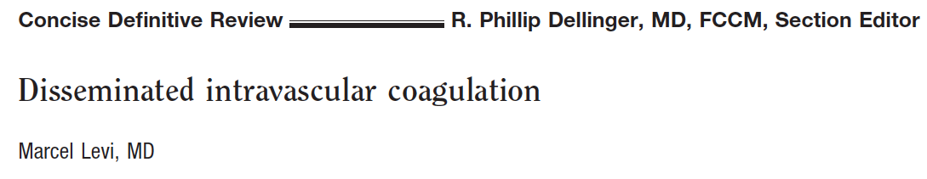

- Pathogenesis of DIC based on tissue factor mediated initiation of systemic coagulation that is insufficiently controlled by anticoagulant pathways

Clinical Setting and Relevance
- DIC is always secondary to an underlying disorder that causes the activation of coagulation
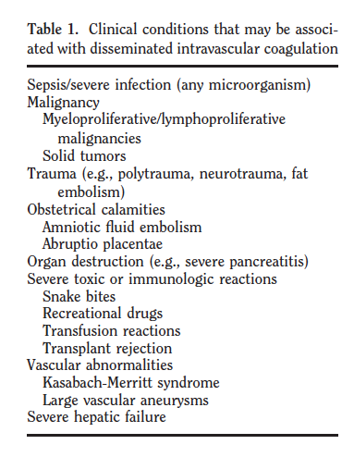

- Severe sepsis complicated by DIC in 35% of cases.
  - Prevalence during gram negative and positive infections are similar
- Prevalence of DIC in cancer is not known.
  - Tissue factor expressed by cancer cells
- Severe trauma can be associated with DIC.
  - Systemic cytokine patterns are identical to those of septic patients.

- Major bleeding occurs in a minority of patients with DIC
  - Prevalence of major bleeding in patients with DIC secondary to severe sepsis was 5-12%
  - Patients with platelets <50x10⁹/L have 4-5 fold higher risk for bleeding as compared with patients with a higher platelet count
- More common is occurrence of organ failure
  - Intravascular thrombi clearly related to clinical dysfunction of the organs

- DIC is a strong predictor of organ dysfunction and mortality in patients with sepsis and severe trauma.
- In patients with sepsis and DIC mortality is two times higher compared to septic patients without DIC

Pathogenesis
- Proinflammatory cytokines are most important mediators
- Tissue factor may be expressed on mononuclear cells in response to proinflammatory cytokines (mainly IL-6) but also on vascular endothelial cells or cancer cells

- Anticoagulant pathways are impaired (ATIII, protein C, tissue factor pathway inhibitor)
  - Endothelial cell dysfunction is important for impaired function of these systems
  - ATIII – reduced due to combination of consumption, degradation by elastase from activated neutrophils and impaired synthesis
  - Protein C – impaired protein synthesis, decrease in free fraction of protein S (reduced activation of protein C), down regulation of protein C receptor
  - TFPI – imbalance of TFPA function in relation to increased tissue factor dependent activation of coagulation

- Fibrinolytic system is inhibited by sustained rise in plasma level of plasminogen activator inhibitor-1 (PAI-1)

Diagnosis
- Reduction in platelet count or prolongation of coagulation times are a sensitive (but not specific) sign of DIC
- Scoring system – prospectively validated, sensitivity and specificity around 95%

International Society of Thrombosis and Hemostasis scoring system for DIC
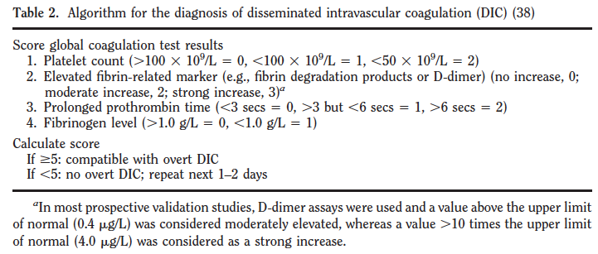

Management
- Studies aimed at inhibition of coagulation activation may be justified – being evaluated
- Heparin can partly inhibit activation of coagulation in DIC. No significant reduction in mortality
- Treatment with TFPA in patients with sepsis did not show overall survival benefit
- Antithrombin – large scale controlled trial showed no significant reduction in mortality of septic patients who were treated with AT
- Protein C supplementation may be of benefit. Shown to be effective in reducing mortality and organ failure. Activated Protein C more effective in higher disease severity groups.

- The use of prohemostatic agents in patients with DIC is not recommended because this may worsen coagulopathy

Questions
1. True or False. Hemorrhage is the most common clinical manifestation of DIC.

2. True or False. Severe sepsis is complicated by DIC in themajority of cases.

3. Name 3 clinical conditions that may be associated with DIC.

4. Which anticoagulant treatment has been shown to have some potential benefit in severely affected septic patients
- Antithrombin
- Protein C
- Tissue factor pathway inhibitor
- Heparin

Answers
1. True or False. Hemorrhage is the most common clinical manifestation of DIC.
Organ failure

2. True or False. Severe sepsis is complicated by DIC in themajority of cases.
False – 35% of septic cases are complicated by DIC

3. Name 3 clinical conditions that may be associated with DIC.

4. Which anticoagulant treatment has been shown to have some potential benefit in severely affected septic patients
- Antithrombin
- Protein C
- Tissue factor pathway inhibitor
- Heparin

