Coxofemoral luxation
- Primary stabilizers of the hip joint include the ligament of the head of the femur, which extends from the fovea capitis in the femoral head to the acetabular fossa; the joint capsule, which attaches medially near the acetabular rim and laterally on the femoral neck; and the dorsal acetabular rim
- Coxofemoral luxation is common in dogs and cats, accounting for up to 90% of all joint luxations
- Vehicular trauma is the cause of up to 85% of coxofemoral luxations reported in the literature
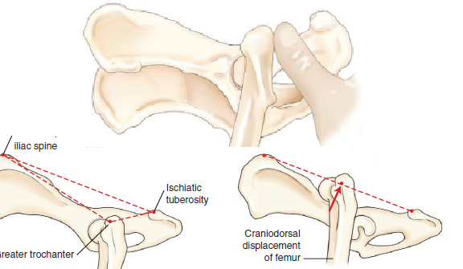
- Other reported causes include severe hip dysplasia, falls, spontaneous luxation, and unknown trauma
- 75% of luxations are craniodorsal
- Ventral and caudal luxations occur less frequently and may be associated with concurrent avulsion fracture of the greater trochanter
- Joint reduction should be performed soon after injury to minimize destruction of cartilage, and before muscle spasticity and fibrosis prevent easy relocation
- Initial open reduction is indicated if acetabular or femoral head fractures are present, the joint reluxates after radiographically confirmed closed reduction, concurrent injuries require immediate return of hip function, or the luxation is chronic and visual evaluation of the cartilage is necessary
- How to replace
- Place under general anesthesia
- An assistant places a small towel or rope in the patient’s inguinal area to provide countertraction and to stabilize the pelvis during reduction
- The femoral head is disengaged from the dorsal acetabular rim by grasping the hock and stifle and externally rotating the limb
- Traction is then applied to the limb in a distocaudal direction to align the femoral head over the acetabulum
- The limb is internally rotated and abducted to seat the femoral head into the acetabulum
- Digital pressure applied to the greater trochanter may be helpful in directing the femoral head into the acetabulum
Open Wounds
- Contamination is the presence of microbes on a surface
- Colonization is when surface microorganisms are replicating
- Infection in when there is invasion and replication of microbes within the tissue
- A burden of 10⁵ colony-forming units (CFU) per gram of tissue has long been considered the threshold for development of infection, with the time frame required for this to occur being 6 hours or more
- A class 1 wound is 0 to 6 hours old and has minimal contamination and tissue trauma
- A class 2 wound is 6 to 12 hours old, at which time replication of microorganisms has occurred
- A class 3 wound is older than 12 hours; microbial replication may have reached the critical level consistent with the development of infection

Primary Wound Closure
- With primary wound closure, wound edges are apposed and allowed to heal by first intention
- Primary closure occurs in most surgical wounds and is indicated in clean, sharply incised wounds that have minimal trauma and contamination and are seen within hours of injury.
- Historically, class 1 wounds were considered amenable to primary closure.
- Class 2 wounds can be closed primarily if the amount of wound contamination and tissue trauma is minimal and can be managed at the time of closure
Delayed primary Closure
- Delayed primary wound closure describes appositional closure within 3 to 5 days after wounding but before granulation tissue has been produced in the wound bed
- This is indicated for mildly contaminated, minimally traumatized wounds that require some cleansing, debridement, and open wound management before closure.
- Class 2 wounds can be managed with delayed primary closure
Healing by Contraction and Epithelialization
- Second intention healing occurs when a wound is left to heal by contraction and epithelialization, eventually producing a continuous epithelial surface
- Open wound management that relies on second intention healing is indicated for dirty, contaminated, traumatized wounds in which cleansing and debridement is necessary but primary or delayed closure is prohibited
Secondary Closure
- Secondary closure describes appositional closure of a wound more than 3 to 5 days after wounding, by which time granulation tissue has formed in the wound bed
- Secondary closure is indicated for severely contaminated, traumatized wounds in which ongoing open wound management allows manipulation of the wound environment to ensure reduction of microbial contamination, treatment of infection if present, and improvement in tissue health before closure
Irrigation Solution
- Tap water is as good if not better than sterile saline for irrigating wounds
- Low-pressure (<5 psi), high-volume irrigation can be generated by devices such as a single-lumen port-type device spiked into a fluid bag
- High-pressure irrigation is above 5 to 8 psi; an 18- to 19-gauge needle on a 35-mL syringe can generate 7 to 8 psi.
Antimicrobials
- Topical agents are indicated early in wound management to control contamination and reduce microbial burden
- Systemic agents are indicated for treatment of wound infection
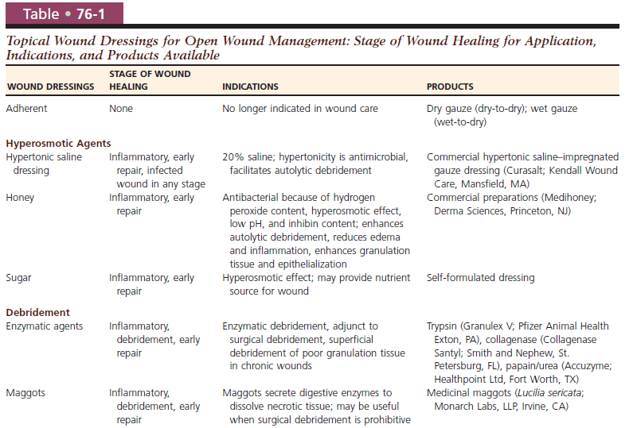
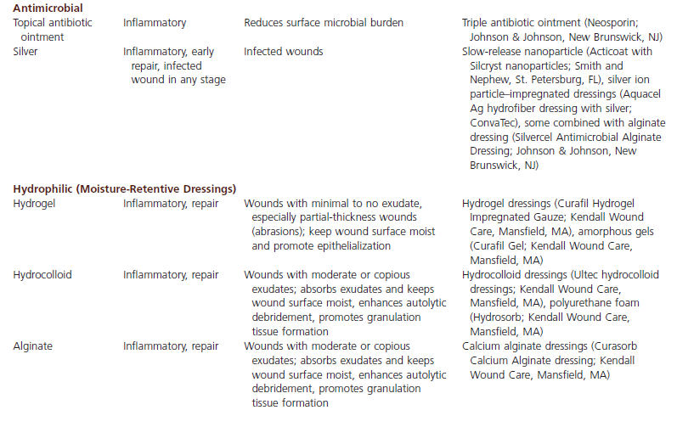
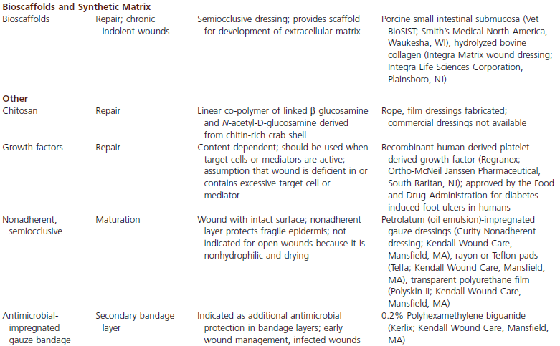

QUESTIONS
1. The most common direction for coxofemoral luxation is….
a) Craniodorsal
b) Cranioventral
c) Caudodorsal
d) Caudoventral

2. Contamination is ….

3. Colonization is …

4. Infection is …

5. A burden of _____________________________colony-forming units (CFU) per gram of tissue has long been considered the threshold for development of infection, with the time frame required for this to occur being 6 hours or more

QUESTIONS AND ANSWERS
1. The most common direction for coxofemoral luxation is….
a) Craniodorsal
b) Cranioventral
c) Caudodorsal
d) Caudoventral

2. Contamination is the presence of microbes on a surface
3. Colonization is when surface microorganisms are replicating
4. Infection in when there is invasion and replication of microbes within the tissue
5. A burden of 10⁵ colony-forming units (CFU) per gram of tissue has long been considered the threshold for development of infection, with the time frame required for this to occur being 6 hours or more

