Smooth Muscle Physiology
- Filaments not organized into sarcomeres
- Two main functions
  - Produce motility
  - Maintain Tension
- Two main types
  - Unitary
    - Gap junctions between cells
    - Coordinated contraction
    - GI Tract; bladder; uterus ; ureter
    - Has spontaneous pacemaker activity
      - Slow Waves
  - Multiunit
    - Each muscle fiber behaves as separate motor unit
    - Iris; ciliary body; vas deferens
  - Combination
    - Vascular smooth muscles
- Calmodulin is protein regulator of smooth muscle, unlike troponin in striated muscle
- Steps of contraction
  - Depolarization – calcium enters via channels, increases intracellular concentration
    - Sarcoplasmic reticulum releases additional calcium
    - Entry of calcium can occur from voltage OR ligand gated channels OR IP₃ gated channels
  - Calcium binds to calmodulin
    - Four calciums + calmodulin = calbodulin complex which binds to myosin-light-chain kinase
  - Phosphorylation of mosin light chains, which increases ATPase activity and allows binding to actin
    - Tension is proportional to Ca++ concentration
  - Calcium-Calmodulin complex also acts on calponin and caldesmon (thin flimaent proteins) which inhibits actin-mysoin bridging at low concentrations and allows it at higher concentrations
  - Relaxation
    - Falling Ca++ concentration, no more calcium-calmodulin complexes
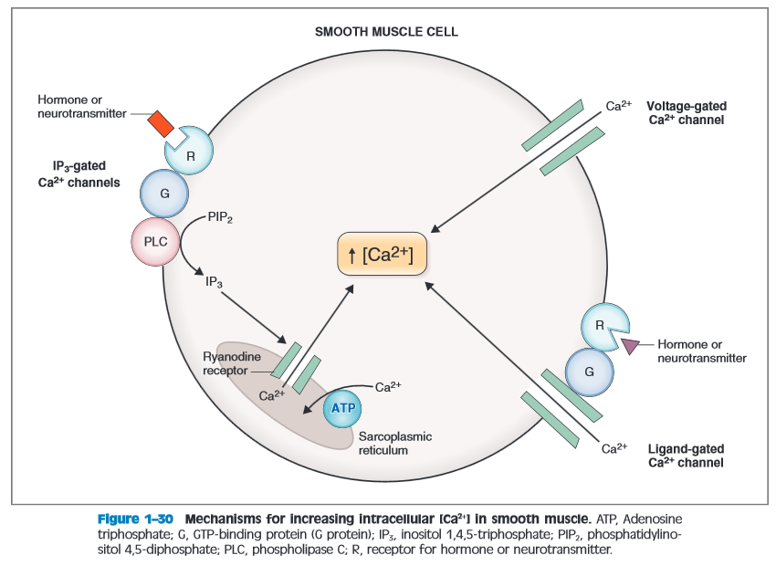
- Entry of Ca to cell
  - Voltage gated Ca channels
    - Action potentials
  - Ligand-gated channels
    - Hormones and neurotransmitters
  - IP₃ gated channels
    - On sarcoplasmic reticulum (only source or Ca in this method)

Questions
- Name two organs in which you can find unitary smooth muscle
- In skeletal muscle, myosin-light-chain kinase is regulated by a calcium - ______ complex, whereas in smooth muscle, it is regulated by a calcium-_______ complex

Questions
- Name two organs in which you can find unitary smooth muscle
Uterus, Bladder, Ureters, GI tract
- In skeletal muscle, myosin-light-chain kinase is regulated by a calcium - ______ complex, whereas in smooth muscle, it is regulated by a calcium-_______ complex
Troponin; Calmodulin

