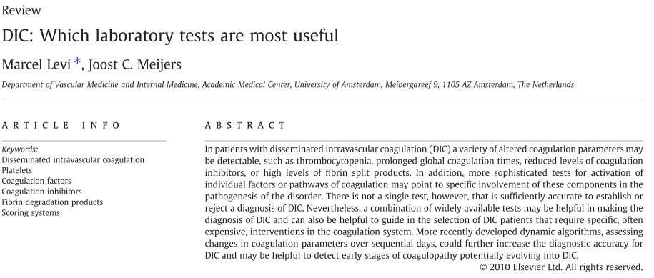
- Clinical and laboratory diagnosis of DIC = difficult; most tests focus on the consumption of coagulation factors or platelet, whereas molecular markers that are more sensitive for coagulation activation are usually insufficiently specific and are often not available.
- Platelets
  - Thrombocytopenia or rapidly decreasing platelet count: hallmark of DIC
    - BUT: thrombocytopenia occurs in 35-44% of critically ill patients = not specific for DIC
    - A platelet count of < 100×10^9/l is seen in 50–60% of DIC
patients, whereas 10–15% of patients have a platelet count of
b50×10^9/l.
    - Regardless of the cause, thrombocytopenia = independent predictor of ICU mortality in multivariate analyses with a relative risk of 1.9 to 4.2 in various studies. A sustained thrombocytopenia during > 4 days after ICU admission or a drop in platelet count of >50% during ICU stay is related to a 4- to 6-fold increase in mortality; low platelet also associated with longer ICU stay (but not total duration of hospitalization)
- Clotting times and coagulation factors
  - Consumption of coagulation factors, impaired synthesis (impaired liver function, vitamin K deficiency), loss of coagulation factors (massive bleeding).
  - A prolonged PT or aPTT occurs in 14 to 28% of ICU patients but is present in > 95% of patients with DIC. A PT or aPTT ratio >1.5 was found to predict excessive bleeding. It is important to emphasize that global coagulation tests poorly reflect in vivo hemostasis. However, these tests are a convenient method to quickly estimate the concentration of one or at times multiple coagulation factors for which each test is sensitive.
  - An increasing number of laboratories use the INR instead of the PT increased standardization between centers, BUT INR has only been validated for control of
the intensity of vitamin K antagonist therapy and has never been
developed for the use as a screening test for coagulation abnormalities.
  - FVIII: INCREASED in DIC generally. Massive release of vWF from the endothelium, acute phase behavior of FVIII.
  - vWF: relative insufficiency of protease
ADAMTS-13 high concentrations of ultralarge vW multimers in plasma facilitate platelet–vessel
wall interaction and the subsequent development of thrombotic
microangiopathy
  - Fibrinogen = acute phase reactant; ongoing consumption plasma levels BUT can remain well within the normal
range for a long period of time. Sensitivity of a low fibrinogen level for the diagnosis of DIC was only 28%
and hypofibrinogenemia was detected in very severe cases of DIC only.
- Fibrin-related markers
  - Concentration of
soluble fibrin increases in patients with DIC BUT so far no reliable test available for quantitating soluble fibrin in plasma. Soluble
fibrin in plasma can only be generated intravascularly (not influenced by extravascular fibrin formation, which may occur during local inflammation or trauma).
  - FDPs: ELISA or latex agglutination; can’t differentiate between degradation of cross-linked fibrin vs fibrinogen degradation (trauma, recent surgery, inflammation, thromboembolism
    - Metabolized by liver, secreted by kidneys…
  - D-dimers: high in patients with DIC; do not discriminate between patients with thrombo-embolism, surgery, inflammation…
    - Detection of epitope related to plasmin-degraded cross-linked γ-chains D-dimers
- Natural coagulation inhibitors
  - May be indicators of ongoing coagulation activation (AT, protein C) – because of exhaustion of these inhibitors during continuous thrombin generation (and also impaired synthesis of AT = negative acute phase, degradation by elastase from neutrophils)
    - Low levels are found in 40–60% of critically ill patients and in 90% of DIC patients
- Markers of fibrinolysis
  - Impaired fibrinolysis in patients with DIC; due to elevation in PAI-1 (fibrinolysis is activated but counteracted by elevated PAI-1 so can’t fight the excessive intravascular fibrin formation)
  - FDP/D-dimers: indicator of fibrinolysis but correlate more strongly with fibrin formation
  - Fibrinolysis activation can be evaluated by measurement of plasminogen and α₂-antiplasmin; plasmin generation can be evaluated by measurement of plasmin–α₂-antiplasmin (PAP) complexes; moderately
elevated in patients with DIC.
- Molecular markers of DIC
  - When a coagulation factor zymogen is converted to an active protease release of activation markers (examples: prothrombin activation fragment F1+2, activation peptides of factor IX and X, elevated thrombin-AT complexes reflect increased generation of thrombin; fibrinopeptide A (FPA) reflects thrombin-mediated fibrinogen to fibrin conversion) elevated in patients critically ill patients; high Sn: can detect even MILD activation of coagulation; low Sp
  - Necessitate optimal venipuncture; not available in clinical setting
- POC
  - TEG/ROTEM: no systematic studies on the diagnostic accuracy for the diagnosis of DIC; useful for global assessment of coagulation.
  - aPTT biphasic waveform analysis: requires specific instrumentation, detects the presence of precipitates
of a complex of very-low-density lipoprotein and C-reactive protein
that appears very early in DIC.
- Composite scoring systems for DIC
  - Score calculated with platelet count, PT (or INR), D-dimer, fibrinogen.
  - Sn: 93%; Sp: 98%
  - Trending score; repeat tests to see if improvement/response to therapy
- Conclusion
  - No single clinical or laboratory test that has an adequate sensitivity and specificity on itself to confirm or reject a diagnosis of DIC.

QUESTIONS
1. TRUE or FALSE: Factor VIII increases in patient with DIC

2. Which of the following is a marker of conversion of fibrinogen to fibrin?
A. ADAMTS-13
B. F1+2
C. Fibrinopeptide A
D.Oligomers-X

3. Explain the cause and the consequence of high concentrations of ultralarge vW multimers in plasma.

4. TRUE of FALSE: Concentration of D-dimers correlate strongly with activation of fibrinolysis in patients with DIC.

QUESTIONS & ANSWERS
1. TRUE: Factor VIII increases in patient with DIC
Due to increased release of vWF from endothelial cells? – Positive active phase protein?

2. Which of the following is a marker of conversion of fibrinogen to fibrin?
A. ADAMTS-13 (a disintegrin and metalloprotease with a thrombospondin type 1 motif, member 13)
B. F1+2 (prothrombin activation fragments)
C. Fibrinopeptide A
D.Oligomers-X

3. Explain the cause and the consequence of high concentrations of ultralarge vW multimers in plasma.
Cause: Relative insufficiency of ADAMTS-13
Consequence: Facilitate platelet-vessel wall interaction subsequent development of thrombotic microangiopathy

4. FALSE: Concentration of D-dimers correlate more strongly with activation of fibrinolysis in patients with DIC.
Indicator of fibrinolytic activity but appears to correlate more strongly with fibrin formation.

