

I. Clinical pharmacology
1. ADDITIVES
(a) Epinephrine
- Causes vasoconstriction and therefore decreases the systemic absorption of the local anesthetic agent this decreases the dose of local anesthetic required and prolongs its duration of effect
- Decreased systemic absorption also reduces the local anesthetic Cmax which decreases the probability of systemic toxicity
- Has analgesic effects on its own when administered epidurally or intrathecally by stimulating α2‐adrenergic receptors
  - This inhibits presynaptic neurotransmitter release from C and Aδ fibers in the substantia gelatinosa of the spinal cord dorsal horn
- Stimulating alpha 1 also modifies certain K+ channels in the axons of peripheral nerves, potentiating the impulse‐blocking actions of local anesthetics
- Disadvantages
  - Decrease in peripheral nerve or spinal cord blood flow nerve or spinal cord ischemia
  - Systemic absorption of epinephrine can also cause cardiovascular effects
    - Increase in heart rate, stroke volume, and cardiac output
    - Decrease in peripheral vascular resistance
- Recommended concentrations of epinephrine for addition to local anesthetic solutions for clinical use range between 1:400 000 (1 mg/400 mL or 2.5 μg/mL) and 1:200 000 (1 mg/200 mL or 5 μg/mL]
  - Concentrations > 5 μg/mL do not provide any additional decrease in Cmax

(b) Hyalauronidase
- Enzyme that depolymerizes hyaluronic acid, the main cement of the interstitium
- May be added to local anesthetics to improve tissue penetration
- Addition raises the pH of the anesthetic solution to a slightly more physiologic level
  - May contribute to the shortening of onset by increasing the amount of unionized drug
  - Local anesthetic Cmax and the risk of systemic toxicity may also increase
- Human and animal studies show variable results

(c) Sodium bicarbonate
- Alkalinization of the solution by adding sodium bicarbonate causes an increase in the amount of local anesthetic in the unionized form (the lipid‐soluble fraction able to cross the axonal membrane)
  - Shortens the onset of the block
- Efficacy of alkalinization depends on
  - Local anesthetic solution
  - Site of the block
  - Concurrent addition of epinephrine
- Also decreases pain on injection when administered subcutaneously and when an epidural catheter is inserted
  - Reduction of pain enhanced by warming of the solution to body temperature
- Most common dose of NaHCO3 used is 0.1 mEq/mL of local anesthetic solution

(d) α2‐adrenergic receptor agonist
- This addition is being increasingly used in veterinary medicine
- Clonidine and dexmedetomidine used in humans
  - Clonidine has been extensively to prolong the duration of intrathecal, epidural, and peripheral nerve blocks
  - Shorter onset, longer duration of sensory and motor block, enhanced block quality, lower pain scores, and decreased systemic opioid requirements when dexmedetomidine is added to bupivacaine or levobupivacaine
- Increased duration of analgesia caused by adding clonidine or dexmedetomidine due to hyperpolarization of C fibers

2. MIXTURES OF LOCAL ANESTHETICS
- Mixtures produce unpredictable and variable clinical results
  - Unpredictable blockade
- Local anesthetic toxicity of combinations of drugs is additive

3. TACHYPHYLAXIS
- Defined as a decrease in duration, segmental spread, or intensity of a regional block despite repeated constant dosages
- Is not linked to structural or pharmacologic properties of the local anesthetics, nor to the technique or mode of administration
  - Can occur with both ester‐ and amide‐linked local anesthetics
  - Can occur with either neuraxial or peripheral nerve blocks
- Mechanisms underlying tachyphylaxis may involve both pharmacokinetic and pharmacodynamic aspects
  - Pharmacokinetic mechanisms include: local edema, increased epidural protein concentration, changes in local anesthetic distribution in the epidural space, a decrease in perineural pH (limiting the diffusion of local anesthetic from the epidural space to binding sites at the Na+ channel), an increase in epidural blood flow, or an increase in local metabolism (favoring clearance of local anesthetics from the epidural space)

II. Specific Drugs and Clinical Uses

1. AMINO-ESTERS
(a) Procaine
- Quick onset and short duration of effect (30–60 min) due to its rapid hydrolysis in blood
- Epinephrine may be added to prolong its duration of effect
- Potential for systemic toxicity is minimal
- Occasionally causes allergic reactions due to a hydrolysis metabolite (PABA)

(b) Benzocaine
- Fast‐acting and short‐lasting
- Available exclusively for topical anesthesia
- Causes methemoglobinemia in several animal species
  - No longer used in clinical practice

(c) Chloroprocaine
- Similar to procaine, with a fast onset and short duration of action (30–60 min)
- Available in concentrations of 1% to 3%.
- Not widely used in veterinary medicine

(d) Tetracaine (aka amethocaine)
- Rarely used in veterinary medicine
- In humans it is most commonly used for intrathecal anesthesia because of fast onset (3–5 min) and its effect lasts 2–3 h
- Excellent topical anesthetic

2. AMINOAMIDES
(a) Lidocaine
- Most versatile and most widely used local anesthetic in veterinary medicine
- Fast onset, moderate duration of effect, and moderate toxicity
- Available as 0.5%, 1%, 1.5%, and 2% solutions
- Uses: infiltration anesthesia, peripheral nerve blocks, epidural and intrathecal blocks, IV regional anesthesia
- Duration of plain lidocaine: ~1h (can be prolonged up to 3h with addition of epinephrine)
- Mechanism by which systemically administered lidocaine produces analgesia is uncertain
  - Thought to include action at Na+, Ca2+, and K+ channels and the NMDA receptor
- Also possesses anti‐inflammatory effects
  - May be important in producing analgesia as inflammatory mediators augment neuronal excitability

(b) Mepivicaine
- Pharmacologic profile very similar to lidocaine
- Slightly longer duration of effect (up to 2 h)
- Available at concentrations from 0.5% to 2%

(c) Bupivacaine
- Highly lipophilic agent (4x as potent as lidocaine)
- Slow onset of action (20–30 min) and a long duration of effect (3–10 h)
- Used in concentrations ranging from 0.125% to 0.75%
- Clinical uses: infiltrative, peripheral nerve, epidural, and intrathecal blocks
- Not used for topical anesthesia and it is not recommended for IV regional anesthesia because of its high cardiotoxicity potential

(d) Levobupivacaine
- Levoisomer or S‐enantiomer of bupivacaine, with slightly less cardiotoxic potential
- Properties and clinical uses are the same as bupivacaine

(e) Ropivacaine
- Structurally related to mepivacaine and bupivacaine
- Marketed as the pure S‐enantiomer to reduce the cardiotoxicity associated with the R‐enantiomer
- Slightly less potent than bupivacaine
- Available in concentrations of up to 1%
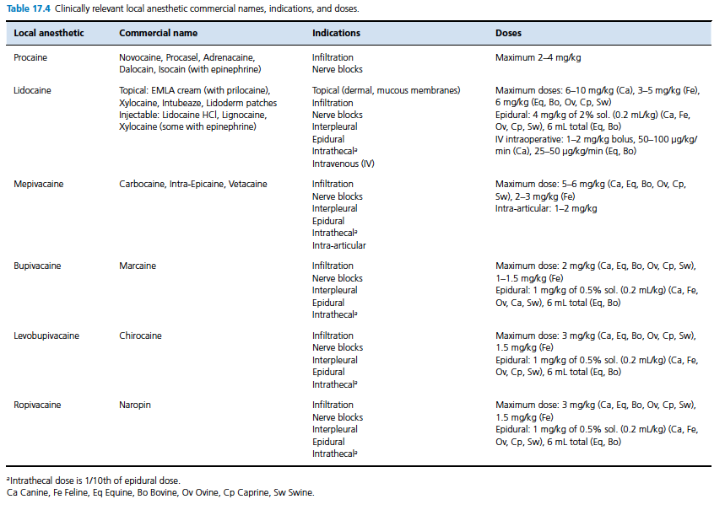
III. Adverse Effects

1. SYSTEMIC TOXICITY
- Local anesthetics vary in their potency at causing systemic toxic reactions
- Generally this potency follows the same rank order as their potency at producing nerve blockade
  - More lipid‐soluble drugs (i.e., bupivacaine) are more potent at causing systemic toxicity than less lipid‐soluble agents (i.e., lidocaine or mepivacaine)
  - The S‐enantiomers are less toxic than the R‐enantiomers

(a) CNS toxicity
- CNS toxic signs follow a progression as the plasma concentration of local anesthetic increases
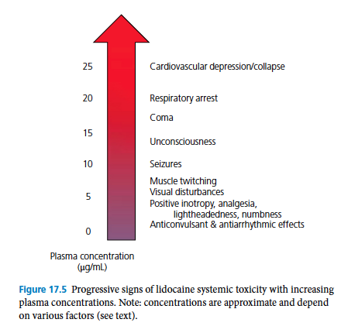

- CNS toxicity is generally assumed to precede cardiovascular toxicity
- In humans
  - Significant difference between the rate of seizure development with caudal > brachial plexus > epidural blocks
  - This occurs with no adverse cardiovascular or pulmonary effects occurring during seizures
- Mean cumulative dose required for convulsive activity in conscious dogs
  - Lidocaine: 21-22 mg/kg
  - Bupivicaine: 4-5 mg/kg
  - Ropivicaine: 5mg/kg
  - Tetracaine: 4 mg/kg
  - Etidocaine: 8 mg/kg
- CRI dose for convulsive activity in conscious dogs
  - Lidocaine: 8 mg/kg/min
  - Bupivacaine: 2 mg/kg/min
  - Ropivacaine: 2 mg/kg/min
- Seizure activity in lightly anesthetized and ventilated cats occurred at:
  - Lidocaine: 12 mg/kg, 16 mg/kg/min
  - Bupivacaine: 5 mg/kg, 4 mg/kg/min
- There is an inverse relationship between the seizure threshold dose of local anesthetics and the arterial carbon dioxide tension
  - Due to an increase in cerebral blood flow during hypercapnia
    - Causes increased delivery of drug to the brain and/or decrease in plasma protein binding of local anesthetics, causing increase in free drug
  - Hypoxemia also increases the CNS and CV toxicity of local anesthetics

(b) Cardiovascular toxicity
- Local anesthetics block cardiac Na+ channels and decrease the maximum rise of Phase 0 of the action potential pronounced inhibition of cardiac conduction
- ECG changes include:
  - Prolonged PR interval
  - Prolonged QRS interval
  - Prolonged refractory period
- CV effects of local anesthetics are complex and non‐linear
  - Involve direct effects on cardiac conduction, contractility and on vascular smooth muscle
  - Involve indirect effects mediated by the CNS
- All local anesthetics cause myocardial depression
  - Shorter acting local anesthetics (lidocaine and mepivacaine) are less arrhythmogenic than longer acting ones (bupivacaine or ropivacaine)
  - Longer acting agents have slower unbinding rates predisposing to cardiac arrhythmias
- CNS toxic effects may be involved in the production of serious cardiotoxicity because of respiratory failure accompanied by hypoxia, bradycardia, hypercapnia, and acidosis
- Hyperkalemia can markedly increase local anesthetic toxicity
  - Since K+ gradient across cardiac myocyte membranes is the most important factor in establishing the membrane potential
  - Seizure‐inducing doses are not affected by hyperkalemia

(c) Treatment of systemic toxicity
- Administration of local anesthetic should be discontinued
- Treatment of systemic toxicity is primarily supportive

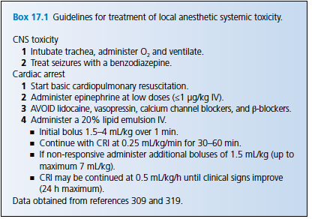

2. LOCAL TOXICITY
(a) Neurotoxicity
- Exposure of the peripheral or central nervous systems to local anesthetics can cause direct damage (this complication is RARE)
- Mechanisms of local anesthetic neurotoxicity remain speculative
  - Suggestion that injury to Schwann cells (time and concentration dependent), inhibition of fast axonal transport, disruption of the blood–nerve barrier, decreased neural blood flow with associated ischemia, and disruption of cell membrane integrity due to a detergent property of local anesthetics
- All local anesthetics are potentially neurotoxic
- Neurotoxicity parallels anesthetic potency (based on the LD50 for neuronal cells)
  - In vitro rank order of potency for cytotoxicity: procaine ≤ mepivacaine < lidocaine < chloroprocaine < ropivacaine < bupivacaine

(b) Myotoxicity
- Local anesthetics can cause toxicity to skeletal muscle at clinically relevant doses
- Concentration dependent
- Mechanism of local anesthetic‐induced muscle toxicity is likely to be related to dysregulation of intracellular calcium concentration and/or alterations in mitochondrial bioenergetics
- In most cases, this myonecrosis appears to be regenerative and clinically imperceptible

(c) Chondrotoxicity
- Has been demonstrated in vivo and in vitro in animal and human cartilage
- Time and concentration dependent
- Greater risk for chondrolysis with a longer exposure to a higher concentration of local anesthetic (i.e. pain pump) than with a single injection
- Mepivacaine seems to be least toxic
  - Therefore preferred drug for intra‐articular administration

3. METHEMOGLOBINEMIA
- Methemoglobin is produced by oxidative damage to the hemoglobin molecule
  - Iron of the heme group is oxidized to the ferric (Fe3+) form
  - In this state it cannot bind oxygen blood O2‐carrying capacity is decreased
- Ester‐type benzocaine and the amide‐type prilocaine more often associated with MHb

4. TOXICOSIS (ORAL INGESTION)
- Clinical signs (cats and ferrets) with benzocaine toxicosis
  - Vomiting
  - Depression
  - Cyanosis
  - Dyspnea
  - Tachypnea
- Other signs in different species
  - Prolonged sedation
  - Vasodilation (leading to hypotension)
  - Cardiac arrhythmias
  - Respiratory depression
  - Tremors and seizures
  - Death

5. ALLERGIC REACTION
- Ester‐type local anesthetics (e.g., procaine) associated with a higher incidence
  - Due to a p‐aminobenzoic acid (PABA) metabolite
- Amide‐type agents do not undergo this metabolism and rarely cause allergic reactions
  - Preservative compounds (i.e., methylparaben, sodium metabisulfite) used in preparations are metabolized to PABA and may cause allergies

IV. QUESTIONS

1. Epinephrine exerts its MAIN analgesic effects by stimulating which receptor?
- α1‐adrenergic receptors
- α2‐adrenergic receptors
- β1‐adrenergic receptors
- β2‐adrenergic receptors

2. True/False. There is a direct relationship between the seizure threshold dose of local anesthetics and the arterial carbon dioxide tension

3. Which electrolyte abnormality can markedly increase local anesthetic cardiotoxicity?
- Hypernatremia
- Hyponatremia
- Hyperkalemia
- Hypokalemia
- Sodium and potassium abnormalities do not affect cardiotoxicity of local anesthetics

3. True/False. Under conditions of hyperkalemia in dogs, the CNS toxic doses of both lidocaine and bupivacaine are decreased compared to conditions of normokalemia.

Bonus question – Describe the treatment for methemoglobinemia?

Answers
1. Epinephrine exerts its MAIN analgesic effects by stimulating which receptor?
- α1‐adrenergic receptors
- α2‐adrenergic receptors
- β1‐adrenergic receptors
- β2‐adrenergic receptors

2. True/False. There is a direct relationship between the seizure threshold dose of local anesthetics and the arterial carbon dioxide tension
There is an INVERSE relationship between the seizure threshold dose of local anesthetics and the arterial CO2 tension

3. Which electrolyte abnormality can markedly increase local anesthetic cardiotoxicity?
- Hypernatremia
- Hyponatremia
- Hyperkalemia
- Hypokalemia
- Sodium and potassium abnormalities do not affect cardiooxicity of local anesthetics

3. True/False. Under conditions of hyperkalemia in dogs, the CNS toxic doses of both lidocaine and bupivacaine are decreased compared to conditions of normokalemia.

Bonus question – Describe the treatment for methemoglobinemia?
- Traditional first‐line therapy of methemoglobinemia consists of slow intravenous administration of 1% methylene blue solution (4 mg/kg in dogs, 1–2 mg/kg in cats).
- The action of methylene blue depends on the availability of reduced nicotinamide adenine dinucleotide phosphate (NADPH) within red blood cells
- Dextrose should also be administered because it is the major source of reduced nicotinamide adenine dinucleotide (NADH) in red blood cells, which is necessary to form NADPH, which is in turn needed for methylene blue to be effective
- In severe cases a blood transfusion may be required

